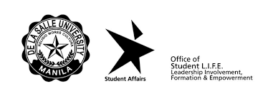

Date: {date}

**Mr. MICHAEL G. MILLANES**

*Director*

Student Discipline Formation Office

De La Salle University

Dear **Mr. MILLANES:**

Greetings!

Please be informed that my son/daughter, Mr./Ms. {firstname} {lastname}, taking up {course} under the College of {college} with ID No. {idn} has notified me that he/she incurred his/her {frequency}; {type} offense on {nature}.

As his/her parent/guardian, I fully understand the seriousness of my son/daughter’s action/s and believes that the University, through the Student Discipline Formation Office has the right to enforce the necessary corrective measure/s as recommended in the present student handbook Sections 1, 4 and 5.

Thank you very much and More Power!

Parent’s/Guardian’s Name: {guardian}

Contact Information: {contact}

Present Address: {address}