**Darkside-50 Detector**

* Detects WIMPs through collisions with ordinary nuclei, giving observable, low energy nuclear recoils.
* Uses LAr TPCs
* Good signal to background discrimination power & 3D position locators.
* 50Kg active mass of liquid argon

The DarkSide-50 is an experiment which uses 50kg of liquid Argon to detect WIMPs, which are a possible candidate for dark matter. It specifically uses liquid Argon Time Projection Chambers (LAr TPCs). This has several benefits, including good discrimination of signal from background and 3D Position locators from events.

A simple model for Dark matters suggests a spherical isothermal halo, meaning it is the same in all directions. This halo is moving with a mean speed of 270km/s. The solar system moves through this halo at a speed 220km/s, so we expect WIMPs to be coming preferentially from a certain direction in the sky. However, since the WIMP velocity dispersion is comparable to our orbital velocity, directional effects are not large.

However, as well as looking for exotic WIMPs, the Darkside-50 detector also observes neutrino interactions with nuclei. This allows for several tests against the standard model.

**Dual Phase LAr TPCs**

Lar is a cyrogenic material with excellent scintillation and ionisation properties. The atomic recoils are approx. 100KeVs. After the primary scintillation event caused by recoil of the nucleus, there is a second scintillation event when the diatomic argon ‘molecules’ relax. However some ionised electrons remain and drift upwards die to an applied drift current.

The ratio of ionisation to scintillation allows for separation of signal from background events. As low-ioniation density events like beta or gamma interactions lead to less recombination, leading to more free electrons.

The scintillations are detected by PMTs.

To detect the ionization, DarkSide uses a two-phase TPC configuration, which contains a small region of gaseous argon above a larger region of liquid argon. A uniform, 200 V/cm electric field is produced by a “field cage” consisting of a cathode plane, field-shaping rings, and an extraction grid. This uniform field drifts the ionization electrons upward to the surface of the liquid. There, a collinear electric field of ~3 kV/cm extracts the electrons into the gas phase, where they produce secondary scintillation photons by a process called “electroluminescence” (EL). The resulting secondary photons (S2 signal) are detected by the PMT arrays as a delayed coincidence, relative to the primary scintillation signal (S1).

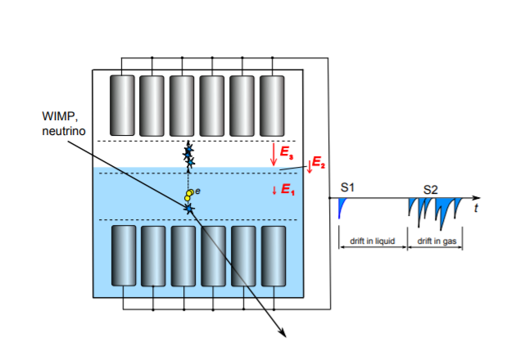

**GANs**

GANs are a type of of neural networks. Used for unsupervised machine learning. Two networks in competition with one another.

Generator and discriminator networks.

Also improve small datasets and lack of human supervision.

**Neural Networks**