**The Simulated Structure of neutron stars**

**Abstract**

Neutron stars are simulated by using the principle of hydrostatic equilibrium with Newtonian and General Relativistic gravitational models. The star is ‘built’ using numerical methods such as the Runge-Kutta 4th order method, with an ideal non-interacting Fermi gas and soft-core interacting equation of state. Radius and mass dependence on the equation of state used was investigated as well as the density structure for comparison against observations. Using the Tolman-Oppenheimer-Volkov equation, with Bethe & Johnson’s equation of state, the maximum mass of a neutron star was found to be 1.79 solar masses with radius 9.26 km and the maximum radius was found to be 11.16 km with mass 0.98 solar masses. [Need to add errors still]

**Intro**

‘It doesn’t matter how beautiful your theory is, it doesn’t matter how smart you are. If it doesn’t agree with experiment, it’s wrong’-Richard P. Feynman. Neutron stars are perhaps the only loophole in today’s physics to this argument, as instead of developing a theory mathematically and comparing its predictions with observations, observations are used to develop an equation of state. After a star can no longer sustain nuclear fusion to counter the gravitational contraction on its own mass, it collapses. If the stellar core is more massive than the Chandrasekhar limit, the electron degeneracy pressure will not stop the star from further collapse. At this stage it becomes energetically favourable for the protons and electrons to decay into neutrons via electron capture. The matter collapses in gravitational free-fall until it hits the core, most often creating a supernova. If the core is less than approximately three solar masses a neutron star is formed, if above this limit a black hole is formed[c].

In this report neutron stars are simulated using numerical integration, the principle of hydrostatic equilibrium and two equations of state. The theorized matter distribution of compact stellar objects is stated before examining the method of ‘building ‘the star. We then aim to show which of the equation of states tested best suits observation and why. Additionally, special relativistic rotation is added as a fictitious force to give understanding of rotational affects.

**The Theoretical structure**

The structure of nuclear matter with varying density is fundamental to comparing observation to simulation. So, we form a theoretical spherically symmetrical density distribution based on current The Standard Model of particle physics for our neuron star model.

On the surface/outer crust for densities less than $4.3x{10}^{14}kgm^{-3}$ a coulomb lattice structure of neutron rich nuclei is formed, induced by inverse beta decay from the relativistic degenerate electrons. The nuclear binding energy peak representing the most stable nuclei ~~for elements~~ will be slightly skewed by this effect. Beyond $4.3x{10}^{14}kgm^{-3}$ the inverse beta decay process becomes more prominent,  causing the ‘neutron drip’, a process in which the neutron rich nuclei expel the neutrons into a neutron gas. Here, free electrons and neutrons co-exist in an equilibrium of superfluid gas. The neutron and electron gas with neutron rich nuclei can exist in this state up until the nuclear density of $2.3x{10}^{17}kgm^{-3}$. Passed the nuclear density, the nuclei begin to merge, in a process called nuclear saturation, causing complex inter-nucleon interactions. This gives rise to a superfluid of electrons, neutrons and protons where neutron degeneracy exerts an outward pressure due to the Pauli exclusion principle. At densities of the order $1x{10}^{18}kgm^{-3}$ the pressure may cause pion condensation; interactions are very important between particles at these densities. Passed this density, quark matter is hypothesised to be formed[a][b][m].

**Building a star.**

For a star not to collapse or explode each infinitesimally thin spherical shell of the neutron star matter must be in an equilibrium of the pressures. The balance must be between the outward pressure caused by the degeneracy of the matter and the gravitational forces inward due to the mass inside that shell; This is the principle of hydrostatic equilibrium.

Using the Newtonian gravitational model, the pressure gradient and therefore condition for stellar equilibrium at radius $r$ due to gravity is

(1).

$$\frac{dP}{dr}=\frac{-Gm\left(r\right)ρ\left(r\right)}{r^{2}}$$

Where $ρ\left(r\right)$ is the density of matter at $r$, $G$ is the universal gravitation constant of gravitation and $P$ is the pressure. The mass enclosed by a sphere of radius $r$, $m\left(r\right)$ is given by the differential equation

.(2)

$$\frac{dm}{dr}=4πr^{2}ρ\left(r\right)$$

In Einstein’s theory of gravitation, the corresponding condition for hydrostatic equilibrium is

(3).

$$\frac{dP}{dr}=\frac{-Gm\left(r\right)}{r^{2}}\frac{\left(1+\frac{P\left(r\right)}{ρ\left(r\right)c}\right)\left(1+4πr^{3}\frac{P\left(r\right)}{m\left(r\right)c}\right)}{\left(1-\frac{2Gm\left(r\right)}{rc^{2}}\right)}$$

Equation (3) is called the Tolman–Oppenheimer–Volkoff equation (TOV). The TOV shows explicit pressure dependence on the pressure gradient leading to a gravitational collapse at a smaller mass than equation (1). Equation (3) was predicted by Oppenheimer and Volkoff in 1939 using a cold Fermi gas (one very similar to our non-interacting model in the following section) and a maximum neutron mass of 0.7 solar masses using the TOV[h]. The TOV has an upper limit of 3 solar mases.

These equations have been used with numerical integration and equations of state (EOS) to model neutron stars. We compare the solutions of equations (1) and (3) with corresponding EOS’s with observation.

**The equation of state**

The equation of state gives a relation between the pressure exerted at a given mass density. In our models for simulations of neutron star two equations of state are used, The Bethe-Johnson (BJ) and an ideal neutron gas EOS.

The Bethe Johnson EOS [d] is a modified Reid soft core interaction model, using the neutron-neutron (N-N) potentials to produce a repulsive core via meson exchange. The BJ EOS uses Yukawa functions with parameters set to model experimental N-N scattering data [b]. The BJ EOS is

(4.b)

(4.a)

$$P\left(n\right)=363.44n^{2.54}$$

$$ρ\left(n\right)=236n^{2.54}+nm_{n}$$

, where $n$ is the number density of neutrons, $P\left(n\right)$ is the pressure in $MeVc^{-2}{fm}^{-3}$ and $ρ\left(n\right)$ is the density in $MeVc^{-2}{fm}^{-3}$. A conversion factor to SI units was applied to equation (4) before application in the computational section. The BJ EOS is valid for the central density range of $\left(1.7×{10}^{17}≤ρ≤3.2×{10}^{19}\right)kgm^{-3}$ [b].

The ideal neutron gas EOS (NI) is the simplest model that can be used [a]. It is based on a non-interacting Fermi gas of neutrons. There are two parts to this equation of state; In the nonrelativistic regime the EOS is

$$P=\frac{ℏ}{5m_{n}^{\frac{8}{3}}}{\left(3π^{2}\right)}^{\frac{2}{3}}ρ^{\frac{5}{3}}$$

The second part of the NI EOS in the extreme relativity approximation is given by

.(5.b).

.(5.a)

$$P=\frac{1}{3}ℏcm_{n}^{\frac{-4}{3}}{\left(3π^{2}\right)}^{\frac{1}{3}}ρ^{\frac{4}{3}}$$

The NI EOS is valid for $\left(0≤ρ≤∞\right)kgm^{-3}$ [b], with the advised upper bound to be $\left(ρ≤5×{10}^{17}\right)kgm^{-3}$ due to the softening of the EOS relations due to N-N interactions. There is a critical density of value $ρ_{c}=5×{10}^{17}kgm^{-3}$ [j] specified for computational processes that acts as a bound between equations (5.a) and (5.b). The value $ρ_{c}$ is derived as an approximate figure using

(6)

$$ε_{F}=\frac{ℏ^{2}}{2m_{n}}{\left(3π^{2}\frac{N}{V}\right)}^{\frac{2}{3}}≪E_{mn}$$

[k], where $ε_{F}$ is the Fermi energy of the neutron in this case, $\frac{N}{V}$ is the density of neutrons per unit volume in ‘k space’ and $E_{mn}$ is the rest mass of a neutron in joules. $ρ_{c}=5×{10}^{17}kgm^{-3}$ is then given when equation 6 is no longer valid, in which the ultra-relavatisitc approximation is then used. The maximum mass obtainable due to an ideal gas of degenerate neutrons is 5.8 solar masses [a].

We apply the BJ EOS central density region to comply simultaneously with both limits of the EOS’s in the simulation. Equations (4) and (5) will be used in conjunction with the differential equations in the previous section to simulate neutron stars. Both the BJ and NI equation of state assume a non-rotating neutron star.

**Computational method**

Figure 1: Computational method for a single central density.

Initialize values using a specified central density

Solve Equation (2) for Using values at

Solve Equation (1)/(3) for Using values at

Use EOS to find new from

Break Condition for

Interpolation methods using values

Error Analysis, Final Values of and for one star

and

Solve: Numerical Method of integration e.g. RK4

The code was written in Python 3.5.3 using numerical integration as the base method to build neutron star from a range of initial central densities. The primary numerical integration method used was the Runge-Kutta 4th order method (RK4). Referring to Figure 1 a central density is initialised from the allowed limits. The central mass and radius were both initialized as zero [f]. A multistep numerical integration method is used until the program hit the break condition. The code then takes the last two points and interpolates using a linear fit/Newton Raphson to find the exact radius at which the pressure goes to zero. A linear fit is then applied to the respective masses and uses a linear fit/interpolation to find the final mass on the neutron star at the final radius.

The above method was implemented for a family of neutron stars constrained by the BJ EOS density limitations for comparative analysis with the NI EOS.

The BJ EOS central pressure was initialized by specifying the central density and using a Newton Raphson with equation (4). The NI EOS depends on two sub EOS’s as mentioned in previous sections. Therefore, when the program iterates through the numerical integration, decreasing in density until the critical density is reached, the EOS then changes from equation (5.b) to (5.a) as lower density regions are reached.

Plots of final mass vs final radius, central density vs final mass and central density vs final radius were all plotted. In addition, four density/matter distribution graphs were plotted to show the internal structure on the star produced by their respective EOS and gravitational model.

Furthermore, Runge Kuta 5th order (RK5) and Euler numerical integration methods were implemented. The RK5 is technically more accurate than RK4 but with more numerical rounding error due to extra calculations. The Euler method is technically less accurate RK4, but with only a single calculation. These two methods provide an indicative bound for our simulation result.

**(Subsection)** – Errors

To calculate the errors on the mass and radius of the simulated neutron stars, two main elements of error were considered. The error in interpolation method is

(7)

$$E_{inter}=±{\left(x_{i}-x_{i-1}\right)}^{n+1}$$

[g],where $x_{i}$, $x_{i-1}$ are the respective points being interpolated and $n$ is the order of polynomial, in our case this is linear and therefore $n=1$. The error on the rk4 is calculated by simultaneously building the star with an rk4 that has a step of twice that of the step size used for the result. The equation for the RK4 error is

(8)

$$E_{RK4}=\frac{\left|X_{2h}-X_{h}\right|}{\left(2^{n}-1\right)}$$

[h], where $X_{h}$ is the final value of numerical integration such as the mass or radius with single step of $h$ and $X_{2h}$ is the RK4 double stepped final value. Both the radius and the mass had both errors for equations (6) and (7) added in quadrature for their respective values.

**(Subsection)** - Fictitious forces.

The NI and BJ EOS’s assume a non-rotating neutron star. To give an indication of ~~to~~ what effect rotation would have on the structure of neutron stars, the pressure gradients of equations (1) and (3) were adapted to include the special relativistic centrifugal fictitious force on a shell of mass at a given radius [i]. Therefore, our adaptation is an approximation of the effect of rotation.

**Results And Discussion**

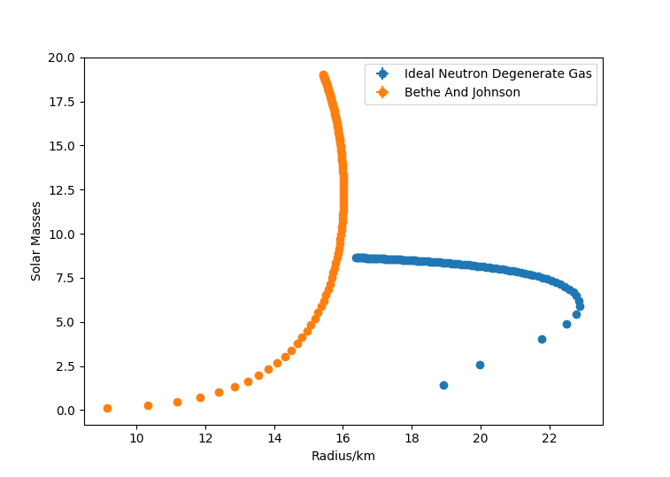Family plots for Newtonian

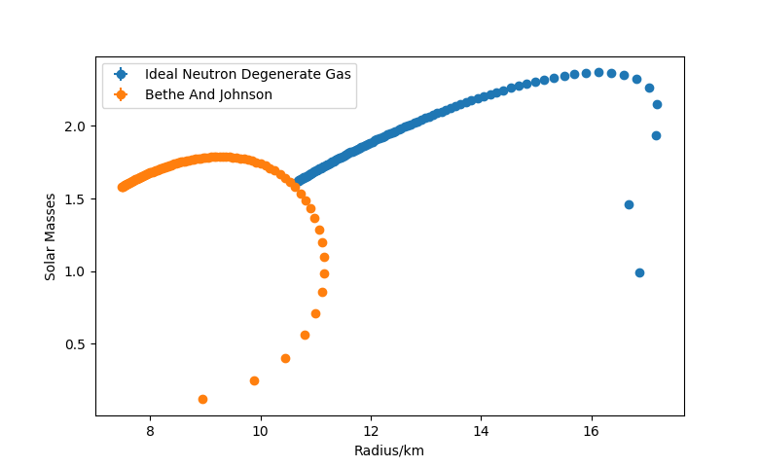Family Plots for TOV

Distribution NI EOS

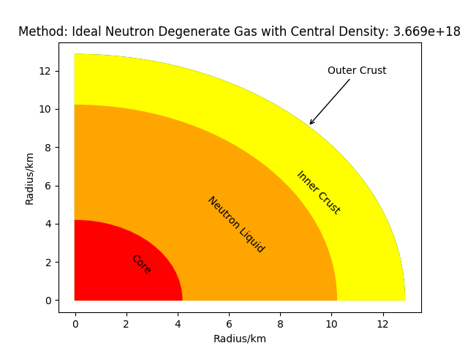

Distribution BJ EOS

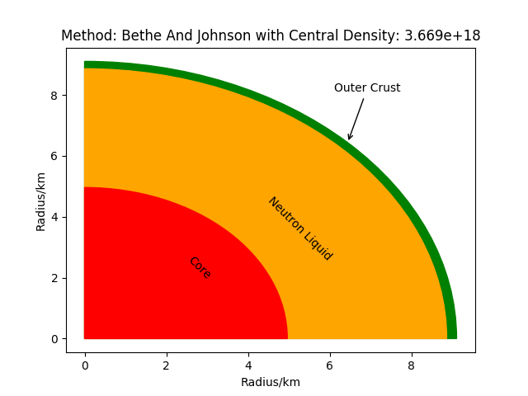

Our results shows ~~that~~ the maximum mass of a neutron star for the BJ EOS was found to be 1.79 solar masses with radius 9.26 km and the maximum radius was found to be 11.16 km with mass 0.98 solar masses. ~~And~~ The maximum mass of the NI EOS was found to be 2.37 solar masses with radius 16.12 km and the maximum radius was found to be 17.19 km with mass 2.15 solar masses.

*“Using method Ideal Neutron Degenerate Gas the maximum radius is 17.1901 km with mass 2.1513 M0*

*Using method Ideal Neutron Degenerate Gas the maximum mass is 2.3686 M0 with radius 16.1247 km*

*Using method Bethe And Johnson the maximum radius is 11.1554 km with mass 0.9828 M0*

*Using method Bethe And Johnson the maximum mass is 1.7884 M0 with radius 9.2616 km”*

The BJ EOS hence fits rather well with current observations of neutron sta*rs. The observed values[o] are a mass between 1.3 to 2.5 solar masses and radii of about than 10 kilometers.*

**For the RK5 method, the values found were:**

Using method Ideal Neutron Degenerate Gas the maximum radius is 18.2221 km with mass 2.3848 M0

Using method Ideal Neutron Degenerate Gas the maximum mass is 2.6023 M0 with radius 17.0342 km

Using method Bethe And Johnson the maximum radius is 11.8762 km with mass 1.1035 M0

Using method Bethe And Johnson the maximum mass is 1.9329 M0 with radius 9.8616 km

**For the Euler method the values found were:**

Using method Ideal Neutron Degenerate Gas the maximum radius is 17.1945 km with mass 2.1514 M0

Using method Ideal Neutron Degenerate Gas the maximum mass is 2.3672 M0 with radius 16.1250 km

Using method Bethe And Johnson the maximum radius is 11.1612 km with mass 0.9825 M0

Using method Bethe And Johnson the maximum mass is 1.7868 M0 with radius 9.2640 km

*The effects of rotation using a first order special relativistic approximation and a frequency of* ***641 Hz*** *corresponding too one of the fasted observed neutron star rotations [n]. The BJ EOS and TOV were used for this exercise, increased the size the modelled neutron star by ….. using a central density of….. This shows an increase although very small in comparison with the size of the star. More accurate approximations will involve treating the structure of the neutron star as a viscous fluid with a oblate spheroid shape and use fictitious forces derived from general relativity, from our exercise we would expect an increase in the radius size for a specific central density. Can you please fill these values in?*

**Summary**

How does the result fit observation? What is the closet result and why?

The BJ EOS fits best observation since it fits well between the mass range and also radius range. It is the best combination out of the one tested since it takes into consideration N-N soft core interactions and together with the general relativistic gravtiational model provided by the TOV they provide a theortical model somewhat close to reality. The TOV gravitational model hence is seen to fit observed values and limitations as opposed to the Newtonian model

References

[a] Irvine, J. (1978). *Neutron stars*. Oxford: Clarendon Press, pp.115-131.

[b] Shapiro, S. and Teukolsky, S. (1983). *Black holes, white dwarfs, and neutron stars*. New York: Wiley, pp.188-294.

[c] Phillips, A. (2013). The Physics of Stars. Hoboken: Wiley, pp.30-31.

[d] Bethe, H. and Johnson, M. (1974). *Dense baryon matter calculations with realistic potentials*. Nuclear Physics A, 230(1), pp.1-58.

[e] A.S.Chai. *Error estimate of a fourth-order Runge-Kutta method with only one initial derivative evaluation*. Hybrid Computer Laboratory, University of Wisconsin Madison.

[f] M.Hjorth-Jensen; Computational Physics; *http://folk.uio.no/mhjensen/computationalphysics.pdf*  (2006) p289-293

[g] *Polynomial Interpolation: error analysis*. Available from: https://www.math.uh.edu/~jingqiu/math4364/interp_error.pdf [Accessed 21 March 2018].

[h] Error estimate of a fourth-order Runge-Kutta method with only one initial derivative evaluation https://www.computer.org/csdl/proceedings/afips/1968/5071/00/50710467.pdf [Accessed 21 March 2018].

[i] Jonsson, R. (2006). An intuitive approach to inertial forces and the centrifugal force paradox in general relativity. American Journal of Physics, 74(10), pp.905-916.

[j] Jolien Creighton (2012). *Relativistic Stars*. University of Wisconsin–Milwaukee.

[k] Hook, J. and Hall, H. (2013). Solid state physics. Hoboken: Wiley, pp.52-82.

[n] Chakrabarty, D., Morgan, E., Muno, M., Galloway, D., Wijnands, R., van der Klis, M. and Markwardt, C. (2003). *Nuclear-powered millisecond pulsars and the maximum spin frequency of neutron stars*. Nature, 424(6944), pp.42-44.

[h] Oppenheimer, J. and Volkoff, G. (1939). On Massive Neutron Cores. Physical Review, 55(4), pp.374-381.

[m] Phillips, A. (2013). The Physics of Stars. Hoboken: Wiley, pp.189-204.

Need to use ref m, b and a in the structure section,

[o] https://www.nasa.gov/mission_pages/GLAST/science/neutron_stars.html