Configuring EtherChannel (Instructor Version)
Completed Topology
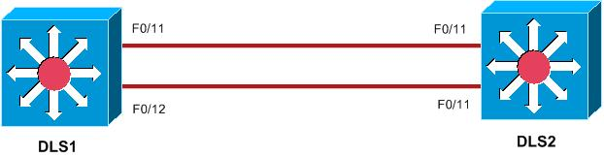
Objectives
- View the default Layer 2 configuration.
- Configure EtherChannel.
Background/Scenario
EtherChannel enables the switch administrator to increase bandwidth between switches by bundling together between 2 and 8 links. In this scenario, you will bundle two Fast Ethernet links to form a single logical link with an effective full-duplex bandwidth of 400 Mb/s.

NOTE: This activity is for observation purposes only and does not require configuration, thus grading will not be conducted.

Task 1: View the Default Configuration.

Step 1. Verify the trunking and VLAN configuration on the switches.
- On the two switches, enter privileged EXEC mode.
- Perform a show run to view the current configuration.
- Issue the show interfaces trunk and show interfaces switchport commands.
Observation: The show interface truck command displayed no output, hence there are no trunk ports configured. The show interfaces switchport command displayed all ports in dynamic auto mode.
- Issue the show vlan command to verify proper VLAN configuration.
Observation: VLAN 10 is the only non-default VLAN appearing. Currently, all ports are associated with VLAN 1.

Step 2. Verify the VTP configuration on the switches.
- From privileged EXEC mode on both DLS1 and DLS2 access layer switches, issue the show vtp status command to verify VTP modes and VLAN information.
Observation: Both DLS1 and DLS2 are VTP servers with no VTP domain name configured.

Step 3. Verify IEEE 802.1D spanning-tree.
- From each switch, issue the show spanning-tree command.
- Verify that all switches are running IEEE 802.1D spanning-tree.
- Verify that S1 is the root bridge for VLANs 1-1001.
Observation: Both switches are running IEEE 802.1D. DLS1 is the spanning-tree root bridge for all VLANs.

Task 2: Configure EtherChannel on the switches.

Step 1. Add EtherChannel functionality to DLS1 and DLS2.
- To enable EtherChannel on DLS1, enter the interface range mode for ports F0/11 and F0/12 on with the command interface range f0/11 - 12.
- Enter the command switchport mode trunk.
- Enter the command channel-group 1 mode desirable.
- Repeat steps a through c on DLS2.

Step 2. Add a logical Port Channel associated with the physical interfaces.
a. Create Port Channel 1 with the interface port-channel 1 command.
b. Enter the switchport mode trunk command.

Task 3: Verify the EtherChannel configuration.
a. Enter the command show etherchannel summary and observe the output.

Observation: Ports F0/11 and F0/12 appear under Group 1, associated with a Port Channel labeled Po1.The default port bundling protocol is PAgP.

b. Enter the command show interface switchport.

Observation: The physical ports F0/11 and F0/12, and the logical port Po1 all appear as 802.11Q trunk ports.

c. On DLS1, enter the command ping 10.10.10.2. The ping should be successful.
d. Enter the command show running-config to determine the EtherChannel load-balancing mechanism.
Observation: The output displays “port-channel load-balance src-mac”, indicating that load balancing across the logical EtherChannel is based on the source MAC address of the data.

