
FACULTY OF COMPUTER SCIENCE AND IT
COMPUTER ENGINEERING DEPARTMENT

MASTER OF SCIENCE IN SOFTWARE ENGINEERING

DIPLOMA THESIS

TITLE: “STAYPLATE” - WEB DEVELOPMENT: ONLINE RESERVATION SYSTEM FOR HOTELS AND RESTAURANTS

DEAN OF THE FACULTY Prof. Asoc. Dr. Ligor NIKOLLA
HEAD OF DEPARTMENT Dr. Elton DOMNORI
SUPERVISOR Dr. Igli HAKRAMA
CANDIDATE Enrik ZAIMI

TIRANA 2026
Declaration of Authenticity

I, Enrik Zaimi here with declare that I wrote this thesis on my own and did not use any unnamed sources or aid. Thus, to the best of my knowledge and belief, this thesis contains no material previously published or written by another person except where due reference is made by correct citation. This includes any thoughts taken over directly or indirectly from printed books and articles as well as all kinds of online material. The work contained in this thesis has not been previously submitted for examination.

Date ___/ ___/____ Signature
ACKNOWLEDGEMENTS

This work would not have been possible without the support and guidance of my supervisor, Dr. Igli Hakrama. I would also like to thank the academic staff at Metropolitan University in Tirana for my education throughout these academic years. My thanks also go to my university colleagues and my family.

I express my most sincere gratitude to all of you.

INDEX
INDEX 4
LIST OF FIGURES 6
LIST OF TABLES 7
LIST OF ABBREVIATIONS 8
ABSTRAKT 9
ABSTRACT 10
CHAPTER 1: INTRODUCTION 11
1.1 Context and background of the problem 11
1.2 Problem definition 11
1.3 Purpose and objectives of the study 12
1.4 Research questions and hypotheses 12
1.5 Significance and contribution of the study 13
1.6 Structure of the paper 13
CHAPTER 2: LITERATURE REVIEW 15
2.1 Hospitality digitalization and reservation systems 15
2.2 Recommendation systems 16
2.3 Sentiment analysis and natural language processing 16
2.4 Demand forecasting and revenue management 17
2.5 Gaps in the literature 18
2.6 Cost analysis 19
CHAPTER 3: RESEARCH METHODOLOGY 21
3.1 Research Approach: Design Science Research 21
3.2 Requirements gathering and analysis 22
3.2.1 Functional requirements 22
3.2.2 Non-functional requirements 23
3.3 Tools, technologies, and the development process 23
3.4 Assessment criteria and methods 24
CHAPTER 4: APPLICATION DESIGN 26
4.1 Overall architecture and data flow 26
4.2 Data model design 27
4.3 Modeling functional requirements: use cases 29
4.4 Modeling dynamic behavior: activity and state 30
CHAPTER 5: APPLICATION DEMONSTRATION 33
5.1 Public interface and exploration 33
5.2 Smart features 37
5.3 Customer panel 39
5.4 Manager and administrator panels 42
CHAPTER 6: CONCLUSIONS AND RECOMMENDATIONS 49
6.1 Answering research questions and verifying hypotheses 49
The first research question 49
The second research question 49
The third research question 49
The fourth research question 49
6.2 Limitations of the study 51
6.3 Recommendations and future work 51
REFERENCES 53
ANNEX 57
ANNEX 2: MAIN SOURCE CODE EXCERPTS 65
A2.1 Application factory and module registration 65
A2.2 Data model 66
A2.3 Role-based access control and helpers 67
A2.4 Authentication 67
A2.5 Reservation creation and overbooking prevention 68
A2.6 Reviews with sentiment analysis 69
A2.7 Manager panel: reservation workflow and AI insights 70
A2.8 Administrator panel: moderation of establishments 70
A2.9 AI concierge: API endpoint and client 71

LIST OF FIGURES
Data Flow Diagram (DFD), level 1 27
Database Entity-Relationship (ER) diagram 28
System class diagram (UML) 29
Use Case Diagram 30
Activity diagram for the reservation process 31
State diagram for the reservation lifecycle 32
Home page with the search bar and featured sections 33
Exploration page with filters and a grid of items 34
Hotel details page with the booking box and AI sentiment analysis. 36
Restaurant details page 37
AI Concierge page 37
Booking form with dynamic fields based on unit type 38
Login page with visual separation 39
Customer dashboard with statistics, bookings, and AI recommendations. 40
List of customer bookings with status filters 41
Manager dashboard with statistics and pending reservations 43
Unit details with the pricing advisor and 14-day demand forecast. 44
AI analytics page with forecasts and prices for each unit. 46
Admin panel with global statistics and pending approvals 47
User management by the administrator 47
Unit moderation: approval, rejection, isolation, and deletion. 48

LIST OF TABLES
Comparison of StayPlate with categories of existing solutions 19
Illustrative analysis of annual costs (in EUR, indicative values) 20
Summary of functional requirements by role 22
StayPlate's technology stack 23

LIST OF ABBREVIATIONS
Abbrevation | Meaning
AI | Artificial Intelligence - Inteligjenca Artificiale
API | Application Programming Interface - Ndërfaqe Programimi e Aplikacioneve
APA | American Psychological Association
CRUD | Create, Read, Update, Delete - Krijo, Lexo, Përditëso, Fshi
CSRF | Cross-Site Request Forgery - Falsifikim Kërkese Ndërvendore
CSS | Cascading Style Sheets
DFD | Data Flow Diagram - Diagrami i Rrjedhës së të Dhënave
DSR | Design Science Research - Kërkim Shkencor Projektues
ER | Entity-Relationship - Entitet-Marrëdhënie
HTML | HyperText Markup Language
HTTP | HyperText Transfer Protocol
KPI | Key Performance Indicator - Tregues Kyç i Performancës
LLM | Large Language Model - Model i Madh Gjuhësor
MVC | Model-View-Controller
NLP | Natural Language Processing - Përpunim i Gjuhës Natyrore
ORM | Object-Relational Mapping
RQ / PK | Research Question - Pyetje Kërkimore
SQL | Structured Query Language
SUS | System Usability Scale - Shkalla e Përdorshmërisë së Sistemit
UML | Unified Modeling Language
UX / UI | User Experience / User Interface - Përvoja / Ndërfaqja e Përdoruesit
WTF | WTForms (biblioteka e formularëve)

ABSTRAKT
Ne Shqiperi industria e mikpritjes po kalon nje trasformim te rendesishem drejt botes digjitale. Rezervimet e sherbimeve si hotele dhe restorante po zhvendosen drejt platformave online. Shume biznese te vogla dhe te mesme vazhdojne te perdorin menyren tradicionale te operacioneve te tyre ditore. Kjo menyre sjell shume humbje kohe dhe humbje klientesh ne disa raste. Nepermjet ketij punimi diplome synojme te sjellim platformen StayPlate e cila do ofroj online per te gjitha bizneset mundesin e rezervimeve. Nje sistem rezervimesh online I implementuar ne Flask (Python) ku ne nje platforme te vetme do rezervohen hoteket dhe restorantetet ku shpesh do te jene edhe sugjerime nepermjet inteligjences artificiale. Sherbimet inteligjente qe do ofrohen ne platforme jane: një motor rekomandimesh të personalizuara, analizë ndjenjash të vlerësimeve, një ndihmës bisedues (concierge) inteligjent, parashikim të kërkesës dhe një këshillues dinamik çmimesh.
Sistemi do bazohet ne tre prole perdoruesisht secili me privilegjet dhe funksionalitetet e tij ne sistem (klienti, manaxheri dhe administratori). Metodologjia e punimit eshte e tipit design science research ku do te zhvilloj artefakte softueri bazuar ne kerkesat funksionale dhe jofunksionale te sistemit. Vlera qe do te ofroj platforma ne treg eshte shume e larte sepse kemi nderthurje te sistemeve aktuale te rezervimeve se bashku me elemente te inteligjences artificiale. Kjo vlere shihet ne askeptike e kontrollit automatik te rezervimeve te shumta dhe ndihmen qe do u japi manaxherve ne percaktimin e cmimeve te ardhme.

Fjalë kyçe: sistem rezervimesh, Flask, inteligjencë artificiale, sistem rekomandimi, analizë ndjenjash, parashikim kërkese, mikpritje, inxhinieri softuerike.

ABSTRACT
The hospitality industry in Albania is undergoing a significant digital transformation, with reservations for services such as hotels and restaurants shifting toward online platforms. Many small and medium-sized enterprises continue to rely on traditional methods. I aim to introduce "StayPlate" platform that provides online reservation functionality for all businesses. This system is implemented using Flask (Python). Hotels and restaurants can be booked onto a single AI-driven platform. Key intelligent features offered by the platform include a personalized recommendation engine, sentiment analysis of reviews, an intelligent virtual concierge, demand forecasting, and dynamic pricing advice.
The system will be based on three user roles. Roles are registered into database with client, manager, and administrator. Each user have specific system privileges and functionalities. The project include a design science research methodology. The software artifacts are based on the system's functional and non-functional requirements. "StayPlate" platform offers significant market value by integrating existing reservation systems with artificial intelligence elements.

Keywords: reservation system, Flask, artificial intelligence, recommender system, sentiment analysis, demand forecasting, hospitality, software engineering.

CHAPTER 1: INTRODUCTION

1.1 Context and background of the problem
The hospitality sector comprises hotels, restaurants, guesthouses, and related services. It has become a key economic factor for many families and for the country's service industry. Tourist numbers have risen rapidly. Most of the places preferred by tourists are coastal areas and mountainous regions. The torusim process has happened anyware in the world and specially in Albania. Cities that have experienced the highest volumes of tourists include Tirana, Saranda, Vlora, Durrës, and Berat. This tourism boom has increased pressure on businesses to respond effectively to tourist demands. Toursim standards has to be the same found elsewhere in the region and in Europe. This is because clients accustomed to diverse global experiences expect similar service levels in Albania. So, clients are able to make comparisons with other destinations and leave reviews and various online platforms
Referred to academic literature it is noticed that places special emphasis on the digital transformation of small and medium-sized enterprises. The process is both domestic and international. The digitization of booking processes impacts business efficiency and revenue. Major hotel and restaurant chains have long adopted AI-driven technologies. Through this thesis I to bring these same capabilities to local businesses that currently rely on manual or semi-manual methods.
COVID-19 pandemic has a negativ imapact in toursim. It also brought about many positive aspects that deserve recognition. It accelerated the digitalization of businesses. Businesses realized that without a digital presence they could not maintain long-term market viability. This valuable lesson led many businesses to view digitalization as a prerequisite for survival. Customers now expect 24-hour availability and price transparency from businesses. The only way to meet these expectations is through online booking systems. Tourism industri include it as a ‘de facto’ standard.

1.2 Problem definition
There are many international online booking management platforms that appear highly sophisticated. However, small and medium-sized businesses in Albania still face several obstacles, namely:
1. Booking commissions charged by international platforms are high, which reduces the business's profit margin.
2. The platforms are primarily geared towards either hotels or restaurants, without integrating both into a single system.
3. Control over customer and business data is lost; this data may be used by the platform provider itself or sold to other companies for business or marketing purposes.
The central issue I aim to address in this paper is whether it is possible to design and implement a cost-effective, intelligent online reservation system that allows customers to book hotels and restaurants. In addition to integrating artificial intelligence features, the system will support multiple user roles based on specific system privileges.

1.3 Purpose and objectives of the study
The goal of this thesis is to design and develop an intelligent online system named "StayPlate" to manage online reservations for hotels and restaurants. The system will be built using a open-source pogramming language. Reducted cost of the platform is the reason for this. Python programming language will be used. Here are listed some objectives of my thesis:
1. Identify gaps in the academic literature related to hospitality sector in Albania and the region.
2. Define the system's functional and non-functional user requirements.
3. Design the system architecture and data model.
4. Implement the system using an open-source programming language.
5. Evaluate costs and benefits of the developed system.

1.4 Research questions and hypotheses
The research questions I am to answer during the thesis are:
RQ1. What are the essential functional and non-functional requirements for a reservation system?
RQ2. How can artificial intelligence functions be integrated into a reservation system?
RQ3. To what extent does a Flask-based modular architecture facilitate system?
RQ4. What are the advantages and limitations of StayPlate platform?
There are two hypotheses that should be tested at the end of the thesis:
H1: The integration of offline intelligent components is technically feasible and adds perceptible functional value to a reservation system.
H2: A modular architecture reduces overbooking and improves workflow of the process.

1.5 Significance and contribution of the study
This thesis is significant for two main reasions:
1. The system offers a concrete and affordable solution to a real-world problem.
2. The work demonstrates how artificial intelligence techniques can be included within application.
The main contributions can be summarized as follows:
1. A baseline model for SME reservation systems in the Albanian context.
2. A lightweight artificial intelligence engine that operates offline.
3. A set of software engineering diagrams.
4. A comparison with commercial alternatives.

1.6 Structure of the paper
his paper is divided into six chapters and each of them has several subtopics. Every chapter of the paper expresses a purpose. The chapter where we currently are is the introduction of the paper. Here, the importance of the paper, the objectives, the research questions and the hypotheses are described. The second chapter does a review of the literature. There, various scientific articles are analyzed to find gaps which the paper will fulfill. In the third chapter, the methodology of the work is explained. Here is shown the way how the data were collected and analyzed and the programming tools that are needed to develop the final platform. The fourth chapter focuses on the concept of software engineering. Here, all the necessary diagrams have been built according to software engineering standards. In the fifth chapter, we have placed images about the program on how it is currently used by users with different profiles. The work is illustrated with real views from the screen. In the end, the sixth chapter presents the conclusions of the study and gives suggestions for the future. In this chapter, we also return answers to the research questions that we formulated in the section above. Also, we will give the evaluation if the hypotheses are rejected or accepted.

CHAPTER 2: LITERATURE REVIEW

2.1 Hospitality digitalization and reservation systems
Scientific research over the past two decades highlights, among many other significant findings, the fact that information technology has not only assisted tourism businesses but has also fundamentally transformed their operational models. A study by Buhalis and Law (2008) described this shift as a transition from traditional methods to digital platforms. Initially, the internet was viewed merely as a communication tool. Noone could think that internet would have channel for selling rooms and managing bookings. However, Gretzel and colleagues (2015) named this landscape as "smart tourism". This is an environment where data, intelligence, and platforms generate value and utility for all participants. Today, the question is how best to integrate data and artificial intelligence. This thesis is focused on the StayPlate platform which aim to make this integration process.
The shift towards technology does not yield the same benefits for everyone. If we eleminate intermediaries this reduces reliance on online travel agencies and the high commissions they charge. Consequently, Law and his colleagues (2015) demonstrate that this change particularly benefits small and medium-sized enterprises. The removal of intermediaries does not happen automatically. Sigala (2018) points out that the adoption of new technology impacts multiple areas. Emergence for modern technology interconnects information systems, consumer behavior and daily operations. These scholarly articles indicate that the success or failure of a booking platform hinges on its ability to integrate all these components into a single system.
Today, online consumer behavior is influenced by both fellow travelers and service providers themselves. Xiang et al. (2015) and Ye et al. (2011) show how travel planning has shifted entirely to the online ecosystem. It provides evidence that reviews from others directly influence hotel booking decisions. Researchers Cantallops and Salvi (2014) notice that electronic word-of-mouth operates in two directions. On one hand, customer reviews shape a business's reputation. On the other hand, the responses provided by business managers also impact that reputation. We made a design decision for the StayPlate platform based on this results. The conculsion is customer reviews should be viewed as signals from which insights can be derived through analysis. They should be modeled using sentiment analysis.
There is a lack of studies and scientific evidence within Albania. Official statistics indicate a rise in tourist numbers. Based on these numbes we can see the number hospitalities and sector within the national economy is risen (INSTAT, 2023). The National Tourism Strategy explicitly identifies digitalization as a key factor of sustainable development (Ministry of Tourism and Environment, 2019). This study aims to address and bridge this specific research gap. I think it will give a huge scientific contribution for the interested community.

2.2 Recommendation systems
For over two decades, various authors have studied recommendation systems. They have gien a lot of conclusions about them. A classic taxonomy in this field was provided by Adomavicius and Tuzhilin (2005). They classify these systems based on collaborative filtering, content-based filtering and hybrid approaches. In their work ‘Recommender Systems Handbook’, Ricci, Rokach, and Shapira (2015) clarify on fundamental evaluation algorithms and scalability challenges.
Sarwar, Karypis, Konstan, and Riedl (2001) proposed item-based algorithms. These key algorithms were initially adopted by many major platforms. Koren, Bell, and Volinsky (2009) popularized matrix factorization techniques following the renowned Netflix Prize competition. An initial problem identified was that the system fails to provide reliable recommendations when a new user has little to no interaction data.
Content-based approaches remain attractive for new systems. Our StayPlate platform relies on a content-based approach. Different user profiles are created based on previously stated preferences, past bookings, and positive ratings. A feature vector is created based on these attribues such as type, city, cuisine, amenities, and price range. If we combine these elements ensures the system is functional from day one. This approach is also supported by the literature Ricci et al. (2015). In their study the authors emphasize explainability as a crucial aspect of recommendation systems. Users are highly inclined to trust the recommendations suggested to them. So, in my platfrom I accompany every recommendation with a reason that is visible to the customer.

2.3 Sentiment analysis and natural language processing
Sentiment analysis poses this question to a text: what stance does the author take? The effort to provide an accurate answer to this question has been central to the field of Natural Language Processing (NLP) for nearly two decades. This entails a balance between accuracy and cos. This is a challenge I aim to address during my thesis. Research initially conducted by Pang and Lee (2008) and expanded by Liu (2012), transformed opinion into a distinct discipline in its own right. These studies highlight key obstacles that must be overcome. Two potential solutions have been proposed to address these challenges:
1. first is represented by the VADER model (Hutto and Gilbert, 2014).
2. second involves the "Transformer" architecture (Vaswani et al., 2017) and implemented in models such as BERT (Devlin et al., 2019).
The first approach requires no training data, operates instantly, and yields excellent results. The second solution requires large volumes of data, high computing power and the use of external services.
The VARDER profile is particularly well-suited for the analysis and design of systems targeting small and medium-sized enterprises. StayPlate builds its sentiment analysis module upon these lexical principles. Each customer review is analyzed word by word. The analysis accounts for negation and assigns a numerical value label (positive, negative, or neutral). There are three main reasons:
1. Independence from external services.
2. Full transparency of the program's logic.
3. Zero implementation cost.
This choice does not preclude future possibilities. It is a model based on Transformer technology that could be adopted later without disrupting the rest of the system.

2.4 Demand forecasting and revenue management
Managing and forecasting the revenues of a business is a difficult process. The price that a business sets depends on the volume of sales that is expected to be realized. Talluri and van Ryzin (2004) make this connection the core concept of their theory. Meanwhile, Mauri (2012) shows how this works in practice inside a hotel. Dynamic pricing is the main point to increase revenue for every available room.
Various authors have discussed numerous methods for making predictions. Hyndman and Athanasopoulos (2018) summarize these methods in their study. Initially, classical techniques were used. In recent years, artificial intelligence models are being used more. Gradient-boosted tree models are considered among the most accurate (Chen & Guestrin, 2016). All these methods are easily implemented thanks to the Python programming language (McKinney, 2017).
There is no single model that can be called "the best". Each method has its own strengths and weaknesses. The best way is to find a golden mean. We have also used this strategy in the StayPlate platform. The platform uses a heuristic method that combines past data with seasonal factors. It forecasts demand for the next two weeks and suggests prices at three levels: conservative, optimal, and premium. This platform can also be improved in the future according to business requirements.
Using this method in the StayPlate platform is a very wise choice. It combines room occupancy data with seasonal factors to estimate demand for the next two weeks. The same methodology also serves for setting dynamic prices across the three mentioned levels. This idea is based on the principles of revenue management (Mauri, 2004). Modeling is simpler than artificial intelligence and offers transparency. Another advantage is that it can easily be used for large data volumes (Big Data).
The use of artificial intelligence in the hotel sector is being studied more and more. Ivanov and Webster (2017) have extensively analyzed the use of robots and service automation in tourism. This also brings ethical and social concerns according to Tussyadiah (2020). The StayPlate platform must always put transparency and user control first.

2.5 Gaps in the literature
A thorough and critical review of the existing literature reveals the following gaps:
1. Very few studies demonstrate how intelligent recommendation techniques, sentiment analysis, and forecasting are integrated. Most works treat them separately, whereas they actually function more effectively when combined within a single system.
2. Most commercial solutions are specialized for either hotels or restaurants, leaving the sector of businesses operating under a hybrid model unaddressed.
3. There is a lack of literature focusing on the Albanian context and on small and medium-sized enterprises (SMEs).
4. Frequent reliance on paid external services hinders replication and adoption by small businesses.
The StayPlate platform aims to bridge these gaps by:
1. unifying hotels and restaurants into a single data model
2. integrating five intelligent components into a single application
3. ensuring offline functionality without mandatory reliance on external APIs
4. fully documenting the architecture using standard diagrams, making it reproducible
Table 1: Comparison of StayPlate with categories of existing solutions
Criteria | Global OTAs | Hotel PMS | Restaurant App | StayPlate
Hotels + Restaurants | Partially | Just Hotels | Just Restaurants | Yes, unified
Commission/Booking | High | Subscription | Subscriptions | No commission
AI recommendations | Yes | Rarely | Rarely | Yes (content-based)
Sentiment analysis | Limited | No | No | Yes (lexical)
AI Forecasting & Pricing | Partially | Yes (premium) | No | Yes (heuristic)
Data Control | Low | High | Medium | Full (self-host)
Open Source Code | No | No | No | Yes

2.6 Cost analysis
One of the key differences between StayPlate and commercial solutions offered by other online platforms lies in cost management and pricing. Global booking platforms typically charge a commission on every reservation (often ranging from 12% to 25% of the value) - a percentage that proves high for small and medium-sized enterprises. Hotel management systems (PMS) and dedicated restaurant applications operate on fixed monthly subscriptions. Neither of these methods offers advantages to a small business with a very modest volume of reservations. The commission model can be costly in absolute terms.
Since the StayPlate platform will be offered as open source it will shift costs from recurring fees to an initial investment and low operating costs. It allows the business unit to manage it independently.
Table 2: Illustrative analysis of annual costs (in EUR, indicative values)
Cost Category | OTA (commission) | PMS / App (subscription) | StayPlate (self-host)
Initial Fee / Installation Fee | 0 | 0-300 | 0 (open source code)
Annual recurring cost | 1.500-4.000 | 600-1.800 | 60-180 (hosting)
Booking Commissions | High | 0 | 0
Customization / control | Low | Limited | Full
Technical maintenance cost | 0 | Included | Moderated

As previously emphasized, the model targeted by the StayPlate platform is advantageous for businesses with modest booking volumes; otherwise, cumulative commissions or subscription fees would exceed hosting and maintenance costs. However, it requires an initial investment in technical expertise or a developer.

CHAPTER 3: RESEARCH METHODOLOGY

3.1 Research Approach: Design Science Research
The main contribution of this study is the creation and evaluation of an artifact designed to solve a real-world problem faced by small and medium-sized enterprises. The paradigm adopted in this study is Design Science Research (DSR). Hevner, March, Park, and Ram (2004) propose four fundamental guidelines for DSR:
1. the artifact must be clear and evaluable
2. the problem must be significant
3. the evaluation must be rigorous
4. the work must clearly contribute to the knowledge base
Peffers, Tuunanen, Rothenberger, and Chatterjee (2007) operationalize this paradigm into a process comprising six key phases:
1. problem identification and motivation
2. definition of the objectives for a solution
3. design and development
4. demonstration
5. evaluation
6. communication
Our work follows precisely this process:
1. Problem identification and motivation are documented in Chapter 1.
2. Solution objectives stem from the literature review.
3. Design and development are documented in Chapter 4.
4. Live testing and demonstration through screenshots of actual execution.
5. Evaluation and communication.
This study does not involve surveys or experiments. We do not test specific hypothesis. The approach taken is grounded in Design Science Research (DSR). The work focuses on giving a solution intended for business use. DSR differs from standard software development through its emphasis on rigor and its contribution to the body of knowledgeDSR pursues four main objectives:
1. clearly articulate the problem;
2. justify every design decision against alternatives;
3. systematically evaluat the artifact
4. reflect on insights gained beyond the specific case at hand.
Hevner et al. (2004) emphasize the balance between relevance and rigor. Artifact must be useful in practice and should be scientifically grounded and evaluated. This study tries to maintain that balance.

3.2 Requirements gathering and analysis
System requirements engineering was based on the best software engineering practices from Sommerville (2016) and Pressman and Maxim (2015). We derived these requirements from the literature review, the study of existing solutions, and the analysis of user needs. They were divided into two large groups. On one hand, functional requirements show concrete actions and how the system should behave. On the other hand, non-functional requirements relate to its quality, such as security, ease of use, and performance.

3.2.1 Functional requirements
Table 3: Summary of functional requirements by role
Role | Main Functional Requirements
Visitor | Search and filtering of listings; viewing details; registration/login; interaction with the AI concierge.
Client | Room/table booking; conflict checking; cancellation; saving to favorites; rating; receiving recommendations and notifications.
Manager | Creation and management of listings (CRUD); management of rooms/tables; confirmation/cancellation/completion of reservations; access to demand forecasting and pricing advisory.
Administrator | Approval/rejection/feature management of listings; user and role management; reservation monitoring; facilities management; statistics dashboard.

3.2.2 Non-functional requirements
Key non-functional requirements include:
1. Security
a. password hashing
b. CSRF protection for forms
c. role-based access control
2. Usability
a. clear interface
b. responsive design
c. accessible from various devices
3. Performance – fast response times for typical operations
4. Maintainability – modular code, organized into blueprints
5. Portability – minimal dependencies, self-hosting capability.

3.3 Tools, technologies, and the development process
The software was developed using an iterative and incremental process. Short cycles consisting of four phases were employed to develop the system. Each incremention has these phases design, implementation, testing, and improvement. This development approach aligns with Agile principles and the iterative nature of DSR. Errors are corrected early on. The software is continuously adapted to business requirements to ensure its refinement. Here we have summarized the key technologies and their roles.
Table 4: StayPlate's technology stack
Technology | Role in the system
Python 3 / Flask | Main server-side language and framework; application-factory pattern with blueprints (Grinberg, 2018).
SQLAlchemy (ORM) | Object-relational mapping design of the data model using SQLite.
Flask-Login | Session and user authentication management.
Flask-WTF / WTForms | Form definition and validation, CSRF protection.
SQLite | Lightweight database, suitable for self-hosting and demonstration.
HTML / CSS / JavaScript | User interface; custom, responsive design system.
Modul ai_engine (Python) | Five intelligent functions implemented without mandatory external dependencies.
Source: author (2026)
We developed intelligent functions them separately from the web application logic. These functions were included into a single module. The reason for this is to facilitate testing and simplify future replacements. The module is named `ai_engine` and includes:
1. content-based recommendation
2. lexical sentiment analysis
3. seasonal demand forecasting
4. a dynamic pricing advisor
5. a conversational assistant that analyzes intent from free-text input
6. extensibility via an external large language model

3.4 Assessment criteria and methods
The artifacts were designed across three general dimensions. (2004).
1. functional evaluation.
2. usability evaluation (Nielsen, 1994; Brooke, 1996).
3. comparative evaluation.
The first dimension verifies the successful implementation of every functional requirement. Key system functions were tested across all three user roles. Platform key functions are - such as registration, login, reservation, conflict checking, and approval . The second dimension is based on usability engineering and the System Usability Scale instrument. The interface was designed according to established usability heuristics. Regarding the third dimension, the StayPlate platform is compared against existing solution categories. The combination of these three dimensions ensures a balanced assessment that covers both the technical soundness and the practical value of the solution. This ensures that the system is easy to maintain and enhance in the future.

CHAPTER 4: APPLICATION DESIGN

4.1 Overall architecture and data flow
The platform is based on the Flask framework. it adopts the "application factory" architectural pattern. The application is created by a single function that configures and registers its components. Logic is divided into independent units known as blueprints. These blueprints comprise authentication, the reservation system, the client panel, the manager panel, the administrator panel, and the API. This approach enhances maintainability and scalabilityp emphasized by Sommerville (2016) and Fowler (2018).
The system architecture is divided into three logical layers:
1. The presentation layer consists of HTML code and static assets (CSS, JavaScript).
2. The business logic layer resides in the blueprints, role management, and the artificial intelligence module.
3. The data layer is implemented via Object-Relational Mapping (ORM) using SQLAlchemy on an SQLite database. Access control is role-based.
To model the system, we begin with the Level 1 Data Flow Diagram (DFD). Is is shown in the figure below. This diagram includes the main processes, external entities, and data stores. The three external entities are the client, the manager, and the administrator. The six main processes are:
1. authentication (1.0)
2. AI-driven search and recommendation (2.0)
3. reservation management (3.0)
4. unit management (4.0)
5. AI analytics for forecasting and pricing (5.0)
6. platform moderation (6.0).

The four data stores contain users, units and resources, reservations, and evaluations, respectively.
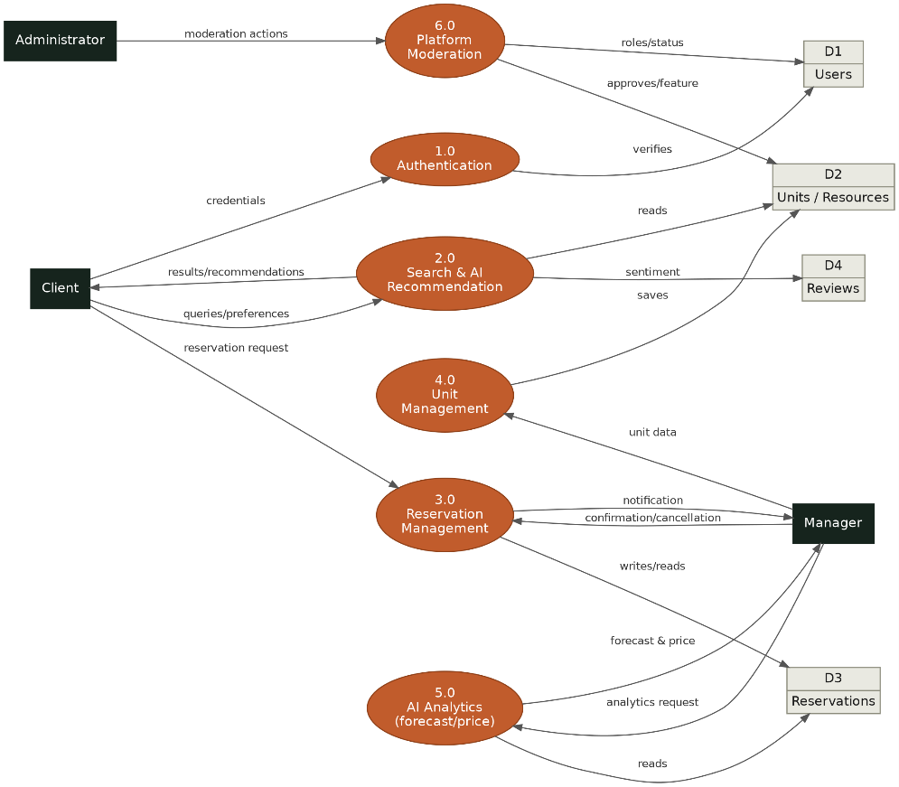
Figure 1: Data Flow Diagram (DFD), level 1
Source: author (2026)
The diagram illustrates the client performing the authentication process by entering their credentials. The client's requests and preferences feed into the search and recommendation process. A booking request proceeds to the booking management process. The booking is recorded in the relevant data store. Later, the manager is notified. The manager then either confirms or cancels the booking. The manager handles listing management and analytics tasks. Meanwhile, the administrator oversees the moderation process regarding listings and users. This high-level view highlights the clear separation of responsibilities and the controlled flow of information.

4.2 Data model design
The most critical part of the system's operation is based on the data model. This model is initially designed as an entity-relationship (ER) diagram and subsequently implemented as a set of ORM classes. The ER diagram in the figure below illustrates the eight primary entities and the relationships between them.
The decision to model the data first adheres to the well-established principle regarding data structure. Interfaces and logic frequently change. On the other hand, the data model remains stable during the time. Every decision within the ER diagram was made to keep the model as understandable as possible.
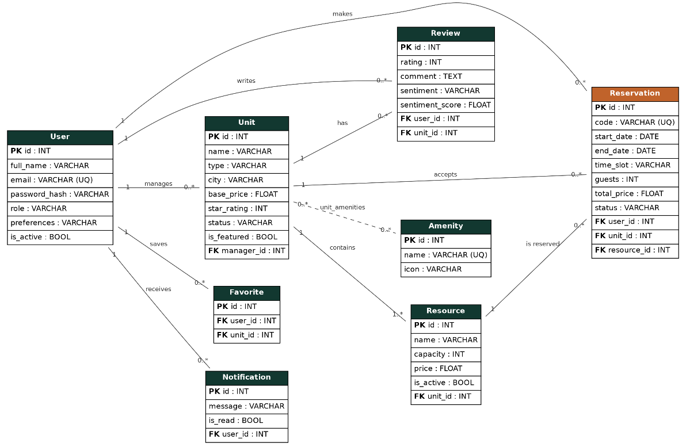
Figure 2: Database Entity-Relationship (ER) diagram
Source: author (2026)
The central `User` entity represents every system user. This entity includes a `role` field that takes the values ​​"user", "manager", or "admin". Using a single table for all three roles simplifies the model and the authentication process. The `Unit` entity represents a hospitality venue and is linked to its manager via the `manager_id` foreign key. Each unit contains one or more `Resource` entities. The `Reservation` entity links three foreign keys: the user making the reservation, the unit, and the specific resource. The model handles both types of reservations:
- hotels use the `start_date` and `end_date` fields
- restaurants use `start_date` in conjunction with a `time_slot`.
The `status` field tracks the reservation's lifecycle. The `Review`, `Favorite`, and `Notification` entities are linked to the user and/or the unit. We can see that `Amenity` is linked to `Unit` via a many-to-many intermediary table.
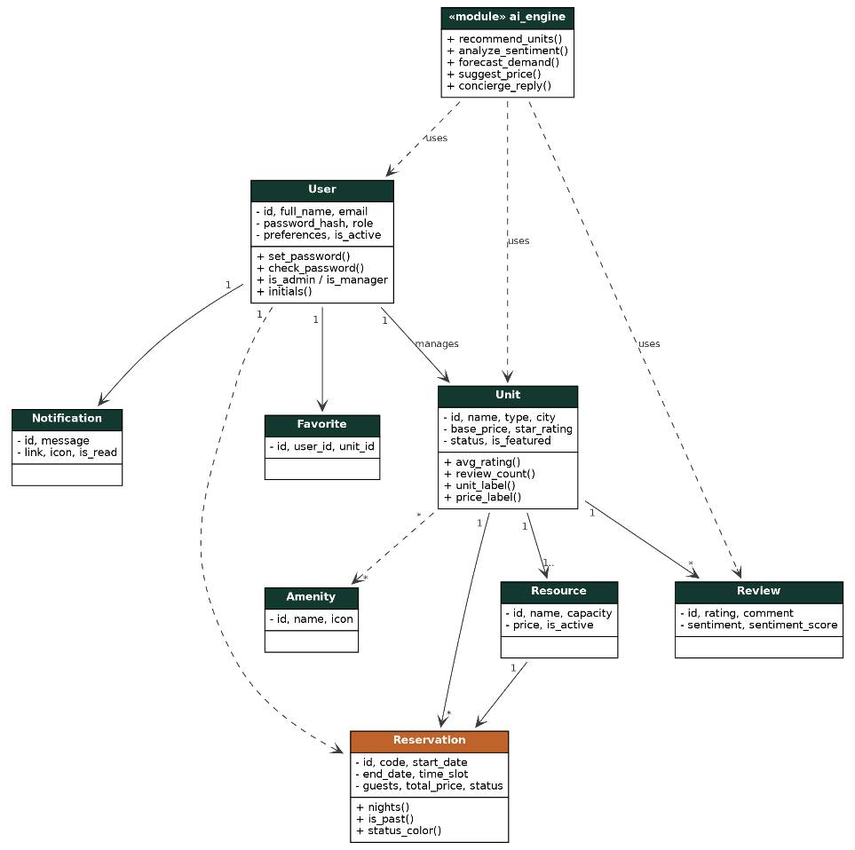
Figure 3: System class diagram (UML)
Source: author (2026)
Each model class contains not only stored fields but also helper methods that encapsulate business logic. The `User` class provides `set_password()` and `check_password()` methods for the secure handling of hashed passwords. The `Unit` class dynamically calculates the average rating, the number of ratings, and the appropriate tags based on the unit type. The `Reservation` class derives the number of nights, the past status, and the status color. The `ai_engine` module relies on the `User`, `Unit`, and `Review` classes to generate recommendations, sentiment analysis, and predictions.

4.3 Modeling functional requirements: use cases
The use case diagram translates functional requirements into concrete interactions between actors and the system. The four actors-visitor, client, manager, and administrator-inherit privileges. Specifically, the client includes the capabilities of the visitor. Specialized roles are reserved for manager and administrator.
Figure 4: Use Case Diagram
Source: author (2026)
A visitor can interact with the system without prior authentication. They can search for and explore units, view their details, register or log in and interact with the AI ​​chatbot. Upon authenticating, the visitor becomes a client. The priviledges it gains are the ability to book rooms or tables, cancel reservations, save units to favorites, write reviews, and receive personalized recommendations. The manager oversees their units and resources, confirms, completes or cancels reservations. Another role of it consults demand forecasts and pricing advice. The administrator approves or rejects units, manages users and roles, and administers the amenities catalog.

4.4 Modeling dynamic behavior: activity and state
Dynamic behavior modeling describes "how" processes unfold over time. The most critical process of the reservation system is modeled using an activity diagram.
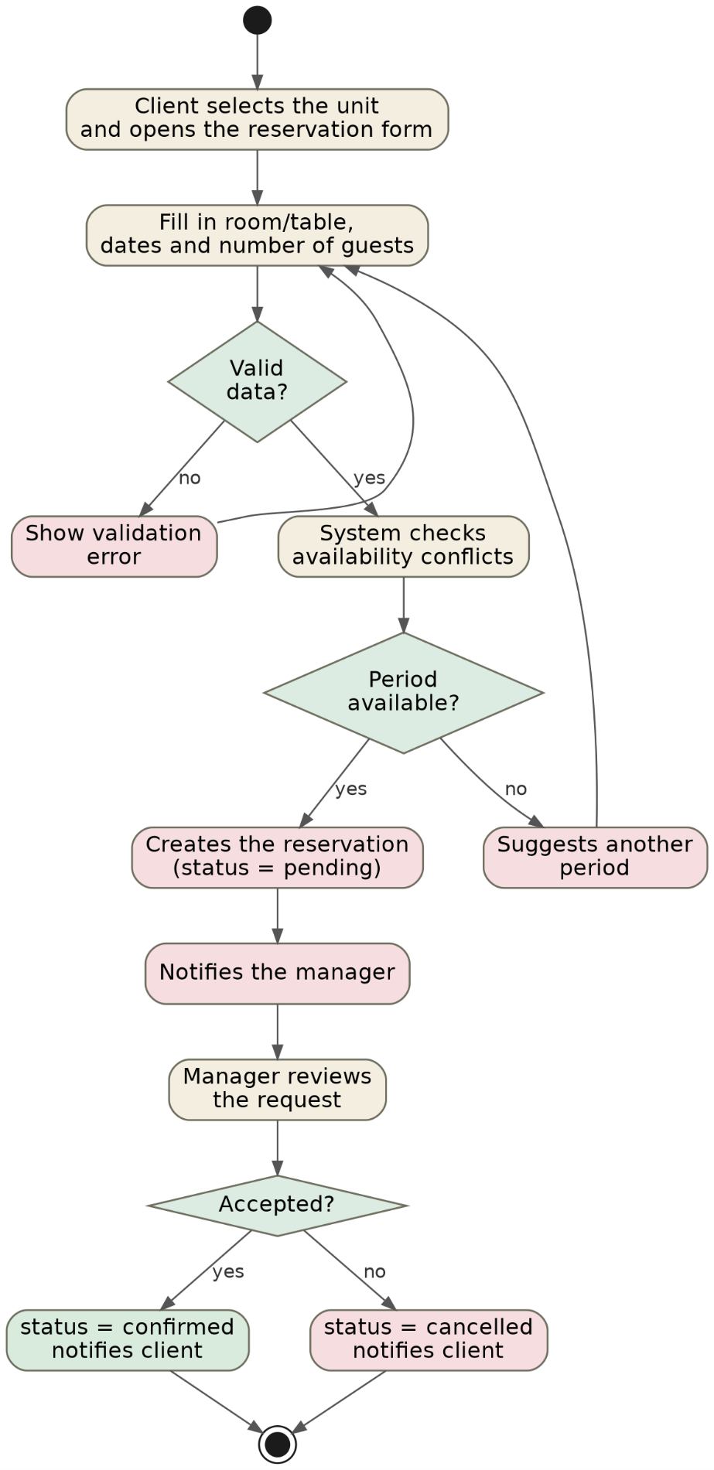
Figure 5: Activity diagram for the reservation process
Source: author (2026)
The process begins when the client selects a unit and opens the reservation form. They then specify the room or table, the dates, and the number of guests. The first condition verifies the validity of the data. If the data is invalid, the system displays a validation error and returns the user to the form. If the data is valid, the system performs an automatic availability conflict check. It will never be overbooked. The second condition in the diagram checks whether the requested period is available. If the period is unavailable, the system suggests an alternative one. If the period is available, the reservation is created with a "pending" status. Later the manager is notified. The manager reviews the request and the reservation status changes to either "confirmed" or "cancelled". A notification message is sent to the cliend.
The last diagram of our platform is state diagram. The primary role of it is to be focused on the lifecycle of a single reservation.
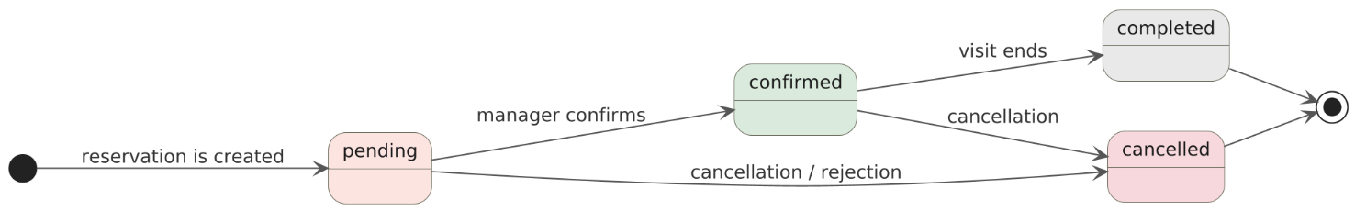
Figure 6: State diagram for the reservation lifecycle
Source: author (2026)
Upon creation, a reservation enters the "pending" state. It can transition to "confirmed" when the manager confirms it. A confirmed reservation can transition to "completed" after the visit has ended. Otherwise it is "cancelled". The "completed" and "cancelled" states are final. This clear state modeling ensures that a completed reservation cannot revert to a pending state and also determines when a review may be submitted. Together, the activity and state diagrams provide a comprehensive view of the dynamic behavior of the system's most important component.

CHAPTER 5: APPLICATION DEMONSTRATION

5.1 Public interface and exploration
The homepage serves as the primary point of contact for the user. It displays all main menus, a search bar and some statistics about the platform.
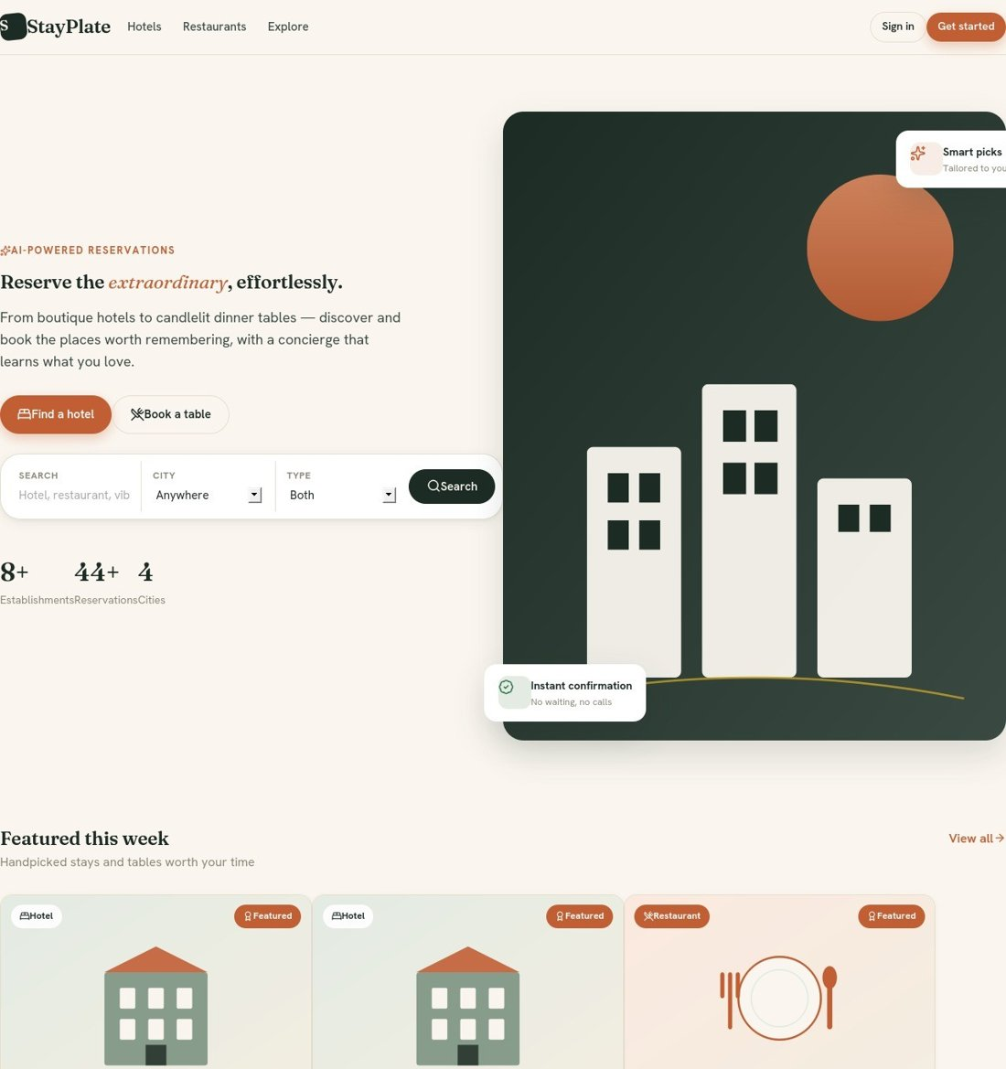
Figure 7: Home page with the search bar and featured sections
Source: author (2026)
The design colors were selected to align with the platform's purpose. A serif typeface is used for the platform's headings. A dedicated bar allows us to fileter immediately. Users can navigate directly to hotels or restaurants. We can simply search by keywords. If we want to do advanced search we can use the grid layouts components. We can filter by selectin city, type, max price and sort. Some detailed information cards are displayed in a grid layout. Each card has a photo, name of the unit, a simplet description and the price if we want to book it.
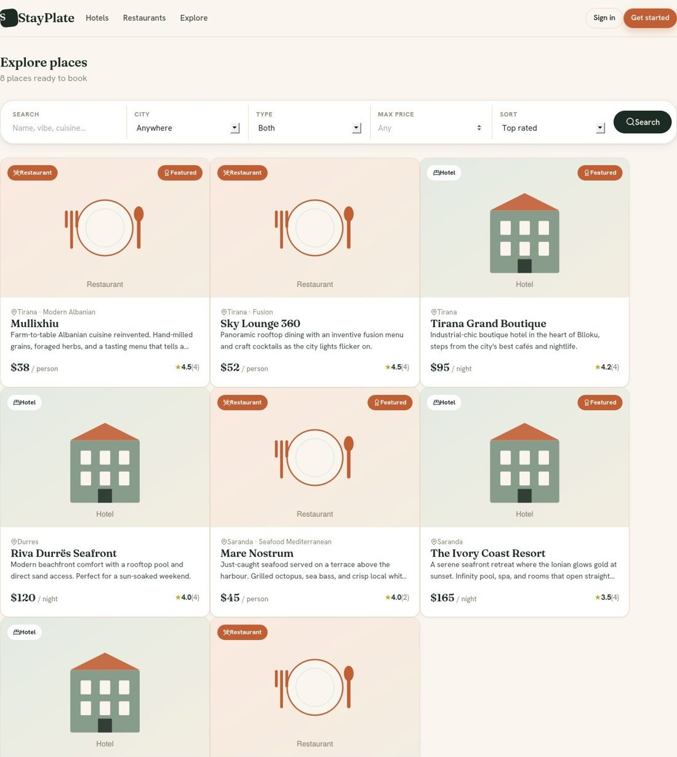
Figurr 8: Exploration page with filters and a grid of items
Source: author (2026)
Each card displays an image of the establishment, its type, city, price, rating, and review count. Data is filtered and sorted on the back end. The functionality of pagination is used to manage large volumes of data. Graphical user nterface fulfills the functional requirements for search and filtering for all visitors. The hotel details page displays the main image, description, amenities, an AI-generated sentiment summary, ratings, and a sidebar widget.
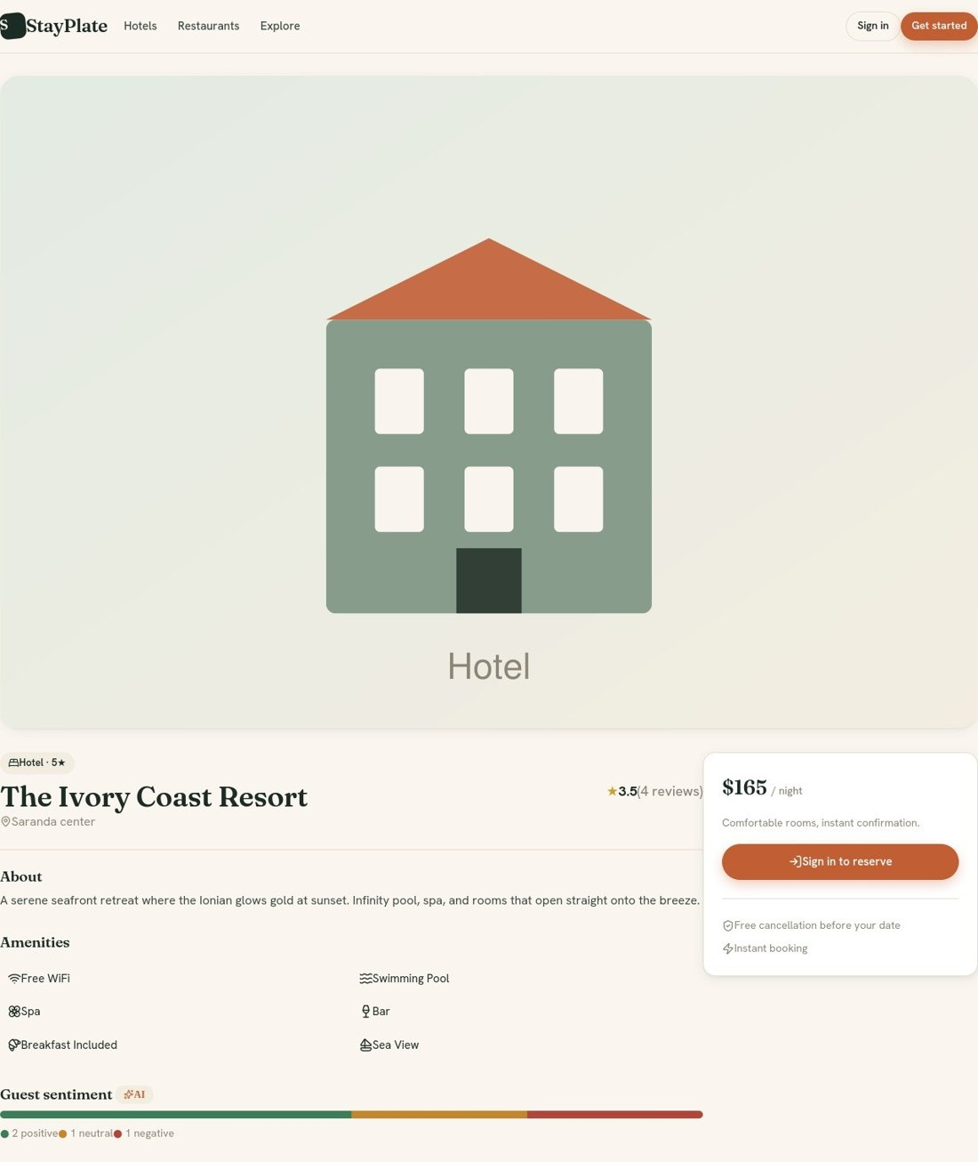
Figure 9: Hotel details page with the booking box and AI sentiment analysis.
Source: author (2026)
The sentiment bar displays the result of ratings into positive, neutral, and negative categories. This indicator is automatically calculated by the sentiment analysis module. The booking box remains in a fixed position at all times. The restaurant page follows the same structure but is adapted for table reservations.
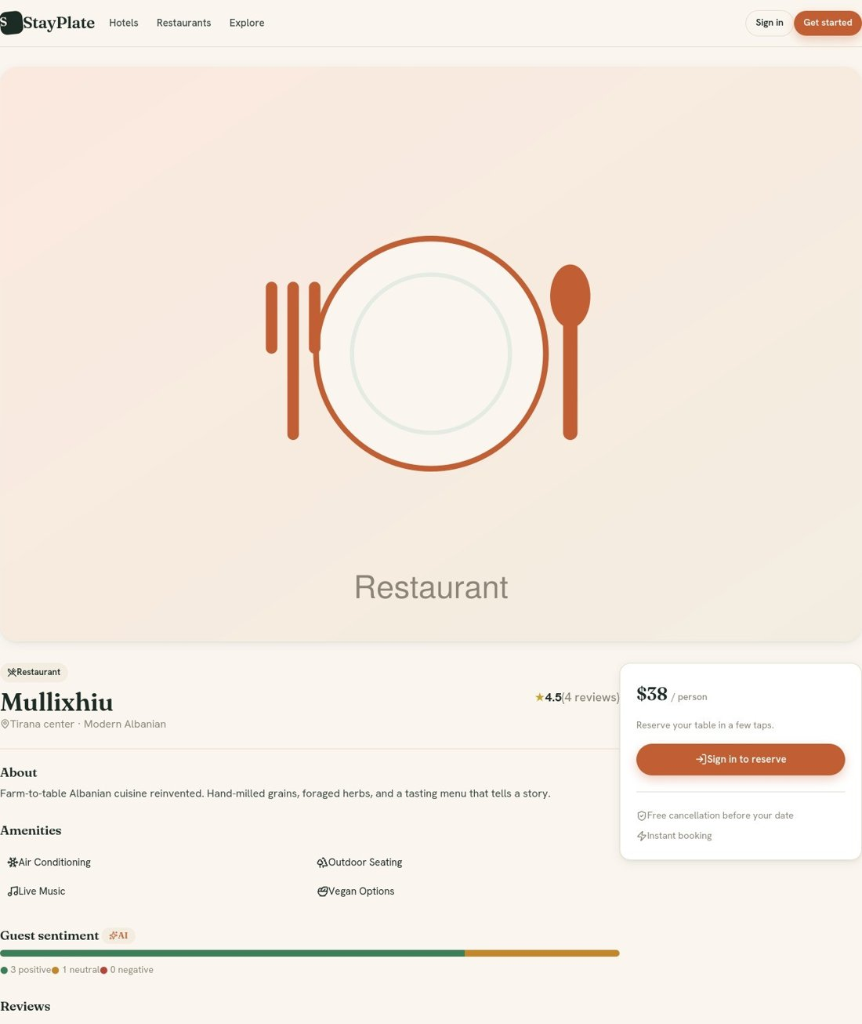
Figure 10: Restaurant details page
Source: author (2026)
The main differences between the two types appear in the labels (“/ night” versus “/ person”), as well as in the icons and booking fields.

5.2 Smart features
The AI ​​concierge is one of StayPlate's standout features. Its dedicated page introduces the concept and offers initial suggestions. Conversation support takes place via chat. A sliding panel is used for it.
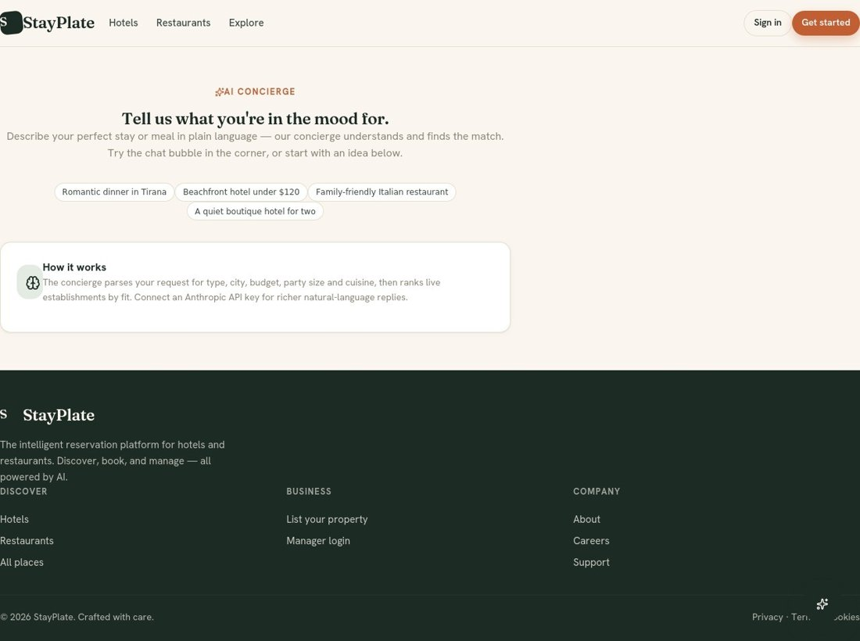
Figure 11: AI Concierge page
Source: author (2026)
The assistant analyzes the user's free-text input and extracts the property type, city, budget, number of people and cuisine. Finally, it returns the best-matching units. To include the use of a large languange model I need an external API key to be configured. By API key I mean openai or anthropic account This directly addresses the second part of the research question regarding AI integration without mandatory dependencies.
The booking form adapts dynamically based on the unit type. Check-in and check-out date fields appear for hotels. If you need to make a restaurant reserveation the time selection is need also.

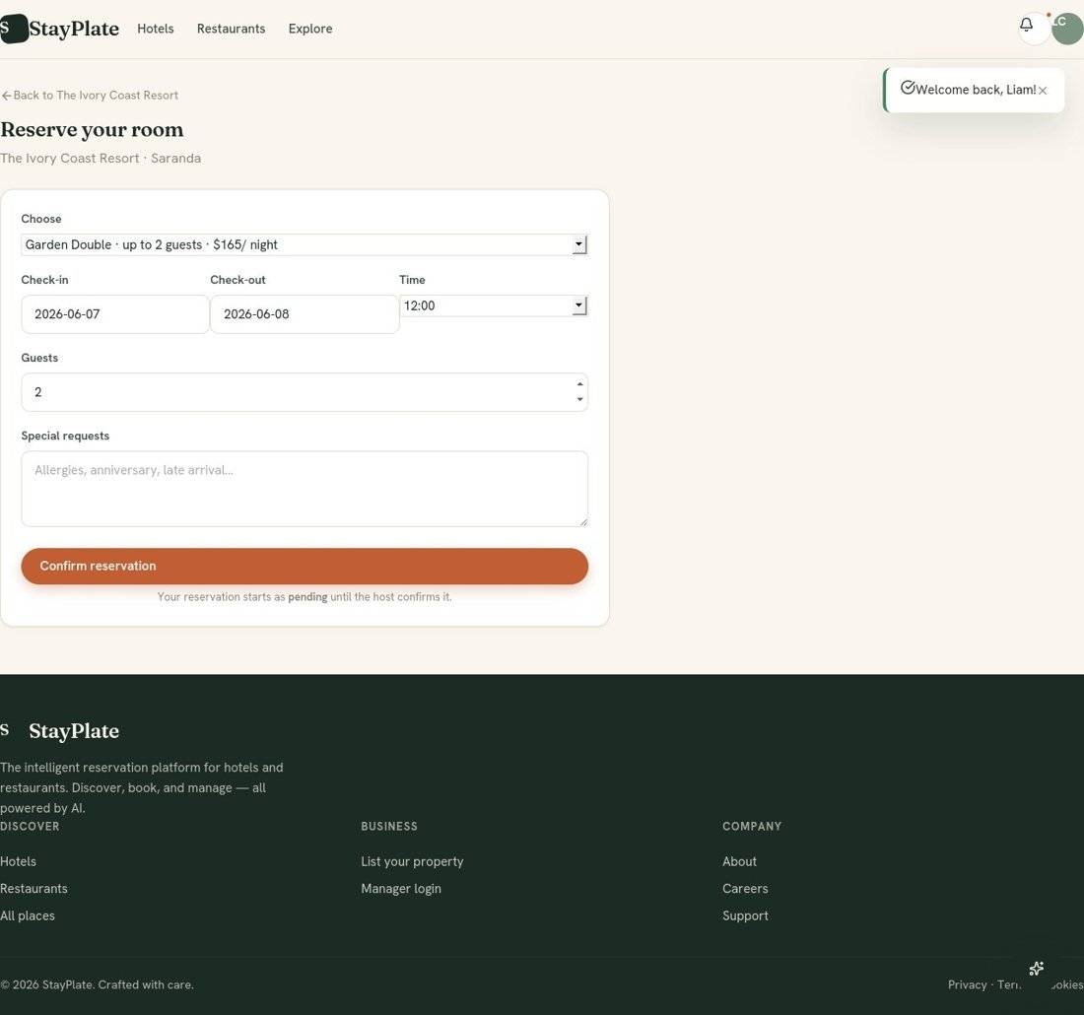
Figure 12: Booking form with dynamic fields based on unit type
Source: author (2026)
In case the user submits the completed form then system performs validation as described in the activity diagram. Reservation status moves to the "pending" state. This is the system's primary mechanism for preventing overbooking. The system does not accept more reservation that the unit capacity.

5.3 Customer panel
System access is provided via a visually split page that combines an illustrative panel with the authentication form.
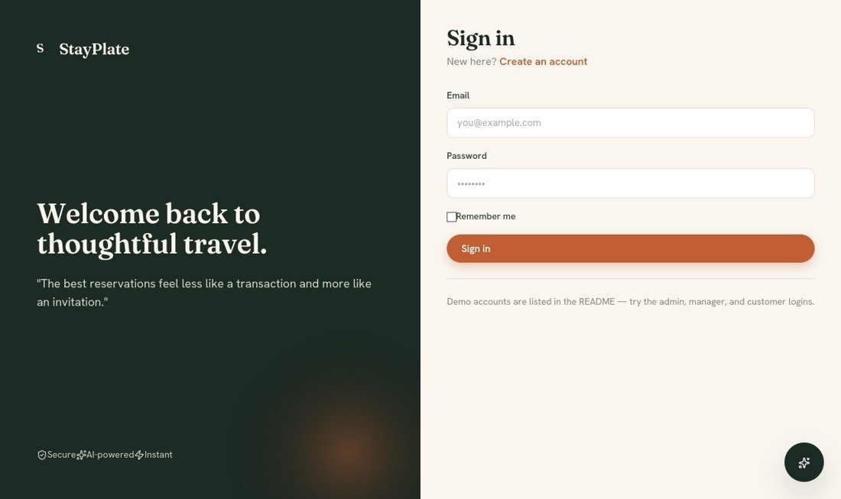
Figure 13: Login page with visual separation
Source: author (2026)
Forms are protected by CSRF tokens. Password values are stored only as hashes. After logging in, the client is redirected to their personal dashboard.
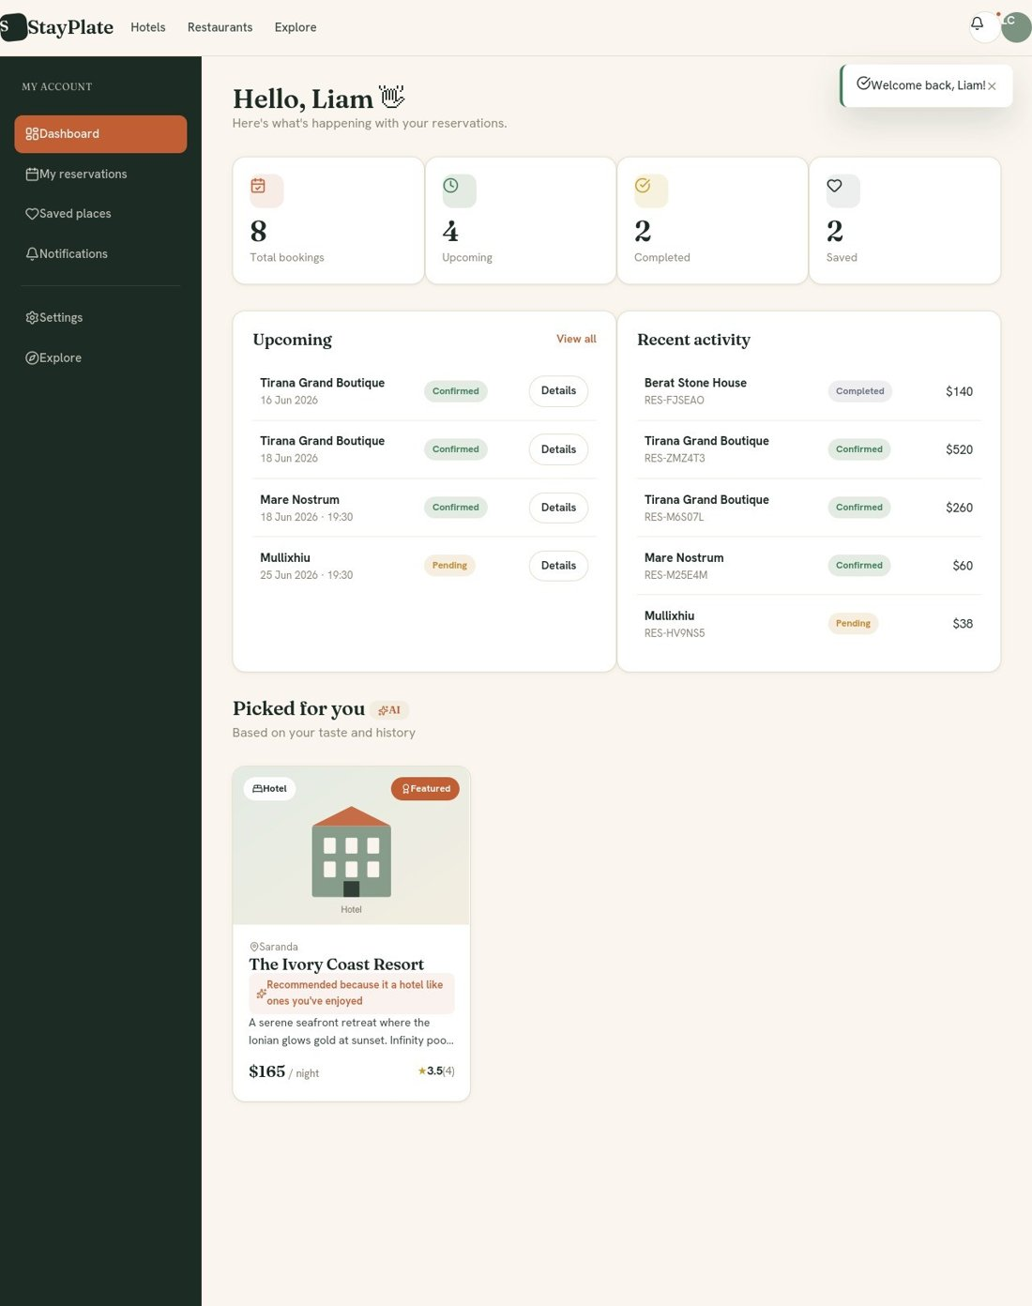
Figure 14: Customer dashboard with statistics, bookings, and AI recommendations.
Source: author (2026)
The customer dashboard shows key statistics:
• total bookings
• upcoming bookings
• completed bookings
• favorite bookings
It displays upcoming bookings and recent activity. It also presents personalized recommendations generated by the artificial intelligence engine. A user-friendly reason is provided for each recommendation. Here we apply personalization and demonstrating the added value of AI. The bookings page lists all the customer's bookings, status filters and options to view or cancel them.
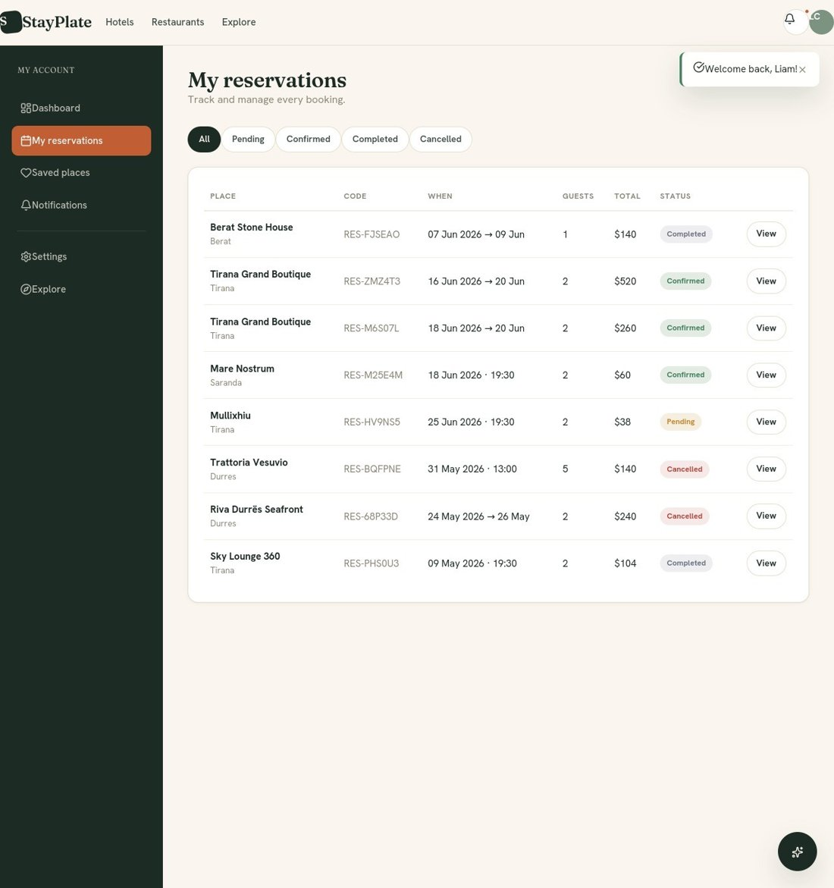
Figure 15: List of customer bookings with status filters
Source: author (2026)
Each row displays the unit, unique booking code, dates, number of guests, value, and status. The client can only cancel bookings that are still eligible for cancellation. The flow of this process is described in the state diagram at any of the above section of this thesis.

5.4 Manager and administrator panels
The manager's dashboard gives an overview of the business performance. There are presented such as key statistics, revenue chart and pending reservations.
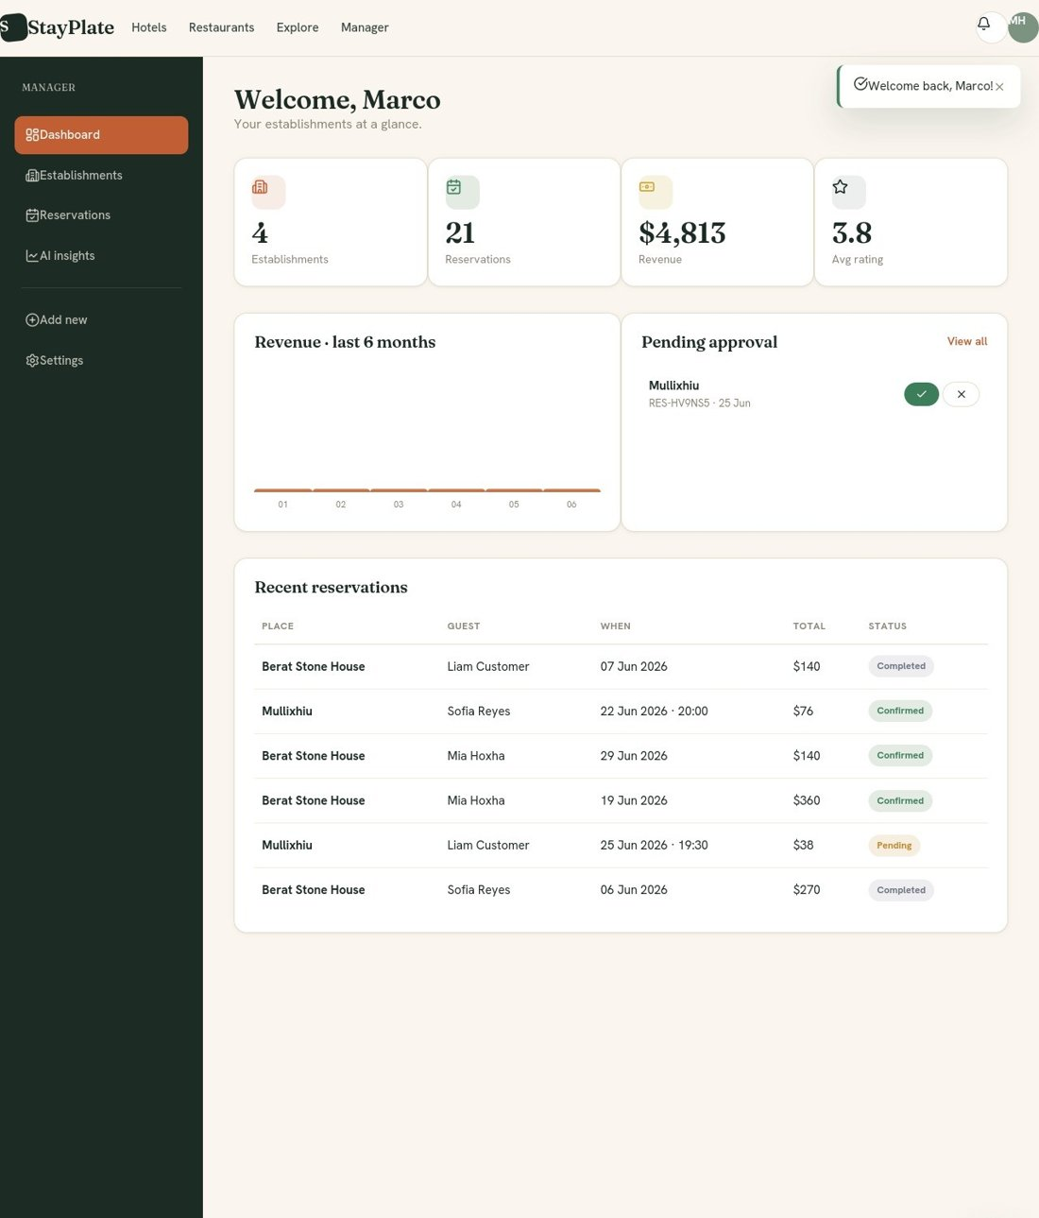
Figure 16: Manager dashboard with statistics and pending reservations
Source: author (2026)
The manager can immediately view the number of units, bookings, revenue, and average rating. They can decide whether to confirm or reject pending bookings directly from the dashboard. The unit details page centralizes intelligent analytical functions.
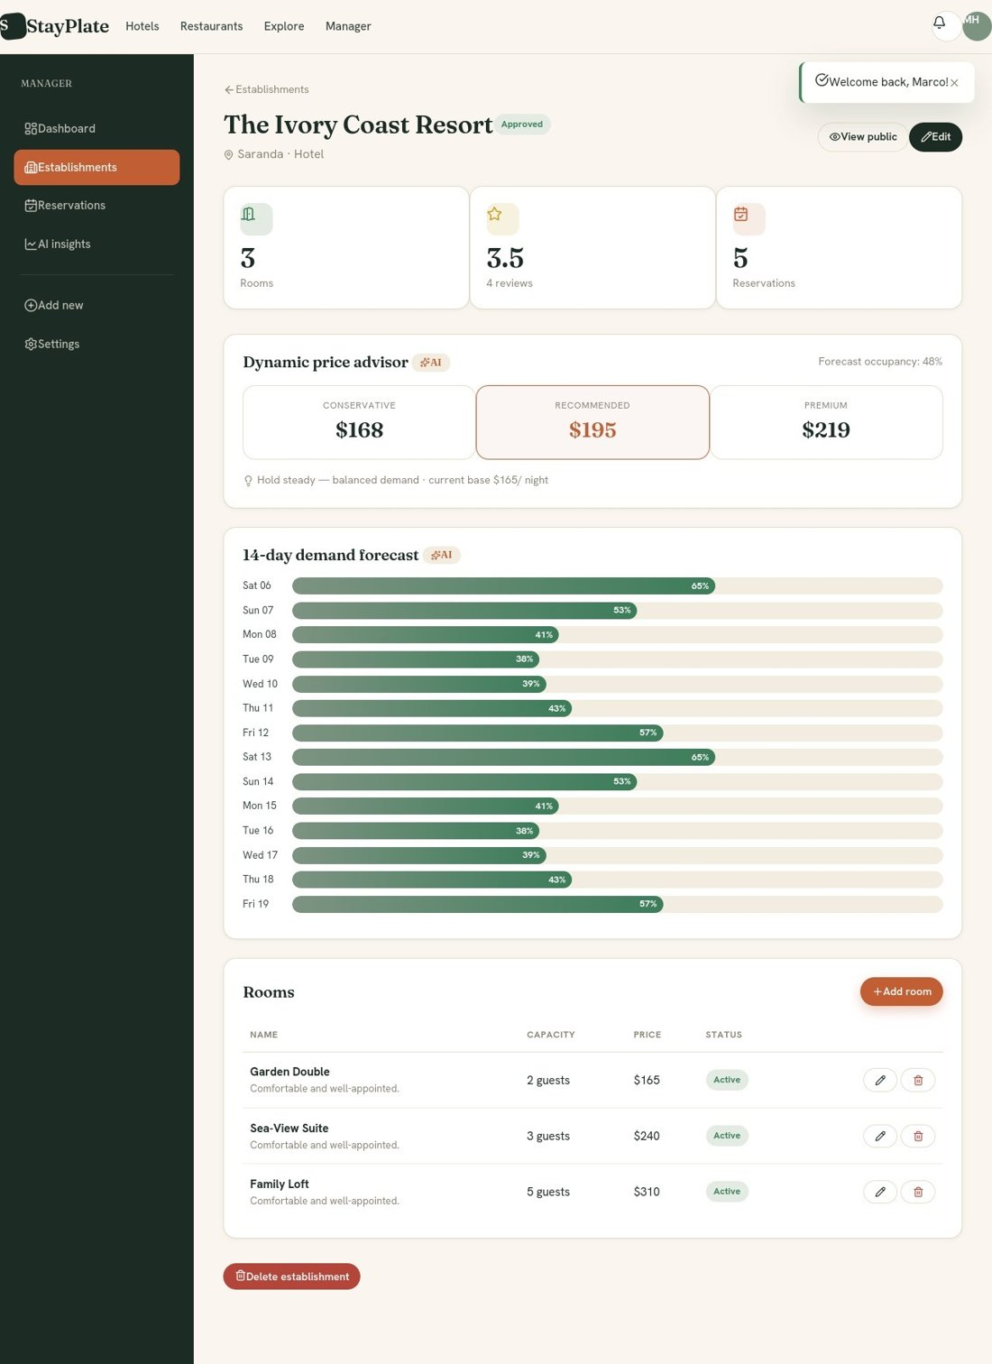
Figure 17: Unit details with the pricing advisor and 14-day demand forecast.
Source: author (2026)
This page presents two of the most important AI components. The dynamic pricing advisor proposes three options accompanied by a clear verdict and projected occupancy. The options are conservative, recommended, and premium. A 14-day demand forecast visualizes expected occupancy for each day using progress bars. The artificial intelligence analytics page gathers them all in one place. There, price recommendations and forecasts for all of the manager's units are presented.
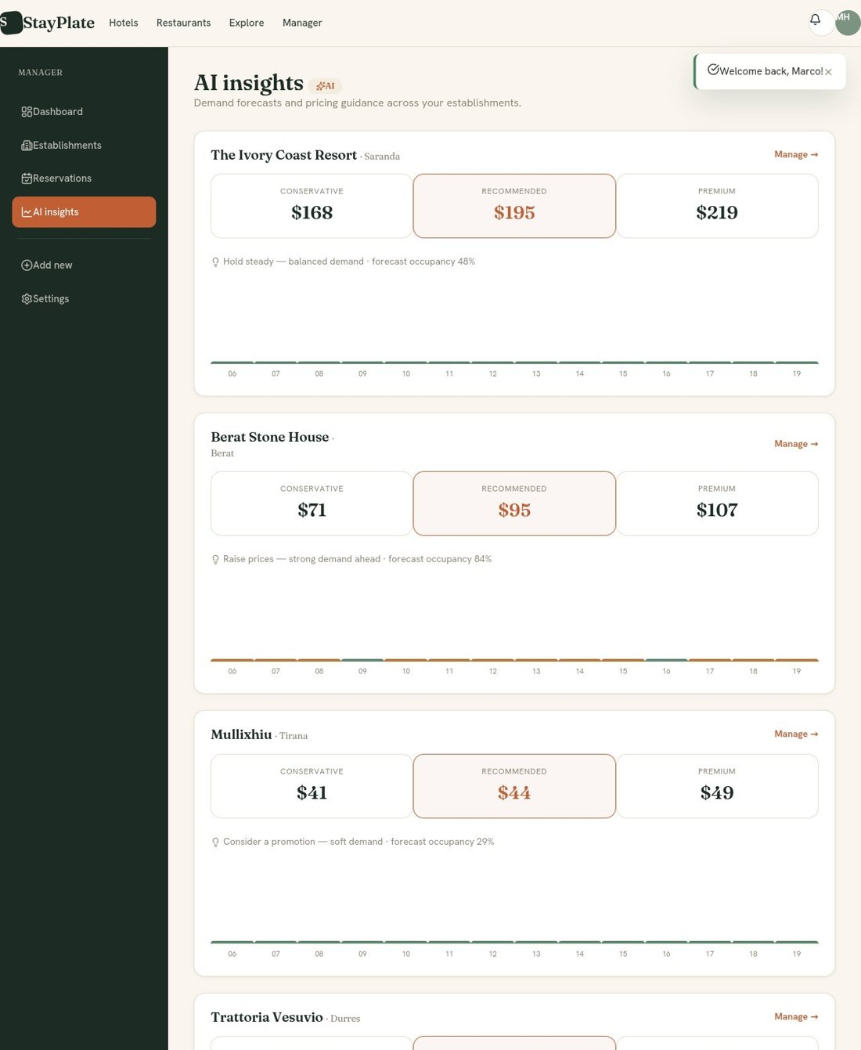
Figure 18: AI analytics page with forecasts and prices for each unit.
Source: author (2026)
This interface allows the manager to compare expected performance across different units and make decisions regarding pricing and capacity. The administrator dashboard provides comprehensive oversight of the platform. There are two charts about global indicators and activity.
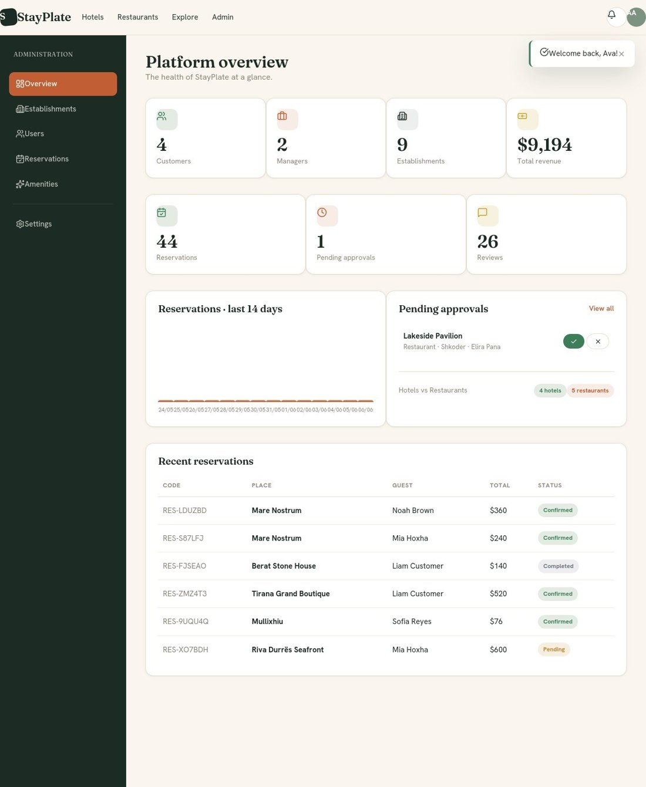
Figure 19: Admin panel with global statistics and pending approvals
Source: author (2026)
The administrator views the number of clients, managers, units, total revenue, a chart of bookings from the last 14 days, units pending approval and recent bookings.
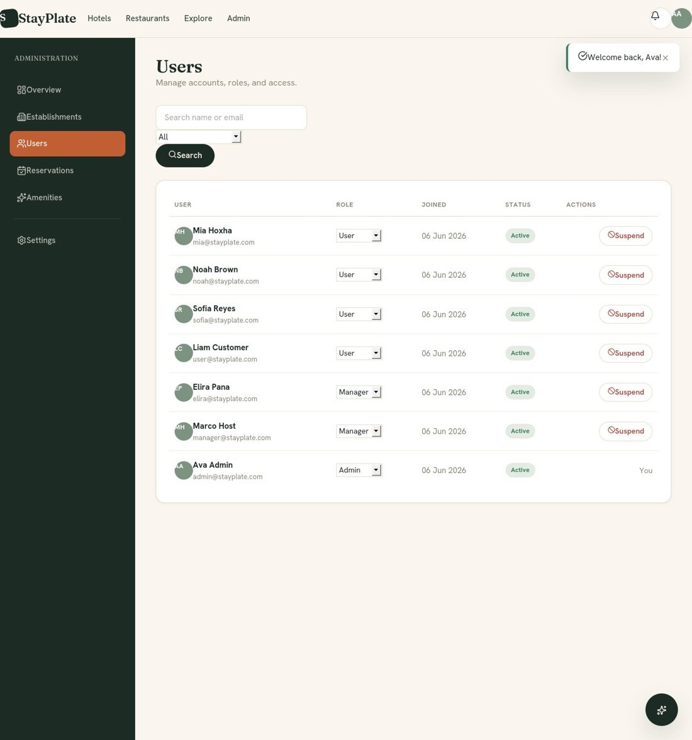
Figure 20: User management by the administrator
Source: author (2026)
The user management page allows us to do searching and filtering by role. User roles can be changed. Their accounts can be suspended or reactivated too.A security measure ensures that the administrator cannot suspend their own account.
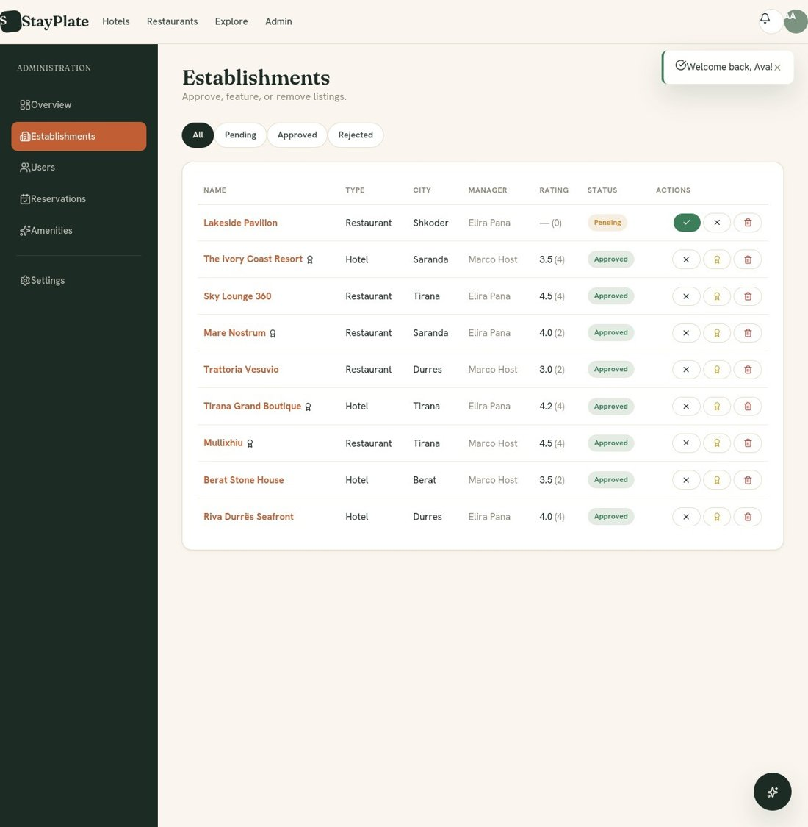
Figure 21: Unit moderation: approval, rejection, isolation, and deletion.
Source: author (2026)
The unit moderation page gives the administrator full control over listings: approving or rejecting new units. The entire workflow starts from unit creation by the manager and approval by the administrator to discovery and booking by the client. Here is completed the whole process. Our platform clearly exhibits how all three roles interact within a coherent workflow.

CHAPTER 6: CONCLUSIONS AND RECOMMENDATIONS

6.1 Answering research questions and verifying hypotheses
In this project, I designed, implemented, and demonstrated the StayPlate platform - an online reservation system serving both hotels and restaurants. Its key innovation lies in the integration of five intelligent functions. Based on this, we can address the research questions.

The first research question
The project implemented all the functional and non-functional requirements listed in the previous chapter. We demonstrated that the system supports three roles, each with distinct rights and privileges; role differentiation is managed via a key stored in the database. Through the data model, the database handles both hotel reservations (based on the duration of stay in days) and restaurant reservations (based on the duration of stay in hours). Regarding non-functional requirements, we prioritized security, usability, and maintainability. These requirements, which were fully met, were derived from the literature and role analysis.

The second research question
In this paper, we also demonstrated the implementation and integration of artificial intelligence functions. The five functions content-based recommendation, lexical sentiment analysis, seasonal demand forecasting, dynamic pricing advice, and a conversational assistant - were implemented within a single module that operates offline. The architecture was also designed to allow for optional enhancement with a large language model without altering the rest of the system. This result also directly confirms the first hypothesis.

The third research question
The modular architecture used to develop the platform was based on the "application factory" model, utilizing blueprints. Implementing this model proved effective for maintainability, security, and scalability. The clear separation of responsibilities facilitated the addition and testing of features. Role-based access control upon system entry ensured that every action was performed only by an authorized role.

The fourth research question
The StayPlate platform was compared with other existing solutions in the above section of this paper. Its strongest points are data control, the absence of commissions, and the integration of hotels with restaurants. A possible disadvantage in the market is the lack of the "network effect" that large global platforms enjoy. The cost analysis showed that the self-hosting model is quite profitable for small and medium-sized businesses. Other models are based on commissions or expensive subscriptions.
The first hypothesis of the paper was confirmed during the implementation and testing of the system. This hypothesis stated that the integration of intelligent components without the need for the internet is possible and adds value to the platform. The second hypothesis was also supported by the control mechanism during bookings. This hypothesis predicted that a structure with role separation and automatic control avoids overbookings and eases the work. The system achieved all the objectives that we set in the first chapter.
For sentiment analysis in comments, we used a dictionary-based (lexical) model. In this platform, more advanced Transformer models were avoided. Also for predictions, we chose a practical (heuristic) model instead of complex artificial intelligence. Also, the entire database is managed by a single SQLite file. This solution is practical, economical, and built quickly. Performance is not the best possible. The “Stayplate” platform gives a small business a system that it owns and manages itself. Thus, the main goal of the project to avoid external services is fulfilled. These have high maintenance costs.
The lesson for users is clear that creating a system easy to use by the manager is better than a slightly more accurate system. Another lesson relates to the structure of the system itself. Right from the beginning, we used the application-factory pattern with blueprints. Also, the module for artificial intelligence called ai_engine was integrated. These choices proved to be quite appropriate and not excessive for the size of the project. The effort was worth it because it enabled adding and testing new features without touching the other parts. Intelligent modules can be changed or improved at any time. These do not affect the data of the reservation process.
Many functionalities still remain undeveloped in the existing platform. They will be added later. If a simple testing study with real users were conducted during development, many decisions about the appearance of the system would be based on concrete data and not just on general rules. Design choices are easier to justify when continuously tested.

6.2 Limitations of the study
Like any other work, this study also has several limitations that can be addressed in the future. The main limitations are:
- The application interfaces were built according to the golden rules of design. Testing with real users was not conducted to gather requirements regarding what they wanted to include in the system.
- Sentiment analysis with a dictionary and predictions are transparent and cost-free. However, they are not as accurate as models based on deep artificial intelligence (deep learning) or large-volume data.
- The system was tested with data simulated by a script and not with real data from daily operation. Its behavior under real load conditions remains to be verified in the future.
- The SQLite database is ideal for small businesses. It must be replaced with a more powerful system (such as PostgreSQL) when it comes to usage on a larger scale and with high load.
- Scientific studies focused on the Albanian environment are still scarce. I did not find other platforms to make comparisons of results and functionalities.

6.3 Recommendations and future work
Some recommendations for further work and for businesses that will use the system:
- To conduct a study with real users for all three roles of the system. The study should be conducted using the SUS questionnaire and interviews. This will help to accurately measure user experience and to find points that require improvement.
- To move to more advanced Transformer models for sentiment analysis in the Albanian language. Also, demand forecasting can be improved with artificial intelligence methods (such as exponential smoothing or XGBoost).
- To add the option of online payments. This would turn the platform into a complete solution for bookings. Its market value increases.
- At the moment when the platform will be implemented in a real business, it is recommended to move to a more powerful database, configure a professional server (WSGI), and add security and data backup measures.
- Since the system is intended for the Albanian environment but will also be used by tourists, it is planned to offer a multilingual interface.
- Building a mobile application version and using push notifications would make the system more modern and easier to use.
In future research, comparative studies can also be conducted between this local version and a version enriched with large language models (LLM). Each of these steps would give more weight to the study and would help in connecting scientific research with practical work. The StayPlate platform is not the final point. Through this thesis, we took the first steps for further projects and research in the field of intelligent booking systems.

REFERENCES
Adomavicius, G., & Tuzhilin, A. (2005). Toward the next generation of recommender systems: A survey of the state-of-the-art and possible extensions. IEEE Transactions on Knowledge and Data Engineering, 17(6), 734-749. https://doi.org/10.1109/TKDE.2005.99
Brooke, J. (1996). SUS: A ‘quick and dirty’ usability scale. In P. W. Jordan, B. Thomas, B. A. Weerdmeester, & I. L. McClelland (Eds.), Usability evaluation in industry (pp. 189-194). Taylor & Francis.
Buhalis, D., & Law, R. (2008). Progress in information technology and tourism management: 20 years on and 10 years after the Internet - The state of eTourism research. Tourism Management, 29(4), 609-623. https://doi.org/10.1016/j.tourman.2008.01.005
Cantallops, A. S., & Salvi, F. (2014). New consumer behavior: A review of research on eWOM and hotels. International Journal of Hospitality Management, 36, 41-51. https://doi.org/10.1016/j.ijhm.2013.08.007
Chen, T., & Guestrin, C. (2016). XGBoost: A scalable tree boosting system. In Proceedings of the 22nd ACM SIGKDD International Conference on Knowledge Discovery and Data Mining (pp. 785-794). ACM. https://doi.org/10.1145/2939672.2939785
Devlin, J., Chang, M.-W., Lee, K., & Toutanova, K. (2019). BERT: Pre-training of deep bidirectional transformers for language understanding. In Proceedings of NAACL-HLT 2019 (pp. 4171-4186). Association for Computational Linguistics. https://doi.org/10.18653/v1/N19-1423
Fowler, M. (2018). Refactoring: Improving the design of existing code (2nd ed.). Addison-Wesley.
Gretzel, U., Sigala, M., Xiang, Z., & Koo, C. (2015). Smart tourism: Foundations and developments. Electronic Markets, 25(3), 179-188. https://doi.org/10.1007/s12525-015-0196-8
Grinberg, M. (2018). Flask web development: Developing web applications with Python (2nd ed.). O’Reilly Media.
Hevner, A. R., March, S. T., Park, J., & Ram, S. (2004). Design science in information systems research. MIS Quarterly, 28(1), 75-105. https://doi.org/10.2307/25148625
Hutto, C. J., & Gilbert, E. (2014). VADER: A parsimonious rule-based model for sentiment analysis of social media text. In Proceedings of the Eighth International AAAI Conference on Weblogs and Social Media (pp. 216-225). AAAI Press. https://doi.org/10.1609/icwsm.v8i1.14550
Hyndman, R. J., & Athanasopoulos, G. (2018). Forecasting: Principles and practice (2nd ed.). OTexts. https://otexts.com/fpp2/
INSTAT. (2023). Statistikat e turizmit 2023. https://www.instat.gov.al/
Ivanov, S., & Webster, C. (2017). Adoption of robots, artificial intelligence and service automation by travel, tourism and hospitality companies - A cost-benefit analysis. In Proceedings of the International Scientific Conference “Contemporary Tourism - Traditions and Innovations”. https://doi.org/10.2139/ssrn.3007577
Koren, Y., Bell, R., & Volinsky, C. (2009). Matrix factorization techniques for recommender systems. Computer, 42(8), 30-37. https://doi.org/10.1109/MC.2009.263
Law, R., Leung, R., Lo, A., Leung, D., & Fong, L. H. N. (2015). Distribution channel in hospitality and tourism: Revisiting disintermediation from the perspectives of hotels and travel agencies. International Journal of Contemporary Hospitality Management, 27(3), 431-452. https://doi.org/10.1108/IJCHM-11-2013-0498
Liu, B. (2012). Sentiment analysis and opinion mining. Synthesis Lectures on Human Language Technologies, 5(1), 1-167. https://doi.org/10.2200/S00416ED1V01Y201204HLT016
Mauri, A. G. (2012). Hotel revenue management: Principles and practices. Pearson.
McKinney, W. (2017). Python for data analysis (2nd ed.). O’Reilly Media.
Ministria e Turizmit dhe Mjedisit. (2019). Strategjia Kombëtare e Turizmit 2019–2023. https://turizmi.gov.al/
Nielsen, J. (1994). Usability engineering. Morgan Kaufmann.
Pang, B., & Lee, L. (2008). Opinion mining and sentiment analysis. Foundations and Trends in Information Retrieval, 2(1-2), 1-135. https://doi.org/10.1561/1500000011
Peffers, K., Tuunanen, T., Rothenberger, M. A., & Chatterjee, S. (2007). A design science research methodology for information systems research. Journal of Management Information Systems, 24(3), 45-77. https://doi.org/10.2753/MIS0742-1222240302
Pressman, R. S., & Maxim, B. R. (2015). Software engineering: A practitioner’s approach (8th ed.). McGraw-Hill Education.
Ricci, F., Rokach, L., & Shapira, B. (Eds.). (2015). Recommender systems handbook (2nd ed.). Springer. https://doi.org/10.1007/978-1-4899-7637-6
Sarwar, B., Karypis, G., Konstan, J., & Riedl, J. (2001). Item-based collaborative filtering recommendation algorithms. In Proceedings of the 10th International Conference on World Wide Web (pp. 285-295). ACM. https://doi.org/10.1145/371920.372071
Sigala, M. (2018). New technologies in tourism: From multi-disciplinary to anti-disciplinary advances and trajectories. Tourism Management Perspectives, 25, 151-155. https://doi.org/10.1016/j.tmp.2017.12.003
Sommerville, I. (2016). Software engineering (10th ed.). Pearson.
Talluri, K. T., & van Ryzin, G. J. (2004). The theory and practice of revenue management. Springer. https://doi.org/10.1007/b139000
Tussyadiah, I. (2020). A review of research into automation in tourism: Launching the Annals of Tourism Research Curated Collection on Artificial Intelligence and Robotics in Tourism. Annals of Tourism Research, 81, 102883. https://doi.org/10.1016/j.annals.2020.102883
Vaswani, A., Shazeer, N., Parmar, N., Uszkoreit, J., Jones, L., Gomez, A. N., Kaiser, Ł., & Polosukhin, I. (2017). Attention is all you need. In Advances in Neural Information Processing Systems 30 (pp. 5998-6008). https://doi.org/10.48550/arXiv.1706.03762
Xiang, Z., Magnini, V. P., & Fesenmaier, D. R. (2015). Information technology and consumer behavior in travel and tourism: Insights from travel planning using the Internet. Journal of Retailing and Consumer Services, 22, 244-249. https://doi.org/10.1016/j.jretconser.2014.08.005
Ye, Q., Law, R., Gu, B., & Chen, W. (2011). The influence of user-generated content on traveler behavior: An empirical investigation on the effects of e-word-of-mouth to hotel online bookings. Computers in Human Behavior, 27(2), 634-639. https://doi.org/10.1016/j.chb.2010.04.014

ANNEX

LINKU I GIT HUB:https://github.com/enrikzaimi-source/Stayplate/blob/main/StayPlate.zip
import re
import math
from collections import Counter
from datetime import date, timedelta

# ===========================================================================
# 1. SENTIMENT ANALYSIS (lexicon + negation handling)
# ===========================================================================
_POSITIVE = {
"amazing", "excellent", "great", "good", "wonderful", "fantastic", "perfect",
"love", "loved", "lovely", "clean", "comfortable", "friendly", "delicious",
"beautiful", "cozy", "helpful", "recommend", "best", "awesome", "superb",
"spotless", "stunning", "exceptional", "outstanding", "pleasant", "fresh",
"tasty", "polite", "spacious", "quiet", "relaxing", "value", "worth", "happy",
}
_NEGATIVE = {
"bad", "terrible", "awful", "horrible", "dirty", "rude", "slow", "cold",
"expensive", "noisy", "disappointing", "disappointed", "poor", "worst",
"broken", "smell", "smelly", "uncomfortable", "overpriced", "crowded",
"unfriendly", "stale", "bland", "tiny", "cramped", "filthy", "avoid",
"waited", "wait", "never", "problem", "issue", "leak", "mold", "bug",
}
_NEGATORS = {"not", "no", "never", "without", "hardly", "barely", "neither"}

def analyze_sentiment(text):
"""Return (label, score) where score is in [-1, 1]."""
if not text:
return "neutral", 0.0
tokens = re.findall(r"[a-z']+", text.lower())
score = 0
negate = False
for tok in tokens:
if tok in _NEGATORS:
negate = True
continue
weight = 0
if tok in _POSITIVE:
weight = 1
elif tok in _NEGATIVE:
weight = -1
if negate:
weight *= -1
negate = False
score += weight
# Normalise by a soft length factor
norm = score / math.sqrt(max(len(tokens), 1))
norm = max(-1.0, min(1.0, norm))
if norm > 0.15:
label = "positive"
elif norm < -0.15:
label = "negative"
else:
label = "neutral"
return label, round(norm, 3)

# ===========================================================================
# 2. CONTENT-BASED RECOMMENDER
# ===========================================================================
def _unit_feature_vector(unit):
"""Build a simple feature dictionary describing a unit."""
feats = Counter()
feats[f"type:{unit.type}"] += 3
if unit.city:
feats[f"city:{unit.city.lower()}"] += 2
if unit.cuisine:
for word in re.findall(r"[a-z]+", unit.cuisine.lower()):
feats[f"cuisine:{word}"] += 2
for am in unit.amenities:
feats[f"amenity:{am.name.lower()}"] += 1
# price bucket
bucket = "budget" if unit.base_price < 60 else "mid" if unit.base_price < 150 else "luxury"
feats[f"price:{bucket}"] += 1
return feats

def _user_profile_vector(user):
"""Aggregate a user's taste from preferences, reservations and reviews."""
profile = Counter()
for tag in (user.preferences or "").split(","):
tag = tag.strip().lower()
if tag:
profile[f"amenity:{tag}"] += 2
profile[f"cuisine:{tag}"] += 1
profile[f"type:{tag}"] += 1
# Learn from booking history
for res in user.reservations:
if res.unit:
for feat, w in _unit_feature_vector(res.unit).items():
profile[feat] += w * 0.5
# Boost things they rated highly
for rev in user.reviews:
if rev.unit and rev.rating >= 4:
for feat, w in _unit_feature_vector(rev.unit).items():
profile[feat] += w * 0.4
return profile

def _cosine(a, b):
keys = set(a) | set(b)
dot = sum(a.get(k, 0) * b.get(k, 0) for k in keys)
na = math.sqrt(sum(v * v for v in a.values()))
nb = math.sqrt(sum(v * v for v in b.values()))
if na == 0 or nb == 0:
return 0.0
return dot / (na * nb)

def recommend_units(user, all_units, limit=4):
"""Return a ranked list of (unit, score, reason) for the given user."""
approved = [u for u in all_units if u.status == "approved"]
if not approved:
return []

booked_ids = {r.unit_id for r in user.reservations} if user else set()
profile = _user_profile_vector(user) if user else Counter()

scored = []
for unit in approved:
if unit.id in booked_ids:
continue
vec = _unit_feature_vector(unit)
sim = _cosine(profile, vec) if profile else 0.0
# Blend similarity with popularity & quality signals
quality = unit.avg_rating / 5.0
popularity = min(unit.review_count / 20.0, 1.0)
featured = 0.15 if unit.is_featured else 0.0
score = 0.55 * sim + 0.30 * quality + 0.10 * popularity + featured
reason = _explain_recommendation(profile, vec, unit)
scored.append((unit, round(score, 3), reason))

scored.sort(key=lambda x: x[1], reverse=True)
return scored[:limit]

def _explain_recommendation(profile, vec, unit):
"""Produce a short human-readable reason for a recommendation."""
if not profile:
if unit.avg_rating >= 4.5:
return "Top-rated by our community"
if unit.is_featured:
return "Featured pick of the week"
return "Popular near you"
overlap = {k: profile[k] for k in vec if k in profile and profile[k] > 0}
if not overlap:
return "Highly rated and trending"
best = max(overlap, key=overlap.get)
kind, _, value = best.partition(":")
pretty = {
"amenity": f"matches your love of {value}",
"cuisine": f"serves {value} cuisine you enjoy",
"city": f"in {value.title()}, where you often book",
"type": f"a {value} like ones you've enjoyed",
"price": f"fits your usual {value} budget",
}.get(kind, "matches your taste")
return f"Recommended because it {pretty}"

# ===========================================================================
# 3. DEMAND FORECASTING (seasonality + trend heuristic)
# ===========================================================================
_WEEKDAY_FACTOR = [0.85, 0.80, 0.82, 0.90, 1.20, 1.35, 1.10] # Mon..Sun
_MONTH_FACTOR = [0.7, 0.7, 0.8, 0.9, 1.0, 1.15, 1.3, 1.3, 1.05, 0.9, 0.8, 1.1]

def forecast_demand(unit, days=14):
"""Forecast occupancy % for the next `days` days based on existing bookings."""
resources = max(len([r for r in unit.resources if r.is_active]), 1)
today = date.today()

# Historical baseline: how booked the last 30 days were
recent = [r for r in unit.reservations if r.status in ("confirmed", "completed")]
base_load = min(len(recent) / (resources * 4.0), 1.0) if recent else 0.35

forecast = []
for i in range(days):
d = today + timedelta(days=i)
booked = sum(
1 for r in unit.reservations
if r.status in ("pending", "confirmed")
and r.start_date <= d <= (r.end_date or r.start_date)
)
seasonal = _WEEKDAY_FACTOR[d.weekday()] * _MONTH_FACTOR[d.month - 1]
predicted = min((base_load * seasonal) + (booked / resources), 1.0)
forecast.append({
"date": d.isoformat(),
"label": d.strftime("%a %d"),
"occupancy": round(predicted * 100),
"booked": booked,
"capacity": resources,
})
return forecast

def suggest_price(unit):
"""Dynamic-pricing advisor: suggest a price band from demand & quality."""
fc = forecast_demand(unit, days=7)
avg_occ = sum(f["occupancy"] for f in fc) / len(fc) / 100.0
quality_mult = 0.9 + (unit.avg_rating / 5.0) * 0.3 # 0.9 .. 1.2
demand_mult = 0.85 + avg_occ * 0.45 # 0.85 .. 1.30
base = unit.base_price or 50
low = round(base * quality_mult * 0.92)
optimal = round(base * quality_mult * demand_mult)
high = round(base * quality_mult * demand_mult * 1.12)
verdict = (
"Raise prices — strong demand ahead" if avg_occ > 0.7 else
"Hold steady — balanced demand" if avg_occ > 0.4 else
"Consider a promotion — soft demand"
)
return {
"current": round(base),
"low": low,
"optimal": optimal,
"high": high,
"avg_occupancy": round(avg_occ * 100),
"verdict": verdict,
}

# ===========================================================================
# 4. SMART CONCIERGE (intent parsing + optional LLM)
# ===========================================================================
_CITY_HINTS = ["tirana", "durres", "vlore", "saranda", "shkoder", "berat",
"london", "paris", "rome", "milan", "athens", "berlin", "barcelona"]

def parse_query(text):
"""Extract structured filters from a free-text search/chat message."""
t = (text or "").lower()
intent = {
"type": None, "city": None, "guests": None,
"max_price": None, "amenities": [], "cuisine": None,
}
if any(w in t for w in ["hotel", "stay", "room", "sleep", "night", "accommodation"]):
intent["type"] = "hotel"
if any(w in t for w in ["restaurant", "dinner", "lunch", "eat", "table", "dine", "food"]):
intent["type"] = "restaurant"
for city in _CITY_HINTS:
if city in t:
intent["city"] = city
break
m = re.search(r"(\d+)\s*(?:people|guests|persons|pax|of us)", t)
if m:
intent["guests"] = int(m.group(1))
m = re.search(r"(?:under|below|less than|max|up to)\s*\$?(\d+)", t)
if m:
intent["max_price"] = int(m.group(1))
for am in ["wifi", "pool", "parking", "spa", "gym", "breakfast", "pet", "balcony", "terrace"]:
if am in t:
intent["amenities"].append(am)
for cz in ["italian", "japanese", "sushi", "seafood", "vegan", "mediterranean",
"indian", "mexican", "french", "greek", "albanian", "bbq", "pizza"]:
if cz in t:
intent["cuisine"] = cz
break
return intent

def search_units(intent, all_units, limit=6):
"""Score units against a parsed intent."""
results = []
for u in all_units:
if u.status != "approved":
continue
score = 1.0
if intent["type"] and u.type != intent["type"]:
continue
if intent["city"]:
if u.city and intent["city"] in u.city.lower():
score += 2.0
else:
continue
if intent["max_price"]:
if u.base_price <= intent["max_price"]:
score += 1.0
else:
score -= 1.0
if intent["guests"]:
if u.capacity >= intent["guests"] or any(r.capacity >= intent["guests"] for r in u.resources):
score += 1.0
if intent["cuisine"] and u.cuisine and intent["cuisine"] in u.cuisine.lower():
score += 1.5
unit_ams = {a.name.lower() for a in u.amenities}
for am in intent["amenities"]:
if any(am in ua for ua in unit_ams):
score += 0.8
score += u.avg_rating * 0.2
results.append((u, round(score, 2)))
results.sort(key=lambda x: x[1], reverse=True)
return [u for u, _ in results[:limit]]

def concierge_reply(message, all_units, api_key=""):
"""
Generate a concierge response. Returns dict:
{ "text": str, "units": [Unit, ...] }
Uses the LLM if api_key is present, otherwise the offline engine.
"""
intent = parse_query(message)
matches = search_units(intent, all_units, limit=4)

if api_key:
llm_text = _llm_concierge(message, matches, api_key)
if llm_text:
return {"text": llm_text, "units": matches}

# ---- Offline natural-language response ----
parts = []
if not matches:
return {
"text": ("I couldn't find an exact match. Try telling me the city, "
"whether you want a hotel or a restaurant, your budget, and "
"how many guests — e.g. \"Italian restaurant in Tirana for 4 "
"under $40\"."),
"units": [],
}
descriptor = []
if intent["type"]:
descriptor.append(intent["type"] + "s")
if intent["city"]:
descriptor.append("in " + intent["city"].title())
if intent["max_price"]:
descriptor.append(f"under ${intent['max_price']}")
head = "Here are some great " + (" ".join(descriptor) if descriptor else "options") + " I found for you:"
parts.append(head)
for u in matches:
line = f"• {u.name} — {u.city}, {u.avg_rating}★"
if u.type == "restaurant" and u.cuisine:
line += f", {u.cuisine}"
line += f" (from ${round(u.base_price)}{u.price_label})"
parts.append(line)
parts.append("Tap any card below to view details and book instantly. Anything else you'd like to refine?")
return {"text": "\n".join(parts), "units": matches}

def _llm_concierge(message, matches, api_key):
"""Optional Anthropic-powered reply. Returns None on any failure."""
try:
import json
import urllib.request

catalogue = "\n".join(
f"- {u.name} | {u.type} | {u.city} | {u.avg_rating}star | "
f"${round(u.base_price)}{u.price_label} | {u.cuisine or ''}"
for u in matches
) or "(no direct matches in catalogue)"

system = (
"You are the friendly concierge for StayPlate, a hotel & restaurant "
"reservation platform. Be concise, warm and helpful. Only recommend "
"establishments from the provided catalogue. Never invent places."
)
user_block = f"Catalogue:\n{catalogue}\n\nGuest message: {message}"

payload = json.dumps({
"model": "claude-sonnet-4-20250514",
"max_tokens": 400,
"system": system,
"messages": [{"role": "user", "content": user_block}],
}).encode()

req = urllib.request.Request(
"https://api.anthropic.com/v1/messages",
data=payload,
headers={
"content-type": "application/json",
"x-api-key": api_key,
"anthropic-version": "2023-06-01",
},
)
with urllib.request.urlopen(req, timeout=20) as resp:
data = json.loads(resp.read())
return "".join(b.get("text", "") for b in data.get("content", []) if b.get("type") == "text")
except Exception:
return None

ANNEX 2: MAIN SOURCE CODE EXCERPTS
This annex presents condensed excerpts of the main source code modules of the StayPlate platform, which was developed with Flask (Python). Comments are summarised in English and non-essential lines (imports, template details and repetitive validations) are omitted and marked with “...”. The artificial intelligence module (ai_engine.py) is presented in the previous annex.

A2.1 Application factory and module registration
The application is created through the factory pattern. The function initialises the database and authentication extensions, registers one blueprint for each functional area and defines centralised error pages.
Listing A2.1: app.py – create_app()
# app.py - Application factory: builds and configures the Flask app
def create_app(config_class=Config):
app = Flask(__name__)
app.config.from_object(config_class) # load settings from config.py
os.makedirs(app.config["UPLOAD_FOLDER"], exist_ok=True)

db.init_app(app) # SQLAlchemy ORM
login_manager.init_app(app) # session-based authentication

@login_manager.user_loader
def load_user(user_id):
# Reload the logged-in user from the session id
return db.session.get(User, int(user_id))

# Register one blueprint per functional area / user role
app.register_blueprint(auth_bp) # login, register
app.register_blueprint(main_bp) # public + booking
app.register_blueprint(user_bp, url_prefix="/account") # customer panel
app.register_blueprint(manager_bp, url_prefix="/manager") # manager panel
app.register_blueprint(admin_bp, url_prefix="/admin") # admin panel
app.register_blueprint(api_bp, url_prefix="/api") # JSON API (AI)

# Centralised error pages
@app.errorhandler(403)
def forbidden(e):
return render_template("errors/error.html", code=403,
message="You don't have permission..."), 403

@app.errorhandler(500)
def server_error(e):
db.session.rollback() # keep the DB session clean
return render_template("errors/error.html", code=500,
message="Something went wrong..."), 500
return app

A2.2 Data model
The main entities of the platform are implemented as SQLAlchemy models. Only the most important fields and relationships of the User, Unit and Reservation entities are shown.
Listing A2.2: models.py – User, Unit and Reservation
# models.py - Core entities of the data model (SQLAlchemy)
class User(UserMixin, db.Model):
"""Platform user; role is one of 'user', 'manager', 'admin'."""
id = db.Column(db.Integer, primary_key=True)
full_name = db.Column(db.String(120), nullable=False)
email = db.Column(db.String(120), unique=True, nullable=False, index=True)
password_hash = db.Column(db.String(255), nullable=False)
role = db.Column(db.String(20), nullable=False, default="user")
is_active = db.Column(db.Boolean, default=True)
preferences = db.Column(db.String(255), default="") # tags for recommender

reservations = db.relationship("Reservation", backref="customer",
cascade="all, delete-orphan")

def set_password(self, password):
# Passwords are never stored in plain text, only as a salted hash
self.password_hash = generate_password_hash(password)

def check_password(self, password):
return check_password_hash(self.password_hash, password)

class Unit(db.Model):
"""A bookable establishment: a hotel or a restaurant."""
id = db.Column(db.Integer, primary_key=True)
name = db.Column(db.String(140), nullable=False)
type = db.Column(db.String(20), nullable=False, default="hotel")
city = db.Column(db.String(80), index=True)
base_price = db.Column(db.Float, default=0.0)
status = db.Column(db.String(20), default="pending") # admin approval flow
manager_id = db.Column(db.Integer, db.ForeignKey("user.id"), nullable=False)
resources = db.relationship("Resource", backref="unit") # rooms / tables
reviews = db.relationship("Review", backref="unit")
amenities = db.relationship("Amenity", secondary=unit_amenities) # M:N

@property
def avg_rating(self):
# Average of all review ratings, 0.0 when there are no reviews
if not self.reviews:
return 0.0
return round(sum(r.rating for r in self.reviews) / len(self.reviews), 1)

class Reservation(db.Model):
"""Booking of a resource (room or table) made by a customer."""
id = db.Column(db.Integer, primary_key=True)
code = db.Column(db.String(12), unique=True, index=True) # e.g. RES-8K2QZ1
user_id = db.Column(db.Integer, db.ForeignKey("user.id"), nullable=False)
unit_id = db.Column(db.Integer, db.ForeignKey("unit.id"), nullable=False)
resource_id = db.Column(db.Integer, db.ForeignKey("resource.id"),
nullable=False)
start_date = db.Column(db.Date, nullable=False)
end_date = db.Column(db.Date) # hotels only
time_slot = db.Column(db.String(10)) # restaurants only, e.g. "19:30"
guests = db.Column(db.Integer, default=1)
total_price = db.Column(db.Float, default=0.0)
status = db.Column(db.String(20), default="pending")
# status lifecycle: pending -> confirmed -> completed | cancelled

A2.3 Role-based access control and helpers
Access to the manager and administrator panels is restricted with a reusable decorator. The same module generates reservation codes and in-app notifications.
Listing A2.3: utils.py – role_required(), gen_code(), notify()
# utils.py - Shared helpers used by all blueprints
def role_required(*roles):
"""Decorator: allow the view only for the given roles, else HTTP 403."""
def decorator(view):
@wraps(view)
def wrapped(*args, **kwargs):
if not current_user.is_authenticated:
abort(403)
if current_user.role not in roles:
abort(403)
return view(*args, **kwargs)
return wrapped
return decorator

def gen_code(prefix="RES"):
"""Generate a short, human-readable reservation code."""
rnd = "".join(random.choices(string.ascii_uppercase + string.digits, k=6))
return f"{prefix}-{rnd}"

def notify(user_id, message, link=None, icon="bell"):
"""Create an in-app notification (committed by the caller)."""
n = Notification(user_id=user_id, message=message, link=link, icon=icon)
db.session.add(n)
return n

A2.4 Authentication
The login view validates the credentials against the stored password hash, blocks suspended accounts and redirects each role to its own dashboard.
Listing A2.4: blueprints/auth.py – login()
# blueprints/auth.py - Login with role-based redirection
def _dashboard_for(user):
# Each role lands on its own panel after login
if user.is_admin:
return url_for("admin.dashboard")
if user.is_manager:
return url_for("manager.dashboard")
return url_for("user.dashboard")

@auth_bp.route("/login", methods=["GET", "POST"])
def login():
if current_user.is_authenticated:
return redirect(_dashboard_for(current_user))
form = LoginForm() # WTForms + CSRF protection
if form.validate_on_submit():
user = User.query.filter_by(
email=form.email.data.lower().strip()).first()
if user and user.check_password(form.password.data):
if not user.is_active: # suspended by the admin
flash("This account has been suspended.", "danger")
return render_template("auth/login.html", form=form)
login_user(user, remember=form.remember.data)
return redirect(request.args.get("next") or _dashboard_for(user))
flash("Invalid email or password.", "danger") # generic message
return render_template("auth/login.html", form=form)

A2.5 Reservation creation and overbooking prevention
The booking view calculates the price according to the type of establishment and applies the conflict check that prevents double bookings of the same room or table.
Listing A2.5: blueprints/main.py – book() and _has_conflict()
# blueprints/main.py - Reservation creation and overbooking prevention
@main_bp.route("/unit/<int:unit_id>/book", methods=["GET", "POST"])
@login_required
def book(unit_id):
unit = Unit.query.get_or_404(unit_id)
form = ReservationForm()
# ... fill the room/table choices with the unit's active resources ...
if form.validate_on_submit():
resource = db.session.get(Resource, form.resource_id.data)
start = form.start_date.data
# ... validate: resource belongs to unit, date not in past, capacity ...

if unit.type == "hotel": # price per night
end = form.end_date.data
total = (end - start).days * resource.price
time_slot = None
else: # restaurant: price per guest
end = None
time_slot = form.time_slot.data or "19:00"
total = resource.price * form.guests.data

# Business rule: the same resource cannot be booked twice
if _has_conflict(resource, start, end, time_slot):
flash("Those dates/time are already booked.", "warning")
return render_template("book.html", unit=unit, form=form)

res = Reservation(code=gen_code(), user_id=current_user.id,
unit_id=unit.id, resource_id=resource.id,
start_date=start, end_date=end, time_slot=time_slot,
guests=form.guests.data, total_price=total,
status="pending") # waits for manager approval
db.session.add(res)
notify(unit.manager_id, f"New reservation for {unit.name} ({res.code})")
db.session.commit()
return redirect(url_for("user.reservation_detail", code=res.code))
return render_template("book.html", unit=unit, form=form)

def _has_conflict(resource, start, end, time_slot):
"""Return True if the resource is already booked for the requested window."""
existing = Reservation.query.filter(
Reservation.resource_id == resource.id,
Reservation.status.in_(["pending", "confirmed"]), # active bookings
).all()
for r in existing:
if r.end_date and end:
# Hotels: two date ranges overlap if each starts before the other ends
if start < r.end_date and r.start_date < end:
return True
else:
# Restaurants: same table, same date and same time slot
if r.start_date == start and r.time_slot == time_slot:
return True
return False

A2.6 Reviews with sentiment analysis
When a customer submits a review, the comment is automatically classified by the sentiment analysis component before it is stored.
Listing A2.6: blueprints/main.py – add_review()
# blueprints/main.py - Review submission with automatic sentiment analysis
@main_bp.route("/unit/<int:unit_id>/review", methods=["POST"])
@login_required
def add_review(unit_id):
unit = Unit.query.get_or_404(unit_id)
form = ReviewForm()
if form.validate_on_submit():
# Only customers with a confirmed/completed booking may review
completed = Reservation.query.filter_by(
user_id=current_user.id, unit_id=unit.id).filter(
Reservation.status.in_(["completed", "confirmed"])).first()
if not completed:
flash("You can only review places you've booked.", "warning")
return redirect(url_for("main.unit_detail", unit_id=unit_id))
# ... one review per customer and unit ...

# AI: classify the comment as positive / neutral / negative
label, score = ai_engine.analyze_sentiment(form.comment.data)
review = Review(rating=int(form.rating.data), comment=form.comment.data,
sentiment=label, sentiment_score=score,
user_id=current_user.id, unit_id=unit.id)
db.session.add(review)
notify(unit.manager_id,
f"New {form.rating.data} star review on {unit.name}")
db.session.commit()
return redirect(url_for("main.unit_detail", unit_id=unit_id))

A2.7 Manager panel: reservation workflow and AI insights
Managers confirm, cancel or complete reservations of their own establishments and receive demand forecasts and pricing suggestions from the AI engine.
Listing A2.7: blueprints/manager.py – reservation_action(), unit_detail()
# blueprints/manager.py - Reservation workflow and AI insights for managers
def _owned_unit_or_404(unit_id):
# A manager can only act on his own establishments (admin on all)
unit = Unit.query.get_or_404(unit_id)
if unit.manager_id != current_user.id and not current_user.is_admin:
abort(403)
return unit

@manager_bp.route("/reservations/<int:res_id>/<action>", methods=["POST"])
@login_required
@role_required("manager", "admin")
def reservation_action(res_id, action):
res = Reservation.query.get_or_404(res_id)
_owned_unit_or_404(res.unit_id)
# Allowed state transitions of a reservation
mapping = {"confirm": "confirmed", "cancel": "cancelled",
"complete": "completed"}
if action not in mapping:
abort(400)
res.status = mapping[action]
notify(res.user_id, f"Your reservation {res.code} was {mapping[action]}.")
db.session.commit()
return redirect(request.referrer or url_for("manager.reservations"))

@manager_bp.route("/units/<int:unit_id>")
@login_required
@role_required("manager", "admin")
def unit_detail(unit_id):
unit = _owned_unit_or_404(unit_id)
forecast = ai_engine.forecast_demand(unit, days=14) # occupancy forecast
pricing = ai_engine.suggest_price(unit) # dynamic price advice
# ... count review sentiments for the dashboard chart ...
return render_template("manager/unit_detail.html", unit=unit,
forecast=forecast, pricing=pricing)

A2.8 Administrator panel: moderation of establishments
The administrator approves, rejects, features or deletes establishments submitted by managers.
Listing A2.8: blueprints/admin.py – unit_action()
# blueprints/admin.py - Administrator moderation of establishments
@admin_bp.route("/units/<int:unit_id>/<action>", methods=["POST"])
@login_required
@role_required("admin")
def unit_action(unit_id, action):
unit = Unit.query.get_or_404(unit_id)
if action == "approve": # unit becomes public
unit.status = "approved"
notify(unit.manager_id, f"'{unit.name}' was approved and is now live!")
elif action == "reject":
unit.status = "rejected"
notify(unit.manager_id, f"'{unit.name}' was not approved.")
elif action == "feature": # toggle home-page highlight
unit.is_featured = not unit.is_featured
elif action == "delete":
db.session.delete(unit) # cascades to child records
db.session.commit()
return redirect(url_for("admin.units"))
else:
abort(400) # unknown action
db.session.commit()
return redirect(request.referrer or url_for("admin.units"))

A2.9 AI concierge: API endpoint and client
The concierge chatbot communicates with the server through a JSON endpoint. The client script sends the message asynchronously and displays the reply together with the matching establishments.
Listing A2.9a: blueprints/api.py – concierge()
# blueprints/api.py - JSON endpoint used by the AI concierge chatbot
@api_bp.route("/concierge", methods=["POST"])
def concierge():
data = request.get_json(silent=True) or {}
message = (data.get("message") or "").strip()
if not message:
return jsonify({"text": "Tell me what you're looking for!", "units": []})

# Uses the LLM when an API key is configured, otherwise the offline engine
api_key = current_app.config.get("ANTHROPIC_API_KEY", "")
result = ai_engine.concierge_reply(message, Unit.query.all(), api_key=api_key)

# Serialise matching units as lightweight cards for the chat window
payload_units = [{
"id": u.id, "name": u.name, "type": u.type, "city": u.city,
"rating": u.avg_rating, "price": round(u.base_price),
"url": url_for("main.unit_detail", unit_id=u.id),
} for u in result["units"]]
return jsonify({"text": result["text"], "units": payload_units})
Listing A2.9b: static/js/main.js – sendMessage()
// static/js/main.js - Client side of the concierge chatbot
async function sendMessage() {
const text = input.value.trim();
if (!text) return; // ignore empty messages
userSay(text); // show the user's bubble
input.value = "";
showTyping(); // "typing..." indicator
try {
// Send the message to the Flask API and wait for the JSON answer
const res = await fetch("/api/concierge", {
method: "POST",
headers: { "Content-Type": "application/json" },
body: JSON.stringify({ message: text }),
});
const data = await res.json();
hideTyping();
botSay(data.text); // concierge text reply
showUnits(data.units); // clickable result cards
} catch (err) {
hideTyping();
botSay("Sorry, I had trouble connecting. Please try again.");
}
}

