**Request an appointment version 1.0**

The “Request an appointment” version 1.0 feature will allow patient to request an appointment. There will be a link of “request an appointment ” under “patients and visitors”. After the form is filled up the request will go to admin section.

**For public:**

There will be link of “request an appointment” under “patients and visitor” where the user can click and form will be displayed to the user. The user will fill the necessary details required to book an appointment. All mandatory fields should be filled up. After clicking on submit all fields will be validated and confirmation message will be generated after that.

**For admin:**

When the admin logins he will be able to see the appointment request. The admin will follow up with the patient and will fix appointment time with the patient. The admin can also update and delete the details according to the follow up with the patient. If request for the appointment will be accepted then book status will be updated to 1 otherwise the default value for it will be 0. The admin can also search the patient with their name and also can see the list of patient on the particular day with the help of search feature.

**Wireframes**

**Request an appointment Feature: Version 1.0 (Public - Visitors View)**

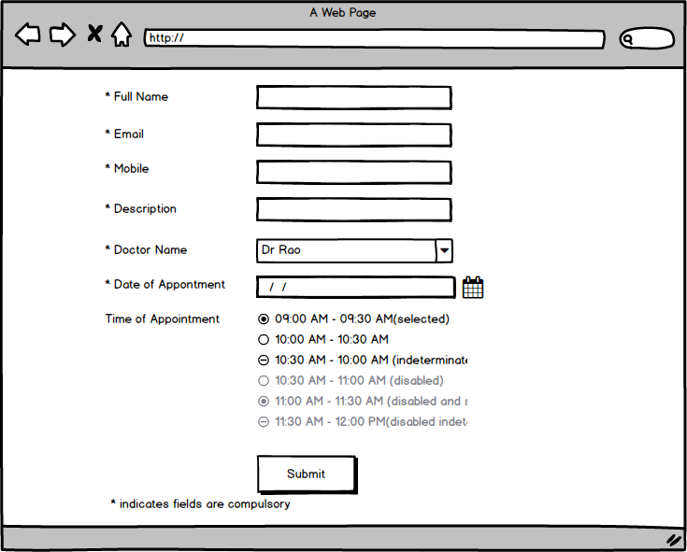

**Accept or Reject an appointment Feature: Version 1.0 (Admin View)**

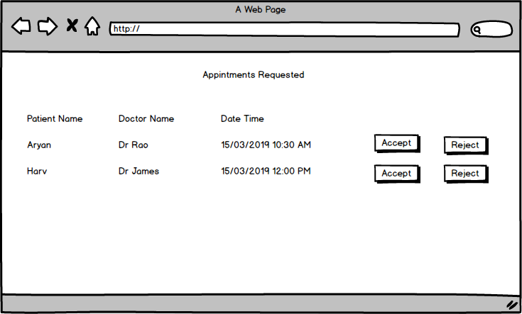

**List of appointment Feature: Version 1.0 (Admin View)**

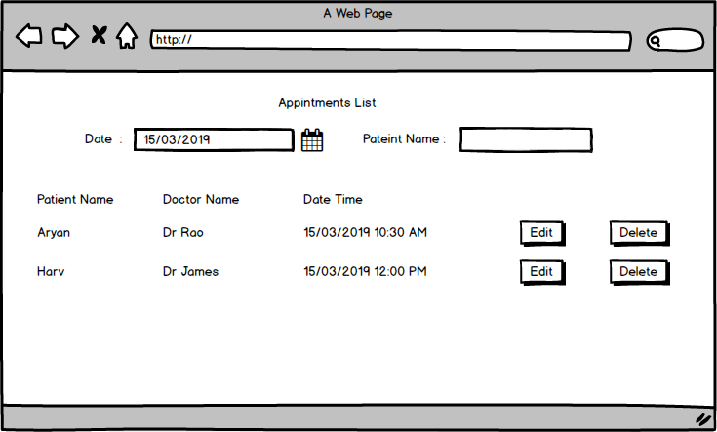

**Edit an appointment Feature: Version 1.0 (Admin View)**

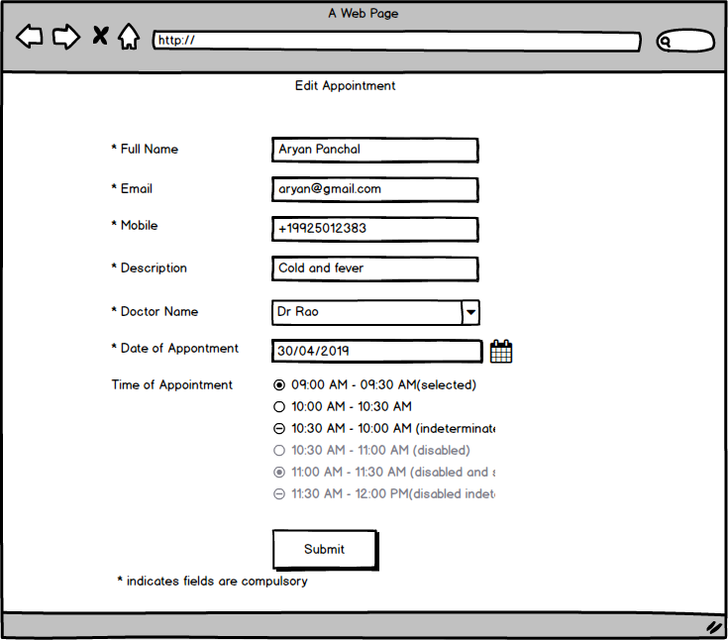

**Delete an appointment Feature: Version 1.0 (Admin View)**

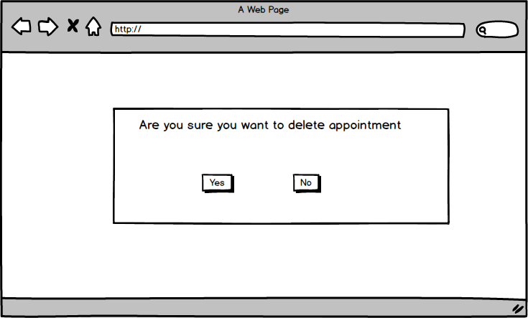

**Feedback Feature version 1.0**

The “Feedback Feature” version 1.0 feature will allow patient to write a feedback regarding the hospital and the doctor’s treatment. There will be a link of “Feedback Feature”. After the form is filled up the request will go to admin section.

**For public:**

There will be link of “Feedback Feature” where a logged in user can click and form will be displayed to the user. The user will fill the necessary details required and give their feedback for doctor, hospital etc. on it. After clicking on submit all fields will be validated and confirmation message will be generated after that.

**For admin:**

Admin can view the list of feedback and can also, edit update and delete the feedback. After viewing the feedback the admin can also give reply to the user feedback. After clicking submit the user will get the email regarding the feedback he/she had given.

**Wireframes**

**Feedback Feature: Version 1.0 (Public - Visitors View)**

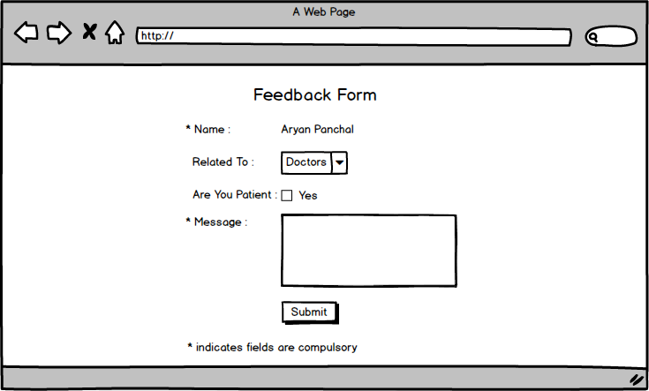

**List Feedback Feature: Version 1.0 (Admin View)**

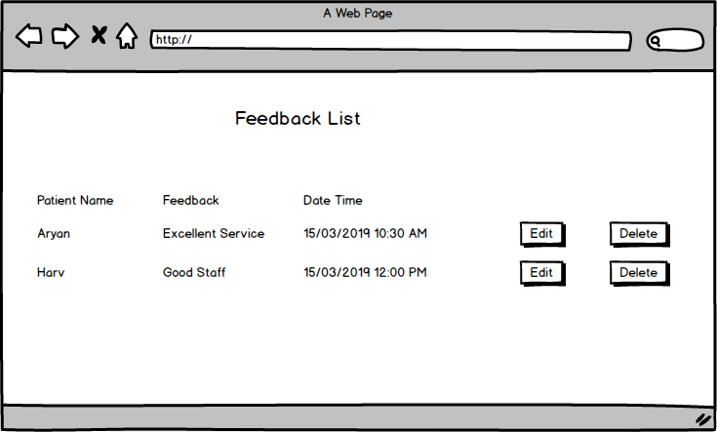

**Edit Feedback Feature: Version 1.0 (Admin View)**

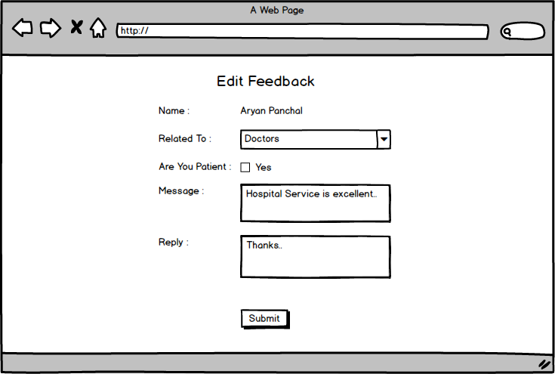

**Delete Feedback Feature: Version 1.0 (Admin View)**

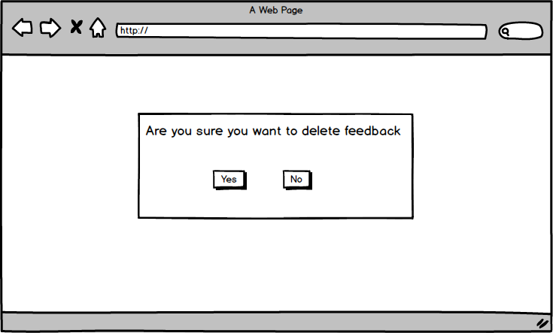

**CMS Feature version 1.0**

The “CMS Feature” version 1.0 feature will allow the admin to add new pages to the website. It will also help the admin to update and delete the pages on the website. This will help the staff they do not need to go to the developer every time they want to make changes to the website.

**For admin:**

The admin can make changes to the existing pages of the website or can also add new pages to the website. The admin only needs to add the information and fill the required fields to the form and new page will be created. It will also keep track of the admin who made changes to the webpage or who created it.

**Wireframes**

**CMS: Add Page Feature Admin View Version 1.0**

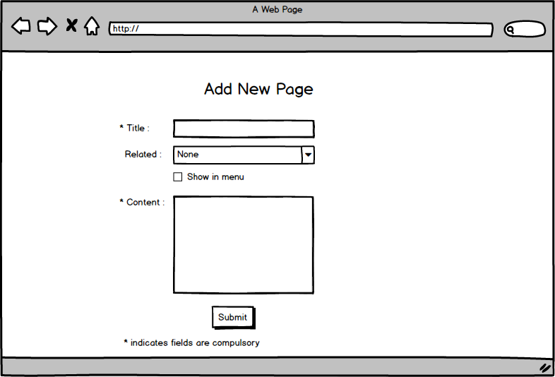

**CMS: List Pages Feature Admin View Version 1.0**

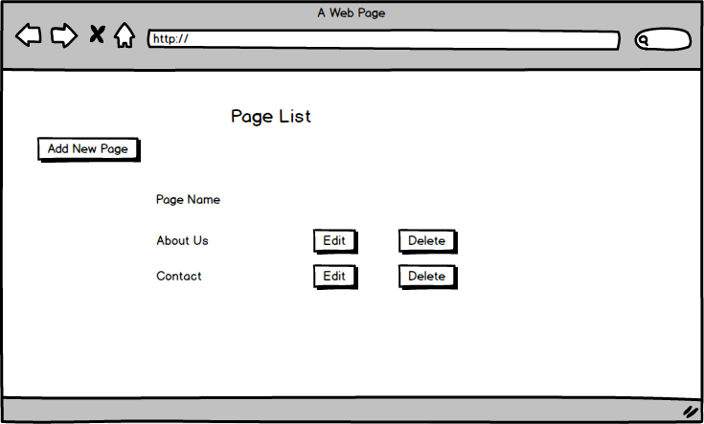

**CMS: Edit Page Feature Admin View Version 1.0**

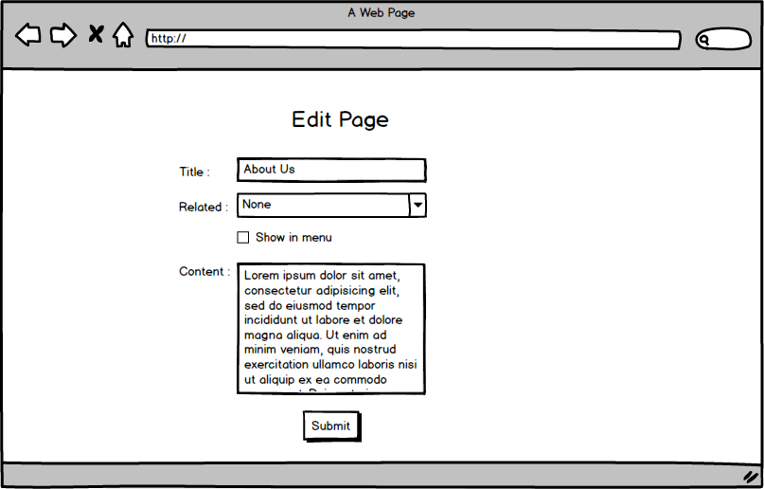

**CMS: Delete Page Feature Admin View Version 1.0**

