Wireframes

Testimonial   
Create Testimonial: By clicking on the button of create testimonial, you will able to add new testimonial. Following the wireframe of create new testimonial. 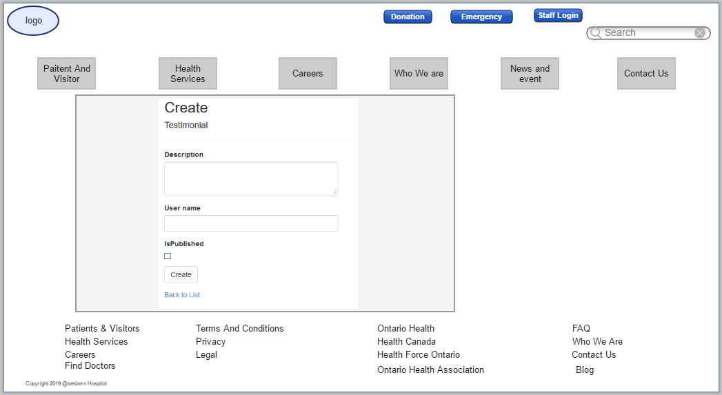

Edit Testimonial: If user want to update any testimonial, he/she can edit it by clicking on the edit button. Its wireframe will look like this following wireframe: 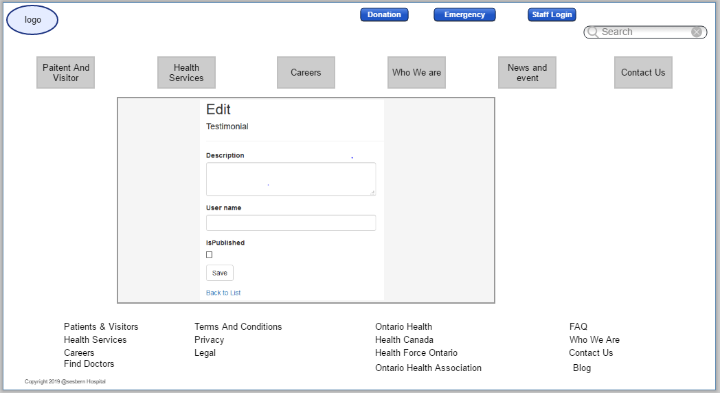

Delete Testimonial: We can delete any testimonial by clicking on delete button. And here is wireframe of deleting testimonial: 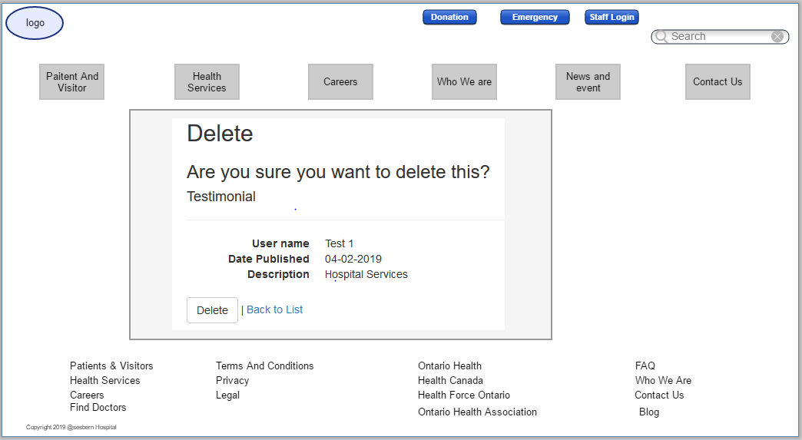

Details of testimonial: user can see the full detail of any testimonial when he/she clicks on the detail button and it will be look like this: 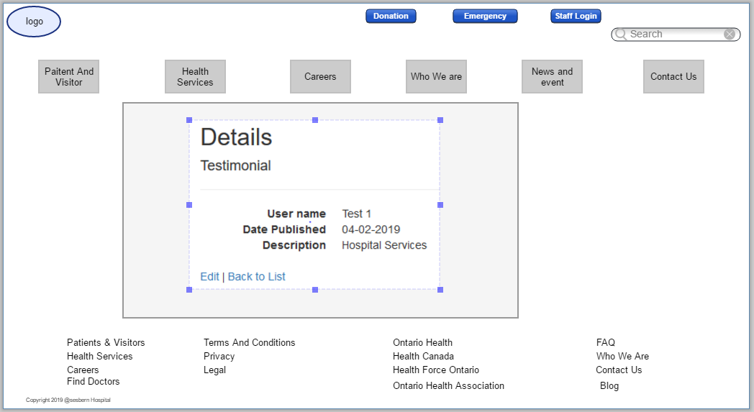

Event

Create Events: Only Admin can create new event by clicking on “Create new Event”. And the wireframe will look like this: 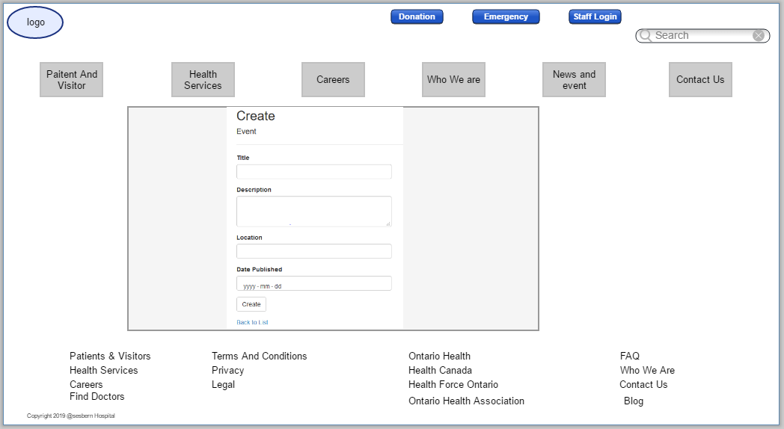

Edit Event: If Admin wants to make any changes in current event then he/she can do it by clicking on “Edit” button. 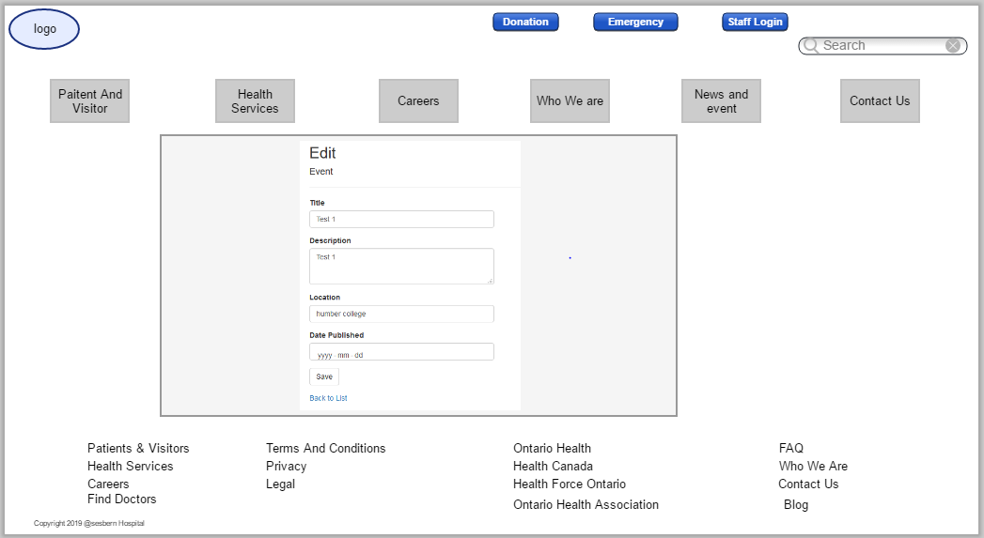

Details of Event: User can see the details of any event by clicking on detail button. Detail will look like this.

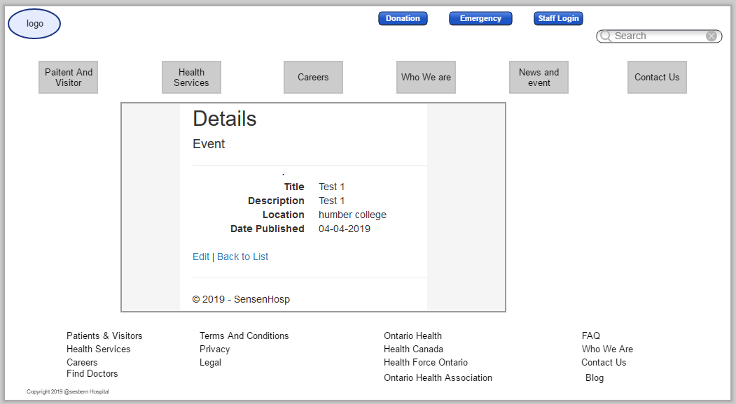

Delete Event: Admin is authorized to delete any event by clicking on “delete Event” link. Here is the wireframe of Delete Event. 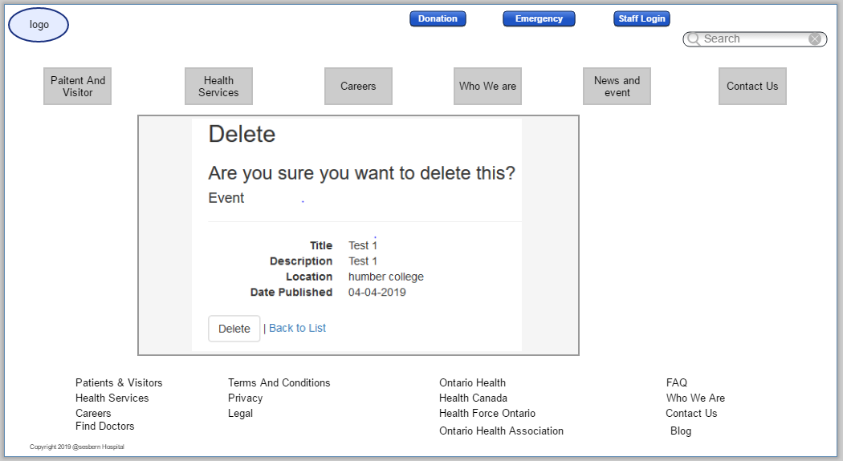

Patient login/ Registration

Register Patient: If any patient wants to book an Appointment then He/she has to register them self by clicking on the link “Registration/Login”. Then a form will open, patient has to fill his personal information there. That registration form will look like this: 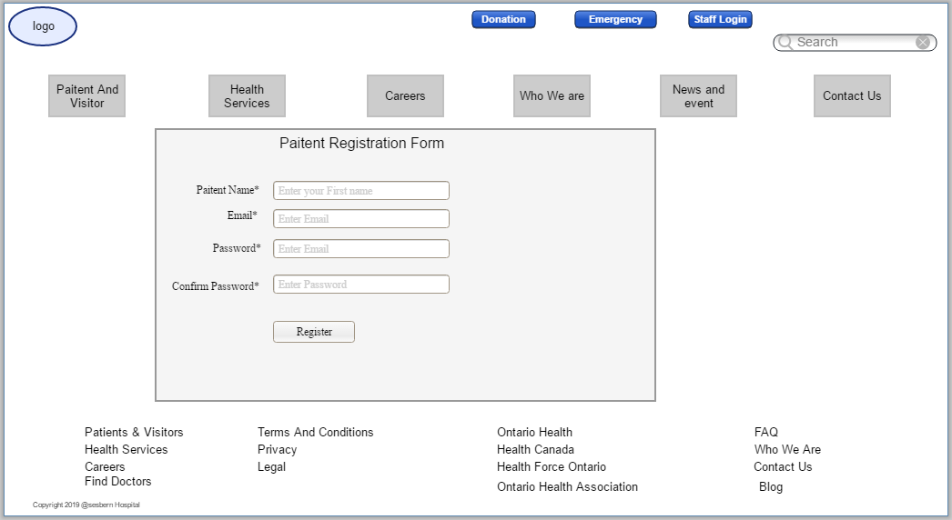

Login for Patient: Once a patient completes his registration then he/she would be able to login with their user name and password. Login page will look like this: 