
COSMIC Measurement Manual simplified version:
Key Principles & Rules of
COSMIC Function Points
Version January 27, 2019 V0.1
This document presents a ‘light’ version of the COSMIC definitions, principles and rules to allow people to get started in measuring the functional size of a piece of software in basic situations: COSMIC provides a standardized method of measuring a functional size of software using ISO 19761 [16].
For situations beyond basic measurement or that require conformity to ISO 19761, refer to the official COSMIC Measurement Manual v 4.0.2 that documents the full set of definitions and rules of the COSMIC method. ‘Further Guidance’ in Appendix A.
Questions on the application of the COSMIC method
You can use the forum on cosmic-sizing.org/forums to post your questions and receive answers from our world-wide community. The quality of any answers will depend on the knowledge and experience of the community member that writes the answer.
Commercial organizations exist that can provide training and consultancy or tool support for the method. Please consult the www.cosmic-sizing.org web-site for further detail.

The Common Software Measurement International Consortium (COSMIC)
COSMIC is a voluntary, not-for-profit organization of software metrics experts from around the world, founded in 1998. All its publications are ‘open’ and available for free distribution subject to copyright and acknowledgement restrictions. For more on COSMIC and its organization, see the COSMIC website www.cosmic-sizing.org
Copyright 2019. All Rights Reserved. The Common Software Measurement International Consortium (COSMIC). Permission to copy all or part of this material is granted provided that the copies are not made or distributed for commercial advantage and that the title of the publication, its version number, and its date are cited and notice is given that copying is by permission of the Common Software Measurement International Consortium (COSMIC). To copy otherwise requires specific permission.
A public domain version of the COSMIC Measurement Manual and other technical reports, including translations into other languages can be found at the Knowledge base of www.cosmic-sizing.org

Table of Contents
1 quick start 3
1.1 COSMIC Overview 3
1.2 The COSMIC Principles 3
1.3 Identifying the functional users 4
1.4 Identifying functional processes 4
1.5 Identifying data groups 5
1.6 Identifying the data movements 5
1.6.1 Identifying Entries (E) 6
1.6.2 Identifying Exits (X) 6
1.6.3 Identifying Reads (R) 6
1.6.4 Identifying Writes (W) 7
1.7 COSMIC unit of measurement 7
2 Modifying functionality 7
3 other rules 9
3.1 Functional User Requirements (FUR) 9
3.2 The standard level of measurement 9
3.3 Data or groups of data not candidates for data movements 10
3.4 Data movement uniqueness & possible exceptions 10
3.5 Data manipulation associated with data movements 10
3.6 Layers 11
3.7 Documenting a COSMIC size measurement 12
Appendix a: COSMIC Documentation and further guidance 12
Appendix B: Examples of COSMIC MEASUREMENT results 13
A) Example from the Rice Cooker case study 13
B) Example from the Course Registration case study 14
Appendix C: some Examples of COsmic rules 15
Examples of 1.6: Data movements - Types versus occurrences 15
Examples of 2: Modifying functionality 16
Example of 3.3: Data or groups of data not candidates for data movements 16
Examples of 3.4: Data movements uniqueness and possible exceptions 16
Examples of 3.7: Layers 17
Appendix D: estimating with COSMIC software size 19

1 quick start

1.1 COSMIC Overview
Figure 1 provides an overview of the main components relevant to COSMIC, and of their relationships:
- Software to be measured consists of a number of functional processes.
- A functional process:
  - has functional users, which are the senders to and/or receivers of data from the functional process.
  - consists of a number of ‘data movements’ of four kinds: ‘Entry’, ‘Exit’, ‘Read’ and ‘Write’ (abbreviated ‘E’, ‘X’, ‘R’ and ‘W’).
  - can have many E, X, R and W data movements.
- When a functional user:
  - sends a data group to the functional process, an ‘Entry’ data movement is identified.
  - receives a data group from the functional process, an ‘Exit’ data movement is identified
- When the functional process:
  - stores a data group in persistent storage a Write data movement is identified,
  - retrieves a data group from persistent storage a Read data movement is identified.
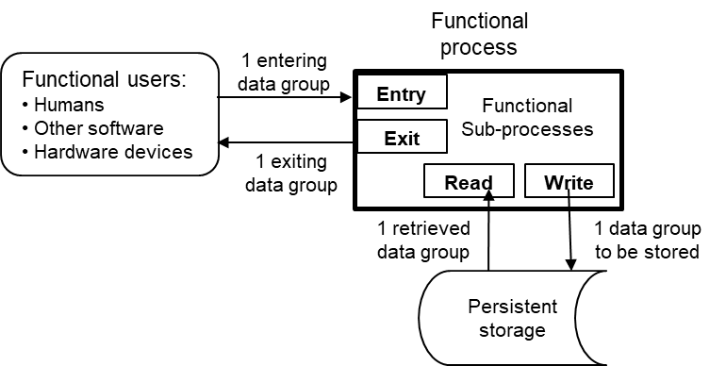
Figure 1 – COSMIC four kinds of data movement, each moving one data group, and their relationship with a functional process.
Note. When a functional process is not concerned with where the data is stored to or retrieved from, the term ‘persistent data’ is used.

1.2 The COSMIC Principles
PRINCIPLES
- A piece of software interacts with its functional users and with persistent storage.
- Functional user requirements of a piece of software to be measured can be mapped to a set of unique functional processes.
- Each functional process consists of one or more sub-processes.
- A sub-process may be either a data movement or a data manipulation.
- A data movement moves a single data group.
- There are four data movement kinds, Entry, Exit, Write and Read.
- An Entry moves a data group into a functional process from a functional user.
- An Exit moves a data group out of a functional process to a functional user.
- A Write moves a data group from a functional process to persistent storage.
- A Read moves a data group from persistent storage to a functional process.
- COSMIC distinguishes between types and occurrences. For ease of reading, we normally omit ‘type’ when using these terms.
- A data group consists of a unique set of data attributes.
- The size of a functional process is equal to the total count of its data movements.
- A functional process shall include at least the triggering Entry data movement and either a Write or an Exit data movement, i.e. it shall include a minimum of two data movements.
- There is no upper limit to the number of data movements in a functional process and hence no upper limit to its size.
- Data manipulation is not separately measured; the functionality of any data manipulation is assumed to be accounted for by the data movement with which it is associated. See section 3.6.

1.3 Identifying the functional users
DEFINITION – Functional user
A user that is identified in the Functional User Requirements (FUR) of a piece of software being measured as a sender and/or an intended recipient of data processed by that software.
The identification of functional users usually depends on the software domain:
- For business application software, the functional users are normally humans, plus perhaps other peer applications with which the application interfaces.
- For real-time software, the functional users would normally be hardware devices that interact directly with the software, plus perhaps other peer software with which the real-time software interacts.

It is helpful when defining the functional users to draw a ‘context diagram’ for the software being measured. See Figures C.4 and C.5 in Appendix C.

1.4 Identifying functional processes
DEFINITION – Functional process
- A set of data movements, representing an elementary part of the Functional User Requirements (FUR) for the software being measured, that is unique within these FUR and that can be defined independently of any other functional process in these FUR.
- A functional process shall have only one triggering Entry. Each functional process starts processing on receipt of a data group moved by the triggering Entry data movement of the functional process.
- The set of all data movements of a functional process is the set that is needed to meet its FUR for all the possible responses to its triggering Entry.
NOTE: When implemented, it is an occurrence of a functional process that starts executing on receipt of an occurrence of a data group moved by an occurrence of a triggering Entry.
Identifying functional processes starts with identifying the following: ‘triplet’:
‘a functional user – (moves a) data group – (to initiate a) functional process’.

1.5 Identifying data groups
DEFINITION – Data group
A distinct, non-empty and non-ordered set of data attributes describing one thing in the world of the functional user.
Note: The FUR of a piece of software may specify data groups to be formed from any combinations of data attributes, as needed by different functional processes.

DEFINITION – Data attribute
The smallest parcel of information, within an identified data group, carrying a meaning from the perspective of the software’s Functional User Requirements.
In practice, a data group can take many forms:
- a physical record structure on a hardware storage device (file, database table, ROM memory, etc.).
- a physical structure within the computer’s volatile memory (data structure allocated dynamically or through a pre-allocated block of memory space).
- the clustered presentation of functionally-related data attributes on an input/output device (display screen, printed report, control panel display, etc.).
d) a message or signal between a device and a computer, or over a network, etc.

RULE - Identifying different data groups moved in the same one functional process
For all the data attributes appearing in the input of a functional process, sets of data attributes that have different frequencies of occurrence define different data group types;
Note: This rule applies for all the data attributes appearing in all data movements kinds.

1.6 Identifying the data movements
This step consists in identifying the data movements (Entry, Exit, Read and Write) of each functional process.
DEFINITION – Data movement
A base functional component which moves a single data group type. There are four kinds of data movement:
- Entry (E). A data movement that moves a data group from a functional user into the functional process where it is required.
- Exit (X). A data movement that moves a data group from a functional process to the functional user that requires it.
- Read (R). A data movement that moves a data group from persistent storage into the functional process which requires it.
- Write (W). A data movement that moves a data group from inside a functional process to persistent storage.

1.6.1 Identifying Entries (E)
An Entry data movement must comply with the following rules:
RULES – Entry (E)
- If the input to a functional process comprises more than one data group, identify one Entry for each unique data group in the input
- The data group of a triggering Entry may consist of only one data attribute which simply informs the software that ‘an event Y has occurred’, or may include many data attributes.
- A clock-tick that initiates a functional process shall always be associated with an Entry.
Note 1: for example, a clock-tick occurring every 3 seconds shall be associated with an Entry moving a data group of one data attribute.
Note 2: It makes no difference whether the clock-tick is generated periodically by hardware or by another piece of software.
- Unless a specific functional process is necessary, obtaining the date and/or time from the system’s clock shall not be considered to cause an Entry or any other data movement.

1.6.2 Identifying Exits (X)
An Exit data movement must comply with the following rules:
Rule – Exit (X)
If the output of a functional process comprises more than one data group, identify one Exit for each unique data group in the output.

DEFINITION – Error/confirmation message
An Exit issued by a functional process to a human functional user that either confirms only that entered data has been accepted, or only that there is an error in the entered data.

RULES – Error/confirmation messages and other indications of error conditions
- One Exit shall be identified to account for all types of error/confirmation messages issued by any one functional process of the software being measured from all possible causes according to its FUR, e.g. successes or failures of: validation of entered data or for a call to retrieve data or to make data persistent, or for the response from a service requested of another piece of software.
- If a message to a human functional user provides data in addition to confirming that entered data has been accepted, or that entered data is in error, then this additional data should be identified as a data group moved by an Exit

1.6.3 Identifying Reads (R)
A Read data movement must comply with the following rules:
RULES – Read (R)
- Identify a Read when, according to the FUR, the software being measured must retrieve a data group from persistent storage.
- If the functional process must retrieve more than one data group from persistent storage, identify one Read for each unique data group that is retrieved.
- A Read data movement always includes any ‘request to Read’ functionality (so a separate data movement shall never be counted for any ‘request to Read’ functionality).

1.6.4 Identifying Writes (W)
A Write data movement must comply with the following rules:
RULES – Write (W)
- Identify a Write when, according to the FUR, the software being measured must move a data group to persistent storage.
- If the functional process must move more than one data group to persistent storage, identify one Write for each unique data group that is moved to persistent storage.
- A requirement to delete a data group from persistent storage shall be measured as a single Write data movement.
- Do not identify a Write when:
- Creation or update of variables or intermediate results that are internal to the functional process;
- Storage of data by a functional process resulting only from the implementation, rather than from the FUR. (Example: the storage of data temporarily during a large sort process in a batch-processed job.)

1.7 COSMIC unit of measurement
DEFINITION – COSMIC unit of measurement
1 CFP (Cosmic Function Point), which is the size of one data movement.

PRINCIPLE – The COSMIC measurement principle
- The size of a functional process is equal to the number of its data movements.
- The functional size of a piece of software of defined scope is equal to the sum of the sizes of its functional processes.
Note: the scope is the set of FUR to be included in a specific functional size measurement exercise

2 Modifying functionality
Any data movement of a given type (E, X, R and W) involves two types of functionality: it moves a single data group and it has some associated data manipulation. See section 3.6.
If there is a FUR that must be measured for a change to data manipulation, determine which type of data manipulation is associated with which type of data movement and consider as a modified Data Movement.

DEFINITION – Modification (of the functionality of a data movement)
- A data movement is considered to be functionally modified if at least one of the following applies:
- the data group moved is modified,
- the associated data manipulation is modified.
- A data group is modified if at least one of the following applies:
- one or more new attributes are added to the data group,
- one or more existing attributes are removed from the data group,
- one or more existing attributes are modified, e.g. in meaning or format (but not in their values)
- A data manipulation is modified if it is functionally changed in any way.

RULES – Modifying a data movement
- If a data movement must be modified due to a change of the data manipulation associated with the data movement and/or due to a change in the number or type of the attributes in the data group moved, one changed CFP shall be measured, regardless of the actual number of modifications in the one data movement.
- If a data group must be modified, data movements moving the modified data group whose functionality is not affected by the modification to the data group shall not be identified as changed data movements.
Sizes of required changes to a piece of software are measured as follows:
- The size of any data movement impacted (i.e. that must be added, modified or deleted) by the required change is measured by convention as 1 CFP.
- The size of the required changes to a piece of software is equal to the number of data movements that are impacted by the required changes.
- The minimum size of a change to a piece of software is 1 CFP.

RULES – Aggregating measurement results
- For any functional process, the functional size of changes to its FUR:
Size (Change(functional process)) = Σ size (added data movements) +
Σ size (modified data movements) +
Σ size (deleted data movements)
- The sizes of pieces of software shall be added together only if it makes sense to do so for the purpose of the measurement.

3 other rules

3.1 Functional User Requirements (FUR)
The COSMIC method involves applying a set of principles and rules to measure the Functional User Requirements (or ‘FUR’) of a given piece of software as defined in this document.
Functional User Requirements are defined by ISO 14143-1 as follows.
DEFINITION – Functional User Requirements (FUR) – ISO 14143-1
A sub-set of the user requirements. Requirements that describe what the software shall do, in terms of tasks and services.
Note 1: Functional User Requirements relate to but are not limited to:
- data transfer (for example Input customer data; Send control signal)
- data transformation (for example Calculate bank interest; Derive average temperature)
- data storage (for example Store customer order; Record ambient temperature over time)
- data retrieval (for example List current employees; Retrieve latest aircraft position)
Examples of user requirements that are not Functional User Requirements include but are not limited to:
- quality constraints (for example usability, reliability, efficiency and portability)
- organizational constraints (for example locations for operation, target hardware and compliance to standards)
- environmental constraints (for example interoperability, security, privacy and safety)
- implementation constraints (for example development language, delivery schedule)
Functional sizes measured by the COSMIC method are designed to depend only on the FUR of the software to be measured (including software functional requirements-FUR that are derived from System Non Functional Requirements - NFR) and to be independent of any requirements or constraints concerning the implementation of the FUR. ‘Functionality’ may be loosely defined as ‘the information processing that the software must perform for its users’.

3.2 The standard level of measurement
The standard level of measurement is the ‘functional process level of measurement’. It is intended to result in repeatable, and therefore comparable, size measurements.
DEFINITION - Functional process level of measurement
The level of the description of a piece of software at which:
- its functional user (-types) are individual humans or engineered devices or pieces of software (and not any groups of these) AND
- single functional processes can be identified (and not any groups of these).

3.3 Data or groups of data not candidates for data movements
Any data appearing on input or output screens or reports that are not related to a functional user should not be identified as indicating a data group, so should not be measured.
When identifying Entries in a screen that enables human functional users to input data into functional processes, analyze only screens that are filled with data. Ignore any screen that is formatted but otherwise ‘blank’ except for possible default values, and ignore all fields and other headings that enable human users to understand the input data required.

3.4 Data movement uniqueness & possible exceptions
There can be circumstances in which different data groups may be required (in the FUR) to be moved in a data movement of the same type (E, R, W, X) in the same functional process.
The following rules cover the most common situation (rule a)). Rule c) concerns occurrences (as opposed to the types) of data movements.
RULES – Data movement uniqueness and possible exceptions
- All data describing the same data group type that is required to be entered into one functional process shall be identified as one data group moved by one Entry.
NOTE: A functional process may, of course, have multiple Entries, each moving data describing a different data group type.
The same equivalent rule applies to any Read, Write or Exit data movement in any one functional process.
- If Functional User Requirements (FUR) specify that different data groups of the same data group type must be entered into one functional process, each from a different functional user, then one Entry shall be identified for each of these different data groups.
The same equivalent rule applies for Exits of data to different functional users from any one functional process.
- Repeated occurrences of any data movement type when it is being executed shall not be counted.
This applies even if multiple occurrences of the data movement type differ in their execution because different values of the data attributes of the data group moved result in different processing paths being followed through the functional process type.

3.5 Data manipulation associated with data movements
RULES – Data manipulation associated with data movements
- An Entry data movement accounts for all data manipulation to enable a data group to be entered by a functional user (e.g. formatting and presentation manipulations) and to be validated.
- An Exit data movement accounts for all data manipulation to create the data attributes of a data group to be output and/or to enable the data group to be output (e.g. formatting and presentation manipulations) and to be routed to the intended functional user.
- A Read data movement accounts for all computation and/or logical processing needed in order to retrieve a data group from persistent storage.
- A Write data movement accounts for all computation and/or logical processing to create or to update a data group to be written, or to delete a data group.
- The data manipulation associated with any of these data movements does not include any data manipulation that is needed after the data movement has been successfully completed, nor does it include any data manipulation associated with any other data movement.

3.6 Layers
The scope of a piece of software to be measured must be confined to a single software layer: therefore, the Measurer may first have to decide what are the layers of the software’s architecture. This section defines and discusses ‘layers’ of software as these terms are used in the COSMIC method. In a defined software architecture, each layer should comply with the following definition and rules.

DEFINITION – Layer
A functional partition of a software system architecture.
Rules - Layers
- Software in one layer provides a set of services that is cohesive according to some defined criterion, and that software in other layers can utilize without knowing how those services are implemented.
- The relationship between software in any two layers is defined by a ‘correspondence rule’ which may be either:
- ‘hierarchical’, i.e. software in layer A is allowed to use the services provided by software in layer B but not vice versa (where the hierarchical relationship may be up or down), or
- ‘bi-directional’, i.e. software in layer A is allowed to use software in layer B, and vice versa.
- Software in one layer exchanges data groups with software in another layer via their respective functional processes.
- Software in one layer does not necessarily use all the functional services supplied by software in another layer.
Software in one layer of a defined software architecture may be partitioned into other layers according to a different defined software architecture.
A measurement may relate to two or more ‘peer’ pieces of software, defined as follows:
DEFINITION – Peer pieces of software
Two pieces of software are peers of each other if they reside in the same layer.
If the software to be measured extends over multiple layers, then:
- When the software to be measured exists within an established architecture of layers that can be mapped to the COSMIC layering principles as defined above, then that architecture should be used to identify the layers for measurement purposes.
- When however, some software to be measured is not structured according to the COSMIC layering principles, the Measurer should try to partition the software into layers by applying the principles defined above.
- Conventionally, infrastructure software packages such as database management systems, operating systems or device drivers, that provide services that can be used by other software in other layers, are each located in separate layers.
Normally in software architectures, the ‘top’ layer, i.e. the layer that is not a subordinate to any other layer in a hierarchy of layers, is referred to as the ‘application’ layer. Software in this application layer relies on the services of software in all the other layers for it to perform properly. Software in this ‘top’ layer may itself be layered, e.g. as in a ‘three-layer architecture’ of User Interface, Business Rules and Data Services components.

3.7 Documenting a COSMIC size measurement
A table can be used to record the results of a measurement for each identified functional process – see Appendix B. The Knowledge base of www.cosmic-sizing.org has a number of spreadsheet tools for measurement recording.

Appendix a: COSMIC Documentation and further guidance
The COSMIC Group has published a number of Guidelines and Case studies for various software domains and related topics. All the COSMIC documents listed below, including translations into other languages, can be found on www.cosmic-sizing.org, including in its Knowledge Base at: https://cosmic-sizing.org/cosmic-publications/overview/
- Measurement Manual
- Introduction to the COSMIC Method of measuring software
- What is a COSMIC Function Point
- Guideline for Sizing Real-time Software
- Guideline for ‘Measurement Strategy Patterns
- Guideline for early or rapid COSMIC functional size measurement
- Guideline for Sizing Business Application Software
- Guideline for sizing Data Warehouse Application Software
- Guideline for Sizing Service-Oriented Architecture Software
- Guideline: introducing COSMIC size measurement to help manage Agile software activities
- Guideline on Non-Functional & Project Requirements
- Quick Reference Guide to the COSMIC method for sizing Business Application Software
- Quick Reference Guide to the COSMIC method for sizing Real-Time Application Software
- Guideline on the accuracy of COSMIC Function Points
- Guideline on how to convert ‘First Generation’ Function Point sizes to COSMIC sizes
- ISO/IEC 14143/1:2011 Information technology – software measurement – functional size measurement. Part 1 Definition of concepts, International Organization for Standardization – ISO, Geneva.

Appendix B: Examples of COSMIC MEASUREMENT results

A) Example from the Rice Cooker case study
Functional Requirement 1 – On receipt of the Start signal:
The software:
- sends a ‘Turn ON’ signal to the Cooking Lamp
- sends a ‘Turn ON’ signal to the heater.
This functional requirement is measured as follows with COSMIC:

Functional user | Data Movement | Data Group moved | Data Movement Kind | CFP
Start button | Receive Start signal | Start signal | E (Entry) | 1
Heater | Send a Turn ON command to the Heater | Heater command | X (eXit) | 1
Cooking Lamp | Send a Turn ON command to the Cooking lamp | Cooking lamp command | X (eXit) | 1
Size of Functional Requirement 1 = 3 CFP
Functional Requirement 2 - On receipt of a 30-second signal:
Starting at t = 0, and at each following 30-second interval, the software:
- receives the 30-second signal;
- receives the elapsed time signal;
- gets the cooking mode from persistent storage;
- selects a new target temperature, for the cooking mode by reading it from the relationship in persistent storage at time = [current elapsed time + 30 seconds]. See Figure 1;
- puts this new target temperature into persistent storage, which becomes the current target temperature until the next 30 sec. signal.
This functional requirement is measured as follows with COSMIC:

Functional user | Data Movement | Data Group moved | Data Movement Kind | CFP
Timer | Receive 30-second signal | 30-second signal | E (Entry) | 1
Timer | Receive Current elapsed time signal | Current elapsed time signal | E (Entry) | 1
 | Get cooking mode | Cooking mode | R (Read) | 1
 | Get New target temperature for [Current elapsed time + 30 secs.] and Cooking mode. (This will replace the Current target temperature) | New target temperature | R (Read) | 1
 | Store the (new) Current target temperature | Current target temperature | W (Write) | 1
Size of Functional Requirement 2 = 5 CFP

B) Example from the Course Registration case study
Functional Requirement 2.1.1.3 - Enquire on a Professor’s details
- When a Registrar wishes to enquire on the details of a Professor, he must first select the sub-option ‘Enquire on a Professor’ as in 2.1.1.2 and he must enter a Professor ID.
- The software searches for a Professor with the specified ID and displays the Professor’s name and address and other details.
- Alternatively, if a Professor with the specified ID is not found, the software displays an error message, "Professor Not Found". The Registrar can then type in a different ID or cancel the operation.
This set of functional requirements is measured with COSMIC as follows:

Functional Requirement | Functional user | Data Movement | Data Group moved | Data Movement Kind | CFP
2.1.1.3 Enquire on a Professor’s details | Registrar | The Registrar enters Professor ID | Professor ID | E (Entry) | 1
 |  | The software retrieves the Professor details | Professor details | R (Read) | 1
 | Registrar | The software displays the Professor details | Professor details | X (eXit) | 1
 | Registrar | Display error message | Error Messages | X (eXit) | 1
Size of Functional Requirement 2.1.1.3 = 4 CFP

Appendix C: some Examples of COsmic rules

Examples of 1.6: Data movements - Types versus occurrences
EXAMPLE 1 – Business domain:
The requirement is: a functional process (-type) enables data to be entered, and validated for a new customer.
- The Entry (-type) data movement will be executed, i.e. it will occur once, each time a human functional user enters data for a new customer.
- During its execution, the functional process must validate the entered data by searching to check if the customer already exists in the database. Hence the Read (-type) data movement for this validation will occur one or more times (depending on the database design).
In summary: one Entry (-type) & one Read (-type) of the customer for this functional process.
EXAMPLE 2 – Real-time domain:
A tire-pressure monitoring system (TPMS) monitors the pressure of each of the four tires of a car. Each wheel has a sensor which obtains the pressure of its tire. Once per second each sensor sends its status, which consists of the sensor id (which identifies the particular wheel) and tire pressure to the software.
The four sensor functional users are subject to the same FUR (‘obtain and send tire pressure’): therefore, one functional user type (‘Tire pressure sensor’) must be identified that represent the four occurrences.
EXAMPLE 3: Navigation, Control commands & Application-general data
The following do not involve any data group of the FUR, hence shall not be considered as data movement or manipulation:
- Commands to ‘page up/down’ or between physical screens.
- Hitting a Tab or Enter key, or pressing a button to continue.
- Clicking on an ‘OK’ button to confirm or cancel a previous action, or to acknowledge an error message or to confirm some entered data, etc.
- Functions that enable a user to control the display (or not) of a header or of sub-totals that have been calculated.
- Menu commands that enable a user to navigate to one or more specific functional processes but which do not themselves initiate any one functional process.
- Commands to display a blank screen for data entry.
- Movement or manipulation of constants or variables which are internal to the functional process and/or that can be changed only by a programmer,
- Computation of intermediate results in a calculation,
- Data stored by a functional process resulting only from the implementation, rather than from the FUR.
- Movement or manipulation of screen titles, screen colour etc.
- When the screen colour for all screens is changed, this change should not be measured.
- Change the calculation, the specific formatting, presentation, and/or validation of the data. ‘Presentation’ can mean the font, background colour, field length, field heading, number of decimal places, etc.

Examples of 2: Modifying functionality
EXAMPLE 4: A change request to a piece of software is: ‘add one new functional process of size 6 CFP, and in another functional process add one data movement, make modifications to three other data movements and delete two data movements.’ The total size of the required change is 6 + 1 + 3 + 2 = 12 CFP.
, changes to control commands and application-general data should not be measured. See section 3.6.
EXAMPLE 5: A change request for a functional process requires:
- three changes to the data manipulation associated with its triggering Entry,
- two changes to the manipulation associated with an Exit, as well as
- two changes to the attributes of the data group moved by this Exit.
The size of the change is 2 CFP = the total number of data movements whose attributes and associated data manipulation must be changed – it must NOT take into account the number of data manipulations or data attributes changed.
EXAMPLE 6: The change request is: add or modify the data attributes of a data group D₁, such that after modification it becomes D₂.
In the functional process where this modification is required, all data movements affected by the modification should be identified and measured as modified. So, if the changed data group D₂ is in both a Write and an Exit data movement in this functional process, identify one changed Write and/or one changed Exit data movement respectively.

Example of 3.3: Data or groups of data not candidates for data movements
EXAMPLE 7: ‘Application-general data’ such as headers and footers (company name, application name, system date, etc.) appearing on all screens.

Examples of 3.4: Data movements uniqueness and possible exceptions
EXAMPLE 8: Consider two occurrences of a given functional process (-type):
1) the values of some attributes to be moved lead to a data manipulation sub-process (-type) ‘A’, and
2) for the same functional process the attribute values lead to a different data manipulation sub-process (-type) ‘B’.
In such circumstances, both data manipulation sub-processes ‘A’ and ‘B’ should be associated with the same one data movement and hence only the one data movement should be identified in that functional process.
EXAMPLE 9 – Business domain:
In a ‘Create Employee’ functional process, a name, address and city must be entered in a first screen and, in a subsequent screen, the date of birth and the email address; identify one Entry.

Examples of 3.7: Layers
BUSINESS EXAMPLE 10: The physical structure of a typical layered software architecture supporting business applications software as in Figure C.1:
Figure C.1 - Typical layered software architecture for a Business/MIS system
REAL-TIME EXAMPLE 11: The physical structure of a typical layered software architecture supporting a piece of embedded real-time software is in Figure C.2.
Figure C.2 - Typical layered architecture for a real-time embedded-software system
A software architecture may exhibit different layers depending on the ‘view’ of the architecture.

BUSINESS EXAMPLE 12: Consider an application A situated in a layered software architecture, as in Figure C.3, which shows three possible layer structures a), b) and c) according to different architecture ‘views’

Figure C.3 - Three views of the layers of an application
View a). The measurement scope is the whole of application A, which exists entirely within the one ‘application’ layer
View b). Application A has been built according to a ‘three-layer’ architecture comprising a User Interface, Business Rules and Data Services components. The three components can be measured separately. Each software component is situated in its own layer of the architecture and the measurement scope must be defined separately for each component.
View c) The Business Rules component of the application has been built using re-usable components of a Service-Oriented Architecture, which has its own layer structure. Measurement of an SOA component of the Business Rules component. Each SOA software component is situated in a layer of the SOA architecture and the measurement must be done separately for each SOA component. (Note that SOA terminology also uses ‘application layer’ within its own architecture.)
Fig. C.4 shows that the application software being measured has two functional users:
- human(s) and a peer application.

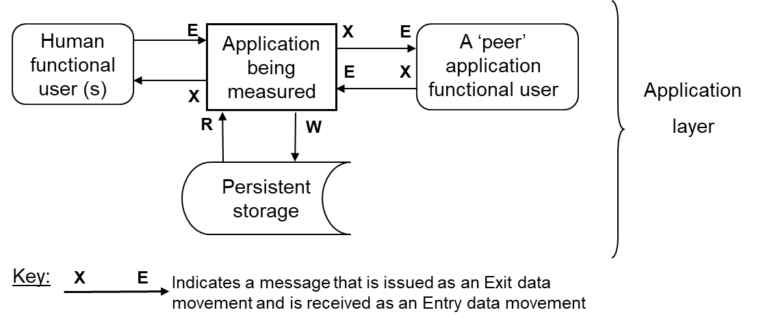
Figure C.4 – SOA - A context diagram of a business application with humans & another ‘peer’ application as its functional users
The embedded software application of Figure C.5 has only hardware devices and a peer application as its functional users.
The arrows showing the movements of data are labeled with the abbreviations showing their types (E = Entry, X = eXit, R = Read, W = Write).
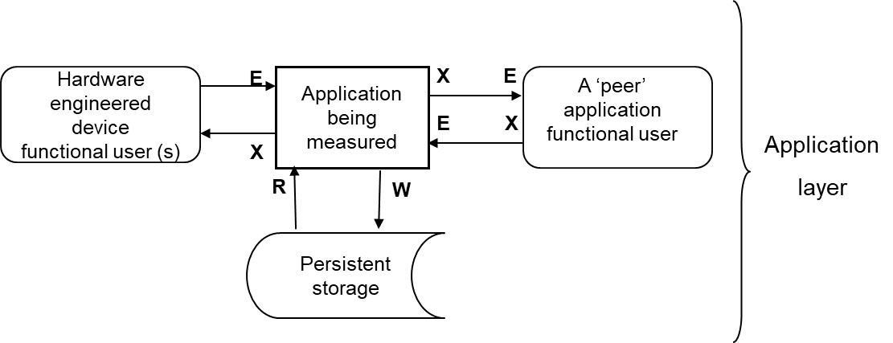
Figure C.5 - A context diagram of a real-time embedded software application with various hardware engineered devices and peer software as its functional users

Appendix D: estimating with COSMIC software size

A main use of COSMIC size is to provide an estimate of the effort of implementing a piece of software. The COSMIC size is based on the functional specifications.
For estimating on basis of COSMIC functional size, both the size and the effort (i.e. in work hours) of a number of pieces of software must be captured. With help of simple regression analysis the relationship between sizes and work hours can be obtained and made visible in a spreadsheet as a linear function. Given a functional size, this function can be used for:
- a tender and/or a Return of Investment (ROI) estimate,
- to serve as a second opinion to an estimate given by a project manager or a contractor.
Figure D.1 presents the linear function built using the data from Table D.1 for 8 pieces of software.
Table D.1: Example of Size & Effort data for 8 pieces of software
Software | Size (CFP) | Effort (hours)
Software1 | 50 | 190
Software2 | 90 | 355
Software3 | 45 | 165
Software4 | 60 | 315
Software5 | 85 | 370
Software6 | 120 | 365
Software7 | 30 | 195
Software8 | 65 | 295
In Figure D.1, the relationship between size and effort is indicated by the trend line. Figure D.1 also displays the formula of the trend line and the ‘coefficient of determination’ R², of which the maximum is 1. The closer to 1, the better the line fits the points.

D.1 COSMIC Estimation Model
Effort (hours) = 2,5 (hrs∕CFP) * Size (CFP) + 109 hrs
As an example, with a measured size of a specification of 100 CFP, the estimated effort would become 2,5 hrs∕CFP * 100 CFP + 109 hrs = 359 hours.
Note that:
- The hours of all pieces of software be collected for the same set of implementation activities. Each estimate is the estimate of the hours to perform that set of implementation activities.
- The formula is specific to the organization where these numbers were collected. An organization with a different development environment will get different efforts.
- The formula is specific to the available size range, i.e. don’t use it for sizes far outside this range.The formula will change when new data are added.When a new software implementation has been finished, its software size and the accompanying work hours, the company data repository can be updated for estimations of future implementations.

Acknowledgements
Version 1,0 Reviewers
Alain Abran  Arlan Lesterhuis  Peter Fagg | …….

Coefficient of determination : it describes the percentage of variability explained by the independent variable – here the functional size in CFP.

