Project Title: **Smart Reading Gloves**

Team: *Enrique Flores Medina, Tianyi Liu*

EECS 149/249A Project Charter, Fall, 2022

**Keywords:**

States machines, sensors, and wireless networks.

**Project Goal**

This project will develop a glove that enables low-vision people to read, by turning (almost) any text they encounter into speech.

**Project Approach**

The project will convert any text into speech as described by a deterministic state machine that receives multiple sensor inputs. One of these inputs will trigger a camera, which will take a picture and send it to a computer. Then, the computer will read the text in the received image and convert it into speech that can be heard with either headphones or a speaker.

**Architecture drawings:**

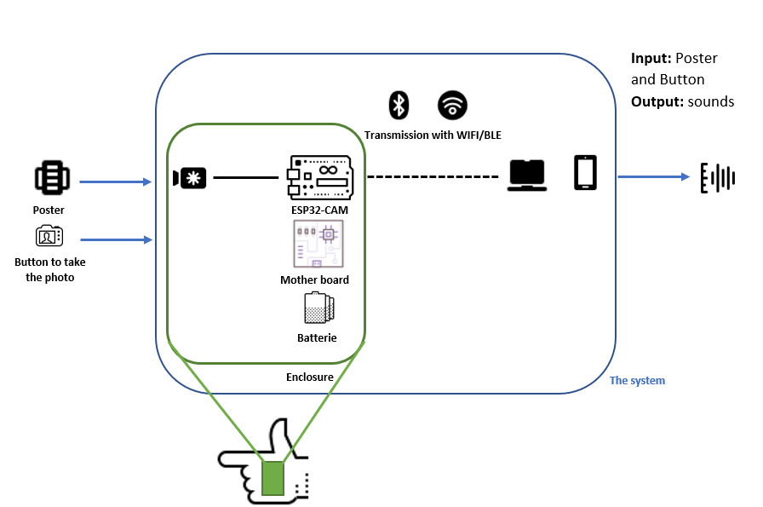

*Figure1: Architecture drawings of the entire system*

*Figure2: Architecture drawings of the enclosure*

*Figure3: Conceptual Sketch of the enclosure*

**Progress so far:**

We did:

* MATLAB code to extract the text from the image and speak it out.
* Design Pcb and enclosure cad (more details on GitHub).
* Finalize the suitable electronic board and the purchase form.

**Resources:**

We plan to use a microcontroller ( ESP32-CAM Wi-Fi Bluetooth camera module development board with Camera (D111) <https://vetco.net/products/esp32-cam-wifi-bluetooth-camera-module-development-board-with-camera-d111/vupn998> ) as the main distributor between the embedded camera and the computer. We can control the ESP-32 CAM by uploading the code on the motherboard. The picture taken by the embedded camera will be transferred wirelessly with BLE or WIFI. Then, using MATLAB’s OCR function, the text will be extracted from the picture. Finally, the text will be sent to an app on the handset, which will read it out through the speaker or the headphones.

The first goal is the transferring of images from the microcontroller via WIFI/BLE. By pushing a button (from the hardware inventory), the microcontroller should instruct the camera to take a picture and send it. The second goal is to use MATLAB to extract all the text from the picture. Then, we create an app to receive the text sent by the laptop. Finally, if we have time, the third goal would be the addition of an ultrasonic sensor (from the hardware inventory) to instruct the user on the proper distance to take the picture, but this is not the focus.  The state machine would take, then, the ultrasonic sensor measurements and the button as inputs.

* 3D printer
* Provided library of ESP32 CAM
* Various mechanical and electrical components
* Power supplier
* The glue to fix the Pcb in our enclosure
* Battery case: 3AA Battery Holder with on/off switch
* AA Fujitsu Alkaline Battery

**Proposed Demo:**

In the end, the proposed demo would be the device should be wearable and capable of reading a text from the final poster. To start reading, the latency must be less than 5 seconds. So, the user feels comfortable with the gadget.

**Schedule:**

~~- October 21: Project Proposal (this document) + creation of GitHub~~

~~- October 31: Finish the architecture drawing (state machine), upload Github, finalize the~~

~~Hardware list (approved by GSI)~~

* November 6: Milestone 1: Present architecture drawing, Pcb design, and the enclosure cad for the ESP32 CAM board and the camera and power supplier.
* November 14: Reliable MATLAB script to read text from images taken with the embedded camera and turn it into speech. Decide on the protocol to send the picture from the ESP32 to the computer. Print the Pcb and finalize the enclosure cad for the gadgets. To be more familiar with the different libraries of the ESP32.
* November 21: Midterm 2, starting writing code to send the image from the microcontroller to the computer.
* November 22: code to send the image from the microcontroller to the computer.
* November 23: Milestone 2: our goal is to receive at the computer the photo taken by the camera by using WIFI or BLE.
* November 28 - December 2: Milestone 2 Meetings
* December 7: Finalize details if there is extra time:
  + Add ultrasonic sensor measurements to determine how far the user has to be from the text to take the image properly.
  + Create an app to hear the speech on the phone
* December 15: Project Poster/Demo Expo
* December 16: Peer Evaluations, Project report

**Risk and Feasibility**

There are many unknowns. First, by sending the image from the microcontroller to the computer, some packets could be lost. Therefore, the image could lose quality which would significantly reduce our ability to detect the text in it. To deal with this, a comparison between the reliability of the image transmission between BLE and WIFI could be taken. Another potential issue could be the latency from the trigger of the camera to the speech, which could make the functionality of the product inefficient. If the system consumes a lot of power, and the hardware components are not ergonomic for the user, the experience would also be worsened. Finally, the quality of the camera is a big factor in determining if we can read the text or not.

**Link to GitHub:**

https://github.com/tianyi-liu-fr/project_ee149_ucBERKELEY