SmartFix uses an event-driven architecture in which six modules (Reports, Validation, Priority, Work Orders, Notifications and Analytics) never call one another directly. Instead, each module publishes events such as IssueReported or RepairCompleted to a RabbitMQ broker, and every module that needs an event consumes it from its own queue. This design isolates failures, allows modules to be developed and tested independently, and provides a complete event history for each issue, supporting faster and fairer infrastructure repairs in line with SDG 9.1.

Term | What it means in SmartFix
Event | A short message saying that something happened, for example IssueReported or RepairCompleted. It carries a unique ID, the issue ID and the details of what happened.
Publisher | The part of the system that announces an event. Example: the Reports module publishes IssueReported when a resident submits.
Broker | The post office in the middle. SmartFix uses RabbitMQ, which receives every event and delivers a copy to everyone who asked for it.
Queue | Each module has its own inbox at the broker. If a module is busy or switched off, its events wait in line instead of being lost.
Subscriber | A module that has signed up for certain events. Example: Validation subscribes to IssueReported.

Every event at a glance
Event | Published by | Who reacts | Result
IssueReported | Reports | Validation | AI classifies and rates severity.
IssueValidated | Validation | Priority, Notifications | Priority score calculated; resident told.
IssueDuplicateDetected | Validation | Priority, Notifications | Report merged into existing issue.
IssueNeedsReview | Validation | Operator dashboard | Operator approves or rejects.
IssuePrioritized | Priority | Work Orders, dashboard | Work order created or moved in queue.
WorkOrderCreated | Work Orders | Notifications, dashboard, scheduler | Crew notified; deadline set.
WorkOrderStatusChanged | Crew portal | Notifications, dashboard | Resident and operator see progress.
RepairCompleted | Crew portal | Validation, Notifications, Analytics | Photos compared; resident asked to confirm; repair time recorded.
RepairDisputed | Reports | Priority, Work Orders | Issue reopened with higher priority.
DeadlineMissed | Scheduler | Priority, Notifications | Issue escalated; supervisor alerted.

The Architecture Diagram

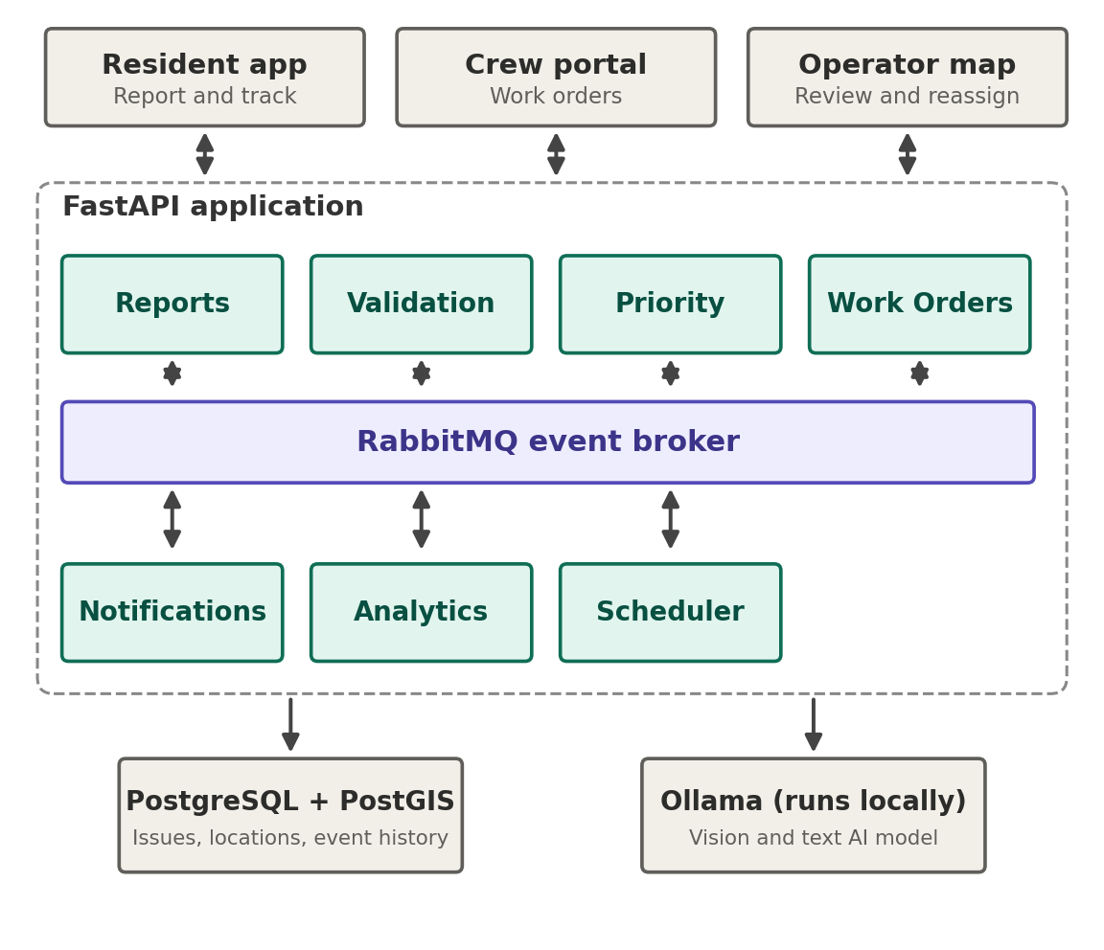
Figure 1. Modules are connected to RabbitMQ, not to each other.
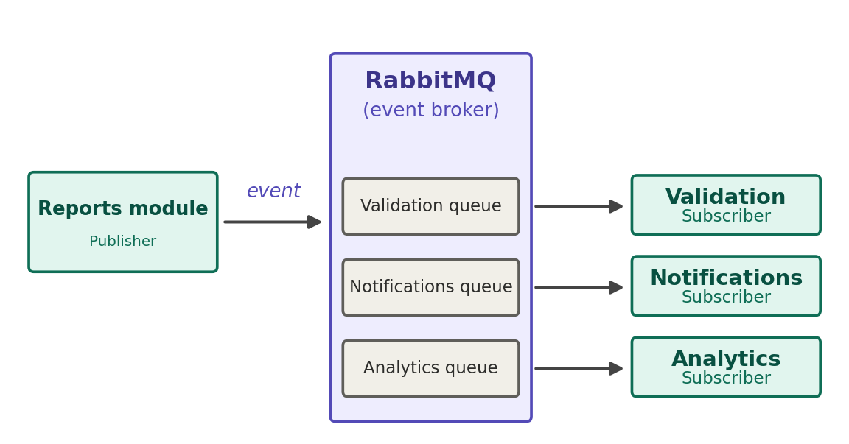
Figure 2. One event goes to the broker, and each subscriber receives it in its own queue.

Here is the normal path for one report, from photo to closed issue. Each step ends with an event that triggers the next.
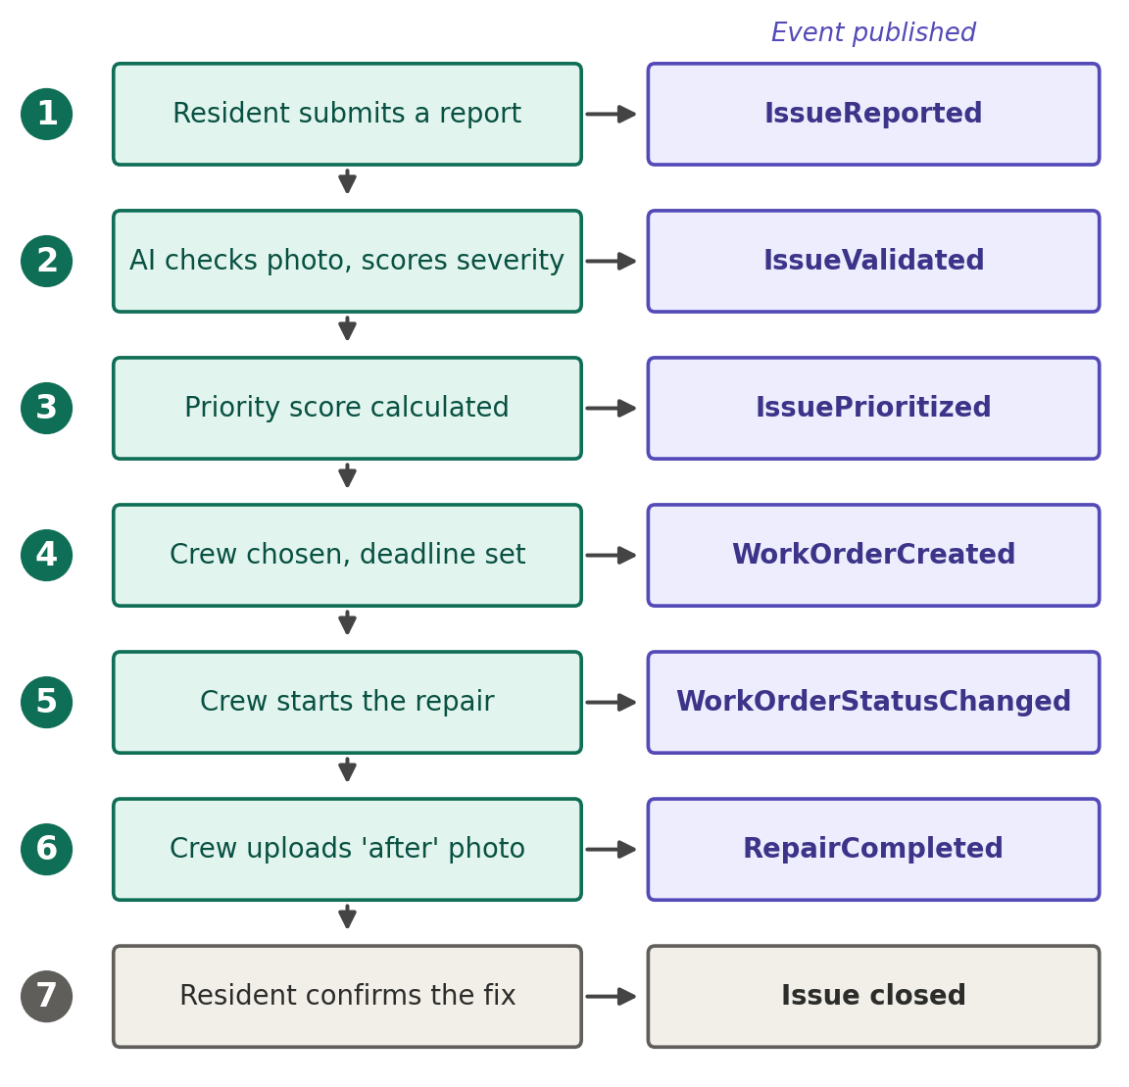
Figure 3. The normal path. Green boxes are what happens, purple boxes are the event published.

What happens at each step
- A resident submits a report. The Reports module saves it and publishes IssueReported. The resident does not wait for the AI.
- The AI checks it. Validation looks at the photo, identifies the problem, rates severity from 1 to 5, and publishes IssueValidated. The resident is told the report was received.
- Priority is calculated. The Priority module combines severity, a capped bonus for repeat reports and a bonus for waiting time, then publishes IssuePrioritized. The operator map updates.
- A crew is assigned. Work Orders picks a crew by problem type, area and workload, sets a deadline and publishes WorkOrderCreated. The crew is notified.
- The crew starts. When the crew updates the status, WorkOrderStatusChanged is published and the resident sees that work has begun.
- The crew finishes. Uploading the after photo publishes RepairCompleted. The AI compares before and after, and the resident is asked to confirm.
- The issue closes. The resident confirms the fix, or after seven days with no reply the system closes it automatically.

Not every report follows the normal path. The same event system handles these cases without any special wiring.
Situation | What the system does
Someone already reported it | Validation finds an open issue of the same type within 50 metres and publishes IssueDuplicateDetected instead. The new report joins the existing issue, priority goes up (with a cap), and no second crew is sent.
The AI is not sure | If confidence is low or the photo is not infrastructure, Validation publishes IssueNeedsReview. The report goes to the operator's review list. Approving it publishes IssueValidated and the normal path continues.
The resident says it is not fixed | Reports publishes RepairDisputed. The issue is reopened with higher priority and a new work order is created.
The repair is late | The deadline scheduler checks open work orders every day. A missed deadline publishes DeadlineMissed, which moves the issue to the top of the queue and alerts a supervisor.

