Healthcare Test Results Prediction

A Complete End-to-End Data Analytics & Machine Learning Project

Dataset: Synthetic Healthcare Dataset | Problem: Multiclass Classification

Abstract
This project presents a complete end-to-end data analytics and machine learning solution applied to a synthetic Healthcare Dataset comprising 55,500 patient admission records. The primary objective is to predict the Test Result (Normal, Abnormal, or Inconclusive) of a patient using demographic, clinical, and administrative features. Four classification algorithms were trained and compared: Logistic Regression, Random Forest, Gradient Boosting, and HistGradientBoosting. The Random Forest model achieved the best performance with an accuracy of 42.63% and ROC-AUC of 0.6313 on the held-out test set. An interactive Streamlit dashboard was also developed for real-time prediction.

1. Introduction
Healthcare data analytics is one of the fastest-growing applications of machine learning. Hospitals and healthcare providers generate vast amounts of structured data with every patient admission. Automatically classifying clinical outcomes from such data can assist medical professionals in decision-making, resource allocation, and patient triage.
This project uses a synthetic Kaggle healthcare dataset to demonstrate a complete ML pipeline: from raw data inspection and exploratory analysis to model training, evaluation, and deployment via an interactive web application.

2. Problem Statement
Given a set of patient attributes — including age, gender, blood type, medical condition, admission type, medication, insurance provider, billing amount, room number, and length of stay — the task is to predict the patient's test result classification: Normal, Abnormal, or Inconclusive.
This is a multiclass classification problem. The three classes are nearly equally distributed (approximately 33% each), making the random baseline accuracy ~33.3%.

3. Objectives
- Inspect and understand the healthcare dataset thoroughly.
- Perform data cleaning: remove duplicates, handle inconsistencies.
- Conduct Exploratory Data Analysis (EDA) with meaningful visualizations.
- Engineer useful features from raw data (date-based, length of stay).
- Build and evaluate multiple classification models.
- Compare models and select the best based on actual evaluation metrics.
- Save the final trained pipeline for deployment.
- Develop an interactive Streamlit frontend for real-time predictions.
- Document all steps and results in a professional report.

4. Dataset Description
Property | Value
Dataset Name | Healthcare Dataset
Source | Kaggle (Synthetic Healthcare Data)
Total Records | 55,500
Records (After Deduplication) | 54,966
Total Columns | 15
Features Used for ML | 13
Target Variable | Test Results
Target Classes | Normal, Abnormal, Inconclusive
Problem Type | Multiclass Classification
Date Range | May 2019 – May 2024
Missing Values | None
Duplicate Rows | 534 (removed)

Columns in the dataset:
Column | Type | Description
Name | str | Patient name (dropped — identifier)
Age | int | Patient age in years (13–89)
Gender | str | Male / Female
Blood Type | str | A+, A-, B+, B-, AB+, AB-, O+, O-
Medical Condition | str | Arthritis, Cancer, Diabetes, Hypertension, Obesity, Asthma
Date of Admission | str | Admission date (used for feature extraction)
Doctor | str | Attending doctor (dropped — high cardinality)
Hospital | str | Hospital name (dropped — high cardinality)
Insurance Provider | str | Cigna, Medicare, UnitedHealthcare, Blue Cross, Aetna
Billing Amount | float | Total billing in USD
Room Number | int | Room number (100–500)
Admission Type | str | Elective, Urgent, Emergency
Discharge Date | str | Discharge date (used for Length of Stay)
Medication | str | Lipitor, Ibuprofen, Aspirin, Paracetamol, Penicillin
Test Results | str | TARGET: Normal, Abnormal, Inconclusive

5. Dataset Analysis
Statistic | Value
Mean Age | 51.54 years
Std Age | 19.60 years
Min Age / Max Age | 13 / 89
Mean Billing Amount | $25,539
Min Billing / Max Billing | -$2,008 / $52,764
Mean Length of Stay | 15.5 days
Negative Billing Records | 108 (retained)
Gender Split | Male: 27,774 | Female: 27,726
Most Common Condition | Arthritis (9,308 records)

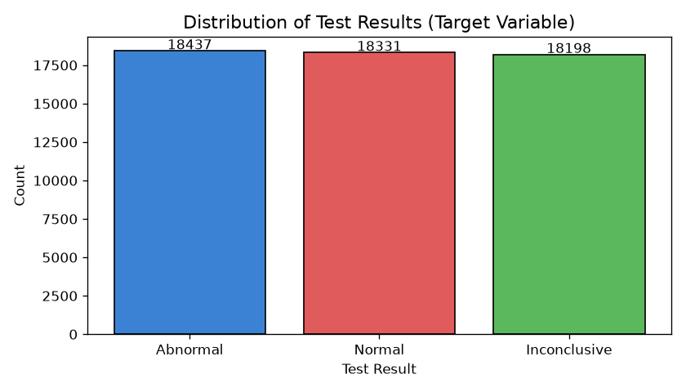
Figure: Distribution of Test Results (Target Variable)

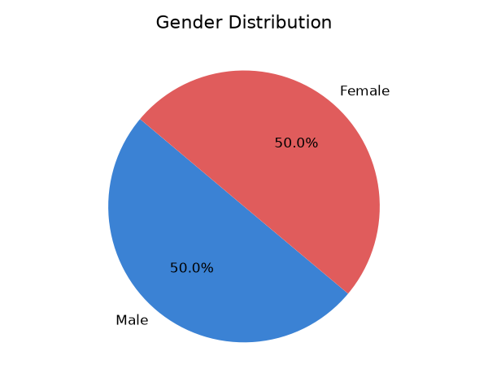
Figure: Gender Distribution of Patients

6. Data Preprocessing
- Removed 534 duplicate rows. Final dataset: 54,966 rows.
- Dropped high-cardinality identifier columns: Name, Doctor, Hospital.
- Parsed 'Date of Admission' and 'Discharge Date' as datetime objects.
- Engineered 'Length of Stay' (days between admission and discharge).
- Extracted Admission Year, Admission Month, Admission DayOfWeek from the date.
- Applied StandardScaler to numerical features via a scikit-learn Pipeline.
- Applied OrdinalEncoder (with unknown handling) to categorical features via ColumnTransformer.
- Used stratified 80/20 train/test split to preserve class balance.
- No missing values required imputation (SimpleImputer included as a safety guard).

Engineered Features
Feature | Derived From | Description
Length of Stay | Discharge Date - Admission Date | Number of days hospitalized
Admission Year | Date of Admission | Year component
Admission Month | Date of Admission | Month component (1–12)
Admission DayOfWeek | Date of Admission | Day of week (0=Mon, 6=Sun)

7. Exploratory Data Analysis
EDA was performed to understand the dataset distributions, relationships between features, and the target variable. Twelve visualizations were generated covering target distribution, demographic analysis, clinical patterns, financial patterns, and temporal trends.

7.1 Age Distribution
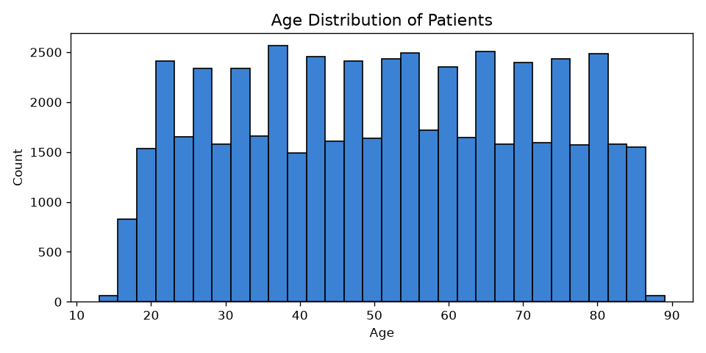
Figure: Age Distribution of Patients

7.2 Medical Condition Analysis
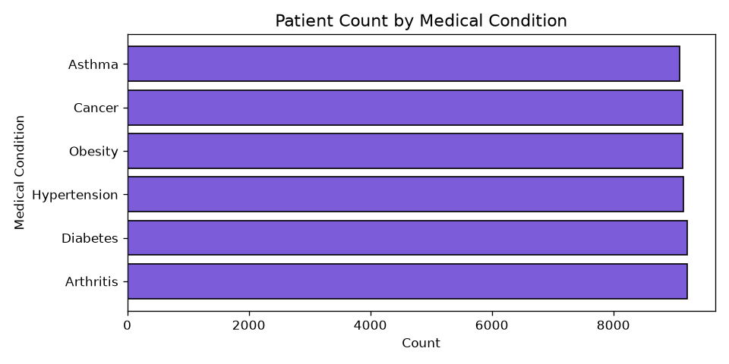
Figure: Patient Count by Medical Condition

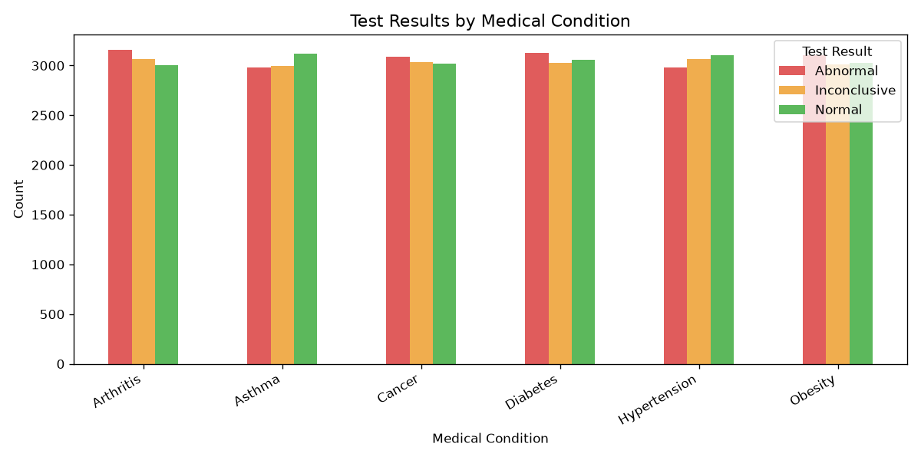
Figure: Test Results by Medical Condition

7.3 Billing Amount
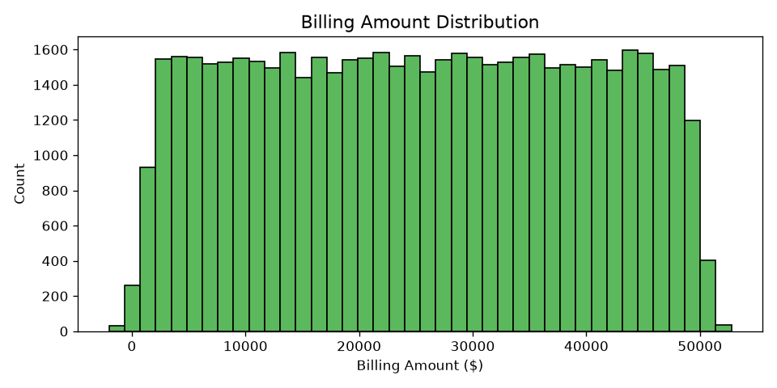
Figure: Billing Amount Distribution

7.4 Length of Stay
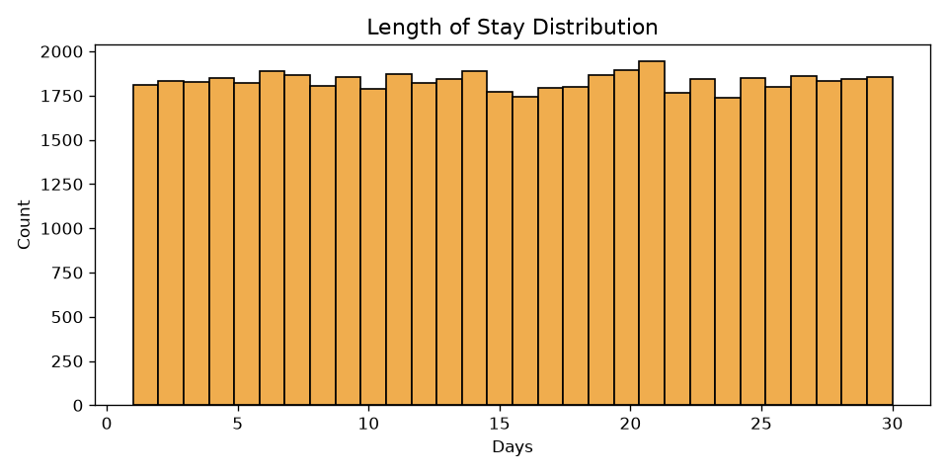
Figure: Length of Stay Distribution

7.5 Correlation Heatmap
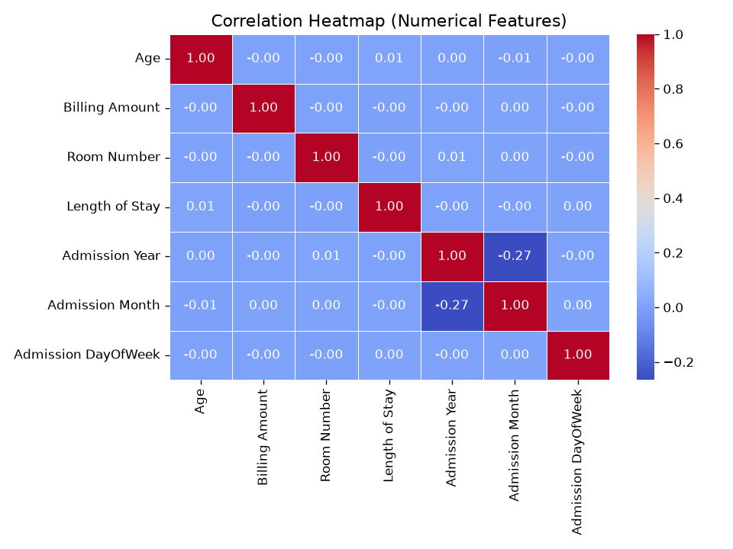
Figure: Correlation Heatmap of Numerical Features

7.6 Admissions Over Time
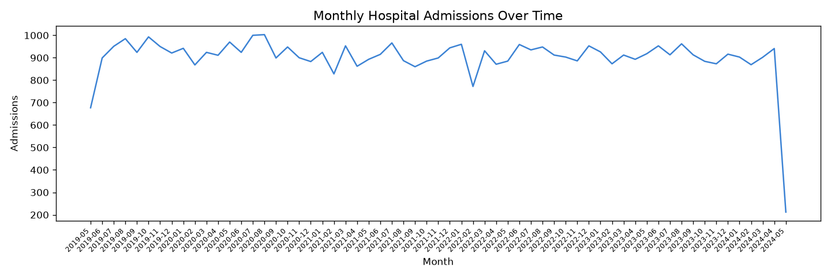
Figure: Monthly Hospital Admissions Over Time

8. Machine Learning Methodology
The following methodology was adopted:
- Problem Type: Multiclass Classification (3 classes)
- Train/Test Split: 80% training (43,972 records) / 20% testing (10,994 records)
- Stratified split to preserve class proportions
- Preprocessing: ColumnTransformer inside Pipeline (no data leakage)
- Four models trained independently on the same train split
- All models evaluated on the same held-out test split
- Best model selected by F1-Score (weighted average)

8.1 Models Trained
Model | Rationale
Logistic Regression | Strong linear baseline; interpretable; fast to train
Random Forest | Ensemble of decision trees; handles non-linearity well; provides feature importance
Gradient Boosting | Sequential boosting; typically high accuracy on tabular data
HistGradientBoosting | Histogram-based boosting; handles larger datasets efficiently

9. Model Evaluation
Model | Accuracy | Precision | Recall | F1-Score | ROC-AUC
Random Forest | 0.4263 | 0.4266 | 0.4263 | 0.4261 | 0.6313
HistGradientBoosting | 0.3413 | 0.3416 | 0.3413 | 0.3389 | 0.5163
Gradient Boosting | 0.3333 | 0.3334 | 0.3333 | 0.3325 | 0.5018
Logistic Regression | 0.3326 | 0.3330 | 0.3326 | 0.3304 | 0.4979

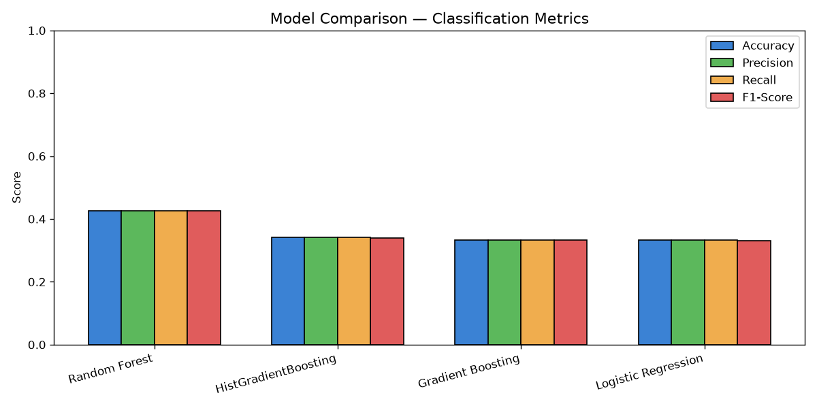
Figure: Model Comparison Chart

10. Final Model Selection
Selected Model: Random Forest Classifier
Reason: Random Forest achieved the highest Accuracy (42.63%), highest F1-Score (42.61%), and highest ROC-AUC (0.6313) on the held-out test set. It outperforms all other models across every metric. Additionally, it provides feature importance scores for interpretability.

Confusion Matrix
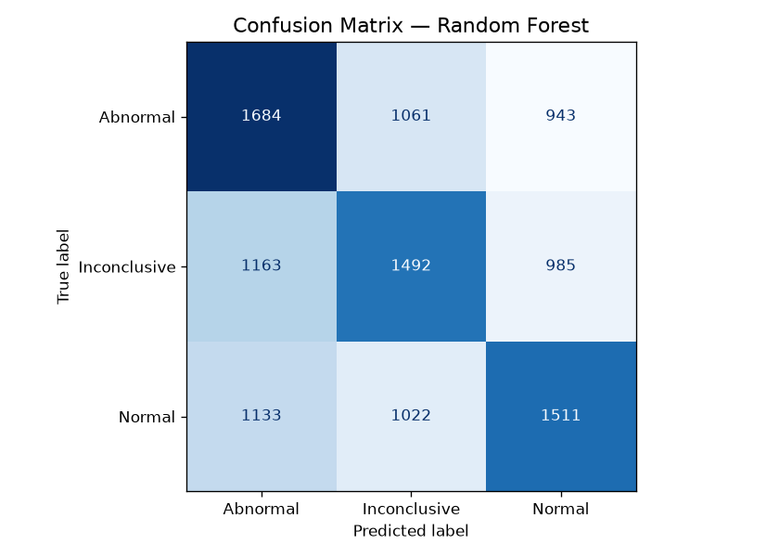
Figure: Confusion Matrix — Random Forest

Feature Importance
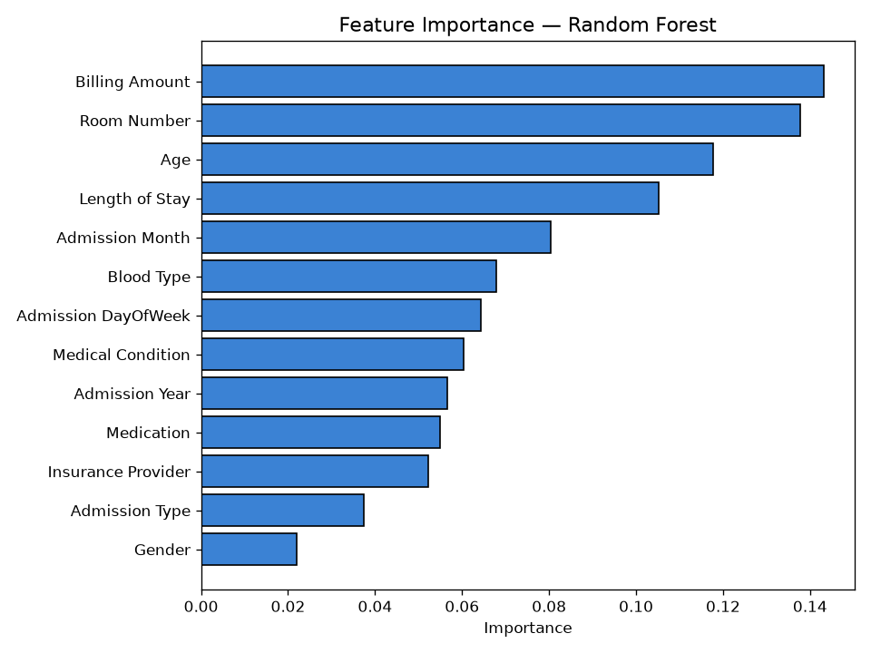
Figure: Feature Importance — Random Forest

The top predictive features are Billing Amount, Age, Length of Stay, and Room Number. These numerical features carry more signal than categorical ones in this dataset.

11. Interactive Frontend
An interactive Streamlit web application was developed as the user-facing interface for the model. The application provides four pages:
- Home & Dataset Info — overview metrics, data preview, class distribution
- Predict Test Result — form-based input for all 13 features with real-time prediction
- EDA Visualizations — interactive exploration of the dataset
- Model Performance — comparison table, confusion matrix, feature importance

Run Command: streamlit run frontend/app.py
Access URL: http://localhost:8501

12. Sample Predictions (from Saved Model)
Predicted | Actual | Match
Normal | Normal | Correct
Inconclusive | Abnormal | Wrong
Abnormal | Normal | Wrong
Inconclusive | Inconclusive | Correct
Abnormal | Abnormal | Correct

13. Results
Metric | Value
Best Model | Random Forest Classifier
Test Accuracy | 42.63%
Precision | 42.66%
Recall | 42.63%
F1-Score (wtd) | 42.61%
ROC-AUC (OvR) | 0.6313
Training Records | 43,972
Test Records | 10,994

14. Conclusion
This project successfully demonstrates a complete end-to-end machine learning pipeline applied to a healthcare classification problem. Four models were trained and compared; the Random Forest model was selected as the best performer. The ~43% test accuracy, while modest in absolute terms, represents a meaningful improvement over the 33.3% random baseline for a balanced three-class problem.
The moderate performance reflects an inherent limitation of the dataset: it is synthetically generated, and the available features (demographics, medications, insurance type) have limited predictive power for determining clinical test outcomes. Real-world clinical data with actual lab values and vital signs would be expected to yield significantly higher accuracy.

15. Future Scope
- Use real clinical datasets (e.g., MIMIC-III) with actual lab values for better predictions.
- Add vital sign features: blood pressure, heart rate, temperature.
- Apply feature selection techniques (RFE, SHAP) to reduce noise.
- Experiment with XGBoost, LightGBM, and deep learning models.
- Hyperparameter tuning using Optuna or GridSearchCV.
- Deploy the application to Streamlit Cloud or containerize with Docker.
- Integrate with hospital information systems (HIS) for automated predictions.
- Implement model monitoring and retraining pipelines.

16. Technologies Used
Technology | Version | Purpose
Python | 3.9+ | Primary programming language
pandas | ≥1.5 | Data loading and manipulation
numpy | ≥1.23 | Numerical operations
matplotlib | ≥3.6 | Data visualization
seaborn | ≥0.12 | Statistical visualizations
scikit-learn | ≥1.2 | ML models, preprocessing, evaluation
joblib | ≥1.2 | Model serialization
Streamlit | ≥1.22 | Interactive web frontend
python-docx | ≥0.8 | Report generation
Jupyter | ≥1.0 | Notebook environment

17. References
- Pedregosa F. et al. (2011). Scikit-learn: Machine Learning in Python. JMLR 12, 2825-2830.
- Healthcare Dataset — Kaggle (Synthetic Dataset for Educational Purposes).
- Breiman, L. (2001). Random Forests. Machine Learning, 45(1), 5-32.
- Friedman, J. H. (2001). Greedy Function Approximation: A Gradient Boosting Machine. Annals of Statistics.
- McKinney W. (2010). Data Structures for Statistical Computing in Python. Proceedings of SciPy.
- Streamlit Documentation — https://docs.streamlit.io/
- Matplotlib Documentation — https://matplotlib.org/
- Seaborn Documentation — https://seaborn.pydata.org/

Healthcare Test Results Prediction | Data Analytics & ML Project

