SETTING UP THE COMPILER
Originally Written By Sevensins
Additions by Arkanis

Introduction

There have been a lot people who have been interesting in coding and modding for Soldier Of Fortune 2, but a great deal have had trouble trying to set up the Soldier Of Fortune 2 compiler – this is where this tutorial comes in. Originally written by Sevensins as a tutorials on the Raven forums (http://forums.ravensoft.com/ib/ikonboard.pl?act=ST;f=4;t=3), this information has been compiled, with some additions, into a handy document.

Getting Started

Before you start coding you are going to need the latest Soldier Of Fortune 2 SDK, Software Development Kit. This SDK contains all the necessary files and documentation to get you on the right track when developing SOF2 mods. The SDK can be downloaded from most Soldier Of Fortune related sites, like www.planetsoldier.com or www.sof2files.com. Once you have downloaded and installed the SDK, you are set to rock and roll.

What Is A .qvm File?
This is what your code should be compiled into. Raven has provided the compiler in the SDK. This file type, compiler, and interpreter was created by Id software as an alternative to window's dll's. qvms, which allows for platform independence.

Setting Up The Compiler
If you try to compile the code without having set up the compiler correctly, you will most likely get an error similar to this:
sof2lcc: cpp: No such file or directory
This simply means that Windows can't find the cpp.exe file which is used for compiling code. This is very simple to fix - you just need to set your .exe path:

If You Are Using Windows 9x/ME:
Open up your autoexec.bat file with Notepad and look for a line similar to this:
SET PATH=C:\WINDOWS;c:\windows;c:\windows\COMMAND
You will need to add the path to your /bin dir of the mod SDK to the end of this path. It would look something similar to this:
SET PATH=C:\WINDOWS;c:\windows;c:\windows\COMMAND;c:\sof2mpsdk\bin
Note that the paths are broken by semi-colons
If you don't have the above line in your autoexec.bat, then you will have to add it.

If You Are Using Windows NT/2000/XP:
Right Click on ‘My Computer’ and go to Properties, then click the Advanced tab; Click Environment Variables (at the bottom).

In the system variables list, find the variable called "path"; select it and click edit.

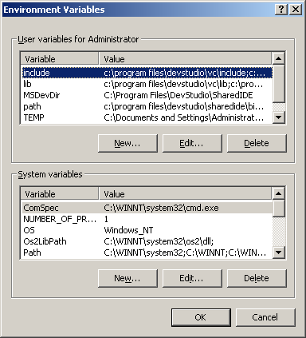 | 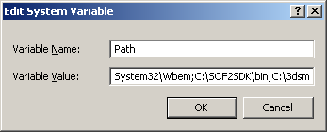
In the variable value box, go to the very end of the line and add the path to your /bin dir of the mod SDK. Something like this
;c:\sof2mpsdk\bin
Note the semicolon which separates each entry.
Ok, you'll need to restart after you do this for the changes to take effect. That should allow you to compile; run one of bat files to test it.

Adding New Files To Be Compiled

Generally it is a good rule when coding to put any new functions and code into new files, rather than adding all this to the existing files. If you decide to do this, you will need to learn how to add these new files to your compiler - currently the SDK is only set up to compile the standard files.

You'll need to edit the .bat files so that your new file is compiled with the existing files. Obviously, you'll need to edit the one that goes with which code you have added (ie cgame, game, ui).
game.bat looks a little like this:
%cc% ../g_active.c
@if errorlevel 1 goto quit
%cc% ../g_antilag.c
@if errorlevel 1 goto quit
%cc% ../g_bot.c
@if errorlevel 1 goto quit
%cc% ../g_client.c
@if errorlevel 1 goto quit
Just add your new file in the same way as the others to the end of the list.
Once you have added the new file names to the .bat file, you also have to add the filename to the q3asm file so it will go through the assembler. In each of the code section there is a q3asm file, ie game.q3asm, cgame.q3asm etc:

game.3asm looks a little like this:

-o "sof2mp_game"

g_main
ai_main
ai_util
ai_wpnav
bg_gametype
...
...
q_shared
You should be able to open these q3asm files with any text editor. After you open them up, you'll notice all the different files for that part of the code. Just add yours to the bottom in the same manner as the other ones. This file is rather long, so for obvious reasons the entire contents of the file has not been shown above.

Running Your Mod

Ok, so now you have your qvm's compiled...what do you do with them?
The qvm's should have been placed automatically by the compiler into the base/vm dir in the mod SDK directory.
You'll need to create a folder for your mod in the main sof2 dir. I'll use the example ‘mymod’. You would have c:\program files\sof2dir\mymod.
There are two ways to place the qvm's in that directory:
1) You can pull the /vm dir and place it into your mod directory. However, this way means that any server that is run is a unpure server.
c:\program files\sof2dir\mymod\vm\[all your qvm's]
you should set, +set sv_pure 0 , in the shortcut command line; if you do it this way.
2) Or you can put the /vm dir in a pk3 file. A pk3 file is just a .zip file renamed. To do this, just zip the vm dir with your program of choice and rename it to .pk3. Make sure that qvm files are in the /vm path inside the .pk3/zip file. After you do that, just place the .pk3 file in your mod directory.
c:\program files\sof2dir\mymod\vmfiles.pk3
Now to run your mod, you should create a new shortcut to the sof2mp.exe file and add this to the command line: +set fs_game mymod Where mymod = your mod directory name.

Alternatively you can make a .bat file like the one below to execute you mod:

cd..
start sof2mp +set fs_game mymod

To make a .bat file simple use notepad, paste the contents above into the file and save the file with the .bat extension. The example above must be executed from within the ‘mymod’ directory.

File Prefixes

q_ - These files contain essential parts to all the code, ie client, server, ui, and even engine. For q3 modding, it was good practice to not modify these files at all, because it usually ended up in strange problems. Its probablly the same with sof2, just a warning.
bg_ (both game)- These contain code that is visible to client and server. If you change anything to these, you'll most likely need to compile both client and game code.
g_ (game)- These files contain code only visible to the server, the client code cannot use things defined within them.
cg_ (cgame) - These files contain code only visible to the client, the server code cannot use things defined within them.
ui_ - These files, of course, are code for the user interface (ie hud, menus). This code works with the .menu script files.
gt_ - These are gametype files. These files are where the events from the .gametype scripts are handled.
Conclusion

Setting up the compiler can be a daunting task if you are new to coding and mod making, but hopefully this tutorial has given you enough information to get you over this hurdle and onto making some great mods.

Legal Notice

The author/s of this tutorial accept no responsibility for damage to data, or physical damage
to hardware, caused by the appropriate or inappropriate use of the information in this tutorial. It is deemed that users who attempt to follow this tutorial, are automatically considered as having read and understood this liability clause before attempting the said tutorial.

