DATA DESCRIPTOR

The EBRAINS Data Descriptor complements data shared through [EBRAINS. A rich data descriptor improves the comprehension of your data and increases the chances of reuse.](https://search.kg.ebrains.eu/) **Please fill in all sections.** You may use tables and figures (with captions) for improved readability where you see fit. References should follow the standard [Nature referencing style](https://paperpile.com/s/nature-citation-style/).

## TITLE

Cerebellar Neuropixels recording and whisking tracking in mice during downregulation of cerebellar Golgi cells

## AUTHORS

Ensor Rafael Palacios12, Conor Houghton2, Paul Chadderton1

### AFFILIATIONS

1. School of Physiology Pharmacology and Neuroscience, University of Bristol, University Walk, Bristol,

UK. BS8 1TD

2. School of Engineering Mathematics and Technology, University of Bristol, Woodland Road, Bristol,

UK. BS8 1UB

### CORRESPONDING AUTHOR(S):

Ensor Rafael Palacios: [ensorrafael.palacios@bristol.ac.uk](mailto:ensorrafael.palacios@bristol.ac.uk)

## SUMMARY

This dataset originates from an experiment aiming to investigate neuronal representations in the lateral cerebellar cortex of whisking behaviour in mice during normal and reduced Golgi cell inhibition. The experiment involved concomitant Neuropixels I recording of lateral cerebellar cortical activity and high-speed camera recording of spontaneous whisking in head-fixed mice. Downregulation of Golgi cell inhibition was achieved after a baseline recording period via CNO-mediated activation of inhibitory DREADDs (designer receptors exclusively activated by designer drugs, hM4Di), selectively expressed by Golgi cells in this brain region.

The dataset includes electrophysiological, behavioural and imaging data obtained from hM4Di-expressing/control (C57BL6J) mice who were administered CNO/phosphate buffered saline (PBS). Electrophysiological data are processed data that have undergone a spike-sorting step, necessary to identify clusters of spikes belonging to the same neuron from raw extracellular recording traces. Available whisking information consist in processed data informing about the position of user-specified whisker landmarks obtained from the raw video recordings. Imaging data include images from cerebellar coronal slices acquired with a confocal fluorescent microscope, used to determine the location of the recording and the expression of hM4Di receptors. Additionally, the dataset also includes Neuropixels recordings from three separate mice who were administered Muscimol to control for drug diffusion in the cerebellar cortex.

## VERSION SPECIFICATIONS:

This is the first version of this dataset. It includes neuronal, behavioural and imaging data from 17 animals; please see the table in the data records section for more details. Additionally, the dataset includes 3 electrophysiological recordings (from 3 mice) where Muscimol was used in place of CNO/PBS.

## MATERIALS AND METHODS

In this study, we recorded both (i) population activity in the lateral cerebellum using NeuroPixels I probes and (ii) whisker position with a high-speed camera in head-fixed mice, while manipulating Golgi cell inhibition. In particular, a subset of recordings was performed in animals that selectively expressed inhibitory DREADDs (designer receptors exclusively activated by designer drugs) in Golgi cells; localised expression of DREADDs was achieved via injection of the AAV-DIO-hM4D(Gi)-mCherry virus in GlyT2-Cre mice expressing Cre-recombinase only in Golgi cells in the cerebellar cortex (Kakizaki, 2017). In these mice, it was possible to reduce inhibition in the granular layer by activating DREADDs with an exogenous drug (Clozapine N-oxide; CNO) applied topically on the recording site. All surgical procedures and recordings were performed in mice (both males and females) aged between 3 to 6 months.

**- Surgical operation**

Mice were anaesthetised for all surgical procedures. Mice were placed in an induction chamber, into which 5% v/v isoflurane (Harvard Apparatus Ltd) was administered via inhalation using oxygen (1.2–1.6 L/min). Once anaesthetized the concentration of isoflurane was lowered to 1–2% v/v to maintain anaesthesia for the duration of the surgery. The body temperature of the mouse was maintained at 37 ± 0.5 °C using a homeothermic heat mat (DC Temperature Control System, FHC). Corneal drying was

prevented using an ocular lubricant (Lacrilube, Allergen). To induce analgesia, mice were injected subcutaneously with carprofen (Rimadyl, 5 mg/kg), buprenorphine (Vetergesic, 0.1 mg/kg) and lidocaine (2 mg/kg, locally). Surgery was carried out in a stereotaxic frame under aseptic conditions to prevent infections. After surgery, mice were placed in a warmed box (~37°C) and allowed to recover for as long as required. Mice were then returned to their home cages and monitored closely for at least 24 hrs.

GlyT2-Cre mice underwent two surgical operations: one to transduce cre-dependent expression of DREADDs in cerebellar Golgi cells via viral injection, and one to prepare the animal for head-fixed extracellular recording. During the first surgical session, a small craniotomy (~1 mm diameter) was performed over Crus 1 (6.36 mm posterior and 2.5 mm lateral of Bregma). AAV9-hSyn-DIO-hM4D(Gi)-mCherry (500-1000 nl) was injected with a glass pipette at different depths (starting at 600μm retracting to surface in steps of 100μm), waiting 2 minutes between pipette retractions. At the end of the operation, skin over the head was sutured and animal was allowed to recover. The second surgical session took place 8 weeks later to enable ample expression of the DREADD receptor protein. First, neck muscles were gently moved to uncover the cerebellum. A custom-made head implant was fixed to the exposed cranium using tissue glue (Histoacryl, Braun Corporation) and dental cement (Associate Dental Products Ltd). A small craniotomy (~1.5 mm diameter) was performed over the right cerebellar hemisphere, the dura was removed, and a reference screw was inserted in contact with the underlying brain. To secure both head place and reference screw, dental cement (Associate Dental Products Ltd) was used to cover the skull, sparing a recording well above Crus 1 of the left cerebellar hemisphere. A second craniotomy (~2 mm diameter) was performed over left Crus 1, and the dura was removed. Finally, a layer of agarose (1.5% in phosphate buffered saline; PBS) was used to cover the brain, a layer of Kwik-Seal was used to protect the brain, and a layer of nail polish was used to fix the Kwik-Seal. Wild-type mice underwent only the second surgical operation in preparation for recordings. All mice had their whiskers trimmed on the left (recording) side, preserving whiskers C1, C2 and C3 (posterior whiskers on the third row from top).

**- Electrophysiological and video recordings**

Mice were head-fixed in the recording apparatus in preparation for electrophysiological recording. The Kwik-Seal was removed, the surface of the brain was cleaned from agarose and kept moist with PBS. NeuroPixels probes were fixed to a micromanipulator (IVM, Scientifica) via a custom-made 3D printed holder. Each probe was coated with DiI stain (2.5 mg/ml) for ex vivo probe tracking before insertion at an angle perpendicular to the cortical surface. The probe was advanced into the cortex at a speed of 2-5 μm/s to a depth of 2500-3000 μm. Thereafter the probe was retracted for ~100 μm and left to settle for 10-15 min, allowing the brain to relax. Under infrared light illumination, whisker movements were filmed with a high-speed camera (Genie HM640; Teledyne Dalsa Inc, USA) operating at 299 frames per second. Video acquisitions were controlled by Streampix 6 software (Norpix, Canada). The open-source software spikeGLX 3.0 (https://billkarsh.github.io/SpikeGLX/) was used to record NeuroPixels data at 30 kHz. Video and electrophysiological recording were synchronised by a TTL pulse originating from the video software. In chemogenetic experiments, a baseline of 10 or 20 min was recorded prior to topical administration of CNO (30 μM), delivered to the recording well. In a subset of the recordings PBS was administered instead. Previously Stachniak et al., 2014 showed that intracranial injection of 1 μM CNO is already sufficient to reliably inhibit presynaptic neurotransmitter release within minutes. After CNO or vehicle delivery, electrophysiological recordings continued for a further 40-50 mins, for a total recording time of 1 hour. Animals underwent two recording sessions, the first performed at least 4 hours after recovery from the craniotomy, the second on the following day. After recording, the probe was extracted, rinsed with deionised water and left in freshly made 1% tergazyme solution for at least 24 hours. After the first recording, the exposed brain surface was first rinsed with PBS, then covered with agarose, and finally protected with a layer of Kwik-Seal that was fixed to the surrounding dental cement with nail polish. Mice were returned to their cage. After the second recording session, mice were humanely killed.

**- Electrophysiological data processing**

Output files (.imec) were preprocessed using the command-line tool CatGT (https://billkarsh.github.io/ SpikeGLX/#catgt) to apply a high pass filter (cut-off 300 Hz) and global demux filters, a common average referencing that takes in account the probe channels subgrouping during data acquisition. Spike sorting was conducted using the open-source software Kilosort 2 (https://github.com/MouseLand/ Kilosort) to

group spikes into units, each representing the activity of a distinct putative neuron. Manual curation of sorted units was done with the open-source Python-library Phy2 (https://github.com/cortex-lab/phy), and consisted in merging and splitting units, as well as categorising them into ‘good’, ‘bad’ and ‘mua’ (multiunit activity) units.

**- Video processing and behavioural analysis**

Video output (.avi) files were transcoded (.mp4, libx265 encoder), re-sampled at 299 Hz) and cropped using the ffmpeg software. We used the open-source toolbox DeepLabCut (https://github.com/DeepLabCut/DeepLabCut) to label four landmarks on whiskers C1, C2 and C3 (Figure 1a) across the entire recording; these landmarks were then used to compute whisker position.

**- Histology**

Brains were extracted and left in 4% PFA solution for 24-48 hours at 4°C. After washing with PBS, cerebellar coronal sections (50-100 μm) were sliced using a vibrating microtome (Leica VT1000S). Fluorescent images were acquired using a confocal microscope (Leica DM4000 B).

## USAGE NOTES

## These data can be used to investigate how cerebellar cortical dynamics encode spontaneous whisking activity in mice, and how these representations change during manipulation of network dynamics induced by decreased levels of Golgi cell inhibition. Thus, it offers an opportunity to investigate the functioning of the cerebellar-behaviour loop at a millisecond scale during normal and altered network dynamics.

## Animals were administered either CNO or PBS; information about the length of the baseline recording can be found in the table in the data records section.

## The electrophysiological data provided have been manually processed using the open-source Python-library Phy2, and they include neither the raw data nor the output of Kilosort 2 (because of their size). Thus, the use of these data will be influenced by subjective decisions made by the curator during the manual curation step. Please refer to the docs (<https://phy.readthedocs.io/en/latest/terminology/>) for a definition of these data.

## The behavioural data provided are the output of the open-source toolbox DeepLabCut, which uses the HDF5 file format to preserve the hierarchical structure of the data. In particular, there are 12 landmarks, 4 for each whisker, that run from `bodyparta1’ to `bodypart12’ (see figure below). Analysis of various whisking properties using these data can be done following Hill, 2011. In some recordings (see table in the data record section, labled as ‘poor’ whisking), the quality of the whisking data is poor, due to the sparseness of spontaneous whisking; we thus recommend to exclude these recordings from analyses of whisking behaviour.

## 

## Imaging data consist of .lif files that can be opened with fiji (<https://imagej.net/software/fiji/>). They include both bright field as well as fluorescence images that can be used to judge the position of the probe in the cerebellum and relative to the expression of hM4Di receptors for GlyT2-Cre mice injected with AAV-DIO-hM4D(Gi)-mCherry virus.

## Mice who were administered muscimol were only used as a control for drug diffusion in the cerebellar cortex; that is, electrophysiological data from these mice can be used to check the dynamics of temporal decay of population activity after administration of Muscimol. Neuropixels data from these mice were processed using Kilosort 3, instead of Kilosort 2 as for the other recordings, but this should not impact the analysis these data are designed for.

## As a final note, recordings aimed at targeting the cerebellar cortex, but often the Neuropixels probe penetrated deeper in the cerebellum, reaching for example the cerebellar nuclei. Thus, in order to focus the analysis on cerebellar cortical units, one can use the `cortical depth’ information in the table below, which informs about the depth of the probe above which it is safe to consider units as belonging to the cerebellar cortex. The `cortical depth’ information was obtained by considering the position on the probe of the deepest unit that matched the signature spike autocorrelogram and waveform characteristics of a Purkinje cell complex spike, as visualised with the Phy2 gui. Additinally, we also evinced the `cortical depth’ from visual inspection of the imaging data combined with information about the clusters distribution on the probe observed with the Phy2 gui.

## DATA RECORDS

1. Reduced generic layout of the file repository structure

*/media/bunaken/Ensor/*

*npx/ * contains all electrophysiological data (output of Phy2) as .npy, .tsv, .meta, .py files*

*CNO/Drop/ * data for GlyT2-Cre mice who were administered CNO/PBS, as well as data for C57BL6J (control) mice who were administered CNO*

*Muscimol/ * data for C57BL6J mice who were administered Muscimol*

*WT/ * data for C57BL6J mice who were administered PBS*

*videos/ * contains all behavioural data (output of DeepLabCut) as .h5 files*

*CNO/Drop/ * data for GlyT2-Cre mice who were administered CNO/PBS, as well as data for C57BL6J (control) mice who were administered CNO*

*WT/ * data for C57BL6J mice who were administered PBS*

*imaging/drop/ * contains all imaging data (output of Leica DM4000B) as .lif files*

*2. Table of file formats and softwares used to create them*

|  |  |  |
| --- | --- | --- |
| **Format** | **Extension** | **Software used / file specification** |
| Tab-Separted Value | .tsv | Generated by Phy2 |
| Numpy array | .npy | Generated by Phy2 |
| medadata | .meta | Generated by CatGT |
| Hierarchical data format (HDF5) | .h5 | Generated by DeepLabCutg |
| Leica Image File | .lif | generated by the confocal microscope (Leica DM4000 B) |
| Python Script | .py | Generated by Kilosort 2/3 |

3.1 Table electrophysiology/behavioral/imaging data

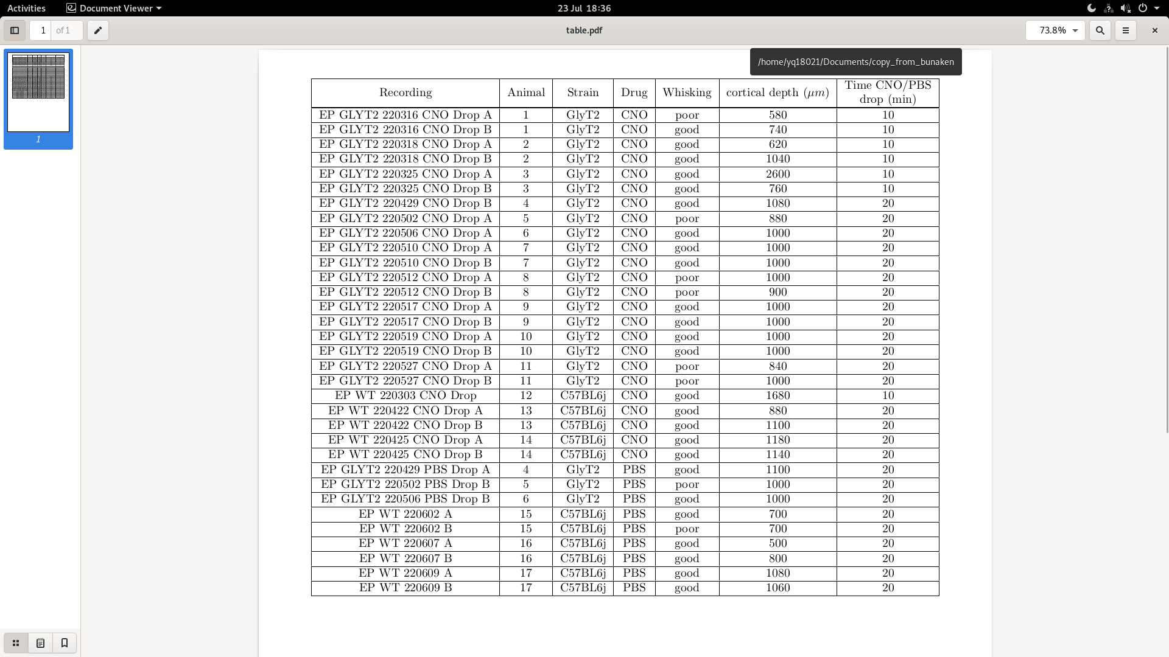

3.1 Ta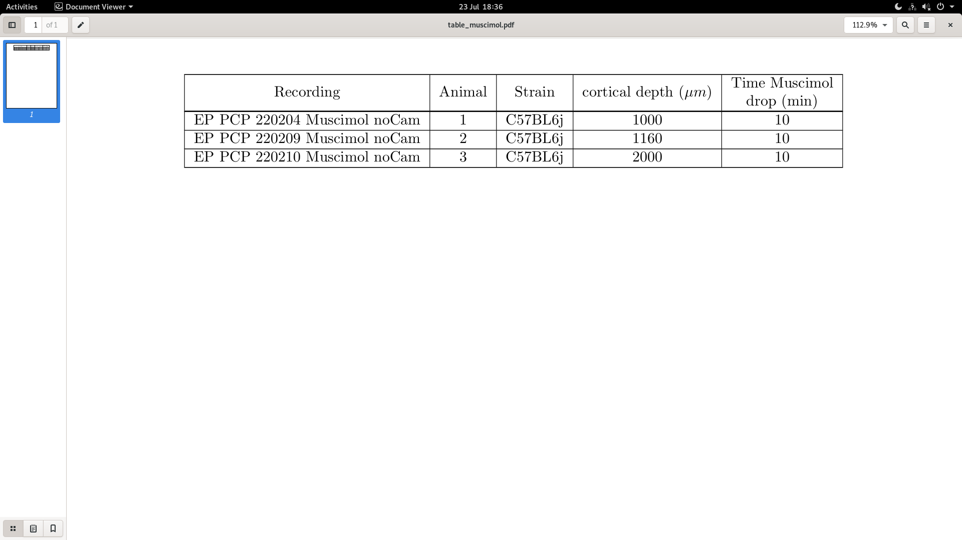ble electrophysiological data (Muscimol)

## Acknowledgements

This work was supported by a Wellcome Trust Neural Dynamics PhD studentship to ERP, Leverhulme Research Fellowship (RF-2021-533) to CH and Wellcome Trust Investigator Award (209453/Z/17/Z) to PC.

## Author contributions

ERP, CH and PC designed the experiments. All experiments were performed by ERP. Data was analysed and interpreted by ERP, CH and PC. The authors declare no

competing interests.

## REFERENCES

Hill, D. N., Curtis, J. C., Moore, J. D., & Kleinfeld, D. (2011). Primary motor cortex

reports efferent control of vibrissa motion on multiple timescales. Neuron, 72(2),

344-356.

Stachniak, T. J., Ghosh, A., & Sternson, S. M. (2014). Chemogenetic synaptic

silencing of neural circuits localizes a hypothalamus-->midbrain pathway for

feeding behavior. Neuron, 82(4), 797-808.

Kakizaki, T., Sakagami, H., Sakimura, K., & Yanagawa, Y. (2017). A glycine transporter 2-Cre knock-in mouse line for glycinergic neuron-specific gene manipulation. IBRO Rep, 3, 9-16.