COAL_A_p200165_R4
In the Lab four we have studied about the direct, indirect, register offset addressing, branching conditions and many other conditions.

- Direct Addressing:
Direct Addressing is that we directly use variables(labels) for addressing and access the value using that labels.
2. Indirect or Register Based Addressing:
In Indirect addressing we move the address of labels into our register and use the registers to access different values from registers.
3. Register + Offset Addressing:
Different combinations of direct and Indirect addressing are used.
Example1
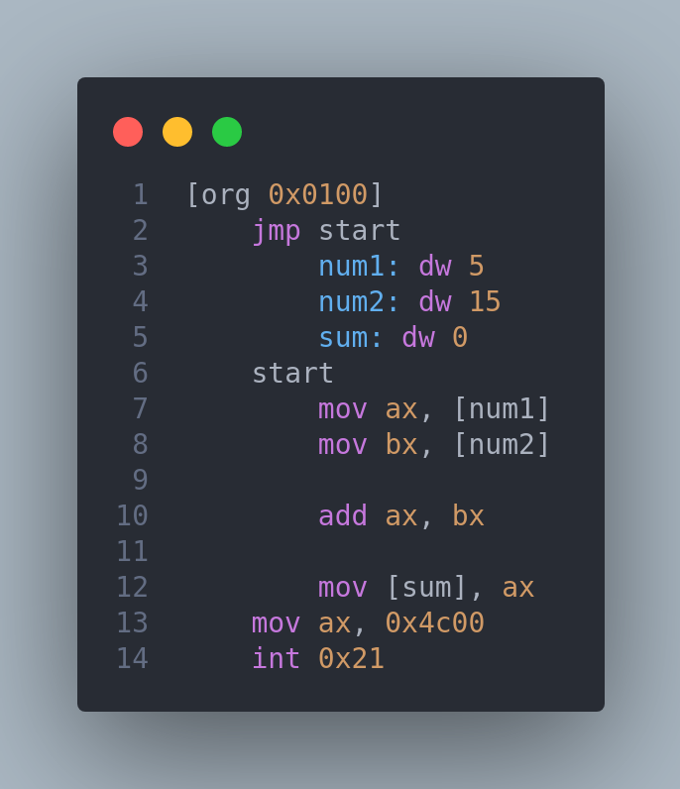
jmp instruction will jump the given address. Jmp is called unconditional jump. This is the example of direct addressing.
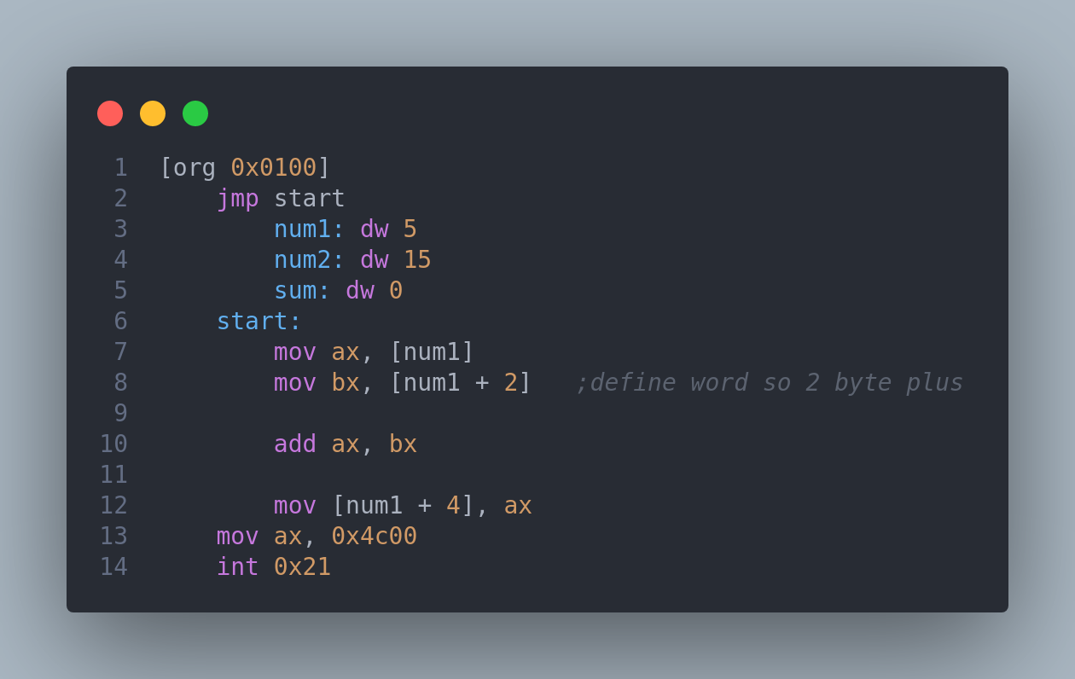
Example2
dw mean define word(2 bytes allocated in memory).
Example3:
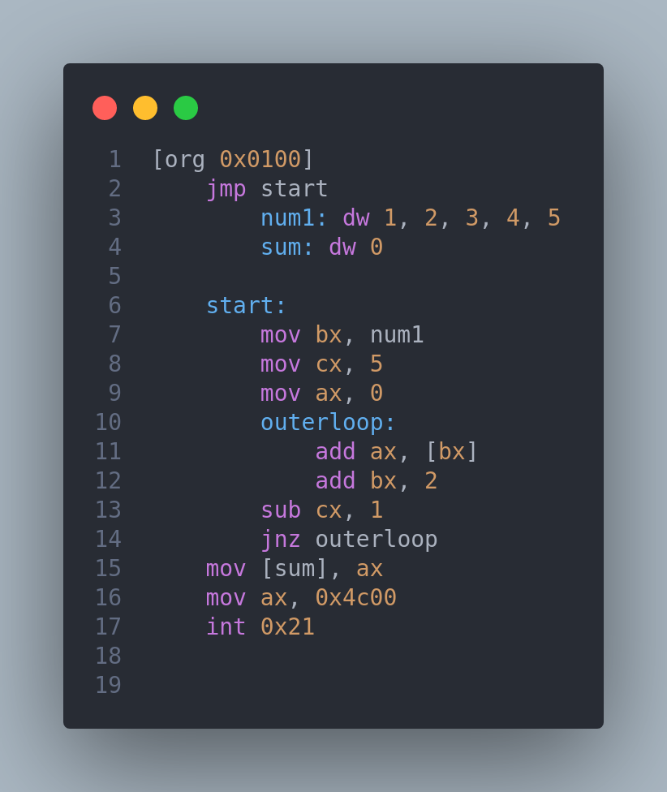
jnz means that if zero flag is not set then jump to the given address. In this we have created the loop using the jnz instruction. This loop will run for 5 times because the cx(counter register) is 5. When cx react to 0 loop will exit. At each iteration all numbers will be added to ax register and at outside the loop the result moved from ax to sum label.
Example4:
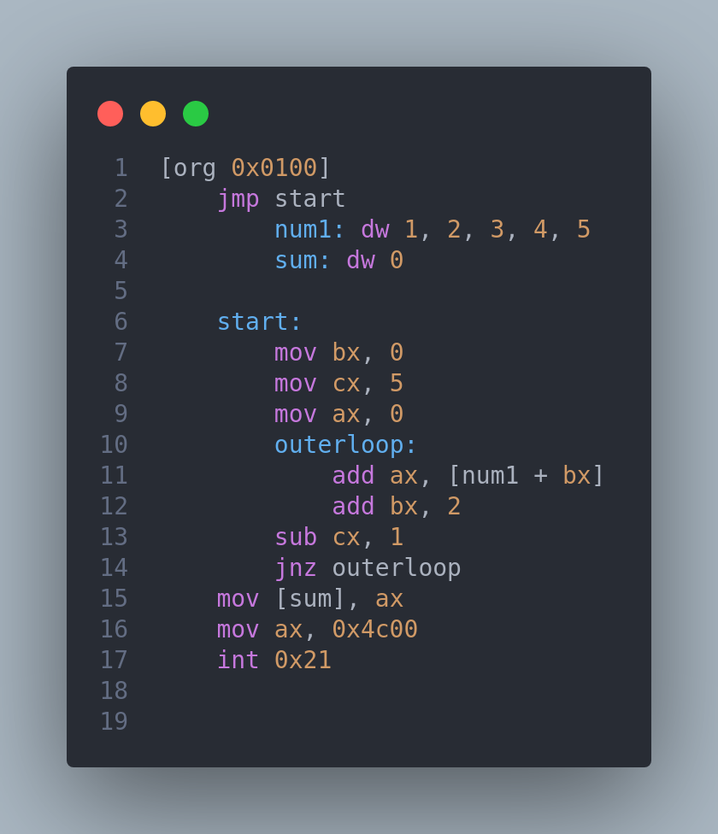
This will work same as upper loop. The difference is that we are using direct addressing in this.(Label is used to get data from Ram)

____________________________________________________________________

