COAL_A_p200165_R10
- Introduction:
In Lab NO 10 we have studied about Code Segment(CS), Data Segment(DS) and Printing. Whatever we have done now we have not printed anything screen. Now In Lab 10 we have learned about clear screen and printing some string on the dosbox console.
- Dosbox:
Dosbox have total 25 rows and 80 columns in the screen and total 80*25 = 2000 cells. The starting location of video memory is b800. Whatever we want to show on the screen we will write that data on to the video memory and that will be shown on the screen.
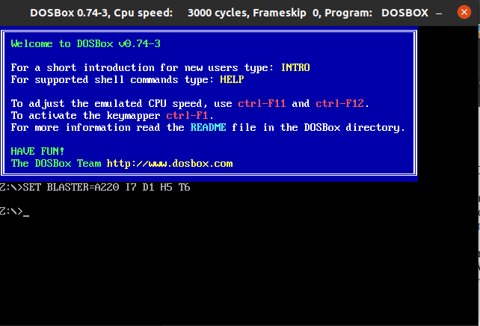

- Code No 1:
First of all we have learned that how will we clear our whole screen. The value of blank space is 20 and the value black background is 07 so what we have done is that we have filled all the video memory with these values and when we runed our program all screen will be cleared and all the existing data is removed from it.
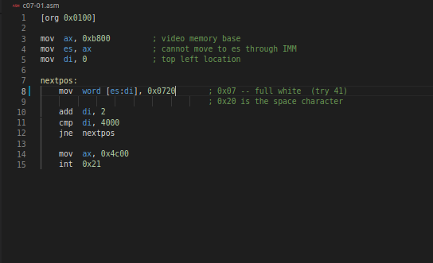
Here is the code [es:di] → mean that take es value add with it di value and go to given location and put 0x0720 to that location, 07 goes to first byte that is black background and 20 goes to another byte and in this way all screen of dosbox will be cleared.

- Code No 2:
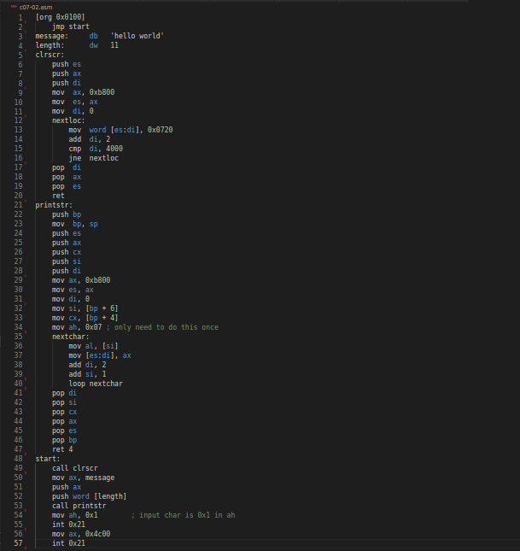
The next thing we have learned is printing string on screen. What we did is that we move all the character ascii value into the video-memory location where we want to print the string and that string will be shown on screen when we run our program. To Print anything on screen we need to move to video-memory location that data and that will be shown on screen.
- 1Kbyte = 1024bits
- CS = 2bytes = 16bits
- DS = 2bytes = 16bits
Name: Jawad Ahmed Roll No: 20P-0165 Section: 3A

