COAL_A_p200165_R11_12
Introduction:
In Lab No 11 and 12 we have a physical lab in which we have interacted with hardware by using our assembly code. We have coded for Atmega328P. Atmega328p is a single chip micro controller created by Atmel.
Atmega328 has 28 pins in total. It has 3 Ports in total which are named as Port B, Port C and Port D.
The Proteus is a proprietary software tool suite used primarily for electronic design automation. The software is used mainly by electronic design engineers and technicians to create schematics and electronic prints for manufacturing printed circuit boards.
You can draw any type of circuit on Proteus and you do not need to purchase all expensive gates for your circuit. It is great for beginners because working with physical circuits is risky and also this step is expensive.
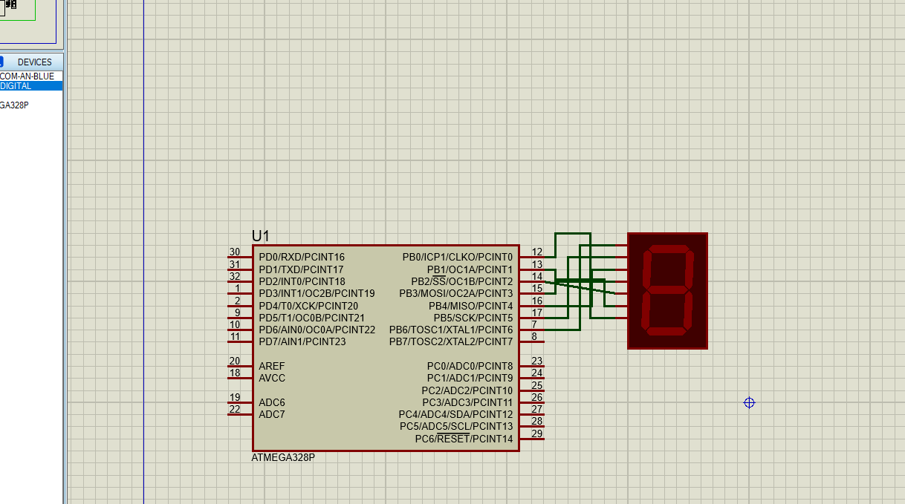
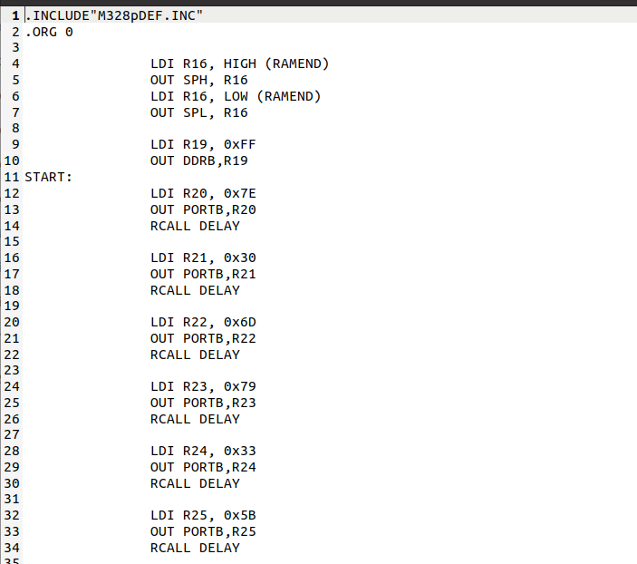
Code:

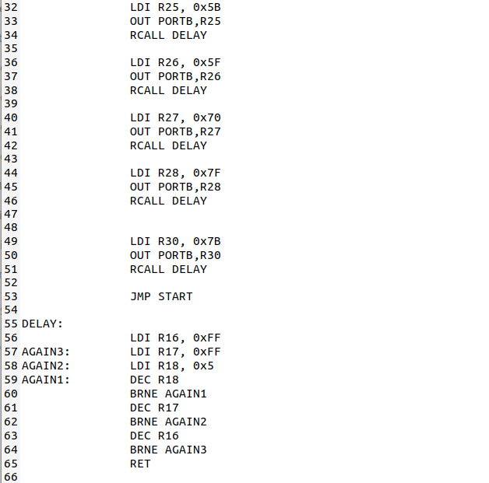

First of all we included the Library for which we are going to code. Like in our case we are going to code for ATMEGA328P so we included M328pDEF.Inc Library.
Then we have instruction that is “LDI” that means Load data in and it takes two operands. We gave loaded HIGH ramend in R16 and then putted that value in SPH stack pointer high after that we have loaded LOW ramend in R19 and moved that to SPL stack pointer.

Then our program starts, So first of all what Is over logic? We are going to produce 0 to 9 counting on the 7 segment display. Here is the 7 segment display.
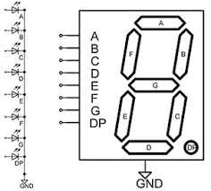
Diagram shows that If we want to display 0 then we have to provide 0 voltage to G LED and others A, B, C, D, E, F will be provided high voltage then zero will be displayed on 7 segment display.
Same if we want to display 1 then we have to on LED B and C and others will be provided 0 voltage.
Also I have given DDRB high voltage(ff) that mean this port will be treated as output port. Now all PB0 to PB7 all pins will be treated as output pins they will produce output.

Once I have written all this the light blinking is so fast so I have to make the Subroutine for delay so that light blinking can be seen.
Once all this done I have assembled my code there is no error In the code and hex file Is generated successfully and I have provided that hex file to the ATmega328p chip and once I have connected my 8 output pins (PB0 to PB7) to 7-segment we will see output from 0 to 7 on 7-Segment display.
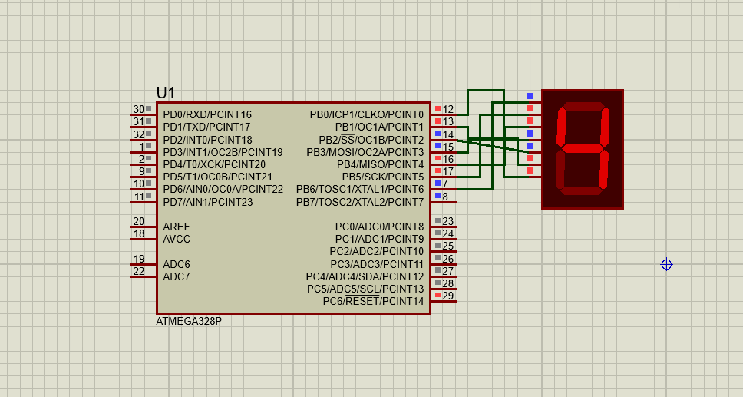

_______________________________________________________________________

Name : Jawad Ahmed
RollNO: 20P-0165
Section : 3A

