COAL_A_p200165_R13_14
Introduction:
In Lab No 13 and 14 we have done similar kind of work as we have doned in Lab No 11 and 12. In lab no 11,12 we have doned that on simulator but in lab 13,14 we have done that on physical hardware.
First of all what we have done is created hex file of our code that we have written in our lab 11 and 12 and then we have burned that code into Atmega328p chip.
Once that done we have connected with the hardware and connected output pins (Pb0 to Pb7) our eight output pins to 7 segment display and provided Ground and 5voltage to the chip.
Then we have Switched On the circuit the problem we faced is that we have connected common anode with the output pins but we have written code keeping in mind common cathode so what we have done we have changed our 7segment from common anode to common cathode and after that this worked fine and we are able to see digits displaying from 0 to 9 on 7 segment display.
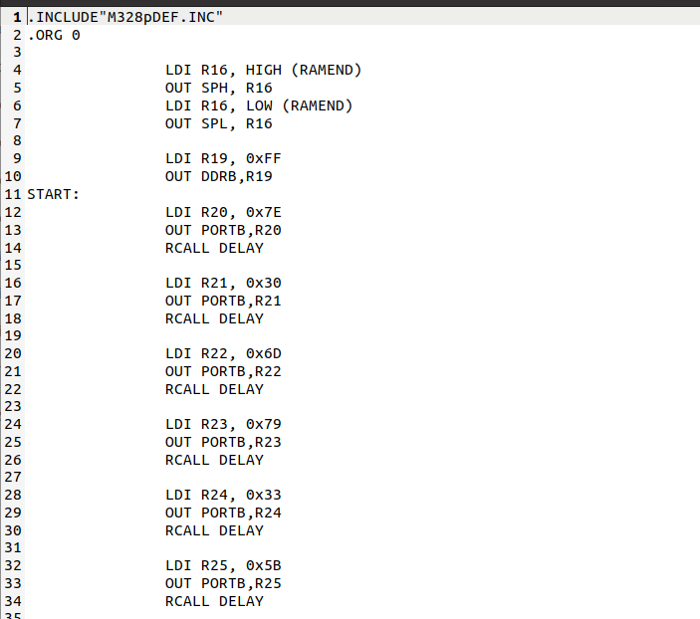
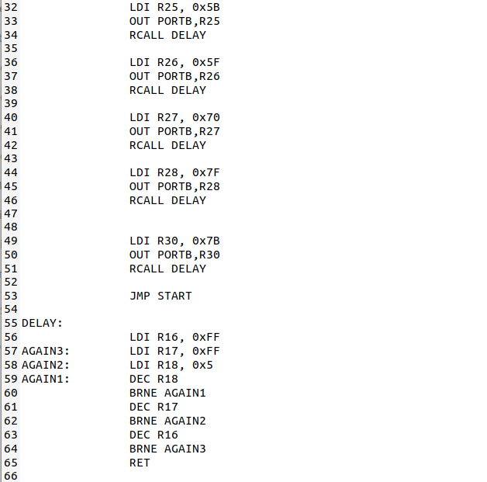

First of all we included the Library for which we are going to code. Like in our case we are going to code for ATMEGA328P so we included M328pDEF.Inc Library.
Then we have instruction that is “LDI” that means Load data in and it takes two operands. We gave loaded HIGH ramend in R16 and then putted that value in SPH stack pointer high after that we have loaded LOW ramend in R19 and moved that to SPL stack pointer.

Then our program starts, So first of all what Is over logic? We are going to produce 0 to 9 counting on the 7 segment display. Here is the 7 segment display.
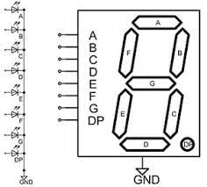
Diagram shows that If we want to display 0 then we have to provide 0 voltage to G LED and others A, B, C, D, E, F will be provided high voltage then zero will be displayed on 7 segment display.
Same if we want to display 1 then we have to on LED B and C and others will be provided 0 voltage.
Also I have given DDRB high voltage(ff) that mean this port will be treated as output port. Now all PB0 to PB7 all pins will be treated as output pins they will produce output.

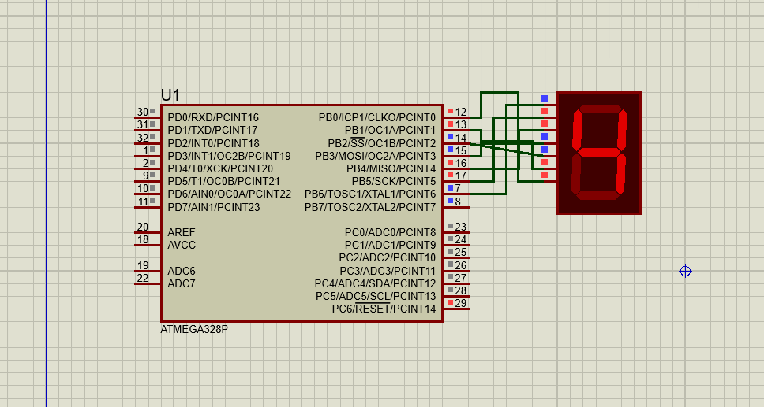

Same kind of circuit we have maked physically and same in this manner this is displaying the output.
_______________________________________________________________________
Name : Jawad Ahmed
RollNO: 20P-0165
Section : 3A

