Name : Jawad Ahmed

Roll No : 20P-0165

Section : BCS-5A

LAB NO 1

Computer Networks LAB

**Task1: Using Ipconfig retrieve TCP/IP information of your computer. Write down the following information:**

a) IP address

b) Subnet mask

c) Default gateway

Solution:

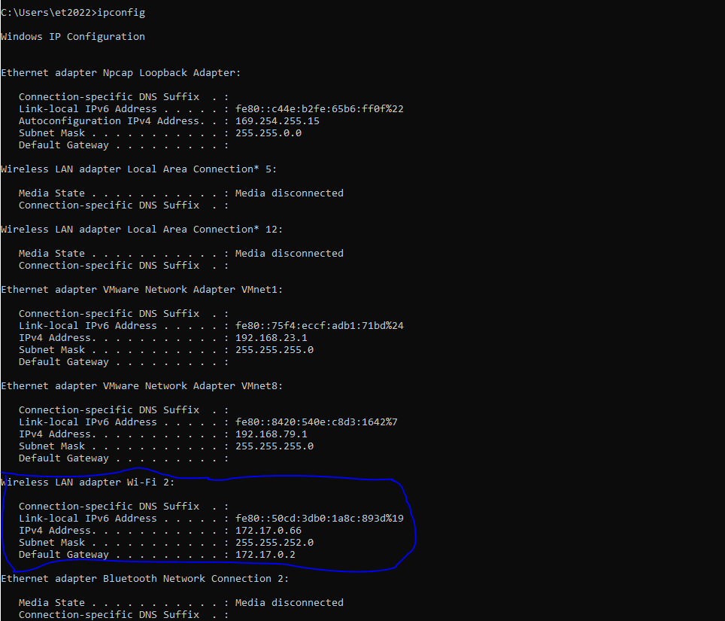

**IPv4 Address : 172.17.0.66**

**Subnet Mask : 255.255.252.0**

**Default Gateway: 172.17.0.0**

**Task2: Record a couple of IP addresses of your nearby hosts.**

**1: Wireless LAN adaptor Wi-fi:**

IPv4 Address: 172.17.0.78

Subnet Mask: 255.255.252.0

**2: Wireless LAN adaptor Wi-fi:**

IPv4 Address: 172.17.0.114

Subnet Mask: 255.255.252.0

**3: Wireless LAN adaptor Wi-fi:**

IPv4 Address: 172.17.0.156

Subnet Mask: 255.255.252.0

**Task3: Find your IP address in at least 6 different ways.**

**1st way: (CMD)**



**2nd way:**

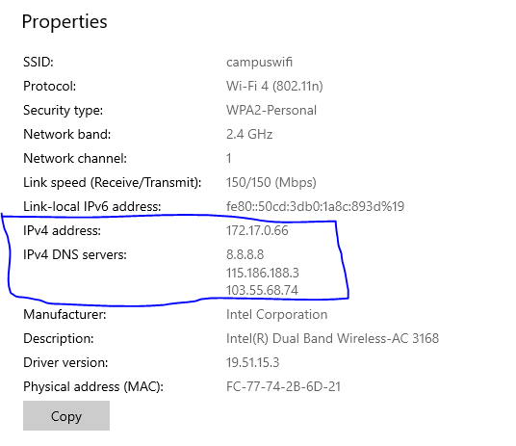

**3rd way: (Ethernet Issue in my PC)**

**4th way:**

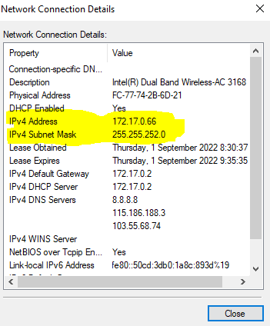

**5th way: (Sytem Information)**

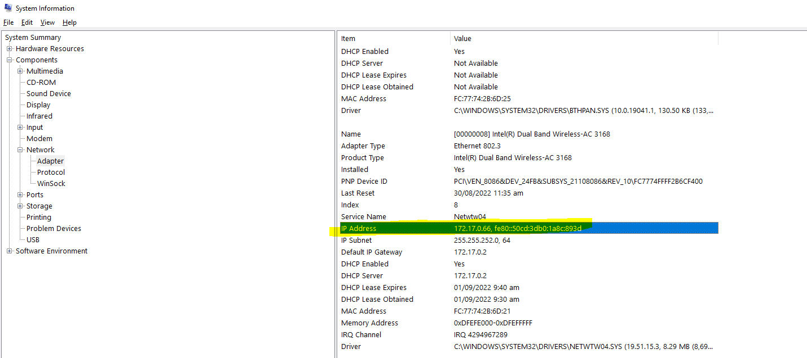

**6th way:**

