Name : Jawad Ahmed
Roll No : 20P-0165
Section : BCS-5A

LAB NO 2

COMPUTER NETWORKS LAB

Task1
First Configure the PCs as shown above and verify the connection using ping command.
Step1:
- First of all connected two PC’s using Copper cross over cable because both devices are same.
- Next Assign IPV4 addresses to the PC’s. Both the PC’s must have the same network IP’s and host IP address can be different.
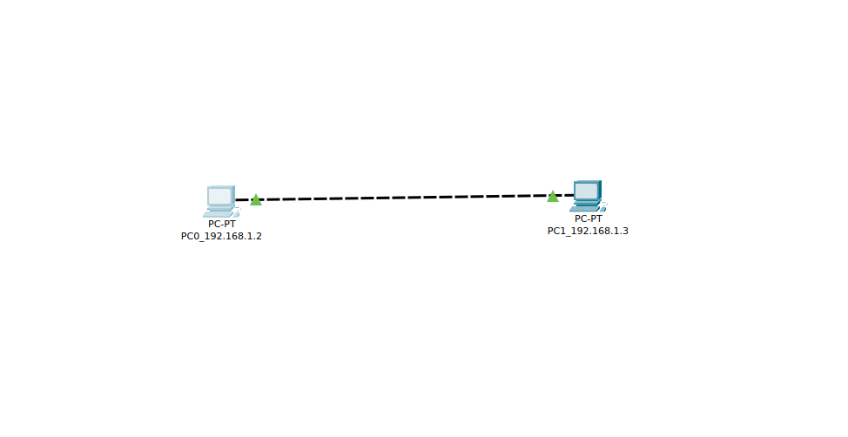
Step2:
- Assigning IP addresses and sub-net mask to PC1.
IP_Address_PC1 = 192.168.1.2
Subnet_mask PC1 = 255.255.255.0
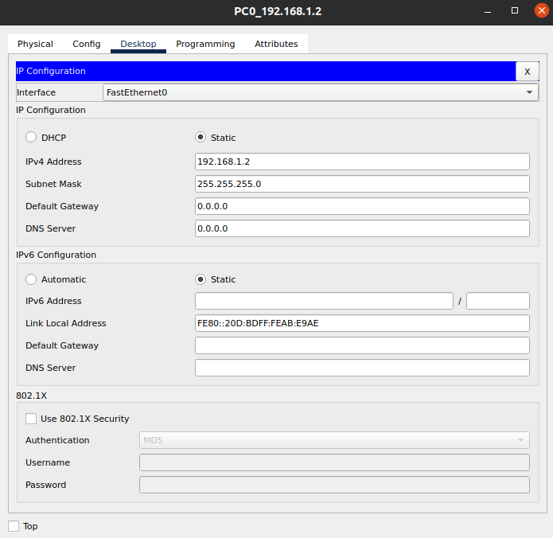

Step3:
- Assigning IP addresses and sub-net mask to PC1.
IP_Address_PC1 = 192.168.1.3
Subnet_mask PC1 = 255.255.255.0
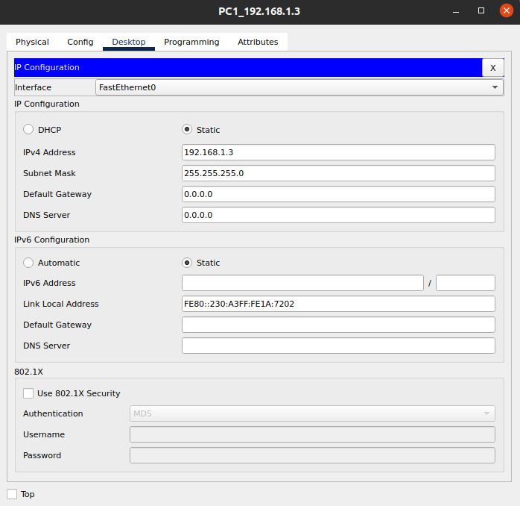

Step4:
- Now using the ping command to check is connection established or not.
- Pinging form PC1 to PC2.
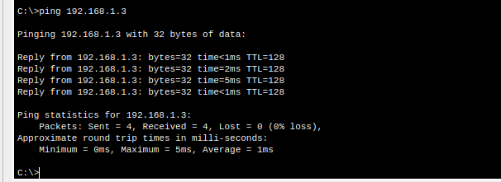
Connection Established Successfully between PC1 and PC2.

TASK2
Configure PC1 as follow: IPv4: 192.168.1.1 Subnet mask: 255.255.255.0
And PC2 as: IPv4: 192.168.2.1 Subnet mask: 255.255.255.0

Step1:
- Providing IP’s to the PC1 that are provided in the task.
Ip-address PC1 = 192.168.1.1
Subnet Mask PC1 = 255.255.255.0
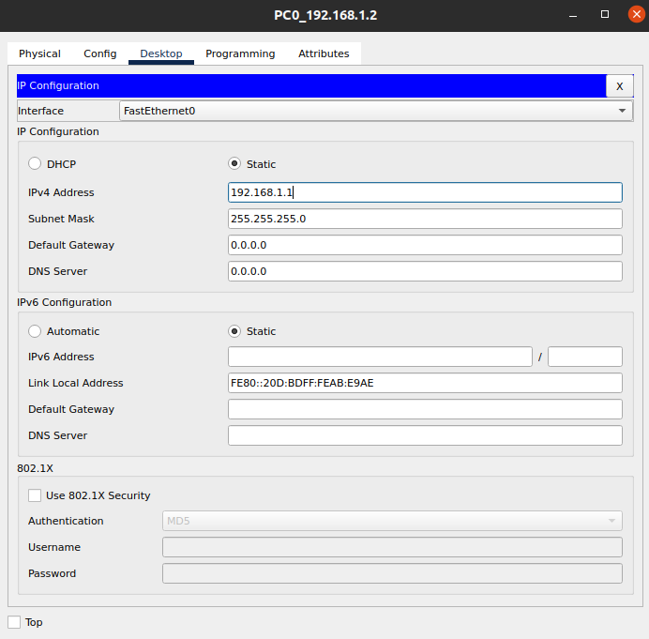
- Step2:
- Providing IP’s to the PC1 that are provided in the task.
Ip-address PC2 = 192.168.2.1
Subnet Mask PC2 = 255.255.255.0
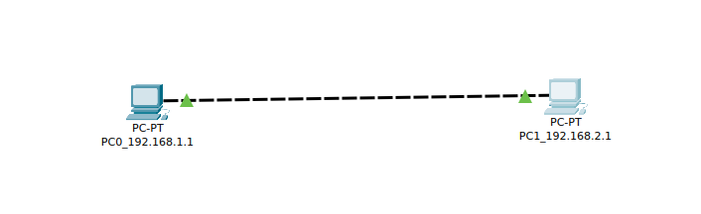

- Step3:
- When try to ping from PC1 to PC2 you will receive this error in the command prompt.
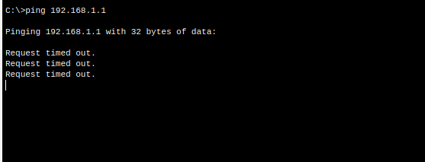
Reason:
PC1 have Network part => 192.168.1.0 and PC2 have Network part => 192.168.2.0 so the both the PC’s have different Network parts that is why both are unable to communicate with each other. Network part we got from subnet mask that is 255.255.255.0 so first three parts of the IP address selected that are not same and connection unable to establish.

TASK3
Configure PC1 as follow: IPv4: 192.168.1.1 Subnet mask: 255.255.0.0
And PC2 as: IPv4: 192.168.2.1 Subnet mask: 255.255.0.0.

Step1:
- Providing IP’s and subnet mask to the PC1 that are provided in the task.
Ip-address PC1 = 192.168.1.1
Subnet Mask PC1 = 255.255.0.0

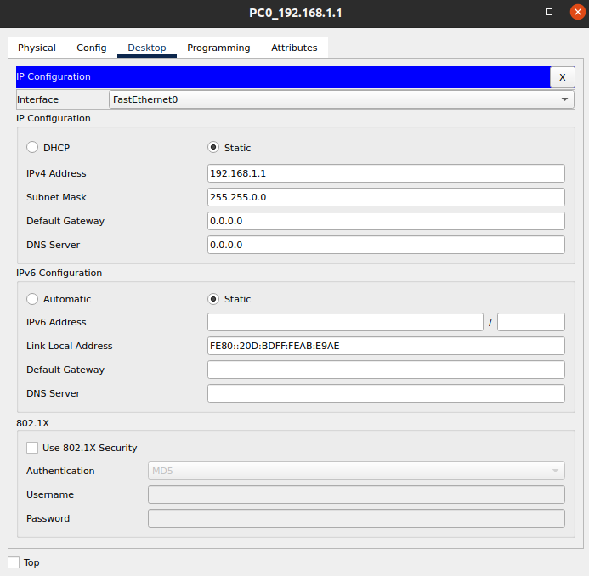

Step2:
- Providing IP’s and subnet mask to the PC2 that are provided in the task.
Ip-address PC2 = 192.168.2.1
Subnet Mask PC2 = 255.255.0.0
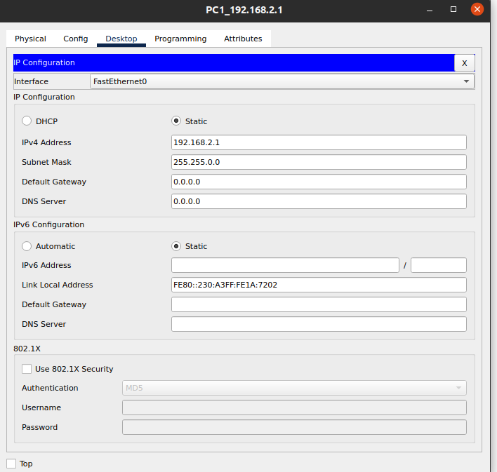

Step3:
- Checking is connection established between PC1 and PC2 using the ping command.
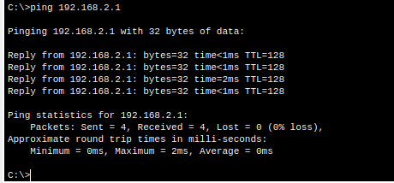

Reason why connection established:
Same IP addresses that given in second task but in this case connection establish but unable to establish in second task. That is due to subnet mask in this case the subnet mask is 255.255.0.0 so the network part of both the PC’s PC1 and PC2 is going to be the same that is 192.168.0.0 but in the second task the network part of both PC1 and PC2 is different so we got the error Request timed out.
TASK4
Simulation of Hub with end devices
Task: Construct and simulate the following topology

- PC1-IP-Configuration
IP_Address = 192.168.1.1
subnetmask = 255.255.255.0

- PC2-IP-Configuration
IP_Address = 192.168.1.2
subnetmask = 255.255.255.0

- Laptop1-IP-Configuration
IP_Address = 192.168.1.3
subnetmask = 255.255.255.0

- Laptop2-IP-Configuration
IP_Address = 192.168.1.4
subnetmask = 255.255.255.0

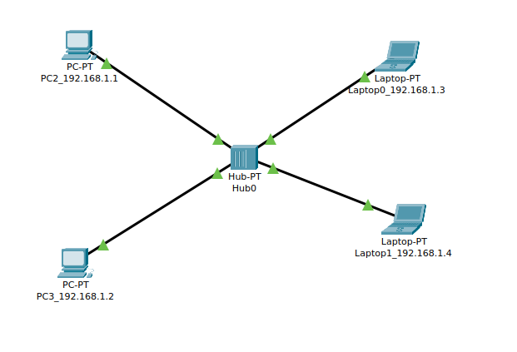

- Sending Message From Source TO Destination using Hub
- Hub is not an intelligence device because it has no memory and it do broadcasting.

1: Source and Destination setted. Source => PC2 and Destination => Laptop1
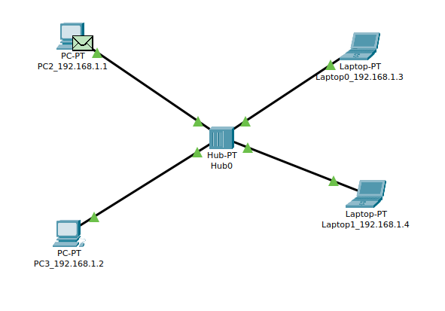

2: Message First goes to hub.
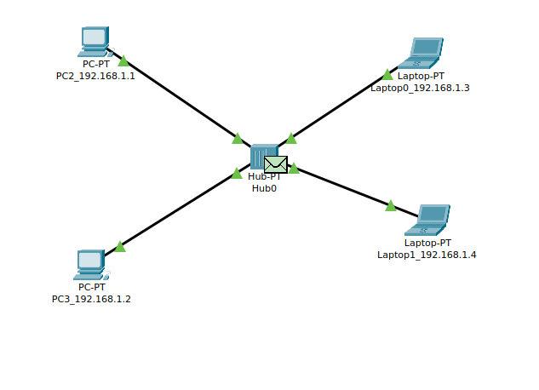

3: Hub will transmit the message to all the devices but the other devices will not accept it and cross sign will going to come if the message is not accepted by the pc. Source => PC2 and Destination => Laptop1 . Message is accepted by Lapop1.
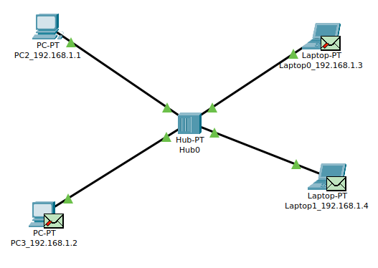

4: After sending message acknowledgment that message received successfully by receiver is sended back to sender.
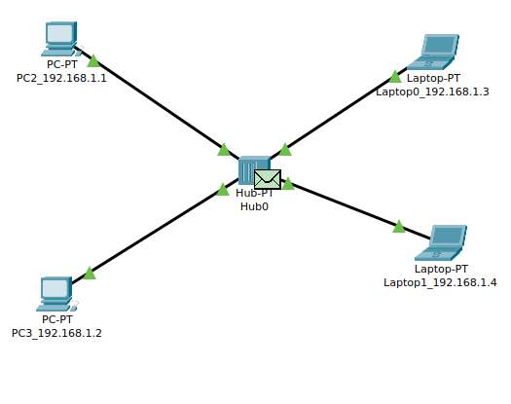

5: Again the hub will be going to broadcast the message to all devices and only the sender is going to receive the message. Source => PC2 and Destination => Laptop1. Acknowledgment is received by PC2.
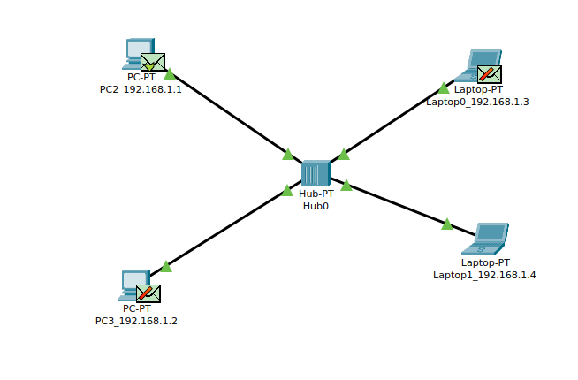

TASK5
Simulation of Switch with end devices
Task: Construct and simulate the following topology

- PC1-IP-Configuration
IP_Address = 192.168.1.1
subnetmask = 255.255.255.0

- PC2-IP-Configuration
IP_Address = 192.168.1.2
subnetmask = 255.255.255.0

- Laptop1-IP-Configuration
IP_Address = 192.168.1.3
subnetmask = 255.255.255.0

- Laptop2-IP-Configuration
IP_Address = 192.168.1.4
subnetmask = 255.255.255.0
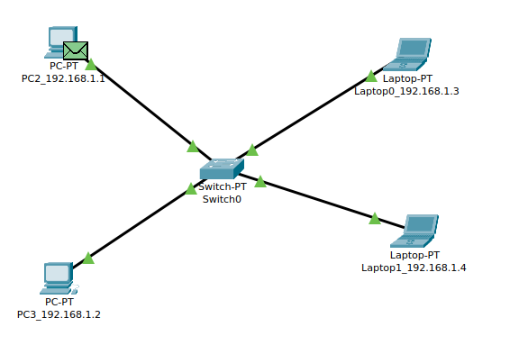

Switch:
Switch is an intelligent device because it store mac addresses. First time switch do broadcasting because initially memory of switches is empty but after first time message sended on acknowledgment switch do uni casting. Because now it has mac addresses and the message is not transmitted to all devices and traffic reduced and data security also improved.
1: Source and Destination setted. Source => PC2 and Destination => Laptop1

2: Message First goes to the switch and then broadcast done on the first time.
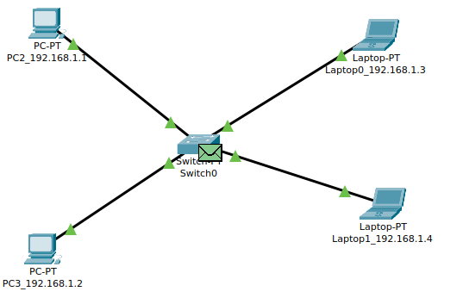
3: After that broadcasting done but now for the next switch will going to store the mac addresses so the next it will not have to do broadcasting.
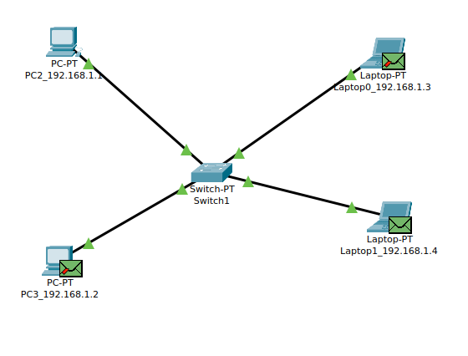

4: Now After that receiver received the message now receiver will send the acknowledgment message back to sender. Now you will see the acknowledgment message will not be broadcasted yet it only sended to sender.

- Message Goes back to Switch.
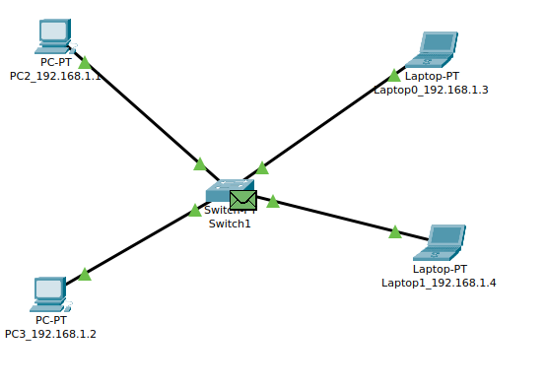
- Acknowledgment message only sended to sender not broadcasted.
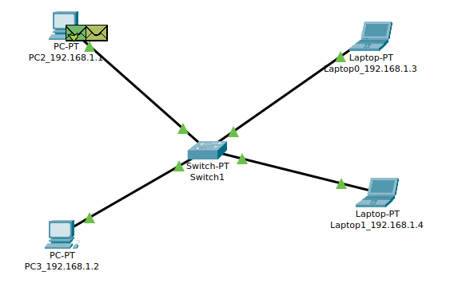

5: Now next time if we send the message same network switch has mac addresses saved so message will not going to be broadcast-ed.
Message Goes to Switch:
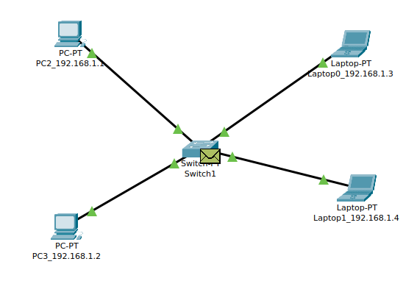
Message unicasted to receiver:
