Name : Jawad Ahmed
Roll No : 20P-0165
Section : BCS-5A

HOME WORK NO 3

1: Setting Router Modes on 2600 Series Routers.
- Router:
Router is a device that is used to establish connection between two devices of different networks.
Modes on 2600 series Router
1: User Execution Mode:
Click on the router the pop box will open. From that box click on the CLI and interface that is opened will be the user Execution mode.

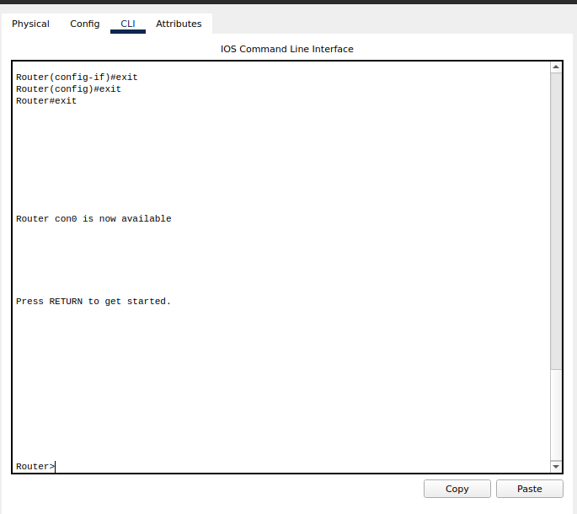
2: Privileged mode
To Enter into the privileged mode press enable in the User Execution mode.
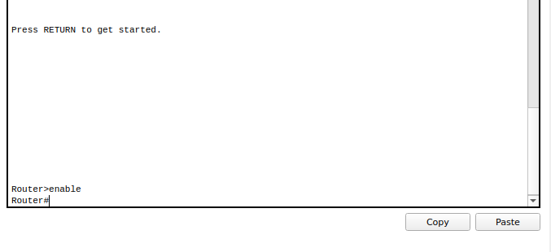
3: Global Configuration Mode
To Enter into the global configuration mode from privileged mode. Type configure terminal then you will be prompted to the global configuration mode.
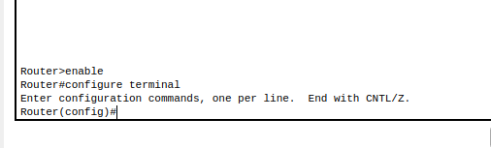

4: Interface Configuration Mode
Entering into interface mode from global configuration mode. Here we have to specify the router’s interface.
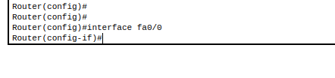

5: ROMMON MODE:
Entering into ROMMON mode from privilege mode.
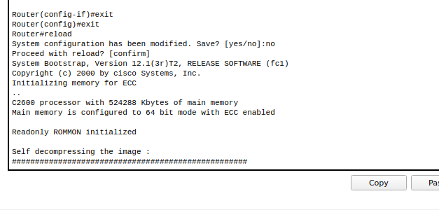
2: Changing Hostname of the Router
To change the hostname of the router we have to issue these commands in the router CLI.

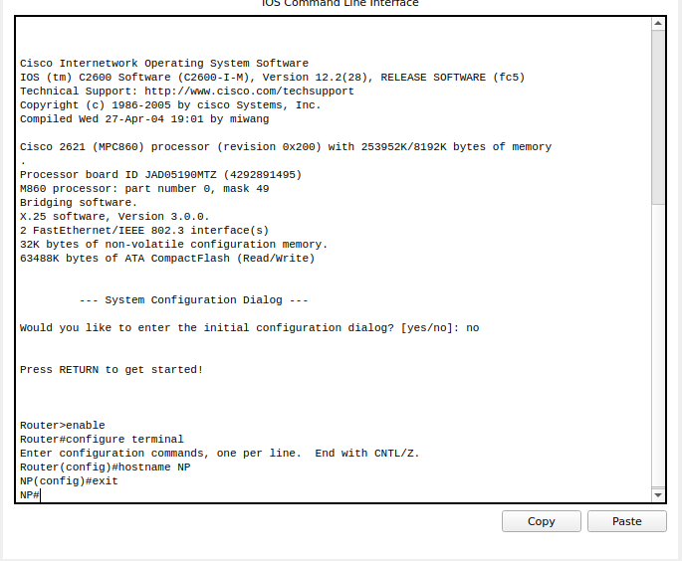
In the output you will see the hostname changed to NP or whatever you have written next to hostname command.
3: Configuring Date and Time on the Router (Clock Set Command)
First of all the time format. For me the time format is hh:mm:ss.
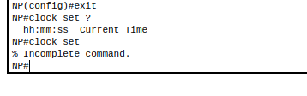

Now let’s set the time.
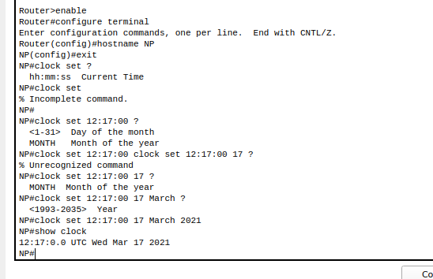
Follow these steps to configure the Data and Time on the Router. Once you setted the time and data you can verify using the command show clock.

4: Setting a banner on the Router
Open the router CLI and go to the privileged mode. Follow these steps to set the banner.

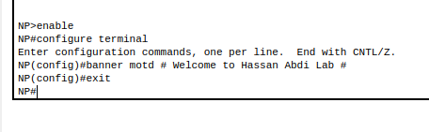

Let’s verify that is the banner setted successfully or Not.
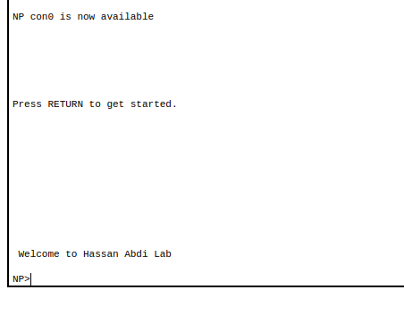

You will be seeing the message that you have setted in the previous step.

5: Displaying the Router’s Running-Configuration and Start-Up Configuration

To display the running configuration issue this command In the router CLI. That is show running-config.
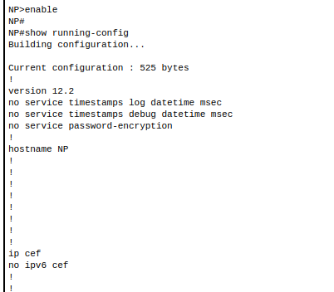

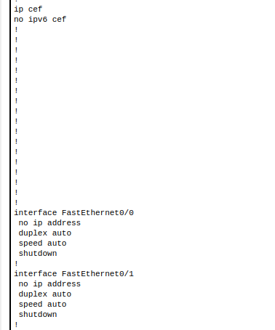

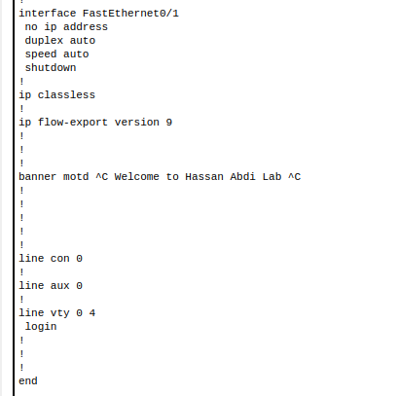

For the Start-Up Configuration we use the command show startup-config.
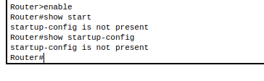

6: Enable Password and Enable Secret Password with the Encryption Techniques/Levels
- Enable Password
To Enable Password use the following commands.

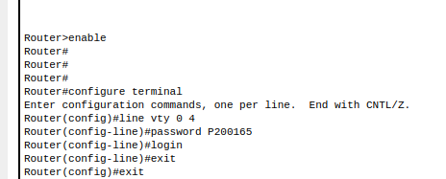

- Enabling Secret Password
Open up the router CLI.
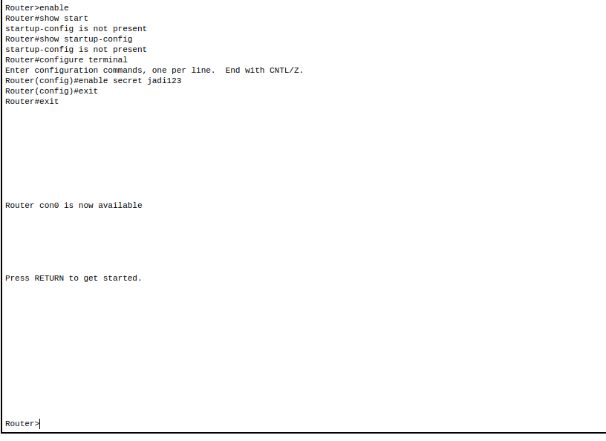
Let’s verify.

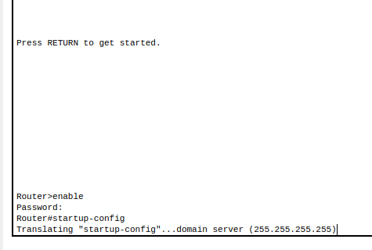

When you try to enter the privileged mode you have to enter the secret password once that you enter you will be redirected to the privileged mode.
7: Line Console Password Implementation on CISCO 2600 Series Router
To Enable Line console Password issue the following commands in the router CLI.
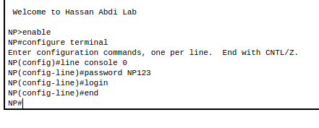

Password is setted let’s verify this.
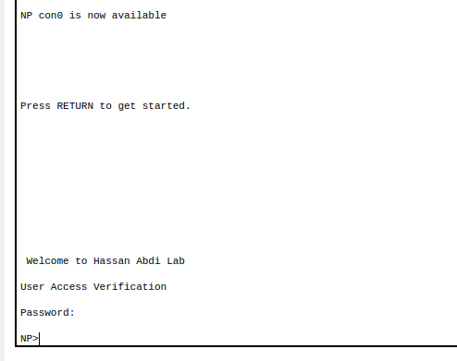

Enter the password and you will be prompted to the NP cli.

8: What is Telnet? How to Telnet? + Line VTY/Telnet Password
Telnet stands for Teletype Network Protocol. Telnet is the network protocol that is used to connect one computer to another computer virtually. Telnet is used to provide two-way collaborative and text-based communication channel between two machines.
On the web, Hypertext Transfer Protocol(HTTP) and File Transfer Protocol(FTP) simply enables users to request specific files from remote computers, while through TELNET users can log on as a regular user with the privileges they are granted to the specific applications and data on that computer.
How to Telnet?
An abstract example of the syntax for a Telnet command request is as follows:
=> telnet the.libraryat.whatis.edu
The result of this request would be an invitation to log on with a user ID, and then the program would prompt the user for a password. If accepted, the user is granted access to the remote host.
Connecting a router to PC using telnet:
First of all create this topology and then assigned the IP addresses to PC = 192.168.1.2 and the Default Gateway = 192.168.1.1.


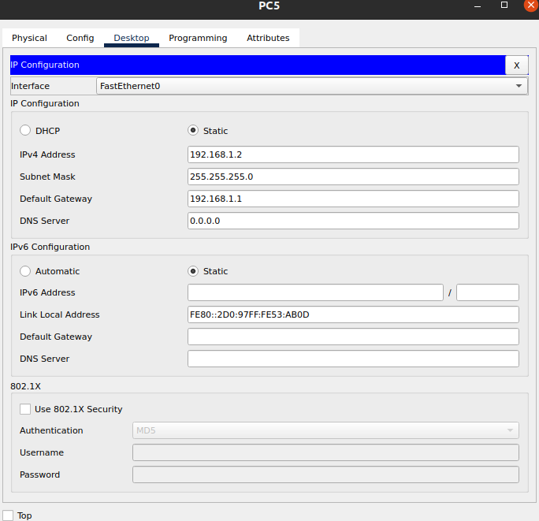
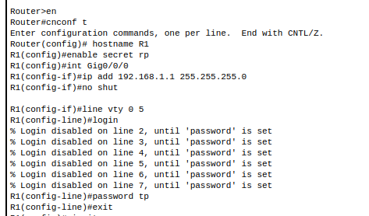

Issue all these commands and then let’s try to connect to the router using the telnet command. Open the command prompt of the PC5 and then issue the following command to connect to the router.
=> telnet 192.168.1.1
It will ask for password the password is tp. Provide that password and you will be connected to the router using telnet.
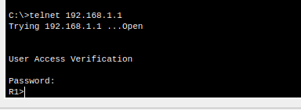

The term “vty” stands for Virtual teletype. VTY is a virtual port and used to get Telnet or SSH access to the device.

9: Usage of Router with different topology.

1st Topology (Mesh Topology):

In mesh topology every device has a dedicated point to point link to every other device.
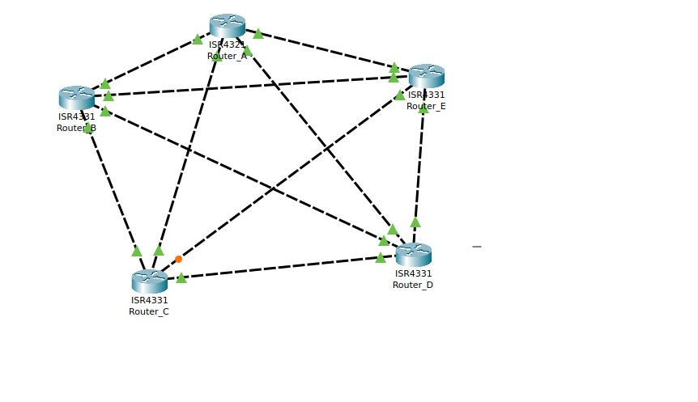

2nd Topology:
Connecting a router to a PC using the Telnet.
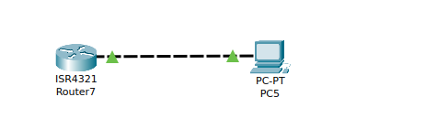

3rd Topology:
Assigning Ip to the PC’s dynamically with the help of router.

