Name : Jawad Ahmed
Roll No : 20P-0165
Section : BCS-5A

Homework No 3

1: Perform communication of four devices using switch
- Use the IP Address of Class C
- Simulate transfer of packet between two PCs
- Write brief and concise description of the whole process.
The Class C IP Address range is from 192 to 223. For the Network IP in class C three octets are reserved.
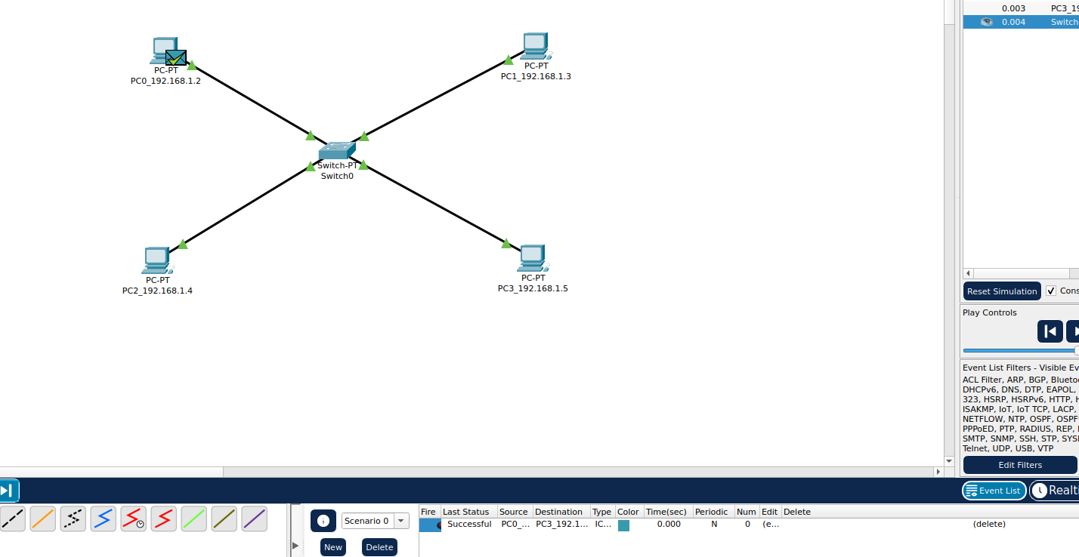
I connected these four PC’s using switch. Straight Through wire is used because when you want to connect two different devices Straight Through wire is used. Packet successfully delivered to the destination.

2: Perform communication through multiple switches
- Use the IP Address of Class C
- Simulate transfer of packet between PC0 and PC3
- Write brief and concise description of the whole process.
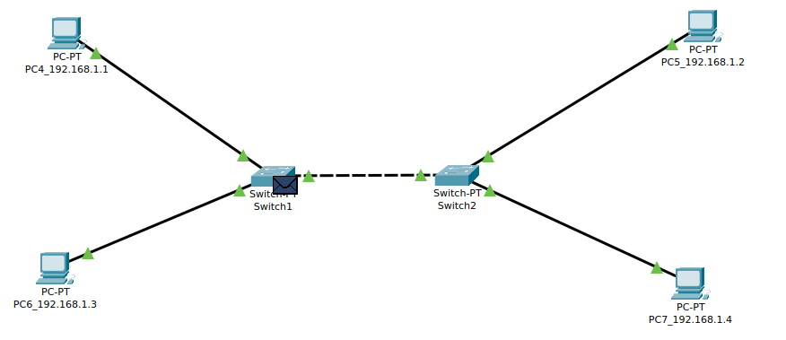

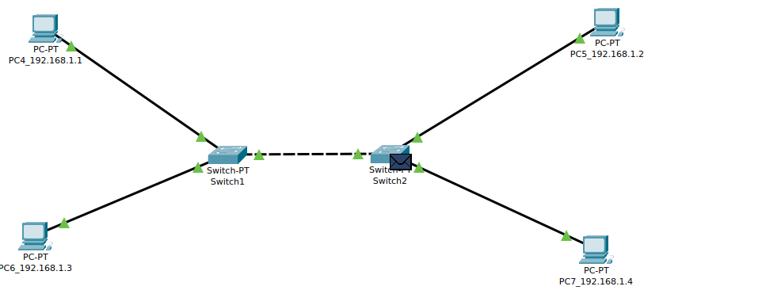
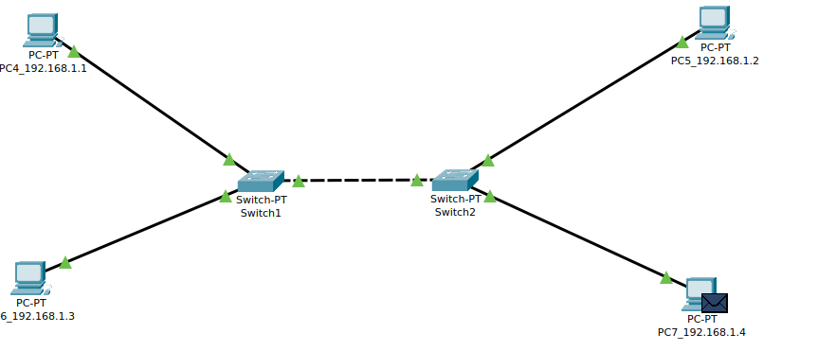
Message is sended successful from PC4 to PC7. I have connected two switches with each other using the Cross over wire and Connected PC’s with switches using the Straight through wire. Using the Class C connection IP because the first octet is starting from 192 and the range of Class C IP is from 192 to 223.

3: Using same way of two switches but the connection is unable to establish once you have two different networks.

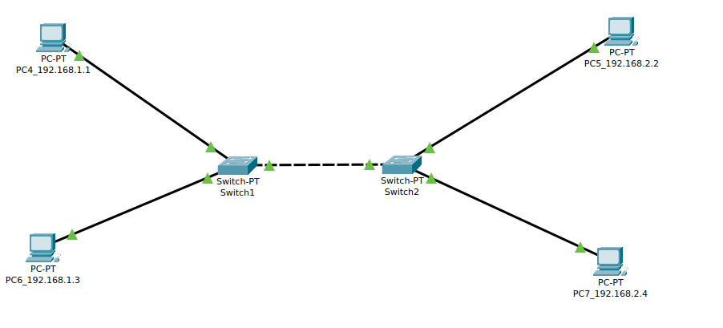

4: Performing communication using Single Router:
To connect two or more different networks, we use
Router.
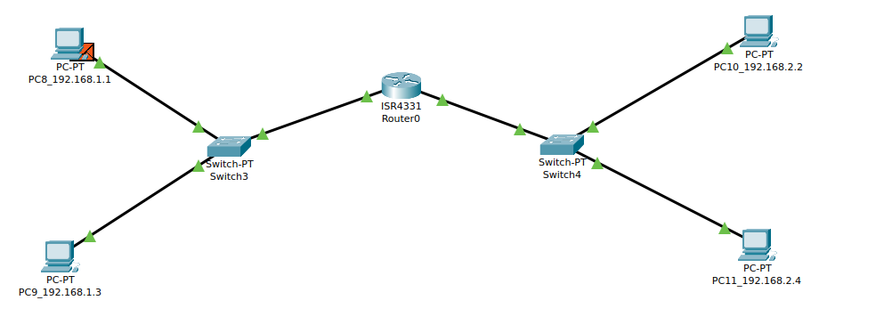
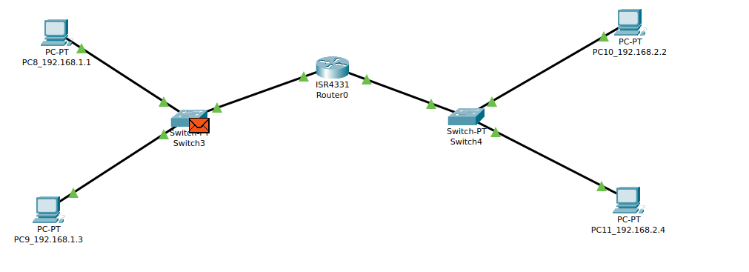
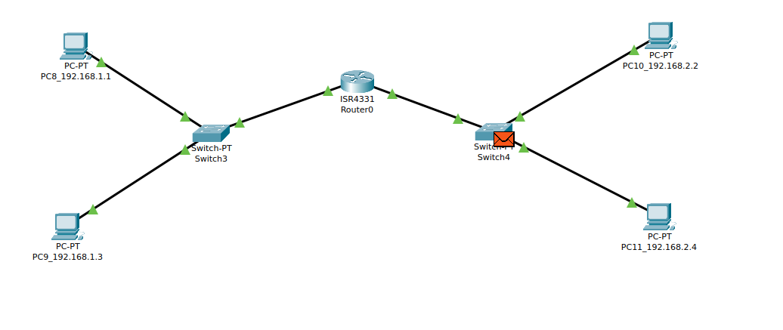
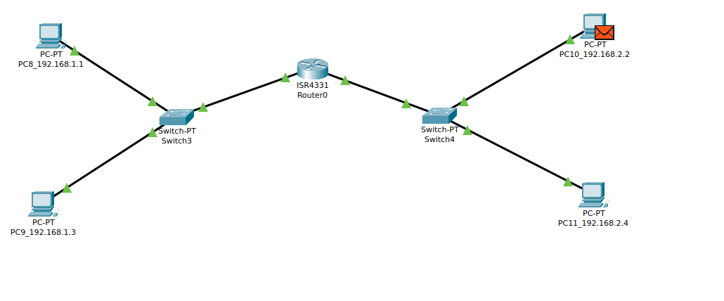
We have connected two devices of different networks using router. First of all we have setted the PC8 Default Gateway to 192.168.1.10 and then in the router GigabitEthernet0/0/1 I have setted it’s IPv4 address to 192.168.1.10 and same mechanism followed with the other PC_10 which have different networks setted it’s Default Gateway to 192.168.2.10 and in the Router setted IPV4 address of GigabitEthernet0/0/0 to 192.168.2.10. Once that done I have sended the packet from PC8 to PC10 and the connection between PC’s of different networks is successfully established.

4. Performing communication using Two Routers:

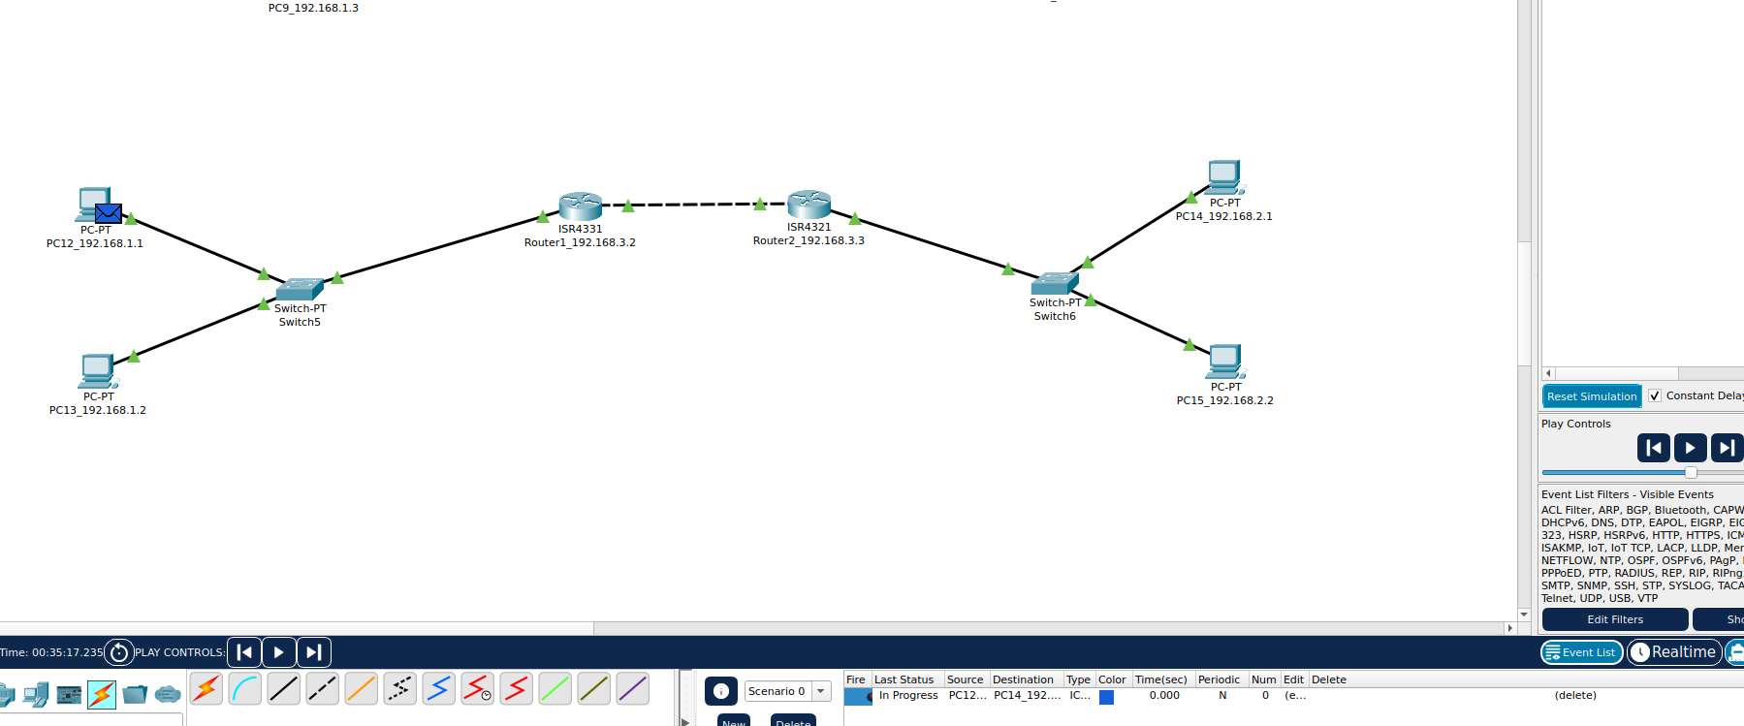

Connecting with the help of two routers is same as with one router the only difference is that in this we also have to establish connection between two routers. We have to tell the router about the next hop and also about the network to which the router is communicating. Once that path is added then we can send message to other PC’s of different network.
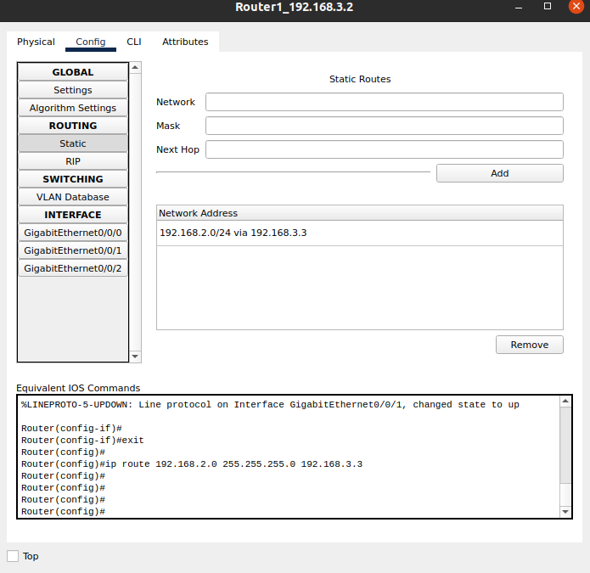

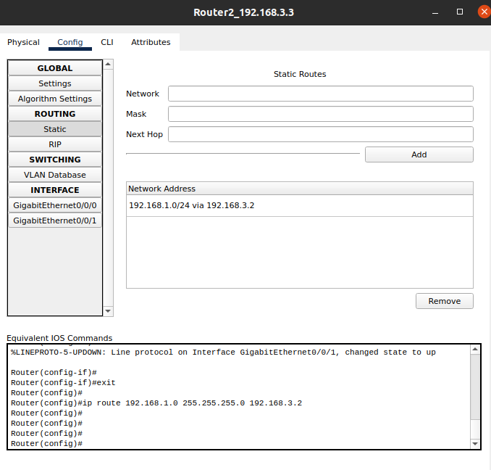

5. Performing communication using Three Routers:
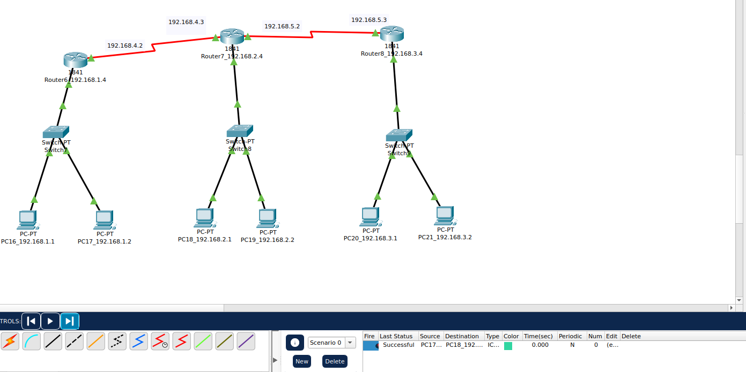
In three routers we have to do static routing for all the three routers. That on which networks the router is going to send the message and what is the next hop to which the message is sended and then message is given to the receiver.

