Name : Jawad Ahmed
Roll No : 20P-0165
Section : BCS-5A
HOME WORK NO 4

Task1: DNS server configuration in Packet Tracer.
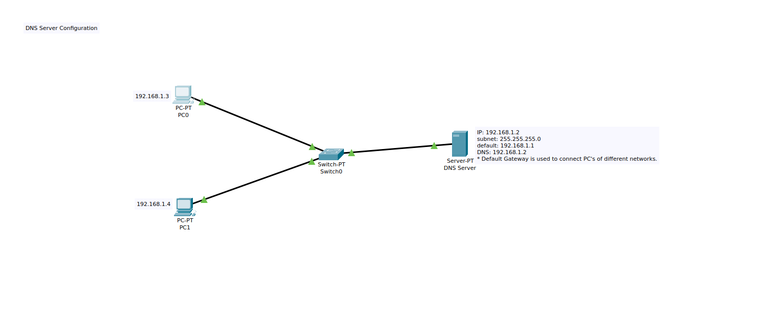
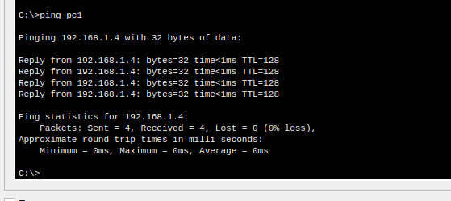
In this task we have to create connection between pc’s using the DNS server so the PC’s can ping each other using pc’s name.

1: First of all the ON the DNS service. Click on the services and then select DNS.

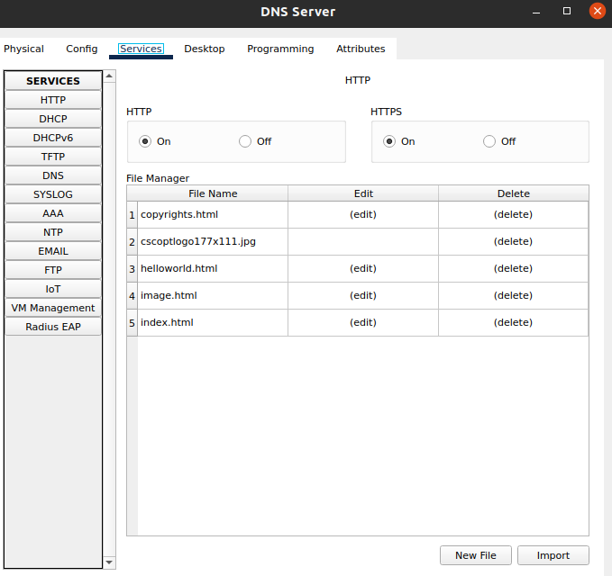
2: Provide the IP’s of the PC’s to which you want to ping.

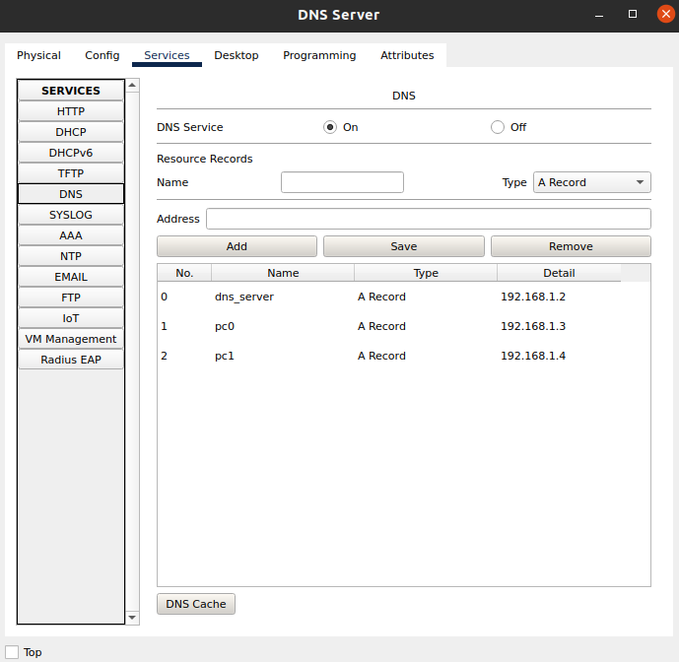
Once that provided then go the command prompt of PC0 and issue the command
=> ping pc1
You will see pc0 will start pinging pc1. Pc1 is the name of the PC now it is the task of the DNS server to translate the name of the PC to corresponding IP address.

Task2: Configuring DHCP server on a Router.
The DHCP is used to assign IP’s randomly. We can make mistakes while assigning IP’s so we are using the DHCP that will assign IP for our PC’s and also the default gateway and DNS Ip also assigned. I will be using the router CLI to activate the DHCP and provide the network for the IP’s.

First of all create this topology and then we will do configuration for all the DHCP.

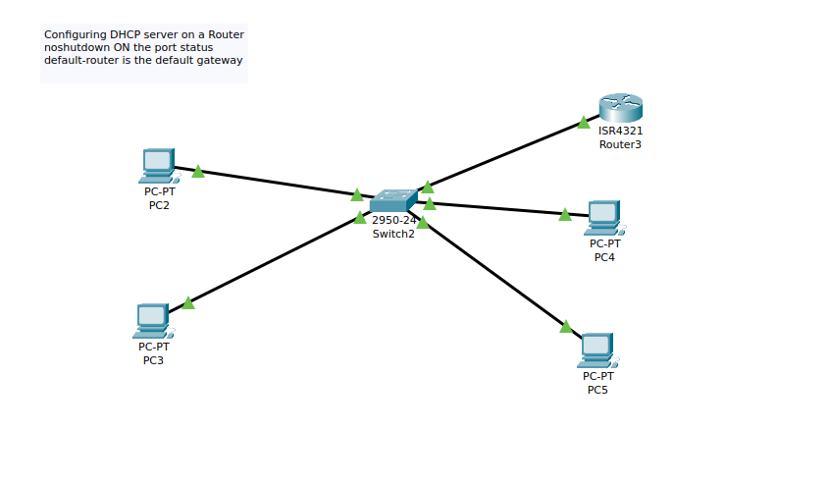
Once that done go to the router CLI and then issue these commands to configure router.
1: Enter no first.

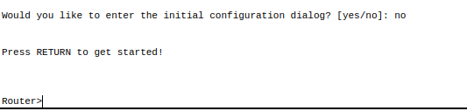
2: Then issue these commands in the cli and all the configuration of DHCP is done.
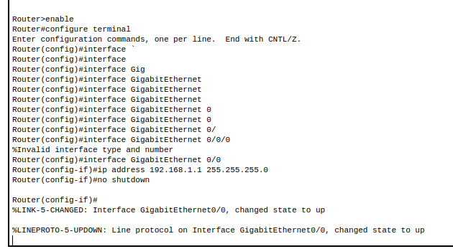
3: Once that done go the PC0 and in the IP configuration instead of static select DHCP. It take some time to assign IP’s.
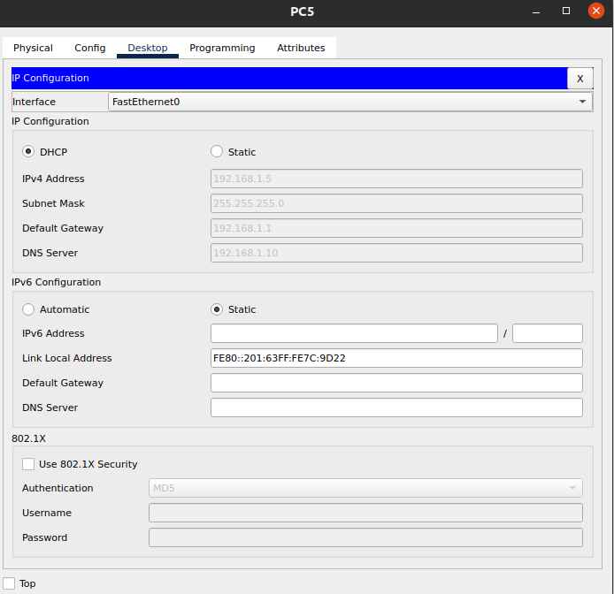

The IP is assigned using the DHCP. You can ping two PC’S using IP’s to verify this.

Task3: Configuring DHCP service on a generic server
1: First of all build I have built this Topology.
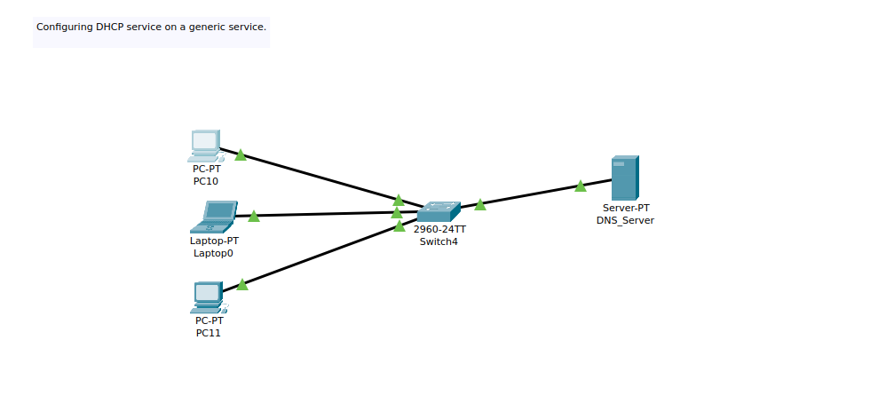
2: Once that create then click on the DNS_Server and assign IP’s, subnet mask and the DNS_Ip to it.
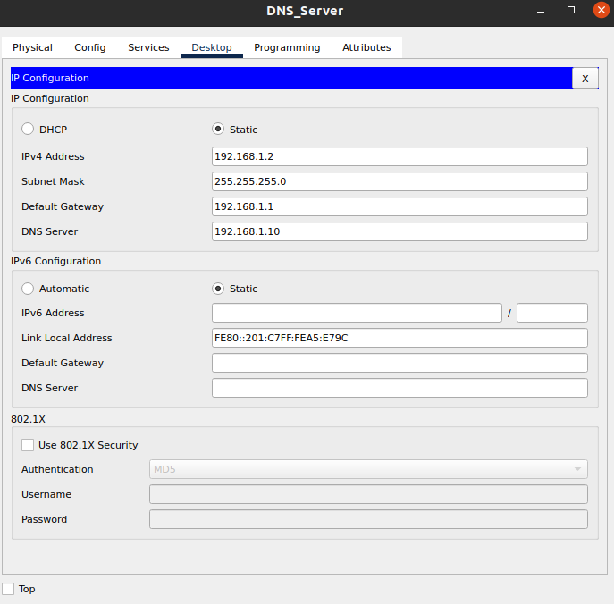
Once that configuration done then next step go the services tab and click on the DHCP service. The serverPool is by default created provide the default gateway and subnet mask and start IP address. We sometime reserved some IP addresses in this case I have reserved first 10 Ip addresses and the Max users will change from 255 to 245. After the click on the save and pool is created successfully.
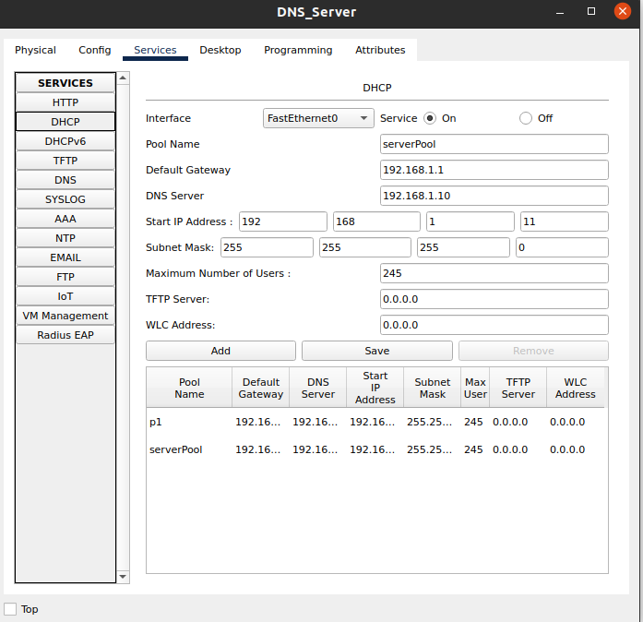
After pool is created go to any PC and in the IP configuration click on the dhcp instead of static IP configuration and IP will be assigned to the PC by DHCP.

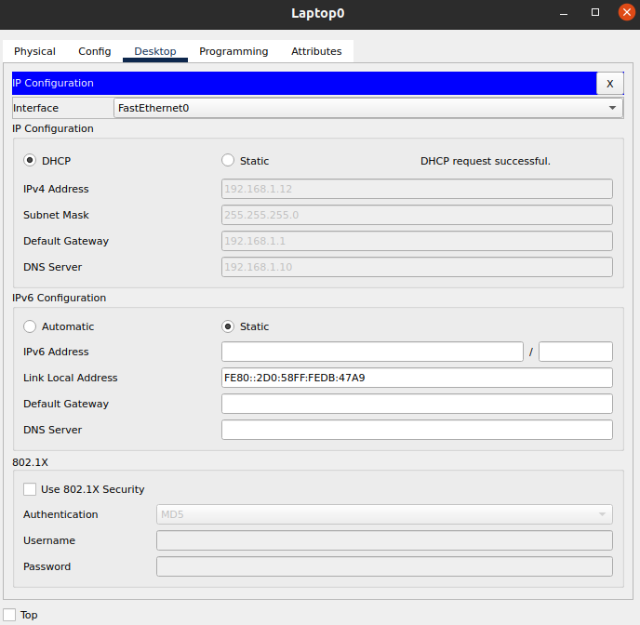
The Ip assigned successfully by using the DNS server.
Pinging PC10 to Laptop0 the IP assigned by DHCP.

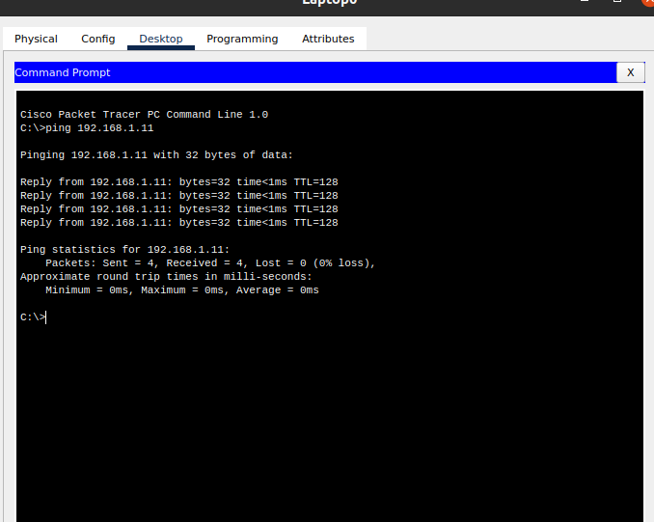
Task4:: Configuring DHCP, DNS and Web Server configuration in cisco packet tracer.

Step1: Create This Topology.
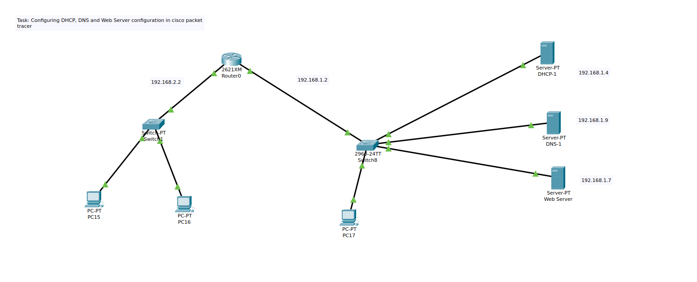
Step2: Assign Ip address to F0/0 and F0/1 of router.

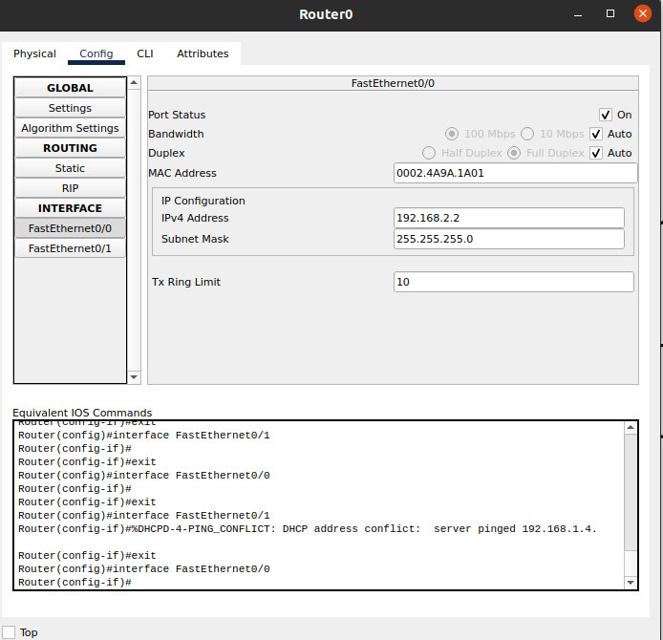

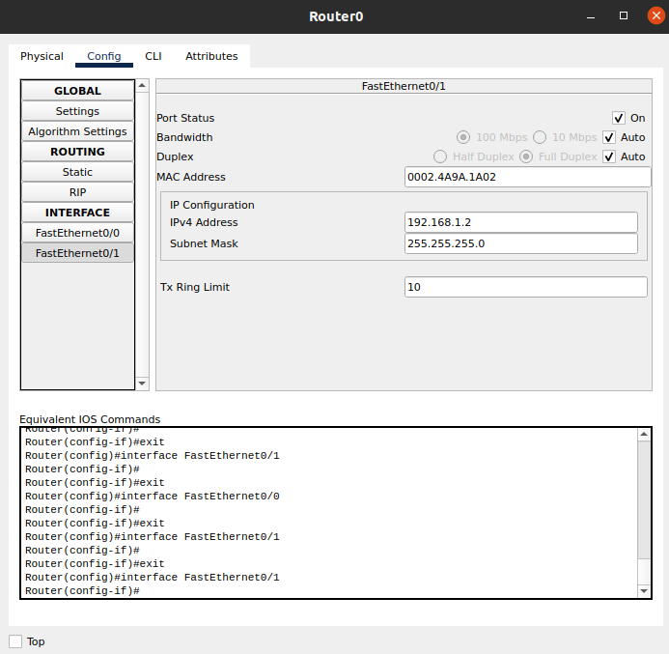
Step3: Open the CLI tab in the Router0 and go the configuration mode and execute the following commands.

To Go To the configuration mode
=> configure terminal

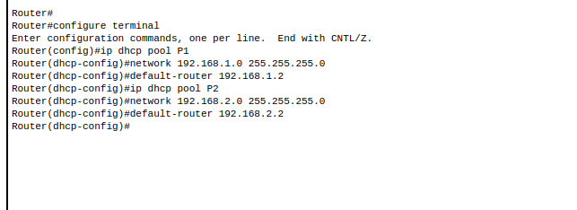
Step4: Apply follows setting on DHCP IP configurations.
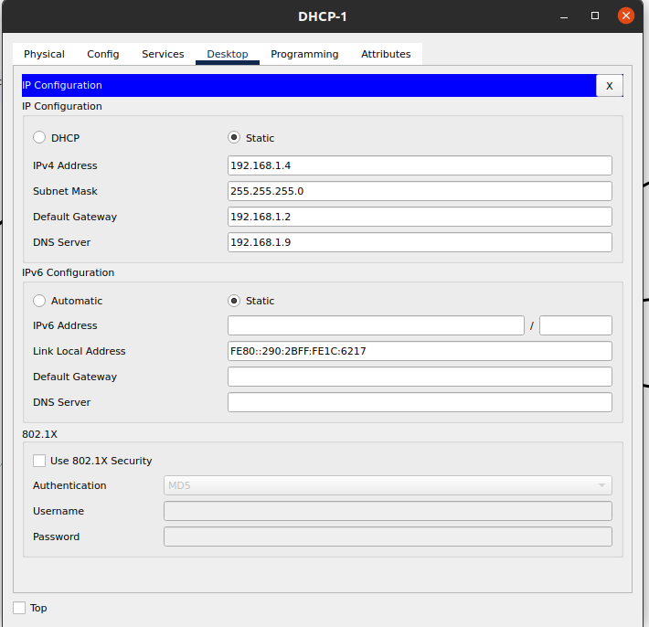
Step5: Open the services tab and enable DHCP Services and Add Pool P1 and Pool P2 with respective Ip Address.
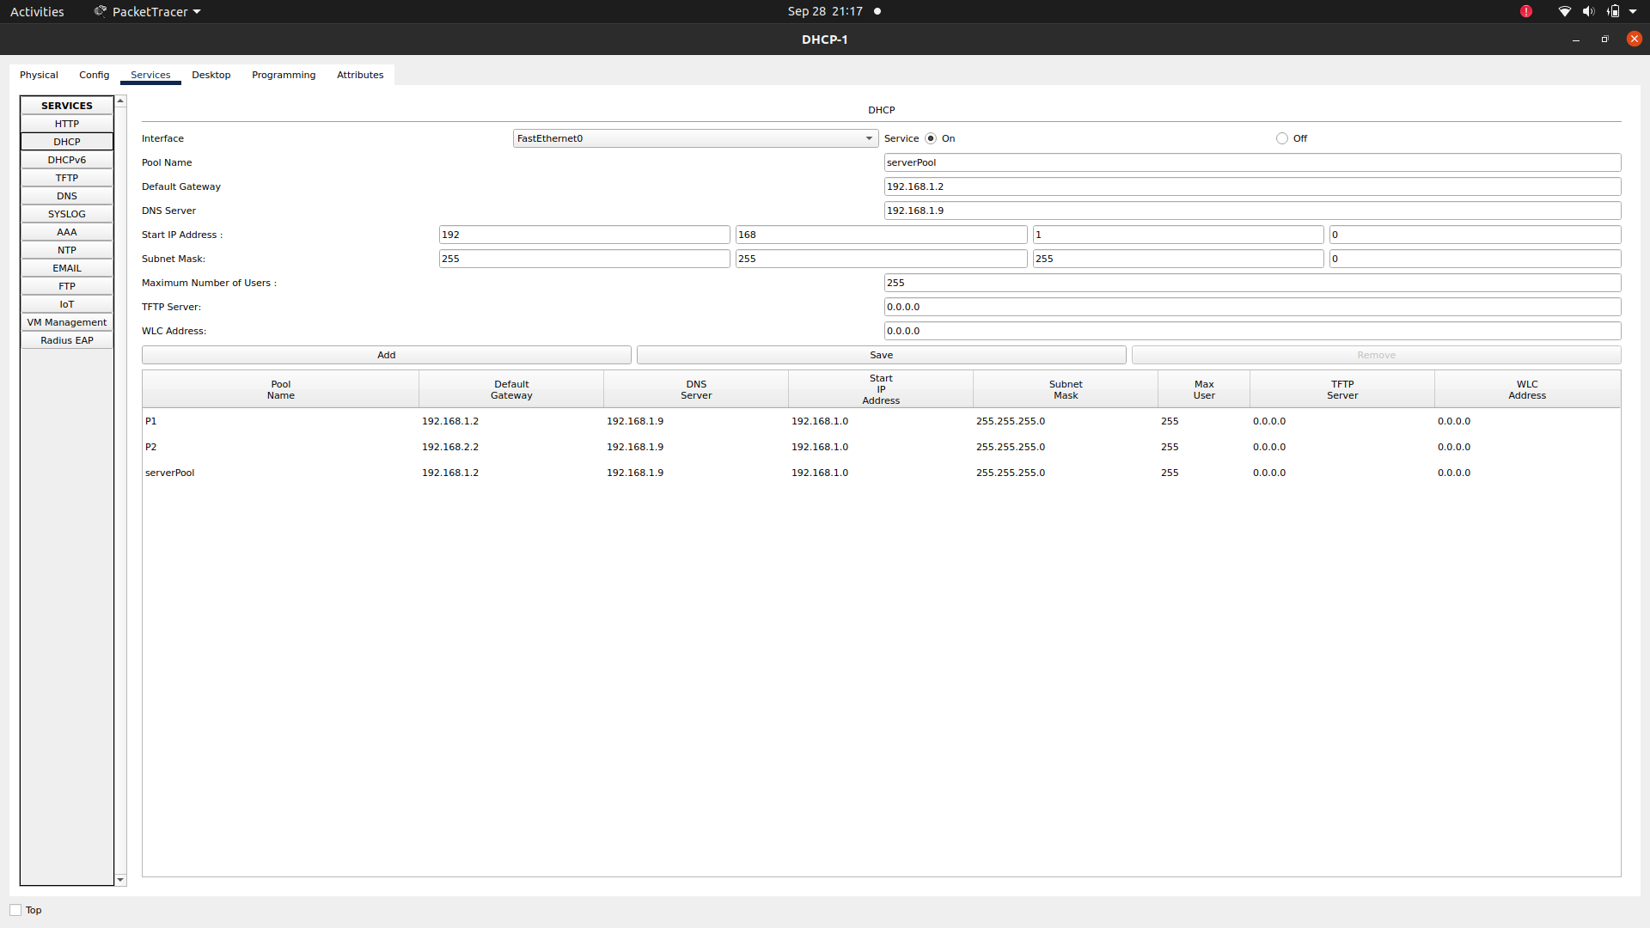
Step 6: Apply follows setting on DNS Ip configuration.

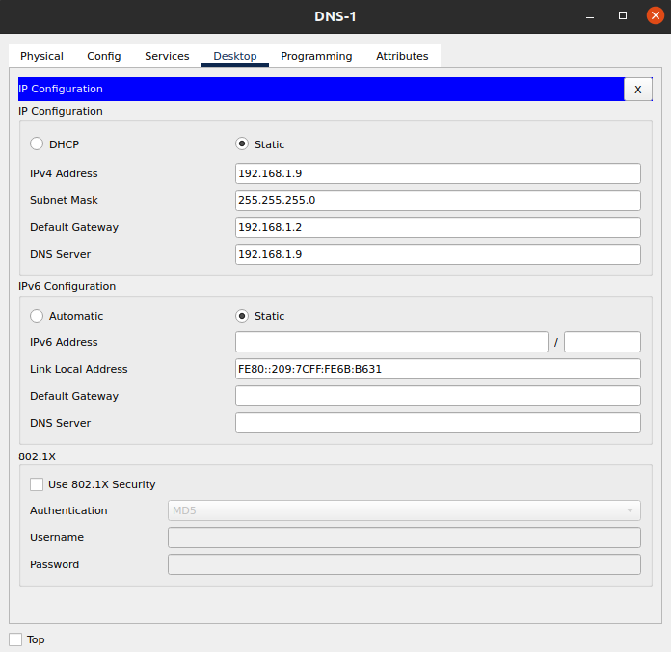

Step7: Enable DNS Services of DNS and add two resources records. Remember To On the DNS Service.
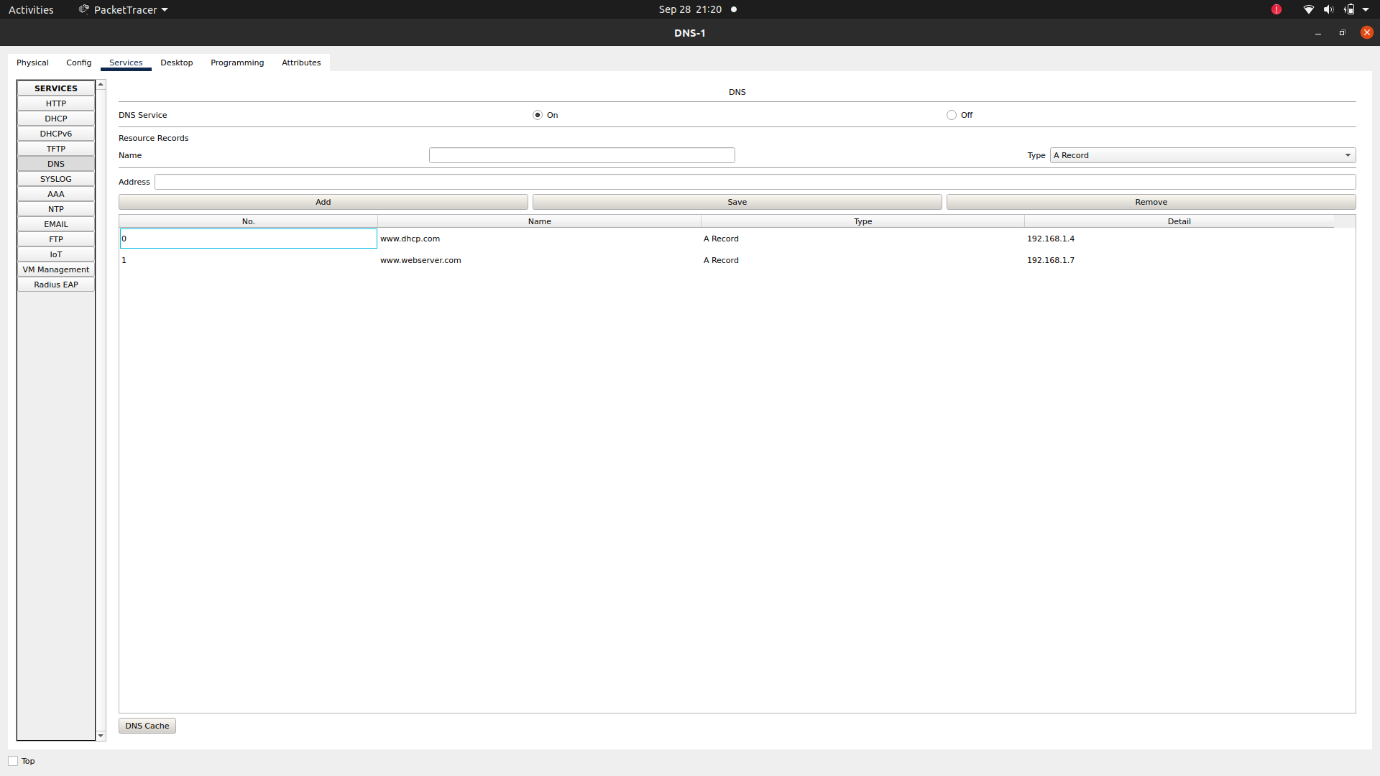
Step8: Apply following IP configuration on the Web Server.
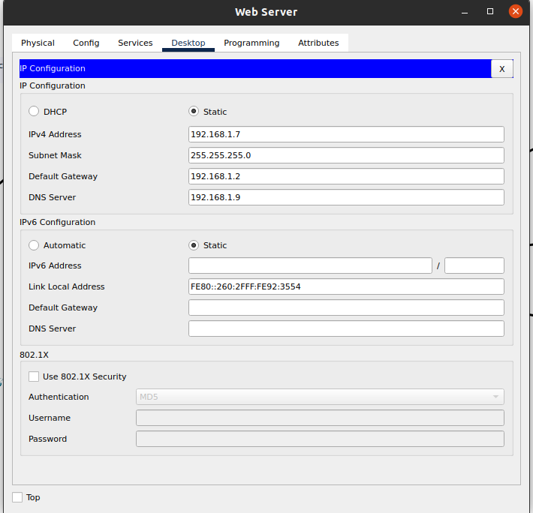

Step9: Go to Services Tab and then Enable Http and Https in Web Server.
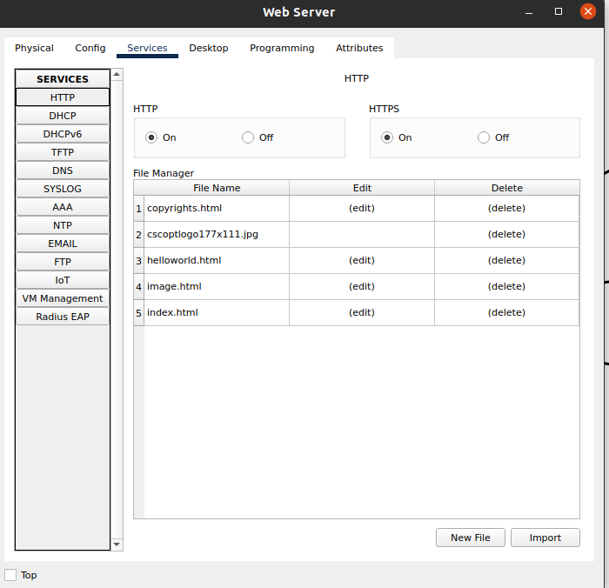

Step10: Edit the index.html file

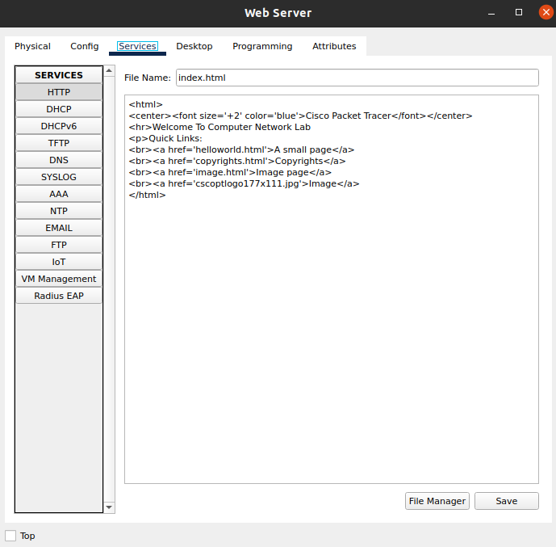

Step11: Now go to every PC and on their IP configuration tabs, enable DHCP. Every PC should be able to obtain
an IP address, default gateway and DNS server.

Click PC17->Desktop->IP configuration. Then enable DHCP:

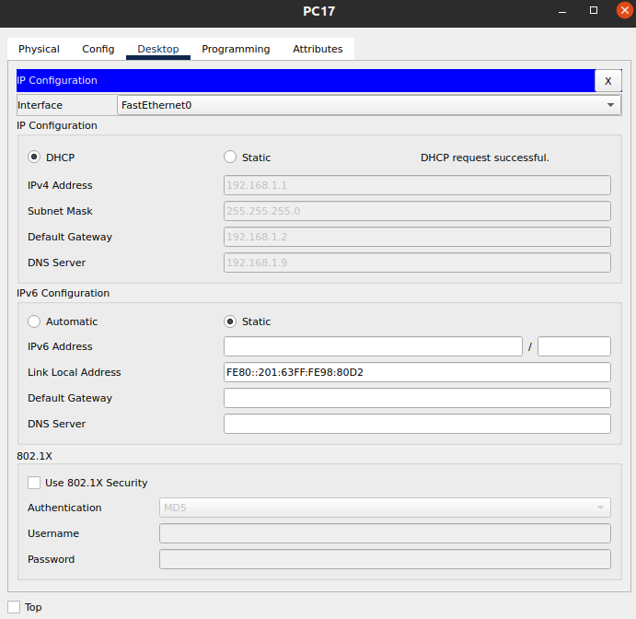

Do it for all the PC’s.

Now let’s Open the PC17 browser and open the URL that you have added. The index file will be shown to you.
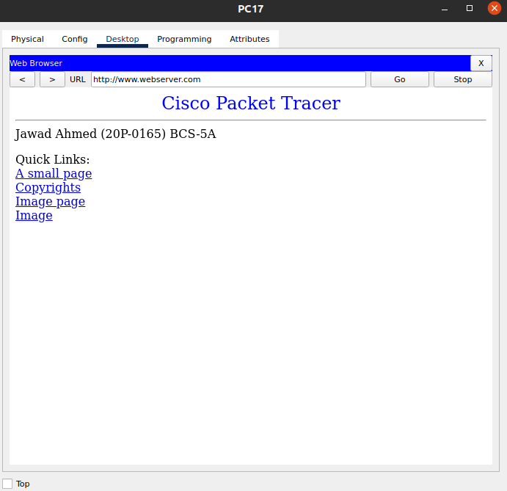

How it works?
We have DNS-1 in which we save domain name and told that when this domain name typed go to that IP server and pick index file from that server and how to user.
For Example: When user type www.webserver.com then the webserver (192.168.1.7) index file is shown and work same for all the other PC’s.

Test the configuration by pinging PC2 from PC1. Ping should succeed.

