Name : Jawad Ahmed
Roll No : 20P-0165
Section : BCS-5A
Lab No 5

- Lab Task is starting From Page 7
- Task1: Configuring an IP helper address:
Step1: Create This Topology
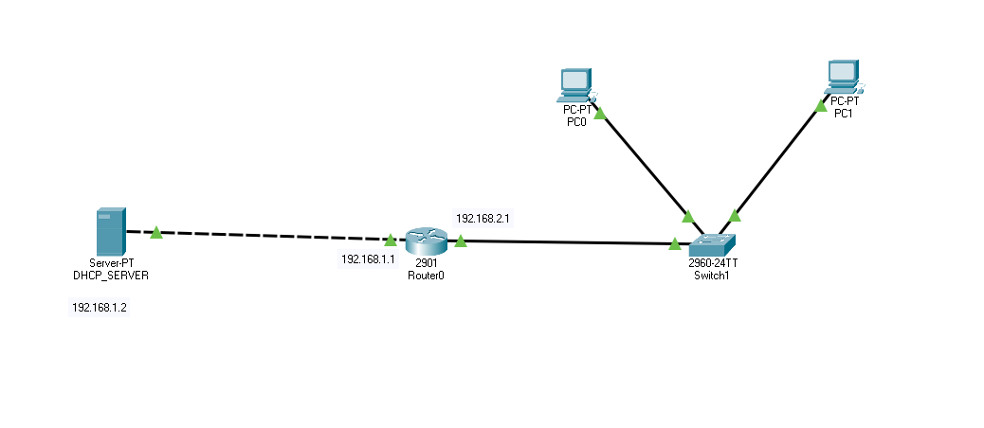

Step2: After Creating this topology Assign IP addresses to the Server.
Server: IP address: 192.168.1.2 Subnet mask: 255.255.255.0 Default gateway: 192.168.1.1

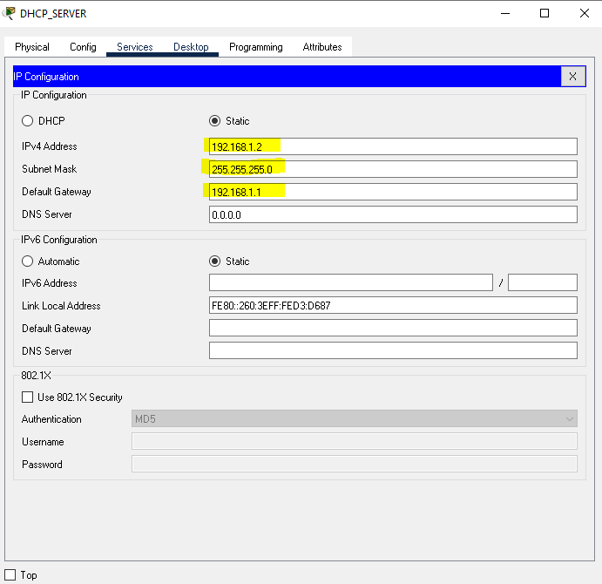

Step3: Do Router Interface Configurations.
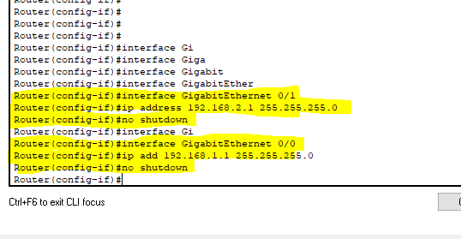
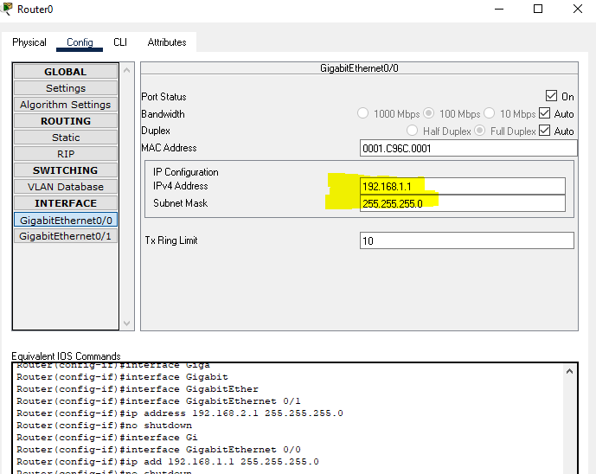

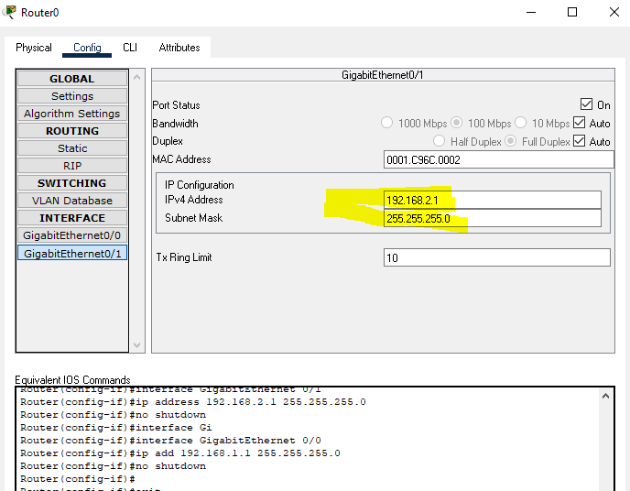

Step4: Enable DHCP services and create a pool of IP addresses.
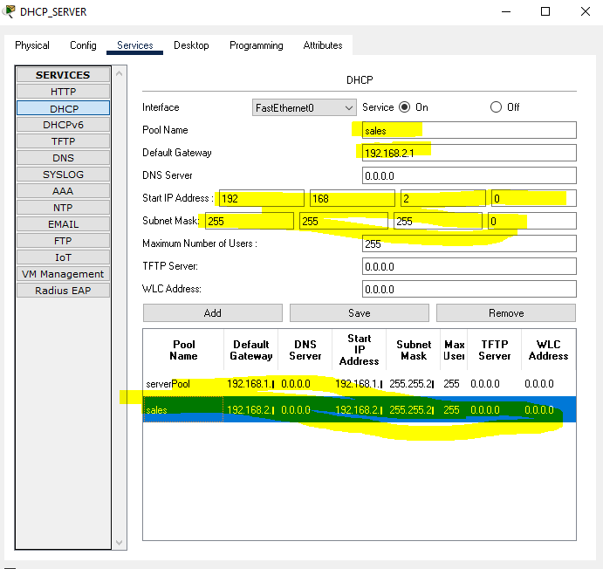

Step5: Add helper ip address using router cli.
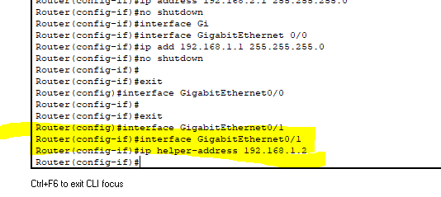

Step6: Now go to the PC1 and enable DHCP in it IP addresses will be assigned.
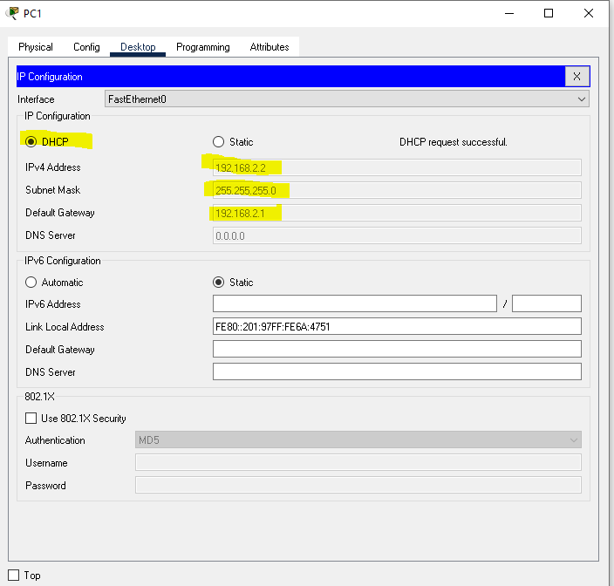
Same goes for PC0.

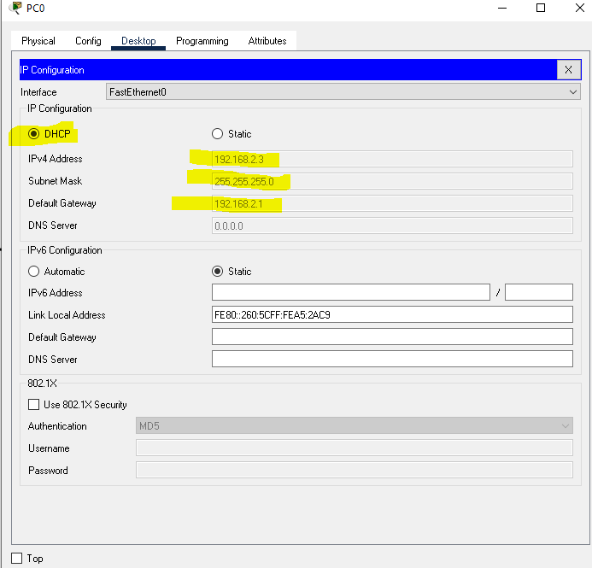

Lab Task:
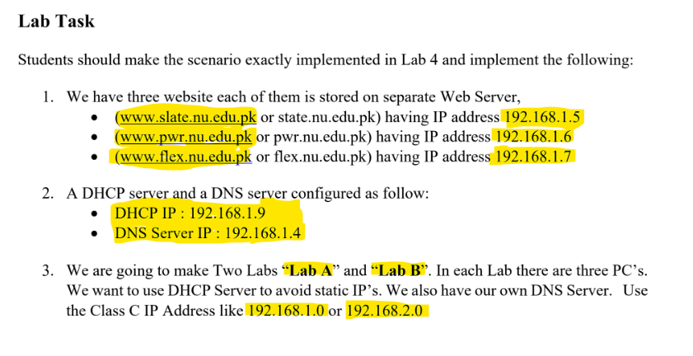

Step1: Create This Topology.
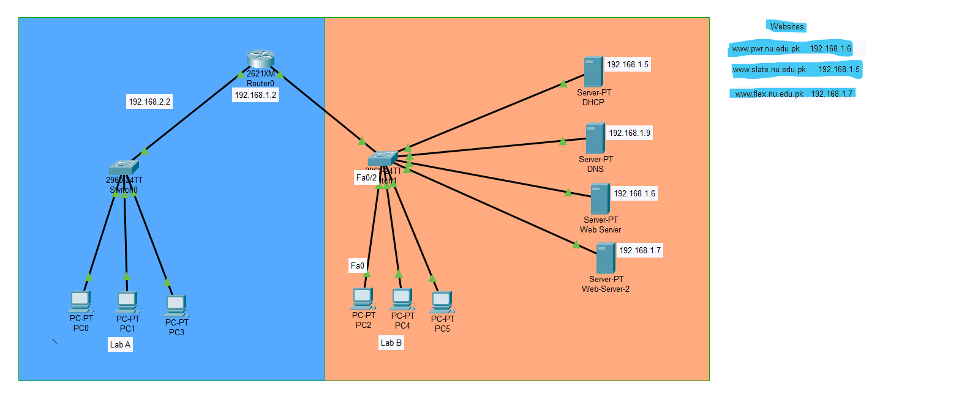

Step2: Assign Ip Addresses to the Router to both the wires FastEthernet0/0 and FastEthernet0/1.
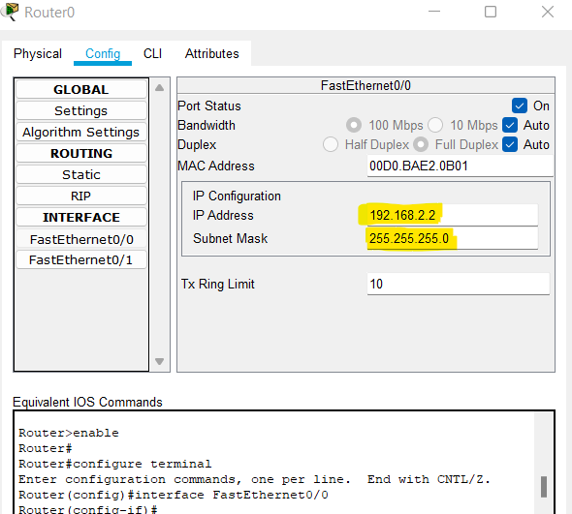

Step3: Go to router CLI and Add Pool P1 and P2.
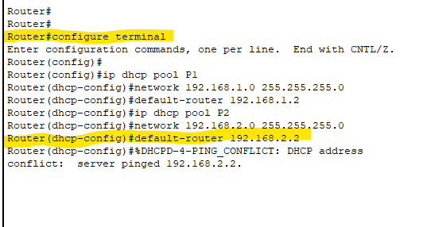

Step4: We need three servers to have three websites. Assign the given IP addresses to the three servers and edit the index file as per your need.
First Edit DHCP server 192.168.1.5 => slate
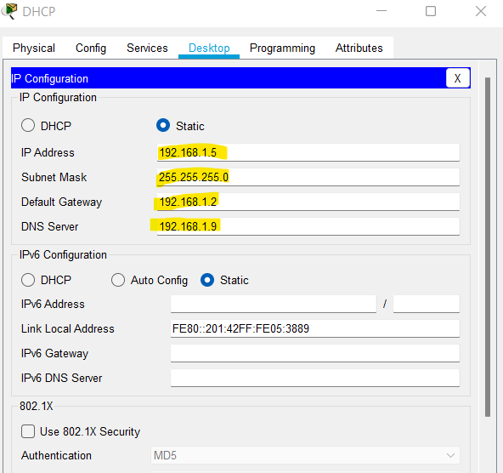

Go to the services and then Edit the index.html file.
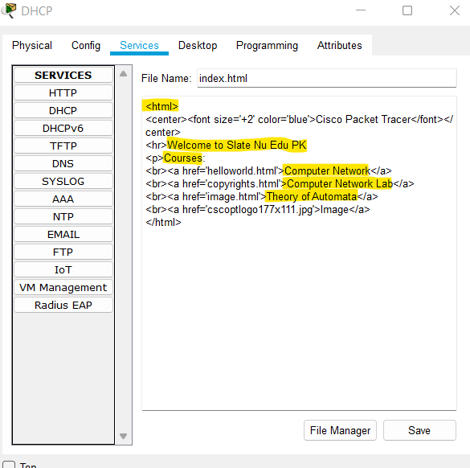

Second Edit Web Server 192.168.1.6 => pwr.
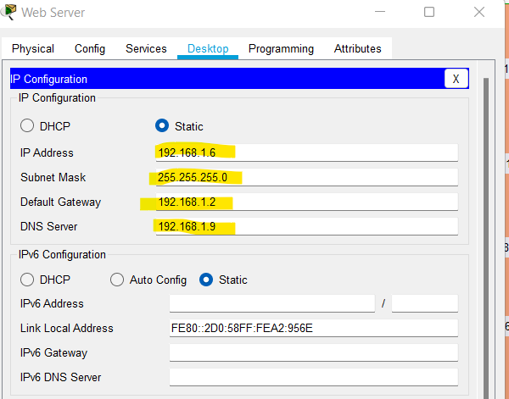

Go to the Services Tab and Edit the index.html file as per your need.
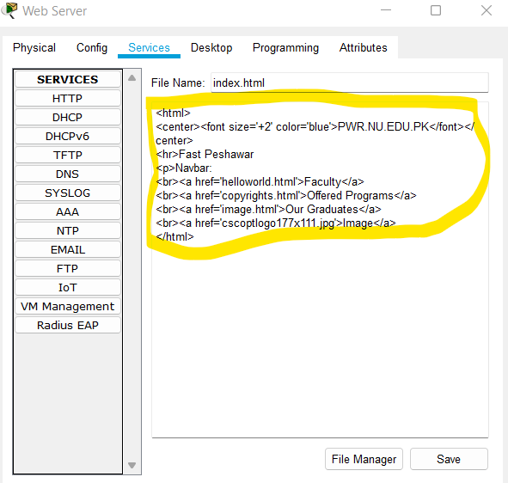

Third Edit Web Server-2 server 192.168.1.7 => flex.
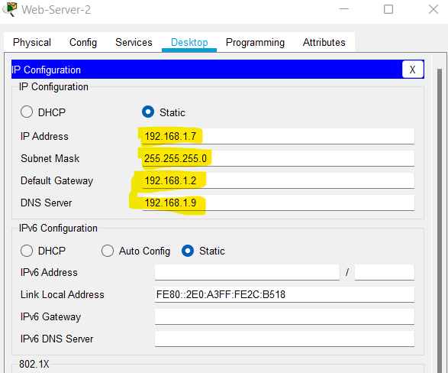

Then Edit the index.html file.
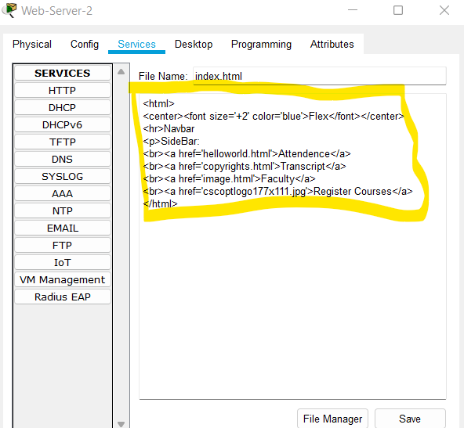
After All this done now On the http and https service in the DNS server and then add the websites and the servers IP addresses in the DNS server.
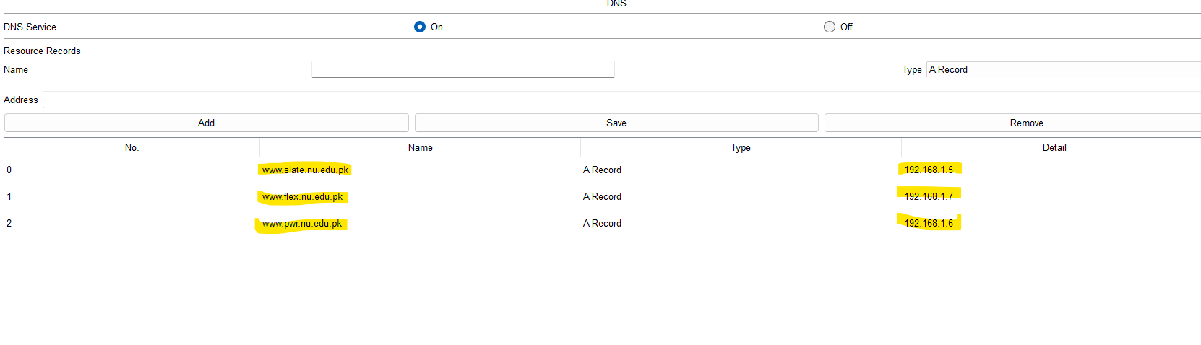
Now to Go the any Lab PC and then assign IP using the option DHCP. I am doing using the PC2.
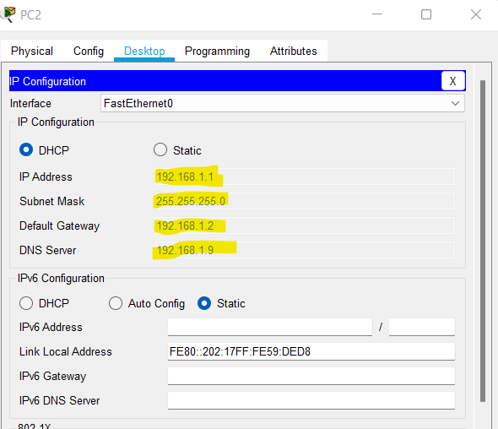

Now open the browser and enter the website url. These are all the screeenshots of proof.

