NAME : JAWAD AHMED
ROLL NO : 20P-0165
Section : BCS-4A
________________________________________________________________________________

Lab 10 Task

DCL & TCL
1. Create a user, user name should be your name.
- CREATING A USER NAMED jawad with password jawad123

=> CREATE USER ‘jawad’@’localhost’ IDENTIFIED BY ‘jawad123’;

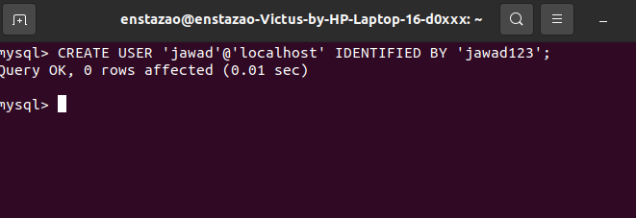

- Loging Into Mysql through the new user

=> mysql -u jawad -p

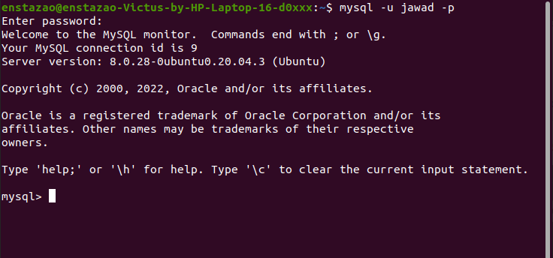

2: Grant Privilege To access EMPLOYEE table (SELECT,UPDATE) from database themepark.

SQL QUERY TO GRANT PERMISSION

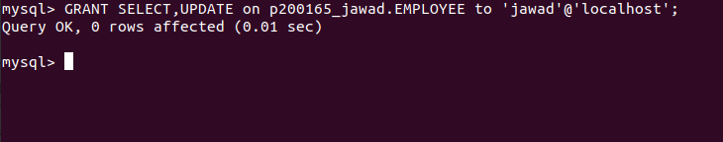
TESTING SELECT COMMAND IN THE jawad user

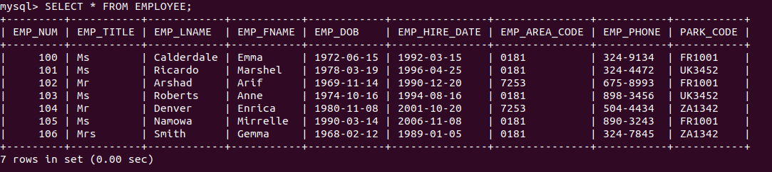
TESTING UPDATE COMMAND IN THE jawad user

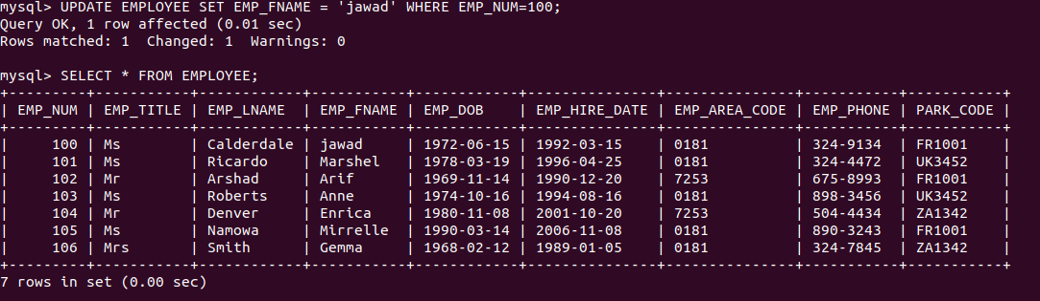

3: To access the views (SELECT) you have created in theme park (at least 1 view).

CREATING A VIEW NAMED ‘jawad_test’

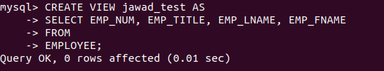
GRANTING USER jawad privilege to access the view
ACCESSING THE VIEW FROM THE USER ‘jawad’

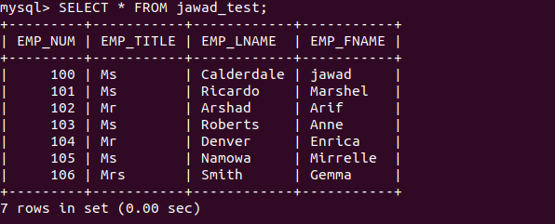

4: To access full database of fb/company (which you have used in last lab).
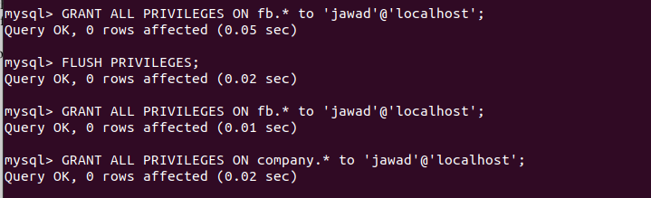
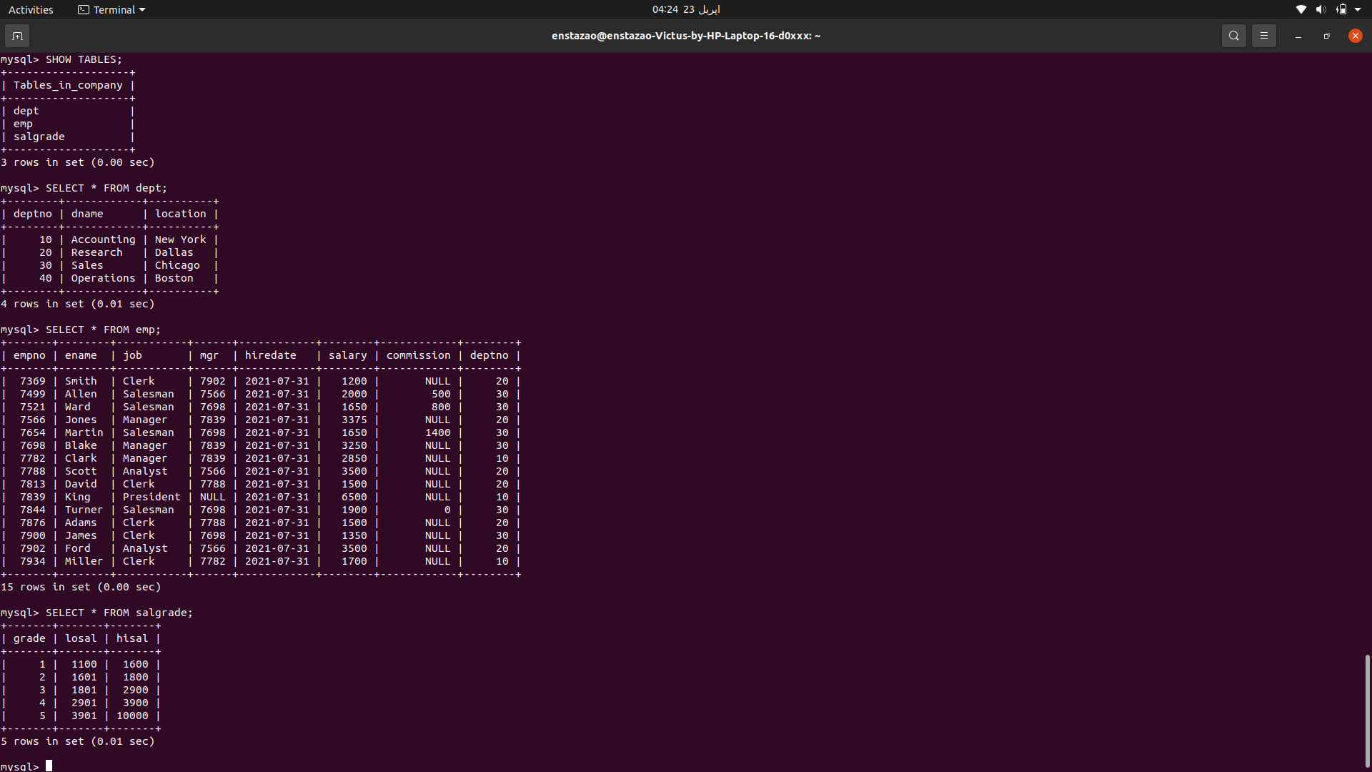

5: Grant A Privilege to Create A Database


CREATING A DATABASE IN THE jawad user


6: Revoke the right to access the view you granted in exercise 2.

ACCESSING THE VIEW as a jawad user

7: Give a demonstration of commit, rollback and save point commands.

- COMMIT COMMAND
When we disable the auto commit then what happen that when we do any operation that will be going to saved to another virtual table not to our actual table unless we commit it.
1: TURNING OFF THE AUTO COMMIT

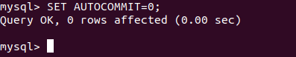

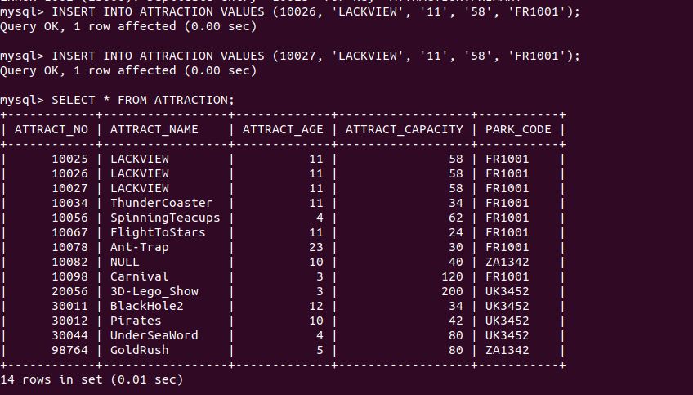
AFTER ROLL BACK THE NEW TWO INSERTION 10026, 10027 ARE GOING TO BE REMOVED.

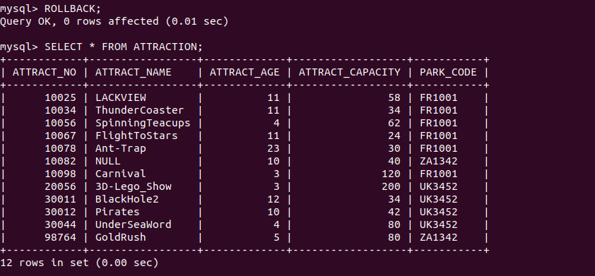
Now I am adding the two savepoints one savepoint is S1 that is before any insertion and another savepoint after the 2 insertions.

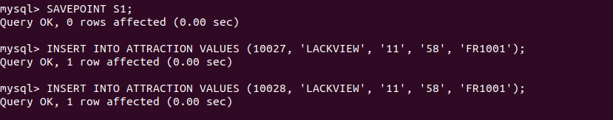

Now Let’s first rollback to the SAVEPOINT S2 you will see only 1 record removed that is inserted after the that savepoint.

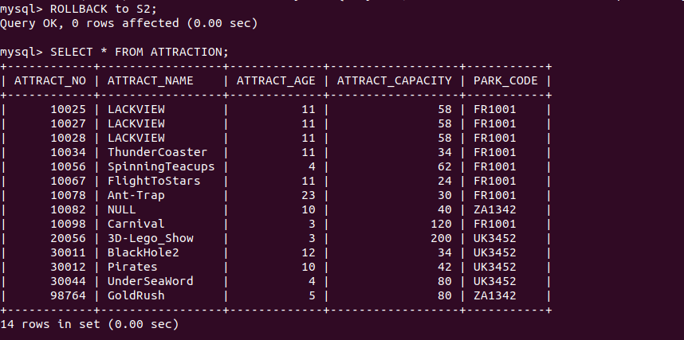
You will see the entry with ATTRACT_NO = 10029 that is added after the savepoint s2 is removed.
Now let’s move to the SAVEPOINT S1 now the entries that are added after the SAVEPOINT S1 will also going to be removed.

