Name : Jawad Ahmed
Roll No : 20P-0165
Section : BCS-4A
____________________________________________________________
1. Create a database named your rollno_section (i.e. P20_8784_4A).
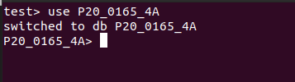

2. Create a collection named users.
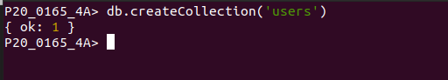

3. Insert the following record in the user’s collection.

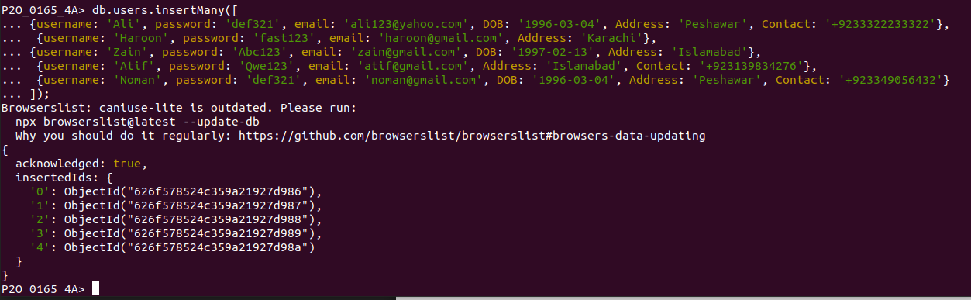

4. Show all users list using find command.
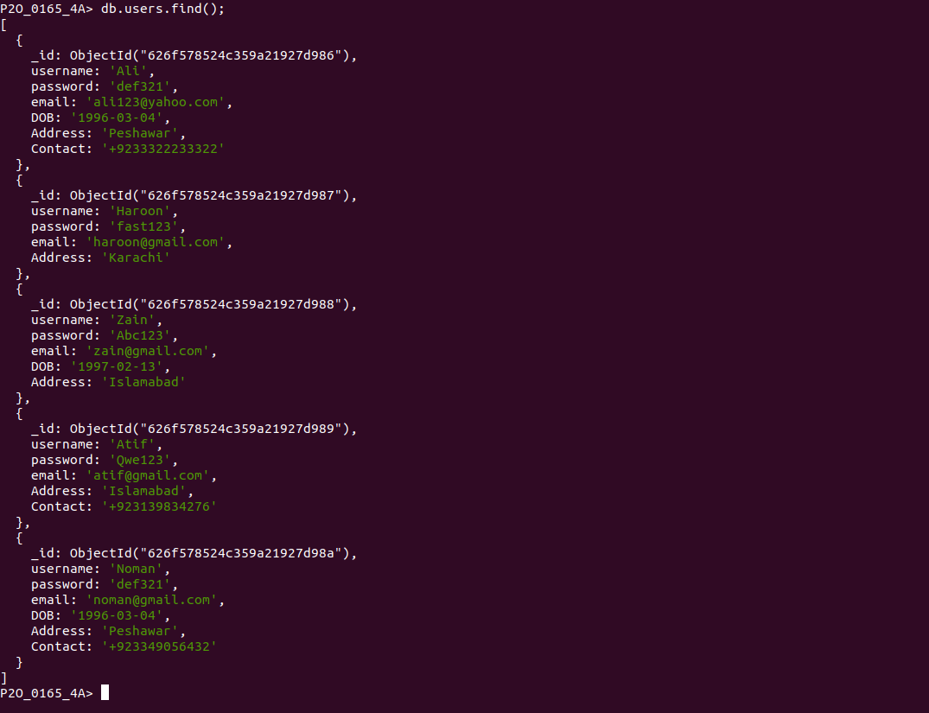
5. Show all users who lives in Islamabad.
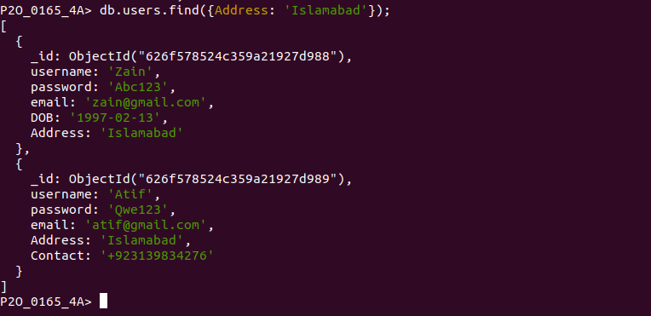

6. Show all the users who lives in Peshawar or in Karachi.
