Name: Jawad Ahmed
Rollno: 20P-0165
Section: BCS-4A
________________________________________________________________________________

1:Create a database named your rollno_section (i.e. 18P0014_6B).
Query => use 20P0165_4A
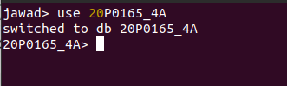

2) Create collections named cities and moviepeople_1000.
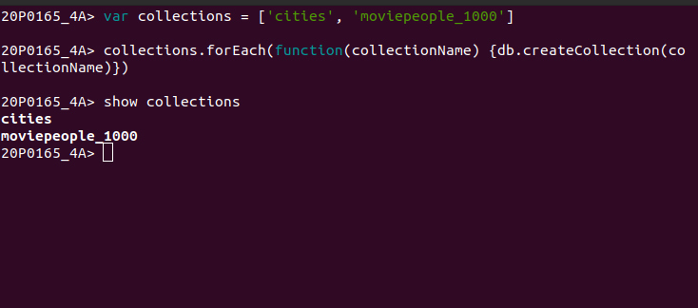
3) Import the documents cities.jsonl and moviepeople-1000.jsonl into the cities and
moviepeople collection respectively by issuing the following command.
(download the datasets from google class room in Datasets directory)

IMPORTING THROUGH COMMAND LINE

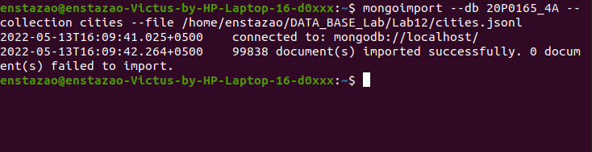

IMPORTING USING THE MONGODB COMPASS

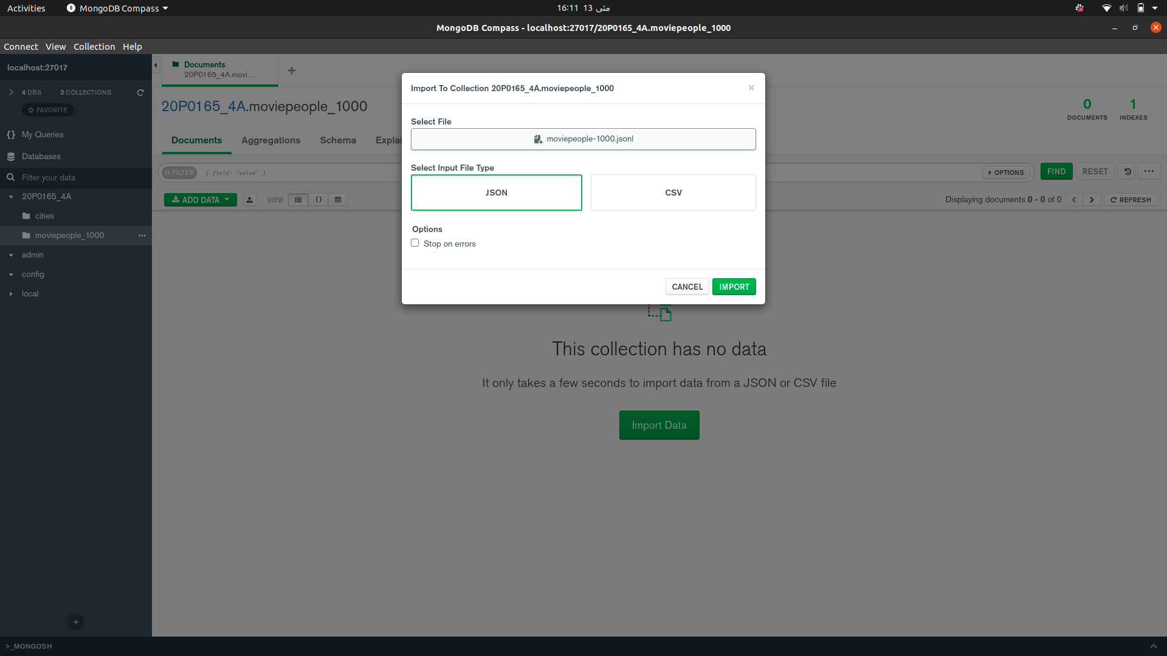
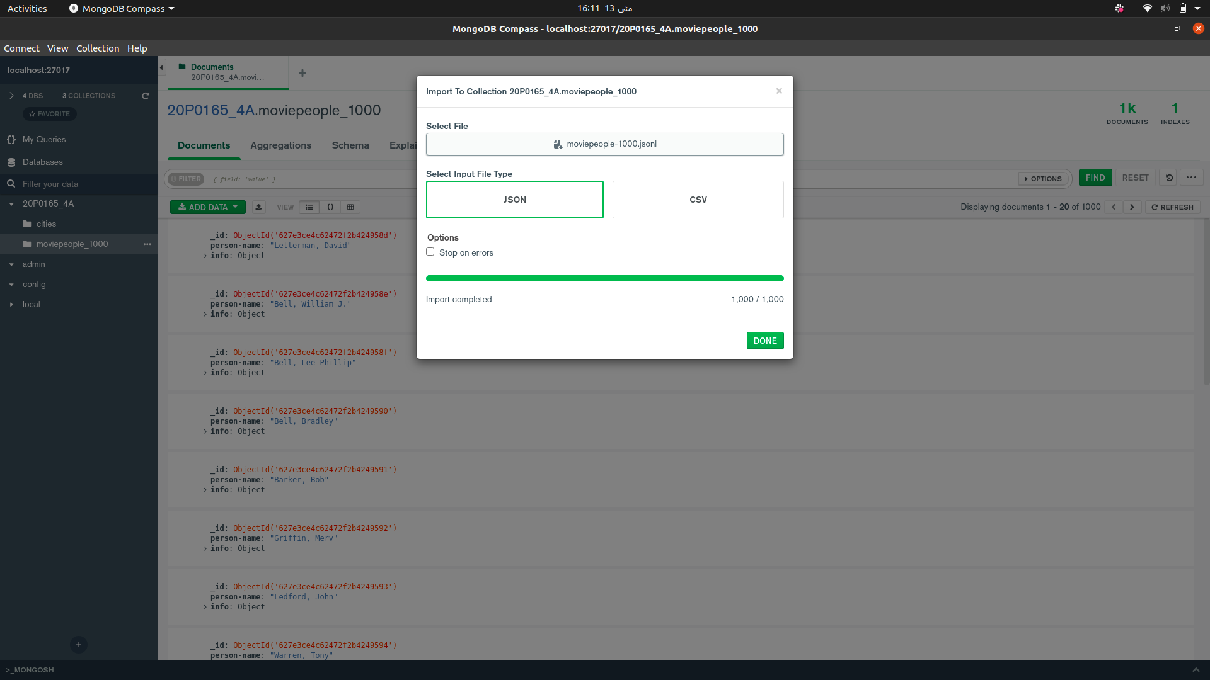

AFTER IMPORTING THE DATA IN THE COLLECTION moviepeople_100:
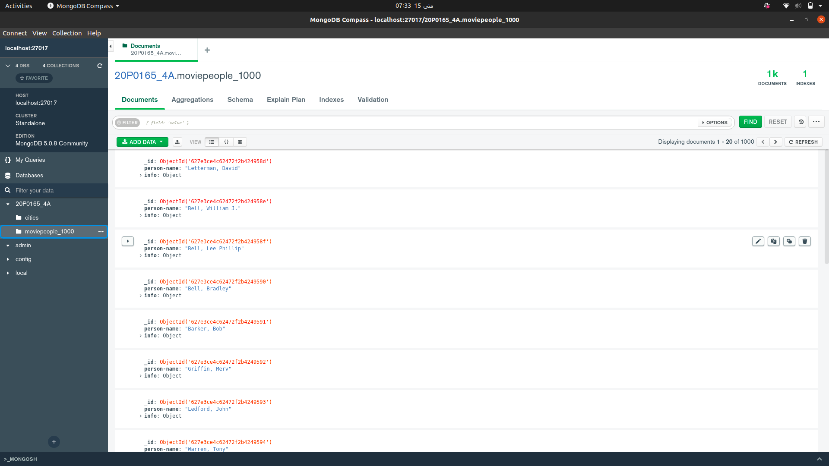

4) In the mongo shell client, write queries for finding: (hint: use cities collection)
i. All those cities whose time zone is Africa/Harare.

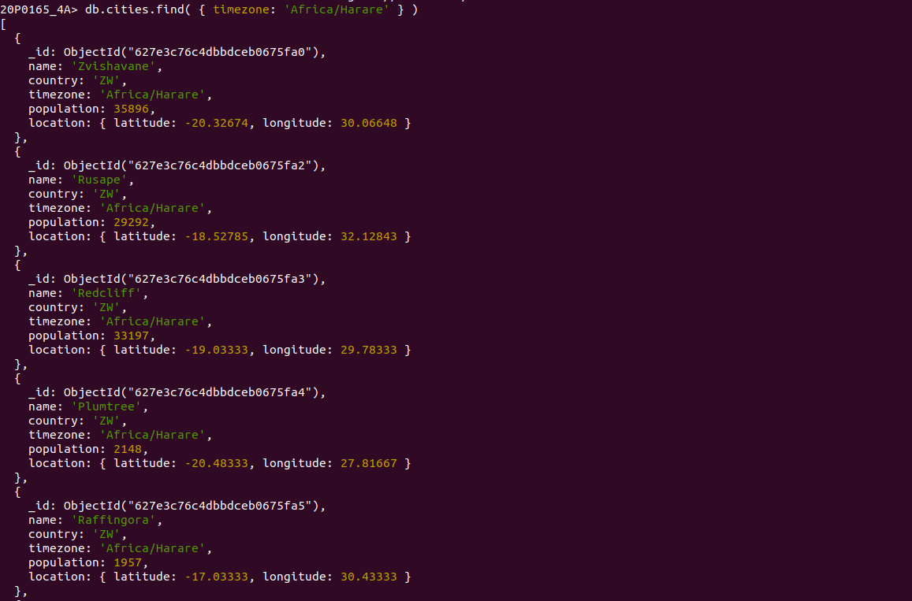

ii. All those cities whose population is greater than 12985000.
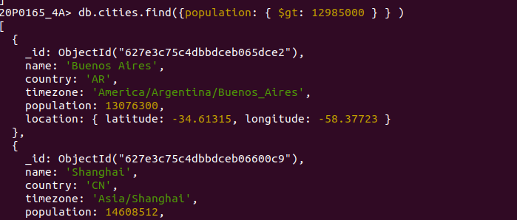
iii. A city whose longitude equals to -58.37723. Your query should return
location and population fields only. (hint: use projection)
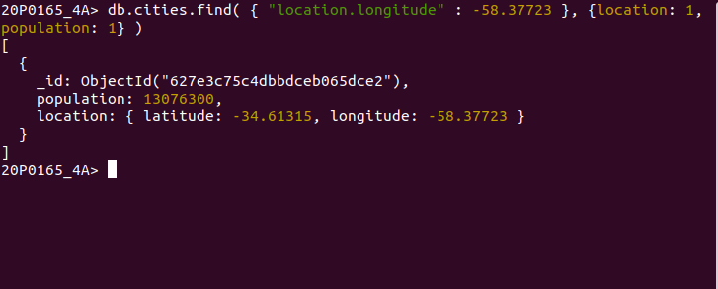
5) Write a query to update the population from 35000 to 55000 whose country is PK
and a location latitude of 73.2122. (hint: use cities collection)
QUERY:

db.cities.updateMany( { $and: [{ country: 'PK' }, { "location.latitude": 73.2122 }, { population: 35000 }] }, { $set: { population: 55000 } })

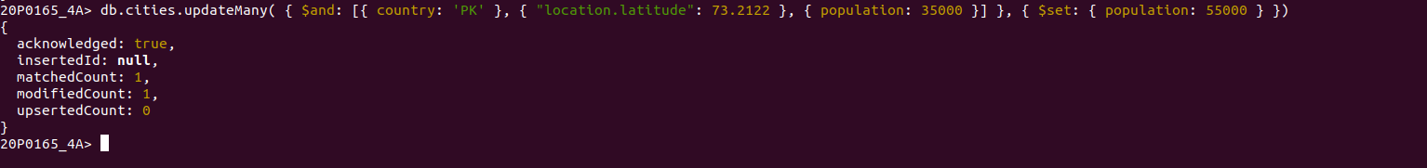

6) Write a query to delete the document whose timezone is Asia/Karachi and a
country is PK. (hint: use cities collection)

By default the AND operator is used

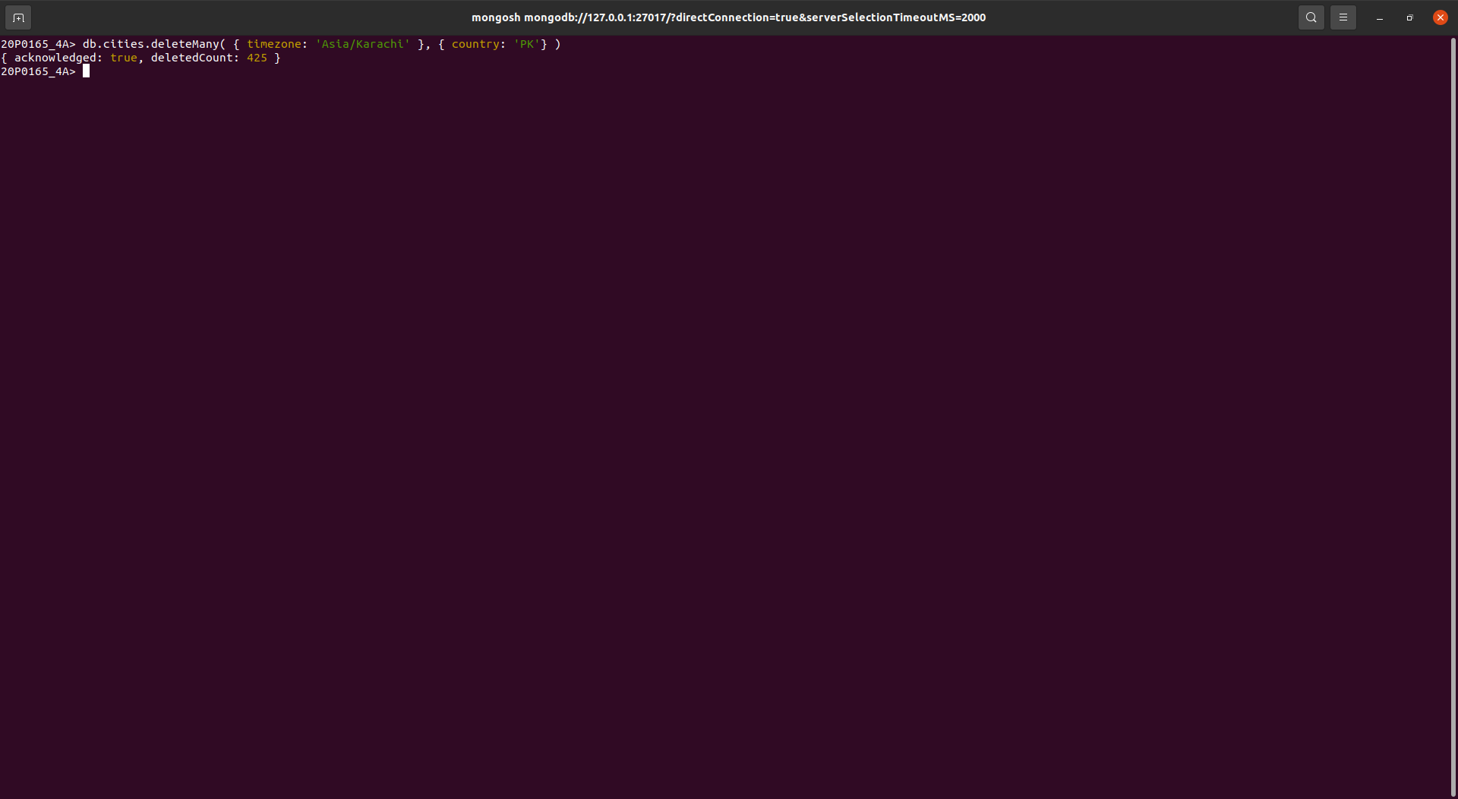
7) Write a query for finding the document whose birthname name array contains
(“Freeman, Crispin McDougal”) as a value. (hint: use moviepeople collection)

