Name : Jawad Ahmed
Roll No : 20P-0165
Section : BCS-4A

LAB#13 Excercises
________________________________________________________________________________

TASK#1:
Write a Query to return all the documents whose cities population is less than 30
not equal to zero, then uses the limit clause to limit the number of documents being returned to
just 2.

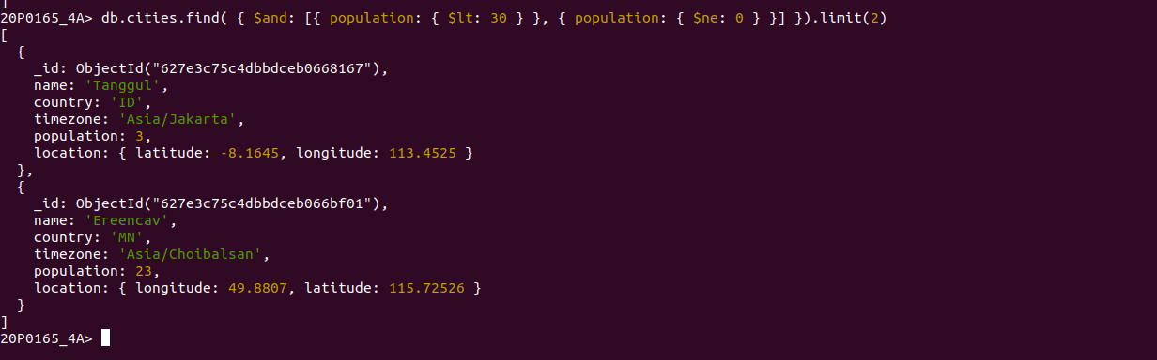

TASK#2:
Write a Query to count the number of the documents whose timezone is
“Asia/Jakarta”.

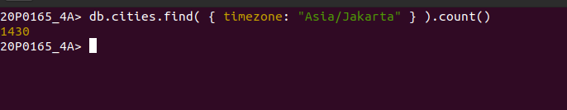

TASK#3:

Write a Query to return all the documents whose country is “PK” and country
timezone is “Asia/Karachi” and return the documents based on the
descending order of population.

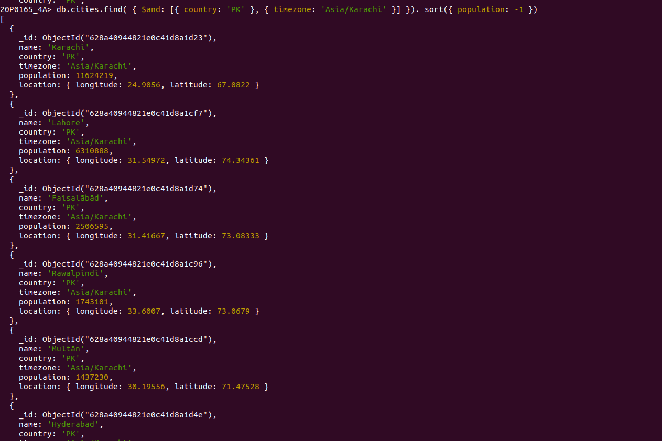
TASK#4:

Write a query to get all the Indexes of cities collection and then add the index on
population field and then drop the index on population field.

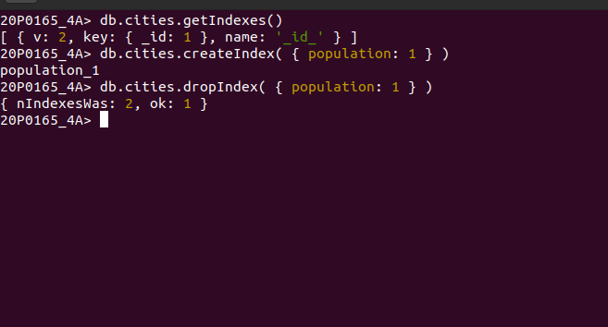

TASK#5:
Use MongoDB compass filter tab to write queries for finding:

- All those cities whose time zone is Europe/Andorra.

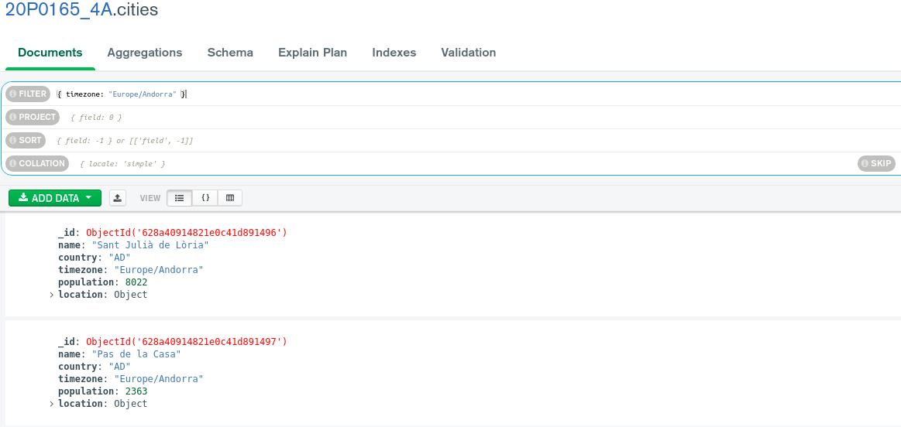
- All those cities whose population is greater than 12955000 and country is
AR.

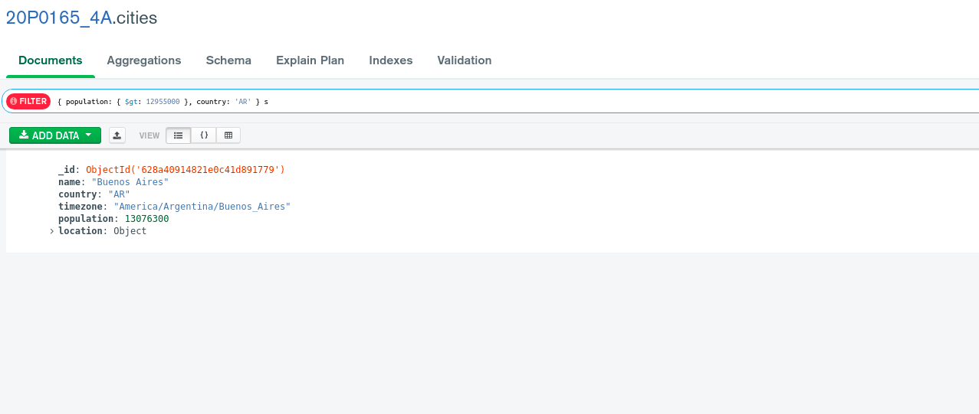

- A city whose longitude equals to 1.6. Your query should return location and
population fields only. (hint: use project)




