1.
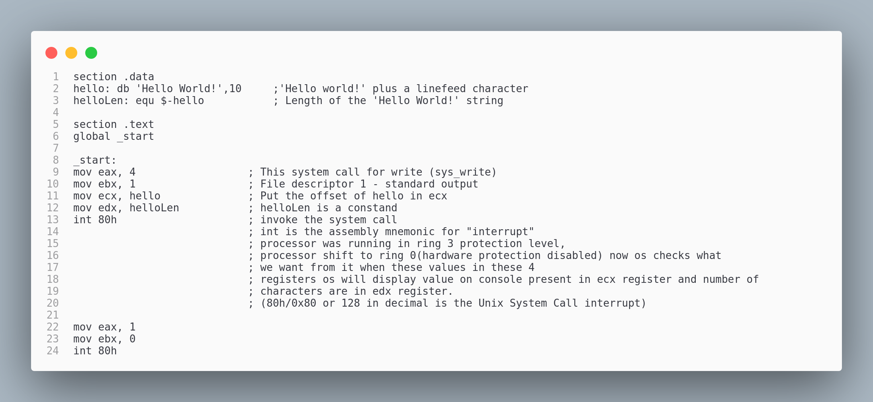
2.

3.

4.

5. int 80h that is equivalent to (80h/0x80 or 128 in decimal is the Unix System Call interrupt) is used to Invoke the system call. The processor was running in ring 3 protection level(the normal level for a process. The processor will switch to ring 0, hardware protection is disabled in this mode. This mean that the code will be executed from now on can do whatever it wants. Write everywhere in physical memory … etc. Now when interrupt is called the Operating see what the user want me to do it will see the values in the register and in this case we have write system call and whatever present in ecx register will be written on console and control goes back.

