Name : Jawad Ahmed
Roll No : 20P-0165
Section : BCS-4A
_____________________________________________________

2. Reproduce the code given in the section titled, “The Process Class”.

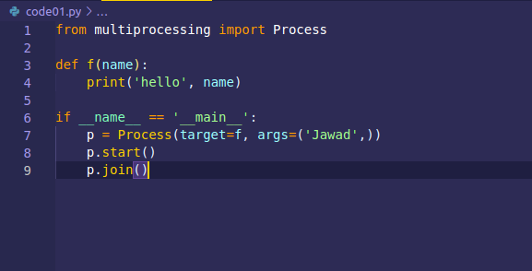
OUTPUT

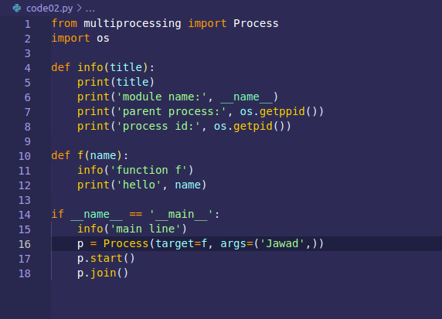

OUTPUT
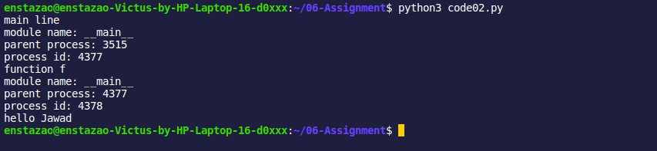
3. Currently, only a single process is being created instead. Modify the code so that 3 processes are created. Make
sure your output clearly demonstrates that there are three processes.

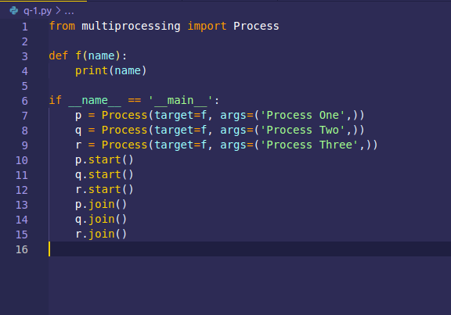
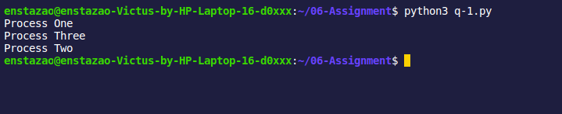
OUTPUT

4. Briefly write an explanation of how the Process class works. Your explanation should not be more than 3 lines
long.

The Process class is taking two parameters one is the function and the other are the function arguments and in this way process created. Then we have to start the process but in order to let our process to complete it’s execution we have to join the process so that on exiting of main function let the process to complete it’s execution and then exits.

