**Entaria**

Wire framing and initial sketches



**Section 1. Initial sketches**

**Section 2. Wire frames**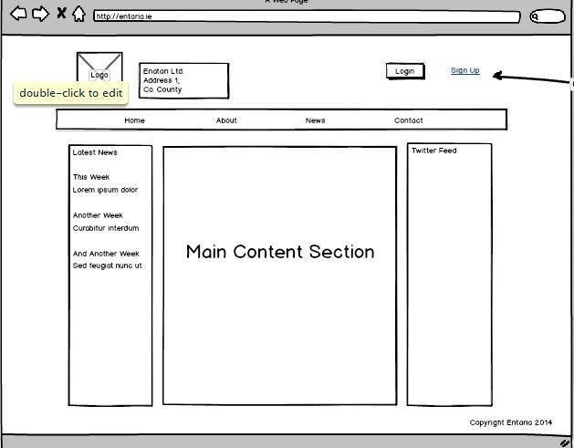

Figure 1. Main landing page with navigation and three column layout.

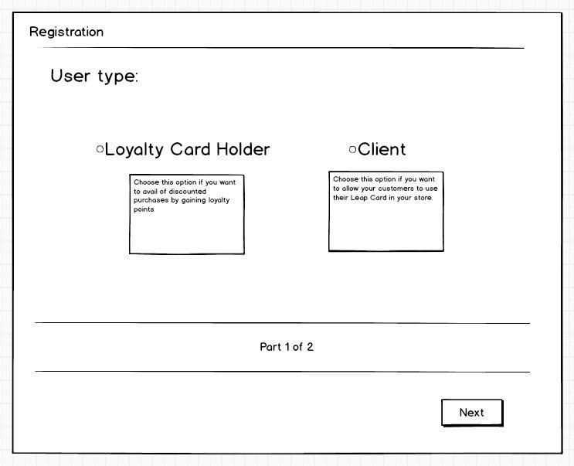

Figure 2. First section of registration.

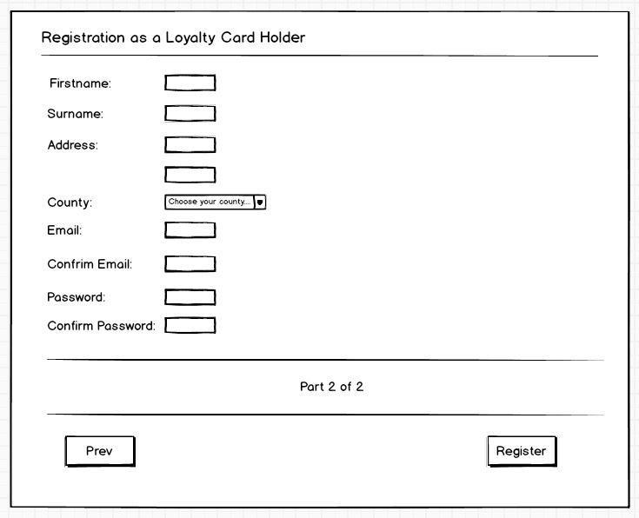

Figure 3. Continue registration as a L.C.H

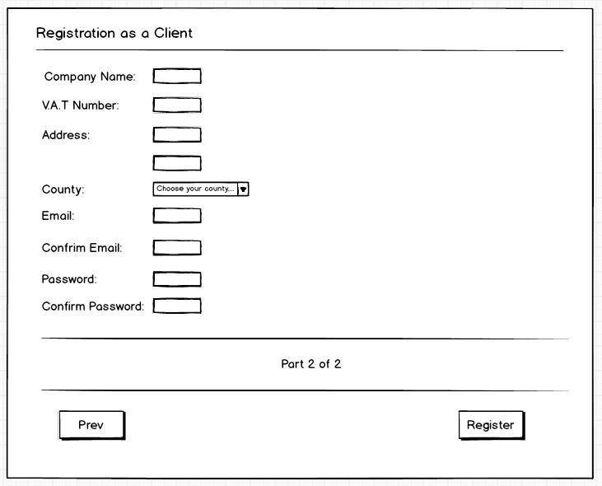

Figure 4. Continue registration as a client

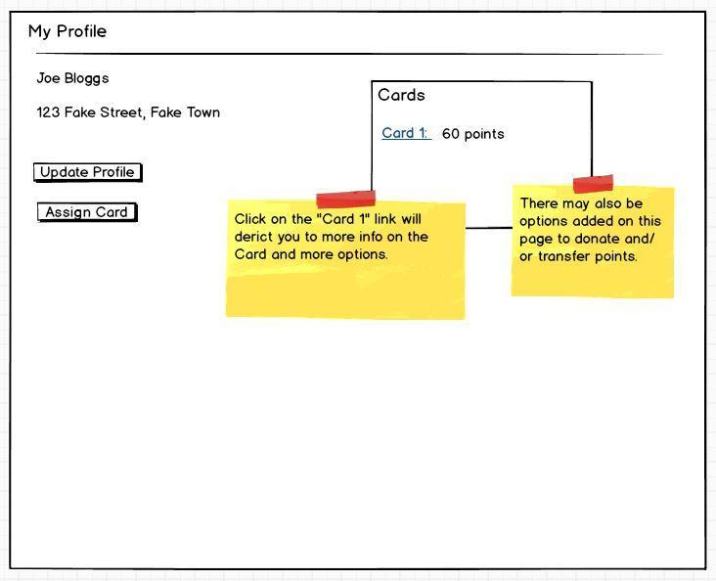

Figure 5. L.C.H profile page

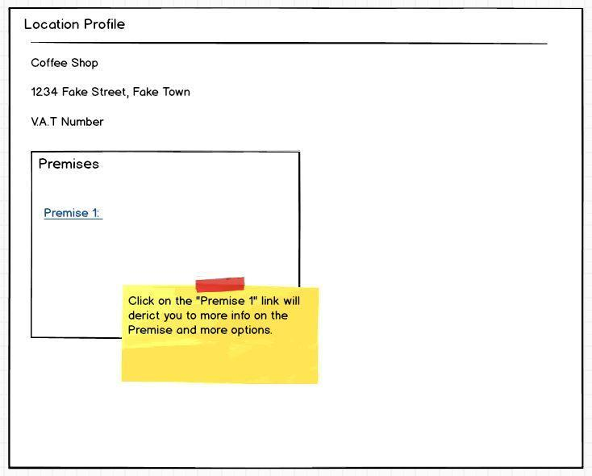

Figure 6. Client profile page

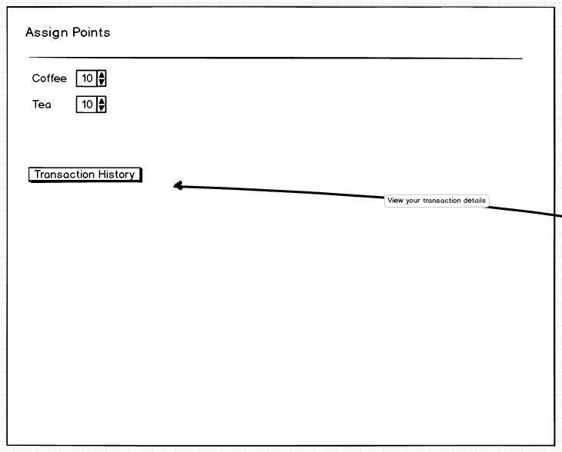

Figure 7. Assign points page

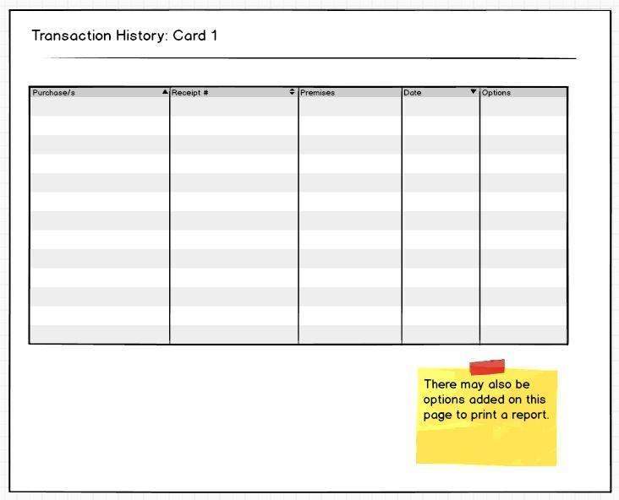

Figure 8. Card transaction history

Figure 9. Premise transaction history