Experiment 1 — VHDL Code for 4-bit ALU

VHDL Design Code (alu4bit.vhd)

library IEEE;
use IEEE.STD_LOGIC_1164.ALL;
use IEEE.STD_LOGIC_unsigned.ALL;

entity alu4bit is Port (
n1 : in STD_LOGIC_VECTOR (3 downto 0); n2 : in STD_LOGIC_VECTOR (3 downto 0); op : in STD_LOGIC_VECTOR (2 downto 0); res : out STD_LOGIC_VECTOR (3 downto 0); flag : out STD_LOGIC
);
end alu4bit;

architecture Behavioral of alu4bit is begin

process(n1, n2, op)
variable temp : std_logic_vector(4 downto 0); begin

flag <= '0'; case op is
when "000" =>
temp := ('0' & n1) + n2; res <= temp(3 downto 0); flag <= temp(4);

when "001" =>
if (n1 > n2) then res <= n1 - n2;
else
res <= n2 - n1; end if;

when "010" =>
res <= n1 and n2;

when "011" =>
res <= n1 nand n2;

when "100" =>
res <= n1 xor n2; when "101" =>

res <= n1 nor n2;

when "110" =>
res <= n1 xnor n2;

when others => res <= n2;

end case; end process;
end Behavioral;

- VHDL Testbench Code (alu_tb.vhd)

library IEEE;
use IEEE.STD_LOGIC_1164.ALL;

entity alu_tb is end alu_tb;
architecture Behavioral of alu_tb is component alu4bit
Port (
n1 : in STD_LOGIC_VECTOR (3 downto 0); n2 : in STD_LOGIC_VECTOR (3 downto 0); op : in STD_LOGIC_VECTOR (2 downto 0); res : out STD_LOGIC_VECTOR (3 downto 0); flag : out STD_LOGIC
);
end component;

signal n1 : STD_LOGIC_VECTOR (3 downto 0); signal n2 : STD_LOGIC_VECTOR (3 downto 0); signal op : STD_LOGIC_VECTOR (2 downto 0); signal res : STD_LOGIC_VECTOR (3 downto 0); signal flag : STD_LOGIC;

begin

uut : alu4bit port map (
n1 => n1, n2 => n2,
op => op, res => res, flag => flag
);

stim_proc : process begin

n1 <= "0101";
n2 <= "1011";

op <= "000";
wait for 500 ns;

op <= "001";
wait for 500 ns;

op <= "010";
wait for 500 ns;

op <= "011";
wait for 500 ns;

op <= "100";
wait for 500 ns;

op <= "101";
wait for 500 ns;

op <= "110";
wait for 500 ns;

op <= "111";
wait for 500 ns; wait;
end process; end Behavioral;

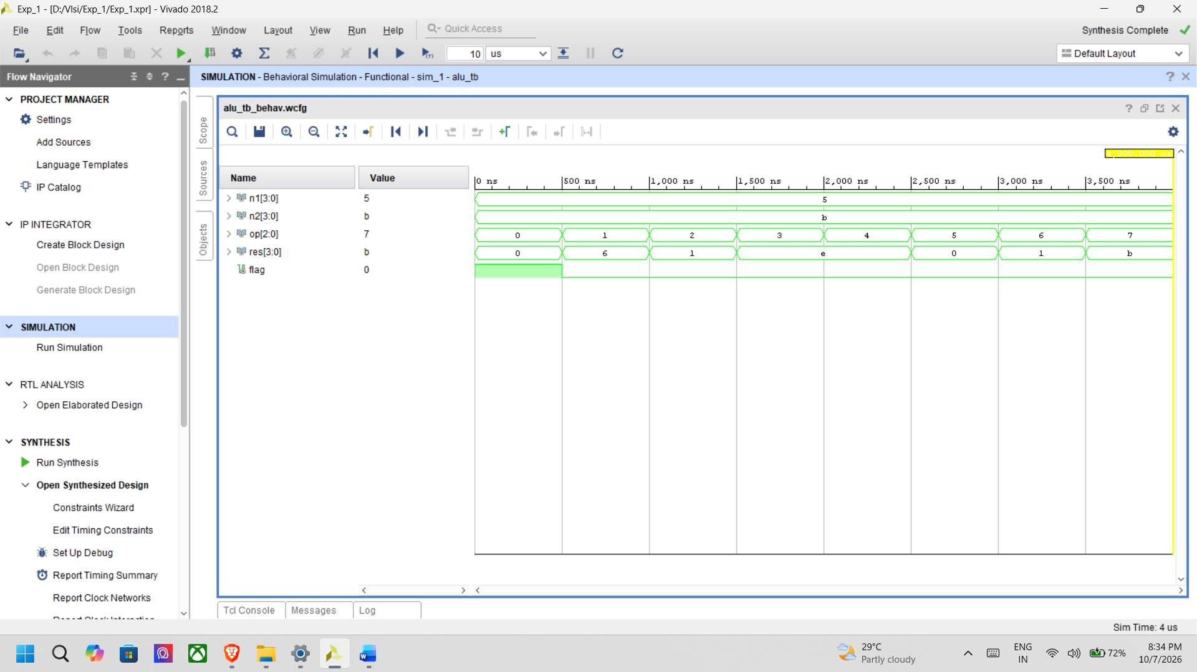

Constraints File (alu4bit.xdc / UCF)
## I/O Standard

set_property IOSTANDARD LVCMOS33 [get_ports {n1[3]}] set_property IOSTANDARD LVCMOS33 [get_ports {n1[2]}] set_property IOSTANDARD LVCMOS33 [get_ports {n1[1]}] set_property IOSTANDARD LVCMOS33 [get_ports {n1[0]}]

set_property IOSTANDARD LVCMOS33 [get_ports {n2[3]}] set_property IOSTANDARD LVCMOS33 [get_ports {n2[2]}] set_property IOSTANDARD LVCMOS33 [get_ports {n2[1]}] set_property IOSTANDARD LVCMOS33 [get_ports {n2[0]}]

set_property IOSTANDARD LVCMOS33 [get_ports {op[2]}] set_property IOSTANDARD LVCMOS33 [get_ports {op[1]}] set_property IOSTANDARD LVCMOS33 [get_ports {op[0]}]

set_property IOSTANDARD LVCMOS33 [get_ports {res[3]}] set_property IOSTANDARD LVCMOS33 [get_ports {res[2]}] set_property IOSTANDARD LVCMOS33 [get_ports {res[1]}] set_property IOSTANDARD LVCMOS33 [get_ports {res[0]}]

set_property IOSTANDARD LVCMOS33 [get_ports flag]

## Package Pins

set_property PACKAGE_PIN R2 [get_ports {n1[3]}]

set_property PACKAGE_PIN T1 [get_ports {n1[2]}] set_property PACKAGE_PIN U1 [get_ports {n1[1]}] set_property PACKAGE_PIN W2 [get_ports {n1[0]}]

set_property PACKAGE_PIN R3 [get_ports {n2[3]}] set_property PACKAGE_PIN T2 [get_ports {n2[2]}] set_property PACKAGE_PIN T3 [get_ports {n2[1]}] set_property PACKAGE_PIN V2 [get_ports {n2[0]}]

set_property PACKAGE_PIN W13 [get_ports {op[2]}] set_property PACKAGE_PIN W14 [get_ports {op[1]}] set_property PACKAGE_PIN V15 [get_ports {op[0]}]

set_property PACKAGE_PIN L1 [get_ports {res[3]}] set_property PACKAGE_PIN P1 [get_ports {res[2]}] set_property PACKAGE_PIN N3 [get_ports {res[1]}] set_property PACKAGE_PIN P3 [get_ports {res[0]}]

set_property PACKAGE_PIN U3 [get_ports flag]


