Experiment 3 — VHDL code for MOD-N counter
- MOD_N_Counter.vhd

library IEEE;
use IEEE.STD_LOGIC_1164.ALL; use IEEE.NUMERIC_STD.ALL;

entity mod6_counter is Port (
clk : in STD_LOGIC; rst : in STD_LOGIC;
q : out STD_LOGIC_VECTOR(3 downto 0)
);
end mod6_counter;
architecture Behavioral of mod6_counter is signal count : unsigned(3 downto 0) := "0000";
signal clk_count : integer range 0 to 49999999 := 0; begin
process(clk, rst) begin
if rst = '1' then count <= "0000";
clk_count <= 0;

elsif rising_edge(clk) then

if clk_count = 49999999 then clk_count <= 0;

if count = 5 then count <= "0000";
else
count <= count + 1; end if;

else
clk_count <= clk_count + 1; end if;

end if;

end process;

q <= std_logic_vector(count); end Behavioral;
- MOD_N_Counter_tb.vhd

library IEEE;
use IEEE.STD_LOGIC_1164.ALL;

entity mod6_counter_tb is end mod6_counter_tb;
architecture Behavioral of mod6_counter_tb is signal clk : STD_LOGIC := '0';
signal rst : STD_LOGIC := '1';
signal q : STD_LOGIC_VECTOR(3 downto 0); begin
-- Connect testbench to MOD-6 counter DUT : entity work.mod6_counter
port map ( clk => clk, rst => rst, q => q
);

-- Generate clock
clk <= not clk after 5 ns;

process begin

-- Reset rst <= '1';
wait for 20 ns;

-- Start counting rst <= '0';

-- Let counter run wait for 500 ns;

wait;
end process; end Behavioral;
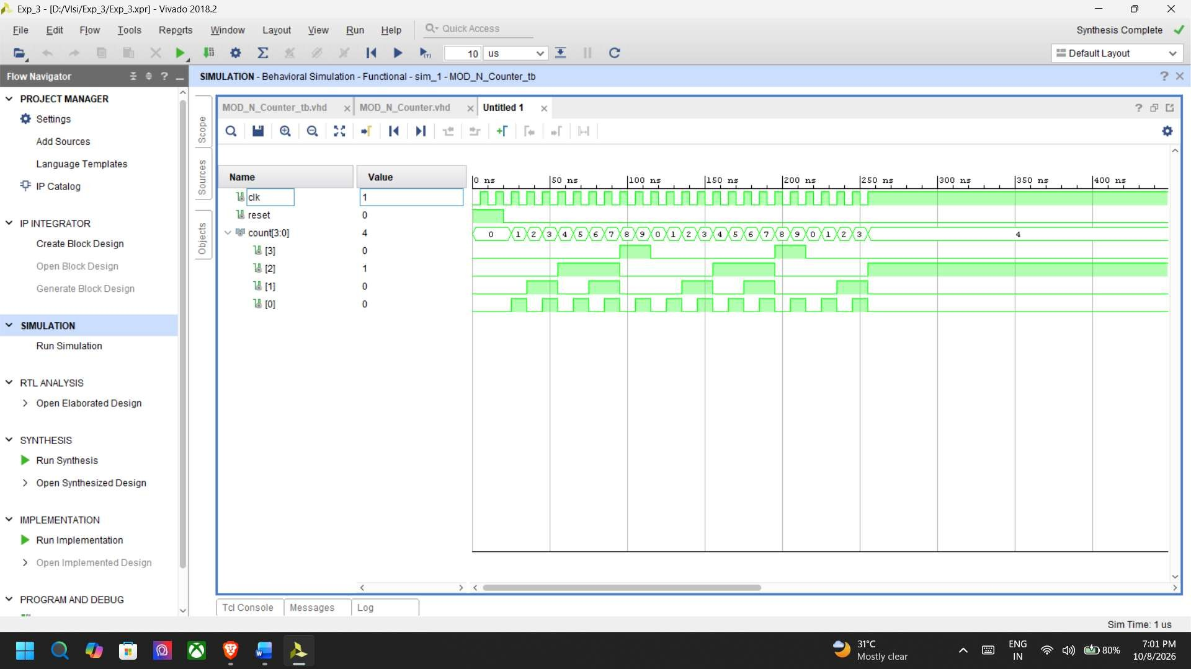

- UCF/XDC
## MOD-7 Counter - Basys 3 (Artix-7 xc7a35tcpg236-1) constraints

## 100 MHz on-board clock
set_property -dict { PACKAGE_PIN W5 IOSTANDARD LVCMOS33 } [get_ports clock] create_clock -add -name sys_clk_pin -period 10.000 -waveform {0 5} [get_ports clock]

## Reset - centre push button (BTNC)
set_property -dict { PACKAGE_PIN U18 IOSTANDARD LVCMOS33 } [get_ports reset]

## Counter output on LD0..LD2
set_property -dict { PACKAGE_PIN U16 IOSTANDARD LVCMOS33 } [get_ports {output[0]}] set_property -dict { PACKAGE_PIN E19 IOSTANDARD LVCMOS33 } [get_ports {output[1]}] set_property -dict { PACKAGE_PIN U19 IOSTANDARD LVCMOS33 } [get_ports {output[2]}]

## Configuration options
set_property CFGBVS VCCO [current_design] set_property CONFIG_VOLTAGE 3.3 [current_design]
set_property BITSTREAM.GENERAL.COMPRESS TRUE [current_design]

