Experiment 4 — VHDL code for FIFO

VHDL Design Code (fifo.vhd)
library IEEE;
use IEEE.STD_LOGIC_1164.ALL; use IEEE.NUMERIC_STD.ALL;

entity fifo is Port (
clk : in STD_LOGIC; rst : in STD_LOGIC; wren : in STD_LOGIC; rden : in STD_LOGIC;
empty : out STD_LOGIC; full : out STD_LOGIC;
dataout : out STD_LOGIC_VECTOR(7 downto 0)
);
end fifo;

architecture Behavioral of FIFO is

-- 8 locations, 8 bits each
type fifo_memory is array (0 to 7)
of STD_LOGIC_VECTOR(7 downto 0);

-- Data used for this experiment signal memory : fifo_memory := (
"10101010",
"10111011",
"10010101",
"11110000",
"00001111",
"10100101",
"11110101",
"01100110"
);

-- Read and write pointers
signal rdptr : integer range 0 to 7 := 0; signal wrptr : integer range 0 to 7 := 0;

-- Number of elements in FIFO
signal count : integer range 0 to 8 := 0;

-- Output register
signal dataout_reg : STD_LOGIC_VECTOR(7 downto 0)
:= (others => '0');

begin

process(clk) begin

if rising_edge(clk) then

-- RESET
if rst = '1' then

rdptr <= 0;
wrptr <= 0;
count <= 0;
dataout_reg <= (others => '0'); else

-- WRITE OPERATION
if (wren = '1') and (count < 8) then

-- Advance write pointer if wrptr = 7 then
wrptr <= 0; else
wrptr <= wrptr + 1; end if;

end if;

-- READ OPERATION
if (rden = '1') and (count > 0) then dataout_reg <= memory(rdptr);
-- Advance read pointer if rdptr = 7 then
rdptr <= 0; else
rdptr <= rdptr + 1; end if;

end if;

-- FIFO COUNT
if (wren = '1') and (count < 8) and
not ((rden = '1') and (count > 0)) then count <= count + 1;
elsif (rden = '1') and (count > 0) and

not ((wren = '1') and (count < 8)) then count <= count - 1;
end if; end if;
end if; end process;

-- EMPTY flag
empty <= '1' when count = 0 else '0';

-- FULL flag
full <= '1' when count = 8 else '0';

-- Output
dataout <= dataout_reg; end Behavioral;
- VHDL Testbench code (fifo_tb1.vhd)

library IEEE;
use IEEE.STD_LOGIC_1164.ALL;

entity FIFO_tb1 is end FIFO_tb1;

architecture Behavioral of FIFO_tb1 is

-- FIFO component component FIFO
Port (
clk : in STD_LOGIC; rst : in STD_LOGIC; wren : in STD_LOGIC; rden : in STD_LOGIC;
empty : out STD_LOGIC; full : out STD_LOGIC;
dataout : out STD_LOGIC_VECTOR(7 downto 0)
);
end component;

-- Testbench signals
signal clk : STD_LOGIC := '0';

signal rst : STD_LOGIC := '0'; signal wren : STD_LOGIC := '0'; signal rden : STD_LOGIC := '0';

signal empty : STD_LOGIC; signal full : STD_LOGIC;

signal dataout : STD_LOGIC_VECTOR(7 downto 0);

begin

-- FIFO instance UUT : FIFO
port map (
clk => clk,
rst => rst, wren => wren, rden => rden,
empty => empty, full => full, dataout => dataout
);

-- CLOCK GENERATION
-- Clock period = 10 ns clk_process : process begin
for i in 0 to 30 loop clk <= '0';
wait for 5 ns;

clk <= '1'; wait for 5 ns;

end loop; wait;
end process;

-- TEST SEQUENCE
stimulus : process begin

-- STEP 1: RESET

rst <= '1';
wren <= '0';
rden <= '0'; wait for 20 ns;

-- STEP 2: RELEASE RESET

rst <= '0';

wait for 10 ns;

-- STEP 3: WRITE 8 DATA VALUES

wren <= '1'; wait for 80 ns; wren <= '0'; wait for 20 ns;

-- STEP 4: READ 8 DATA VALUES

rden <= '1'; wait for 80 ns; rden <= '0'; wait for 20 ns;

-- END SIMULATION
wait;

end process; end Behavioral;

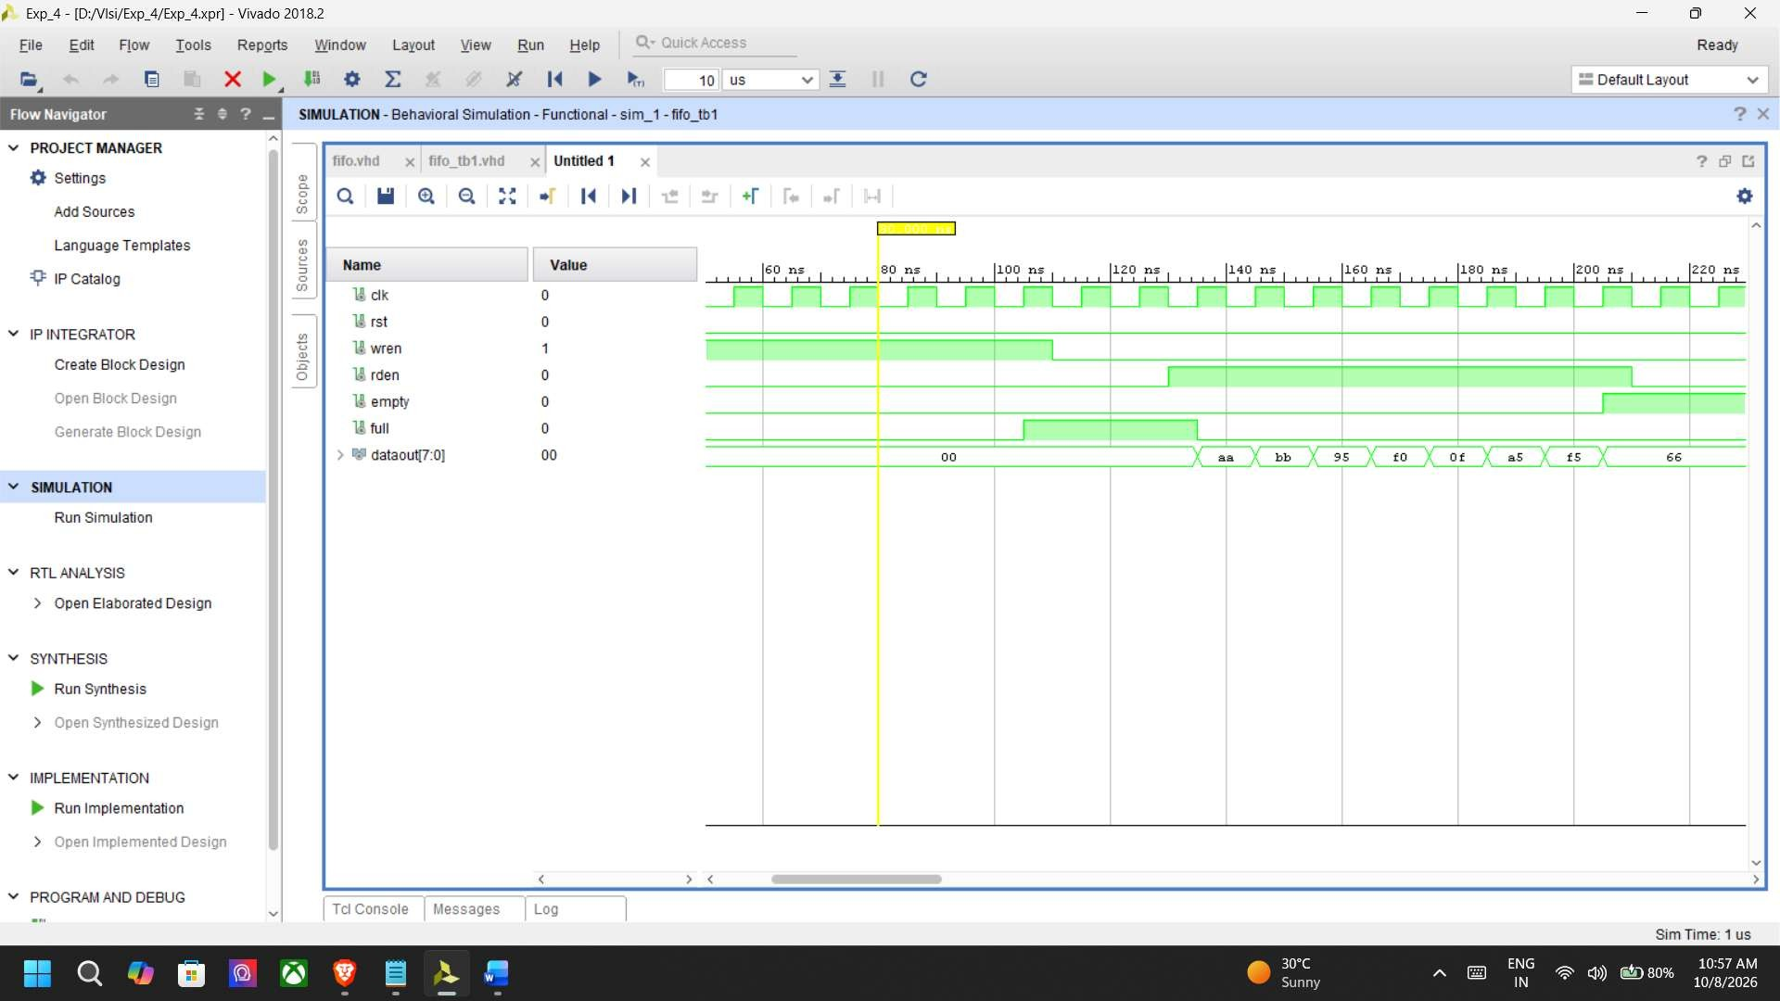
Simulation Waveforms

- (XDC/UCF) file
## =========================================================
## FIFO - Basys 3 Constraints
## =========================================================

## Clock - 100 MHz
set_property PACKAGE_PIN W5 [get_ports clk] set_property IOSTANDARD LVCMOS33 [get_ports clk]
create_clock -period 10.000 -name sys_clk_pin -waveform {0.000 5.000} [get_ports clk]

## ========================================================= ## RESET
## Center Push Button
## =========================================================

set_property PACKAGE_PIN U18 [get_ports rst] set_property IOSTANDARD LVCMOS33 [get_ports rst]

## ========================================================= ## WRITE ENABLE
## Left Push Button
## =========================================================

set_property PACKAGE_PIN W19 [get_ports wren] set_property IOSTANDARD LVCMOS33 [get_ports wren]

## ========================================================= ## READ ENABLE
## Right Push Button

## =========================================================

set_property PACKAGE_PIN T17 [get_ports rden] set_property IOSTANDARD LVCMOS33 [get_ports rden]

## ========================================================= ## FIFO DATA OUTPUT
## dataout[7:0] -> LED[7:0]
## =========================================================

set_property PACKAGE_PIN U16 [get_ports {dataout[0]}] set_property IOSTANDARD LVCMOS33 [get_ports {dataout[0]}]

set_property PACKAGE_PIN E19 [get_ports {dataout[1]}] set_property IOSTANDARD LVCMOS33 [get_ports {dataout[1]}]

set_property PACKAGE_PIN U19 [get_ports {dataout[2]}] set_property IOSTANDARD LVCMOS33 [get_ports {dataout[2]}]

set_property PACKAGE_PIN V19 [get_ports {dataout[3]}] set_property IOSTANDARD LVCMOS33 [get_ports {dataout[3]}]

set_property PACKAGE_PIN W18 [get_ports {dataout[4]}] set_property IOSTANDARD LVCMOS33 [get_ports {dataout[4]}]

set_property PACKAGE_PIN U15 [get_ports {dataout[5]}] set_property IOSTANDARD LVCMOS33 [get_ports {dataout[5]}]

set_property PACKAGE_PIN U14 [get_ports {dataout[6]}] set_property IOSTANDARD LVCMOS33 [get_ports {dataout[6]}]

set_property PACKAGE_PIN V14 [get_ports {dataout[7]}] set_property IOSTANDARD LVCMOS33 [get_ports {dataout[7]}]

## ========================================================= ## FIFO STATUS
## LED8 = FULL ## LED9 = EMPTY
## =========================================================

set_property PACKAGE_PIN V13 [get_ports full] set_property IOSTANDARD LVCMOS33 [get_ports full]

set_property PACKAGE_PIN V3 [get_ports empty] set_property IOSTANDARD LVCMOS33 [get_ports empty]

Schematic


