Professional A/V Solutions



**VM0808H**

8x8 HDMI Matrix Switch

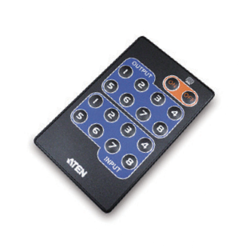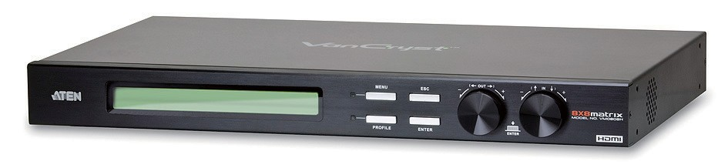

The ATEN VanCryst VM0808H 8x8 HDMI Matrix Switch is a distinct HDMI solution that offers an easy and affordable way to route any of 8 HDMI video sources to any of 8 HDMI displays, and view them in any arrangement.

As a matrix switch the VM0808H allows eight HDMI source devices to cross connect to eight HDMI displays at the same time, while independently controlling the output in any array possible, giving you the ultimate flexibility and control in any multi-display HDMI installation.

**A/V In HDMI**



**A/V Out HDMI**

HDCP



**RS-232**

# Specification

**Features**

* Connects any of 8 HDMI sources to any of 8 HDMI displays
* Long Distance Transmission - supports up to 20 meters (24

**Function VM0808H**

HDMI In 8 x HDMI Type A Female (Black) HDMI Out 8 x HDMI Type A Female (Black) Ethernet 1 x RJ-45 Female

AWG)

* HDMI (3D, Deep Color) and HDCP compatible
* Easily switch between multiple sources and multiple displays
* Front Panel Conﬁguration:
  + Front panel LCD display
  + Tuner Dials and Pushbuttons
  + IR Remote Control
* System Operation:
  + Serial controller
  + Browser Graphical User Interface (GUI)
* Superior video quality – HDTV resolution of 480p, 720p,

Connectors

Switches

RS-232 1 x DB-9 Female (Black)

IR Input Port 1 x Mini Stereo Jack Female (Black) Power 1 x 3-prong AC Socket

In 1 x Tuner Button

Out 1 x Tuner Button

Esc 1 x Pushbutton

Menu 1 x Pushbutton

Proﬁle 1 x Pushbutton

Enter 1 x Pushbutton

Power 1 x Rocker

1080i, and 1080p (1920 x 1080), VGA, SVGA, SXGA, UXGA and WUXGA (1920 x 1200)

* Features EDID Expert technology :
  + EDID Library with 14 default EDID conﬁgurations
  + Built-in EDID Mode selection
  + Copies a display's EDID to selected source devices

Menu 1 (Green)

LEDs

Proﬁle 1 (Green)

I/P Rating 100-240VAC; 50-60Hz;1A

Power Consumption 120V,32W/230V,34W Operating

Temp. 0–50ºC

* Supports Dolby True HD and DTS HD Master audio
* Signaling rates up to 2.25 Gbits in support of 1080p display
* Feature EDID Expert technology to set up different conﬁgurations via different EDID modes
* Power on Detection - If an HDMI sources is powered off, the VM0808H can automatically switch to the next powered-on source
* Firmware upgradeable
* Rack Mountable

Environment

Physical Properties

Storage Temp. -20–60ºC

Humidity 0–80% RH, Non-condensing Housing Metal

Weight 4.01 kg

Dimensions

(L x W x H) 43.24 x 27.12 x 4.40 cm

***ATEN International Co., Ltd.***

3F., No.125, Sec. 2, Datong Rd., Sijhih District., New Taipei City 221, Taiwan

© Copyright 2012 ATEN® International Co., Ltd.

Printed 03/2014 V2.0

Phone: 886-2-8692-6789 Fax: 886-2-8692-6767

[www.aten.com](http://www.aten.com/) E-mail: [marketing@aten.com](mailto:marketing@aten.com)

ATEN and the ATEN logo are trademarks of ATEN International Co., Ltd. All rights reserved. All other trademarks are the property of their respective owners.