PROJECT TITLE PROPOSAL

- Name of Proponents:
Catolico, Denmark N.
Rojas, John Ber R.
Piquero, Stephen Dave M.
Verez, Steffanni

- Proposed Case Study Title
LIKHA: Ang Lahi A Filipino mythology – Themed RPG Game

- Area of Investigation
South East Asian Institute of Technology (SEAIT)
National Highway, Purok 7, Crossing Rubber, Municipality of Tupi, South Cotabato, Philippines, 9505

- Cited Problems
This study aims to answer the following problems of LIKHA: Ang Lahi A
Filipino mythology – Themed RPG Game.
4.1 The game provides limited character customization options, reducing player creativity and personalization.
4.2 The combat system becomes repetitive, making gameplay less engaging for players.
4.3 The game makes it difficult for players to organize their items and equipment, causing inconvenience during gameplay.
4.4 The game has repetitive enemy encounters, reducing the excitement and challenge of battles.
4.5 The game provides limited navigation guidance, making it difficult for players to explore different areas.
4.6 The game does not clearly present story objectives and quests, causing confusion during gameplay.
4.7 The game does not properly retain player progress, which may result in lost game data.
4.8 The game has a user interface that is difficult to understand, making it harder for players to navigate menus.
4.9 The game provides limited rewards and achievements, reducing player motivation to continue playing

- Functions of the Proposed System
The proposed LIKHA: A Filipino Mythology-Themed RPG Game aims to deliver an engaging role-playing experience inspired by Filipino mythology. It allows players to customize their characters, fight mythical enemies, manage inventory and equipment, explore different areas, complete story-driven quests, save game progress, and unlock rewards and achievements. The game also includes a user-friendly interface to provide smooth navigation and an immersive gameplay experience.

- Features of the Proposed System
Character Customization
Allows players to customize their character's appearance to create a unique in-game identity.
Combat System
Provides real-time combat with different attack mechanics against mythical enemies.
Inventory and Equipment System
Allows players to collect, organize, and equip weapons, armor, and other
items.
Mythical Enemy System
Introduces Filipino mythical creatures with unique behaviors and combat abilities.

World and Map System
Allows players to explore different locations through an organized world
map.
Quest and Story System
Provides story-driven quests and objectives to guide players throughout the game.
Save and Progress System
Allows players to save their game progress and continue playing from their last checkpoint.
User Interface (UI) System
Provides an organized and user-friendly interface for easier navigation and gameplay.
Reward and Achievement System
Provides rewards and achievements for completing quests, challenges, and game objectives to encourage continuous gameplay.

- Programming Language and Database to be used:
Specify the programming languages, frameworks, and database to be used.
Front End: Flutter, dart
Back End: Laravel, MySQL Database

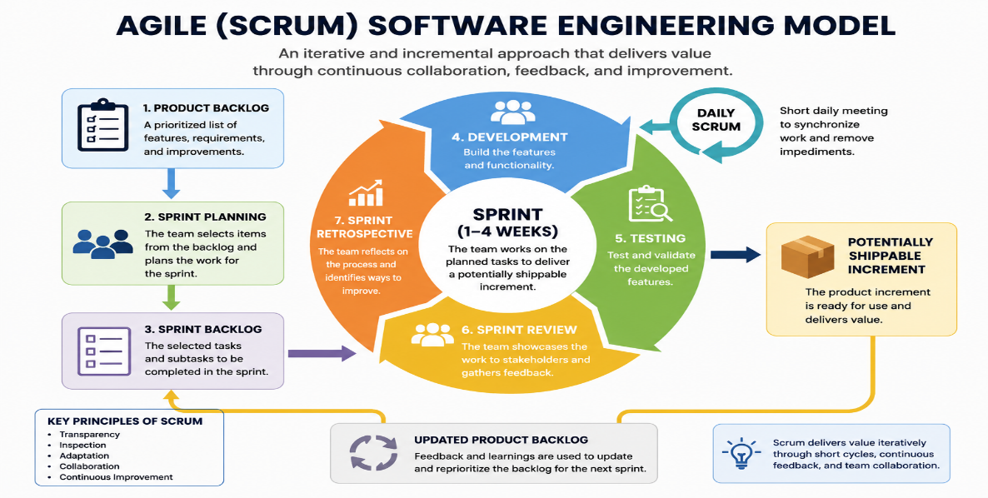
- Software Engineering Model to be Used

The proponents will use the Agile (Scrum) Software Engineering Model. Its iterative and sprint-based approach is suitable for game development, allowing the team to develop, test, and improve game features continuously throughout the project.
- Reasons for the Choice
The development of this system is motivated by the following goals:
9.1 To provide character customization, allowing players to personalize their in-game characters.
9.2 To design an engaging combat system that enhances the overall gameplay experience.
9.3 To implement an inventory and equipment system for easier item management.
9.4 To introduce a mythical enemy system that offers challenging and exciting battles.
9.5 To establish a world and map system that supports smooth exploration of different game locations.
9.6 To integrate a quest and story system that guides players throughout the game.
9.7 To ensure secure game progress through a reliable save and progress system.
9.8 To improve the user interface for easier navigation and better player experience.
9.9 To encourage continuous gameplay by providing rewards and achievements for completed objectives.

10.0 Importance of the Study
Cultural Preservation
The game promotes Filipino mythology by integrating local folklore, mythical creatures, and traditional stories into an interactive role-playing game.
Interactive Gameplay
The game combines character customization, combat, exploration, and quests to provide a more engaging and immersive role-playing experience.
Game Progression
The system supports structured game progression through quests, rewards, achievements, and a reliable save system that enhances gameplay continuity.
System Functionality
The game integrates essential RPG features such as inventory management, world exploration, combat mechanics, and user interface into a single mobile application.
Mobile Game Development
The study demonstrates the application of Agile (Scrum) Software Engineering principles in developing a mobile role-playing game inspired by Filipino mythology.

11.0 Target Users/ Beneficiaries
- Players
- Students
- Researcher
- South East Asian Institute of Technology (SEAIT)

