INTERNCONPH: A WEB-BASED OJT AND EMPLOYMENT MANAGEMENT PLATFORM FOR STUDENTS, EDUCATIONAL INSTITUTIONS, AND HIRING ORGANIZATIONS

A Research Title Proposal Presented to the Faculty of the
College of Information and Communication Technology
South East Asian Institute of Technology, Inc.

In Partial Fulfillment of the Requirements for the Subject
IT 323 – System Integration and Architecture 1

Proponents:

Catolico, Denmark N.
Rojas, John Ber R.
Piquero, Stephen Dave M.
Verez, Stefanni

Bachelor of Science in Information Technology
Specialized in Business Analytics

September 2026

CHAPTER III:
RESEARCH METHODOLOGY 22
Environment 22
Software Engineering Technology 22
Planning/Conception–Initiation Phase 28
Gantt Chart 29
Functional Decomposition Diagram 30
Analysis Design Phase 31
Use Case Diagrams 31
Use Case Matrix 32
Use Case Matrix 33
Database Design 54
Entity Relationship Diagram 55
Data Dictionary 56
Network Design 61
Network Topology 61
Deployment/Construction/Build Phase 62
Technology Stack Development 62
Software Specification 63
Hardware Specification 63
Program Specification 63
List of Modules 64

CHAPTER III

RESEARCH METHODOLOGY Environment

The study and development of the InternConPH: Philippine OJT Coordination and Graduate Career Gateway will be conducted at [Name of Institution], [City/Province], Philippines.

Software Engineering Technology

The Agile Software Development Life Cycle (SDLC) was used in developing the InternConPH system to allow the system to be developed in small and manageable iterations. Each iteration focused on specific system features, such as registration and verification, access-code management, student intake, opportunity posting, application processing, OJT attendance tracking, performance evaluation, portfolio generation, and complaint management. The development process followed six continuous phases: Requirement Gathering, Design, Coding, Testing, Deployment, and Feedback, allowing the developers to improve each feature based on the needs of the intended users.

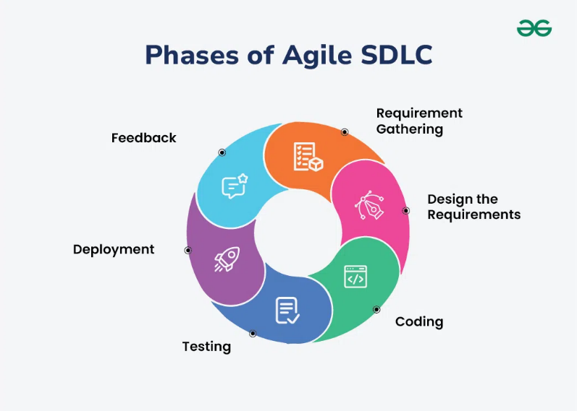

Figure 3.1 Agile Software Development Methodology Model of Residential Estate Navigation Tracking and Leasing System

The researchers aim to find an effective solution to improve the coordination, management, and monitoring of OJT processes by developing the InternConPH: Philippine OJT Coordination and Graduate Career Gateway.

Build 1: Registration, Legitimacy Proof, and Administrator Verification
The system is designed to enable the System Administrator to manage and verify the registration of Institution Directors and Hiring Organizations, including important details such as organization or institution information and submitted legitimacy documents. During the Requirement Gathering phase of the Agile Software Development Life Cycle (SDLC), the researchers identified the requirements needed for registration, document submission, account verification, and administrator approval. In the Design the Requirements phase, the researchers designed an interface that allows institutions and hiring organizations to submit their information and documents while enabling the administrator to review, approve, or reject registrations. During the Coding phase, the researchers developed the feature using React, Vite, Node.js, Express.js, and MySQL, with authentication and role-based access control to secure the system. The researchers then conducted Testing, including unit testing to check individual components such as registration forms, document submission, and validation; integration testing to ensure that the registration feature works correctly with the database and other system components; and acceptance testing, where intended users and/or project advisers evaluated the usability and functionality of the feature and provided feedback for improvements. After successful testing, the feature proceeded to the Deployment phase, where it was implemented in the working environment, allowing the administrator to efficiently review and manage registrations. During the Feedback phase, comments and suggestions from users were used to identify necessary improvements to the registration and verification process. This Agile approach allowed the researchers to continuously improve the feature and provided a foundation for the development of the next InternConPH feature.

Build 2: Access Code and Delegated Passcode Governance
The system is designed to enable authorized users to manage access codes for Institution Staff, Workplace Mentors, and Student Candidates, including details such

as recipient type, target identifier, assigned permissions, and expiration date. During the Requirement Gathering phase of the Agile SDLC, the researchers identified the requirements for generating, validating, and managing access codes to ensure controlled user registration. In the Design the Requirements phase, the researchers designed the access-code interface and workflow, including code generation, recipient matching, expiration checking, and one-time use. During the Coding phase, the researchers developed the feature using React, Vite, Node.js, Express.js, and MySQL, together with authentication and role-based access control. The researchers conducted unit testing to check individual functions such as access-code generation and validation, integration testing to ensure that codes are properly stored and connected to the appropriate user and database records, and acceptance testing where intended users and/or project advisers evaluated the usability and functionality of the feature. After successful testing, the feature was deployed to the working environment, allowing authorized personnel to provide controlled access to users. During the Feedback phase, user suggestions were used to improve the access-code process and prepare the system for the next feature.

Build 3: Institution Staff Operations and Student Intake
The system is designed to enable Institution Staff to manage student intake and verification, including student information, program, classification, OJT status, and required credentials. During the Requirement Gathering phase of the Agile SDLC, the researchers identified the requirements for registering, validating, and routing students according to their academic classification and program. In the Design the Requirements phase, the researchers designed the student intake interface and workflow for reviewing student information and assigning the appropriate staff process. During the Coding phase, the researchers developed the feature using React, Vite, Node.js, Express.js, and MySQL, with authentication and role-based access control. The researchers conducted unit testing to check individual forms and validation functions, integration testing to ensure that student information is properly connected
to institution, program, and staff records in the database, and acceptance testing where intended users and/or project advisers evaluated the feature. After successful testing, the feature was deployed to the working environment, allowing Institution Staff to manage student intake more efficiently. During the Feedback phase, suggestions
from users were used to improve the student verification process and prepare the system for opportunity management.

Build 4: Opportunity Creation and Institutional Clearance
The system is designed to enable Hiring Organizations to create and manage OJT opportunities, career jobs, and on-call projects, including details such as job descriptions, requirements, skills, programs, work setup, available slots, and deadlines. During the Requirement Gathering phase of the Agile SDLC, the researchers identified the requirements for creating opportunities and submitting OJT postings for institutional review. In the Design the Requirements phase, the researchers designed the opportunity posting interface and institutional approval workflow. During the Coding phase, the researchers developed the feature using React, Vite, Node.js, Express.js, and MySQL, with authentication and role-based access control. The researchers conducted unit testing to check opportunity forms and validation, integration testing to ensure that postings are correctly connected to organizations, institutions, programs, and skills in the database, and acceptance testing where intended users and/or project advisers evaluated the feature. After successful testing, the feature was deployed to the working environment, allowing organizations to submit opportunities and institutions to review applicable OJT postings. During the Feedback phase, user feedback was used to improve the posting and approval process and prepare the system for student applications.

Build 5: Candidate Matching, Application, Interview, and Offer Pipeline
The system is designed to enable Student Candidates to search and apply for eligible opportunities, while allowing Hiring Organizations to manage applications, interviews, and offers. During the Requirement Gathering phase of the Agile SDLC, the researchers identified requirements for opportunity browsing, eligibility checking, skill-based matching, application submission, interview scheduling, and offer processing. In the Design the Requirements phase, the researchers designed the application workflow from opportunity selection through candidate review, interview, and offer. During the Coding phase, the researchers developed the feature using React, Vite, Node.js, Express.js, MySQL, and Socket.IO, with authentication and role-based access control. The researchers conducted unit testing to check application forms,
eligibility validation, status updates, and interview functions, integration testing to ensure that applications are properly connected to students, opportunities, interviews, and offers in the database, and acceptance testing where intended users and/or project advisers evaluated the complete application process. After successful testing, the feature was deployed to the working environment, allowing students and organizations to manage the application process digitally. During the Feedback phase, user feedback was used to improve application navigation, interview scheduling, and notifications.

Build 6: Active OJT Deployment, DTR, Attendance, and Hour Verification
The system is designed to enable Student Candidates and Workplace Mentors to manage OJT attendance and rendered hours, including time-in, time-out, task records, required hours, and verification. During the Requirement Gathering phase of the Agile SDLC, the researchers identified requirements for recording daily attendance, calculating rendered hours, monitoring remaining hours, and verifying OJT records. In the Design the Requirements phase, the researchers designed the DTR interface and OJT monitoring workflow for students and Workplace Mentors. During the Coding phase, the researchers developed the feature using React, Vite, Node.js, Express.js, MySQL, and Socket.IO, with authentication and role-based access control. The researchers conducted unit testing to check attendance forms and hour calculations, integration testing to ensure that DTR records correctly update OJT records in the database, and acceptance testing where intended users and/or project advisers evaluated the usability and accuracy of the feature. After successful testing, the feature was deployed to the working environment, allowing students to record their OJT attendance and mentors to verify rendered hours. During the Feedback phase, user feedback was used to improve the DTR and verification process and prepare the system for performance evaluation.

Build 7: Performance Evaluation and Verified Career Portfolio
The system is designed to enable Workplace Mentors and authorized users to manage OJT performance evaluations and verified career portfolio records, including evaluation results, commendations, completed OJT experiences, and portfolio information. During the Requirement Gathering phase of the Agile SDLC, the researchers identified requirements for Midterm and Final evaluations, OJT completion, portfolio-item creation, and verification. In the Design the Requirements phase, the researchers designed the evaluation forms and portfolio workflow to connect completed OJT experiences with verified career records. During the Coding phase, the researchers developed the feature using React, Vite, Node.js, Express.js, and MySQL, with authentication and role-based access control. The researchers conducted unit testing to check evaluation forms, rating functions, and portfolio creation, integration testing to ensure that completed OJT records are correctly connected to evaluations and portfolio records in the database, and acceptance testing where intended users and/or project advisers evaluated the feature. After successful testing, the feature was deployed to the working environment, allowing verified OJT experiences to be organized into career portfolio records. During the Feedback phase, user suggestions were used to improve the evaluation and portfolio presentation.

Build 8: Incident Reporting, Complaints, Accident Records, and Grievance Shielding
The system is designed to enable Students, Hiring Organizations, Institution Staff, and Administrators to manage workplace incidents and complaints, including complaint details, categories, accident information, evidence, reviews, and case status. During the Requirement Gathering phase of the Agile SDLC, the researchers identified requirements for submitting complaints, attaching evidence, reviewing cases, escalating reports, and protecting student identity when applicable. In the Design the Requirements phase, the researchers designed the complaint submission, review, and escalation workflows. During the Coding phase, the researchers developed the feature using React, Vite, Node.js, Express.js, MySQL, and Socket.IO, with authentication and role-based access control. The researchers conducted unit testing to check complaint forms, evidence submission, status updates, and review functions, integration testing to ensure that complaint information is properly connected to students, organizations, applications, evidence, and reviews in the database, and acceptance testing where intended users and/or project advisers evaluated the usability and functionality of the feature. After successful testing, the feature was
deployed to the working environment, allowing authorized users to submit, review, and manage incidents and complaints in a centralized system. During the Feedback phase, user feedback was used to improve the reporting, review, and notification processes, completing the major feature iterations of the InternConPH system.

Planning/Conception–Initiation Phase
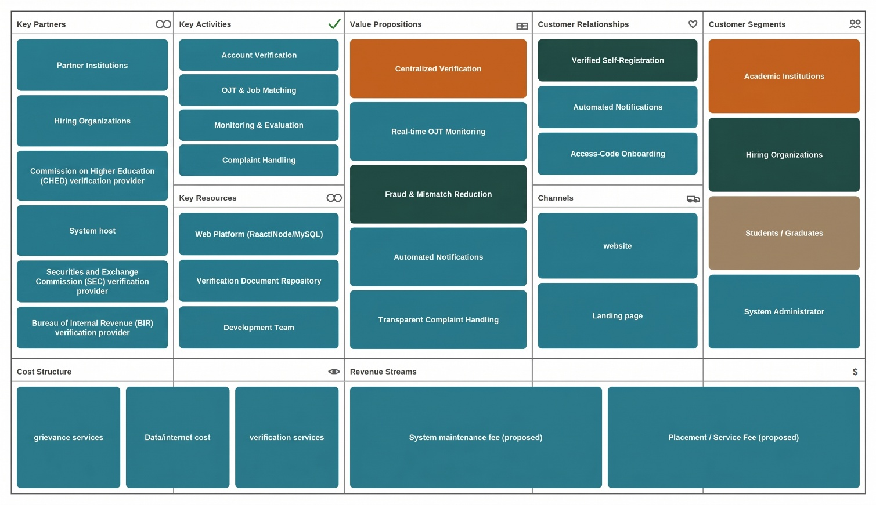

Figure 3.2 Business Model Canvas

This Business Model Canvas outlines a centralized verification platform that partners
with government agencies to provide real-time OJT monitoring, fraud reduction,
and secure job matching for academic institutions, hiring organizations, and students.
Revenue comes from system maintenance and placement fees,
with costs covering grievance, data, and verification services.

Gantt Chart
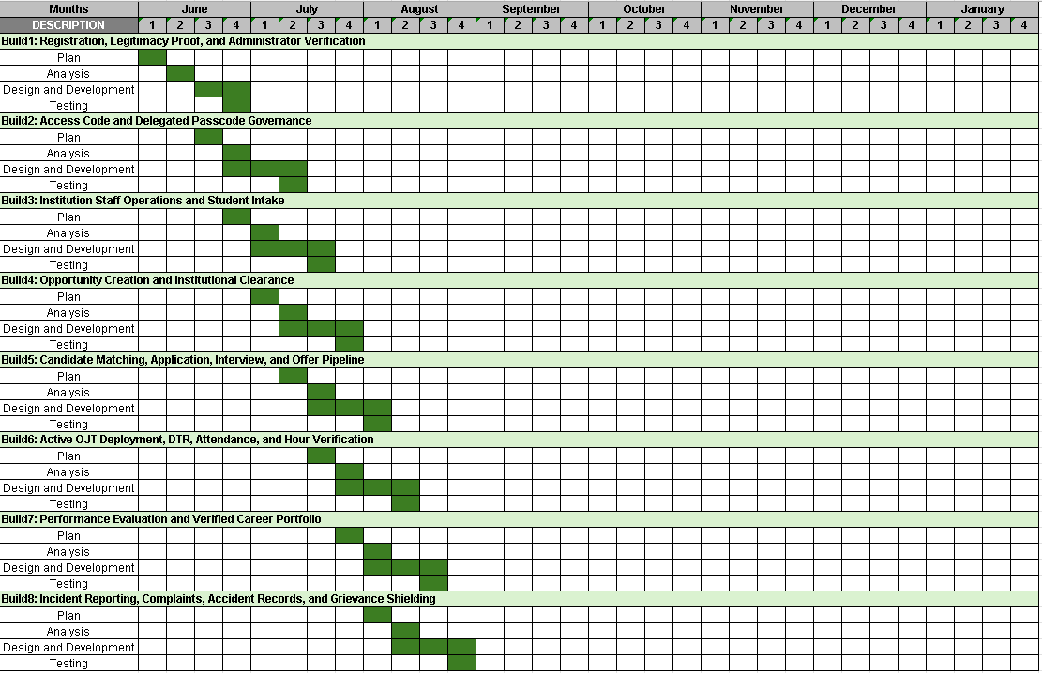

Table 3.1 Gantt Chart for Residential Estate Navigation Tracking and Leasing System
This table represent processes on developing the system.

Legend | Color
Finished
Ongoing
Undone

Functional Decomposition Diagram

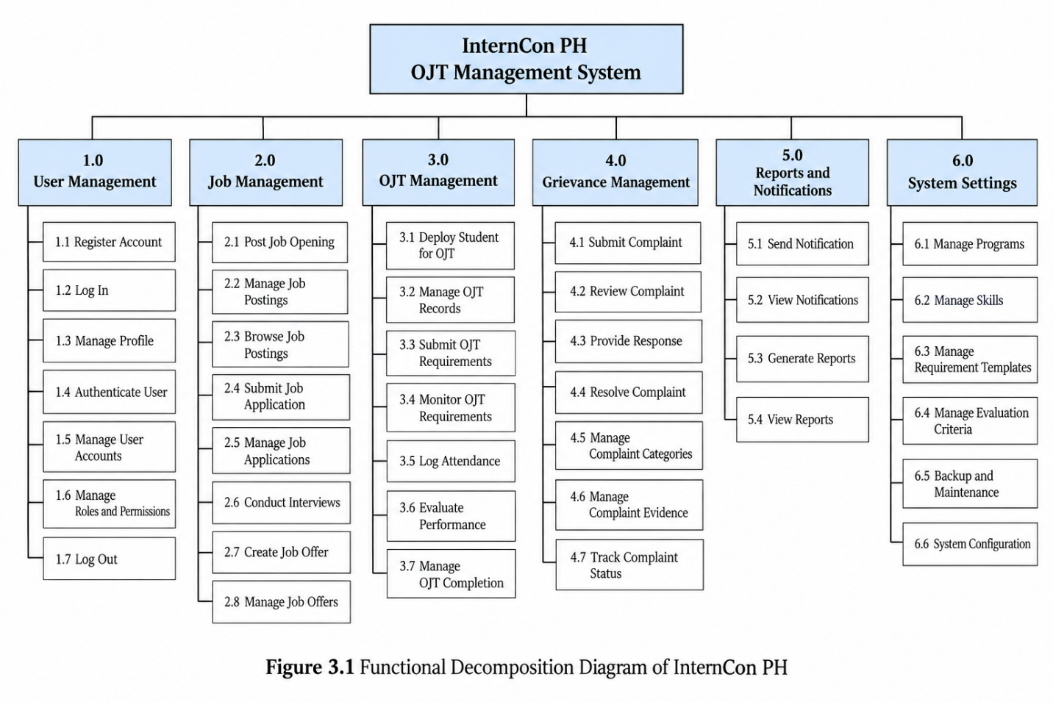

Use Case Diagrams Figure
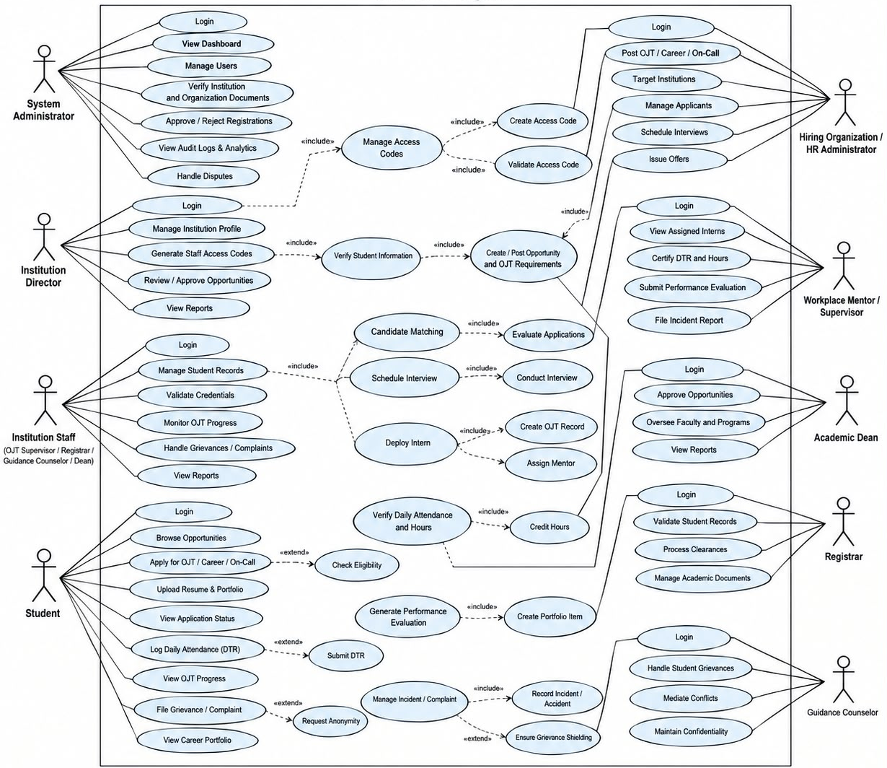

3.4 Use Case Diagram of Residential Estate Navigation Tracking and Leasing System

Use Case Matrix Us
Table 3.1 Use-Case Matrix of InternCon – Manage Account / Access
Use Case | Manage Account / Access
Author | Researchers
Primary Actor | System Administrator
Trigger | When a user needs to access the system according to their assigned role and permissions.
Basic Flow | - System Administrator opens the InternCon web application  - System Administrator logs into the system  - System Administrator enters the required account credentials  - System validates the account credentials  - System verifies the user's assigned role and permissions  - System displays the appropriate role-based dashboard  - System Administrator manages user accounts, roles, or access permissions when required
Post Condition | The user is authenticated and provided access only to functions permitted by the assigned role.
Secondary Actor | Institution Director, Institution Staff, Hiring Organization, Student
Trigger | When the user needs to access InternCon according to their assigned account.
Basic Flow | - User opens the InternCon web application  - User enters their account credentials  - System validates the credentials  - System identifies the user's role  - System displays the corresponding dashboard
Post Condition | The user successfully accesses the appropriate role-based functions.

Table 3.2 Use-Case Matrix of InternCon – Register Entity / Submit Requirements
Use Case | Register Entity / Submit Requirements
Author | Researchers
Primary Actor | Hiring Organization
Trigger | When a hiring organization needs to register and submit required information and documents for verification.
Basic Flow | - Hiring Organization opens the InternCon web application  - Hiring Organization registers an account using the permitted registration process  - Hiring Organization enters the required organization information  - Hiring Organization uploads the required documents  - System records the submitted information and documents  - System forwards the registration for administrative review  - Hiring Organization waits for the verification result
Post Condition | The hiring organization registration and required documents are submitted for administrative verification.
Secondary Actor | Institution Director
Trigger | When an academic institution needs to register and submit its institutional requirements.
Basic Flow | - Institution Director opens the InternCon web application  - Institution Director registers the institution  - Institution Director enters the required institutional information  - Institution Director submits the required documents  - System records the submitted information  - Registration is forwarded for verification
Post Condition | The institution information and supporting documents are submitted for review.

Table 3.3 Use-Case Matrix of InternCon – Review Verification
Use Case | Review Verification
Author | Researchers
Primary Actor | System Administrator
Trigger | When an institution or hiring organization submits registration information and supporting documents for verification.
Basic Flow | - System Administrator opens the verification section  - System Administrator views pending registrations  - System Administrator selects a registration for review  - System Administrator examines the submitted information  - System Administrator checks the submitted supporting documents  - System Administrator determines whether the submitted requirements are sufficient  - System Administrator approves or rejects the registration  - System updates the verification status  - System sends the appropriate account-status notification
Post Condition | The institution or hiring organization receives an updated verification status.
Secondary Actor | Hiring Organization / Institution Director
Trigger | When the submitted registration is reviewed by the System Administrator.
Basic Flow | - Actor submits the required information and documents  - Actor waits for administrative review  - Actor receives the verification result  - Actor views the updated registration status
Post Condition | The actor's registration is marked with the corresponding verification status.

Table 3.4 Use-Case Matrix of InternCon – Manage Programs / Skills
Use Case | Manage Programs / Skills
Author | Researchers
Primary Actor | System Administrator
Trigger | When program or skill information needs to be created, updated, or maintained in the system.
Basic Flow | - System Administrator opens the program and skills management section  - System Administrator views the existing programs or skills  - System Administrator adds new program or skill information when required  - System Administrator updates existing information when necessary  - System validates the submitted information  - System saves the changes  - Updated program or skill information becomes available for related system functions
Post Condition | The program and skill information is stored and available for matching and other related processes.
Secondary Actor | Institution Director / Institution Staff / Hiring Organization
Trigger | When an authorized actor needs to maintain program or skill information according to assigned permissions.
Basic Flow | - Actor opens the permitted program or skill management function  - Actor views available information  - Actor adds or updates permitted information  - System validates and saves the changes
Post Condition | Authorized program or skill information is updated in the system.

Table 3.5 Use-Case Matrix of InternCon – Create Job Posting
Use Case | Create Job Posting
Author | Researchers
Primary Actor | Hiring Organization
Trigger | When a hiring organization wants to offer a job or OJT opportunity to qualified students.
Basic Flow | - Hiring Organization logs into InternCon  - Hiring Organization opens the job posting section  - Hiring Organization enters the job information  - Hiring Organization specifies the required programs and skills  - Hiring Organization submits the job posting  - System validates and records the job posting  - Job posting is submitted for the appropriate review process
Post Condition | The job posting is recorded and available for review before being made available to students.

Table 3.6 Use-Case Matrix of InternCon – Review Job Posting
Use Case | Review Job Posting
Author | Researchers
Primary Actor | System Administrator
Trigger | When a hiring organization submits a job posting for review.
Basic Flow | - System Administrator opens the job-posting review section  - System Administrator views pending job postings  - System Administrator selects a job posting  - System Administrator reviews the job information and requirements  - System Administrator approves or rejects the job posting  - System updates the posting status  - System notifies the hiring organization of the review result
Post Condition | The job posting receives an updated review status and proceeds according to the decision.
Secondary Actor | Hiring Organization
Trigger | When the hiring organization submits a job posting.
Basic Flow | - Hiring Organization creates the job posting  - Hiring Organization specifies the required programs and skills  - Hiring Organization submits the posting  - Hiring Organization waits for the review result  - Hiring Organization receives the posting status
Post Condition | The hiring organization receives the result of the job-posting review.

Table 3.7 Use-Case Matrix of InternCon – Browse / Apply to Jobs
Use Case | Browse / Apply to Jobs
Author | Researchers
Primary Actor | Student
Trigger | When a student wants to find and apply for an available job or OJT opportunity.
Basic Flow | - Student logs into InternCon  - Student opens the available opportunities section  - Student browses available job or OJT postings  - Student reviews the job description and requirements  - Student compares the opportunity with their program and skills  - Student selects an appropriate opportunity  - Student submits an application  - System records the application  - Student monitors the application status
Post Condition | The student's application is recorded and available for processing by the hiring organization.

Table 3.8 Use-Case Matrix of InternCon – Interview / Offer Processing
Use Case | Interview / Offer Processing
Author | Researchers
Primary Actor | Hiring Organization
Trigger | When a student application is available for applicant review and the hiring organization proceeds with selection.
Basic Flow | - Hiring Organization opens the applicant list  - Hiring Organization reviews the student's application  - Hiring Organization selects an applicant for the applicable selection process  - Hiring Organization conducts an interview when required  - Hiring Organization records the interview or selection information  - Hiring Organization creates an offer when the student is selected  - System records the offer  - Student receives the offer notification
Post Condition | The interview or offer information is recorded and the student can respond to the offer.
Secondary Actor | Student
Trigger | When the Hiring Organization sends an offer.
Basic Flow | - Student receives the offer notification  - Student views the offer information  - Student reviews the opportunity details  - Student accepts or declines the offer  - System records the student's response
Post Condition | The offer is marked according to the student's response.

Table 3.9 Use-Case Matrix of InternCon – OJT Deployment
Use Case | OJT Deployment
Author | Researchers
Primary Actor | Institution Staff
Trigger | When a student has completed the required placement process and is ready for OJT deployment.
Basic Flow | - Institution Staff opens the OJT deployment section  - Institution Staff views the student's placement information  - Institution Staff verifies the required deployment information  - Institution Staff processes the student's OJT deployment  - System records the deployment information  - System updates the student's OJT status  - System provides the appropriate notification to involved users
Post Condition | The student is recorded as deployed for OJT and the deployment information is available for monitoring.
Secondary Actor | Student / Hiring Organization / Workplace Mentor
Trigger | When an OJT deployment is processed.
Basic Flow | - Actor receives the deployment information  - Actor views the assigned OJT information  - Actor follows the deployment requirements  - Actor participates in the OJT process
Post Condition | The student begins the OJT process and the workplace-side participants can proceed with monitoring.

Table 3.10 Use-Case Matrix of InternCon – Monitor OJT / Performance
Use Case | Monitor OJT / Performance
Author | Workplace Mentor / Assigned Staff
Primary Actor | Workplace Mentor / Assigned Staff
Trigger | When a student is actively participating in OJT and attendance, hours, or performance information needs to be recorded.
Basic Flow | - Workplace Mentor or assigned staff logs into InternCon  - Actor opens the OJT monitoring section  - Actor selects the assigned student  - Actor records OJT attendance or related information  - Actor records applicable performance information  - System saves the OJT records  - System updates the student's monitoring information  - Authorized institution users can view the updated records
Post Condition | OJT hours, attendance, and performance information are recorded and available to authorized users.
Secondary Actor | Student
Trigger | When the student needs to view their OJT progress and performance-related records.
Basic Flow | - Student logs into InternCon  - Student opens the OJT monitoring section  - Student views recorded OJT information  - Student checks their progress and available performance information
Post Condition | The student can view the recorded OJT progress and related information.

Table 3.11 Use-Case Matrix of InternCon – Portfolio / Resume / Skills
Use Case | Portfolio / Resume / Skills
Author | Researchers
Primary Actor | Student
Trigger | When a student needs to create or update information used for job or OJT applications.
Basic Flow | - Student logs into InternCon  - Student opens the profile or portfolio section  - Student enters or updates personal information  - Student adds resume information  - Student records skills and achievements  - Student adds applicable work samples or portfolio information  - Student saves the updated information  - System records the changes
Post Condition | The student's profile, resume, skills, achievements, and portfolio information are updated and available for applicable placement processes.

Table 3.12 Use-Case Matrix of InternCon – File Complaint
Use Case | File Complaint
Author | Student
Primary Actor | Student
Trigger | When a student needs to report an issue or grievance involving an institution or hiring organization.
Basic Flow | - Student logs into InternCon  - Student opens the complaint section  - Student selects the appropriate complaint category  - Student enters the complaint details  - Student attaches supporting evidence when applicable  - Student submits the complaint  - System records the complaint  - Complaint is forwarded for administrative review  - Student receives a notification regarding the complaint status
Post Condition | The complaint and available supporting evidence are recorded for review and resolution.
Secondary Actor | Institution Staff / Hiring Organization
Trigger | When a complaint is submitted concerning the actor or organization.
Basic Flow | - Actor receives the complaint notification  - Actor views the complaint information when authorized  - Actor provides the required response or information  - Submitted response becomes part of the complaint review process
Post Condition | Relevant information is available to authorized reviewers for complaint resolution.

Table 3.13 Use-Case Matrix of InternCon – Review Complaint
Use Case | Review Complaint
Author | System Administrator
Primary Actor | System Administrator
Trigger | When a complaint has been submitted and requires administrative review.
Basic Flow | - System Administrator opens the complaint management section  - System Administrator views pending complaints  - System Administrator selects a complaint  - System Administrator reviews the complaint details  - System Administrator examines submitted evidence  - System Administrator reviews relevant responses or information  - System Administrator determines the appropriate administrative action  - System records the complaint resolution or status  - Involved users receive the applicable notification
Post Condition | The complaint is reviewed and its status or resolution is recorded in the system.
Secondary Actor | Institution Director / Institution Staff / Hiring Organization / Student
Trigger | When an actor is involved in a complaint under review.
Basic Flow | - Actor receives the complaint-related notification  - Actor provides the required information or response  - Actor waits for the administrative decision  - Actor receives the updated complaint status
Post Condition | The actor's response is recorded and the complaint proceeds according to the administrative review.

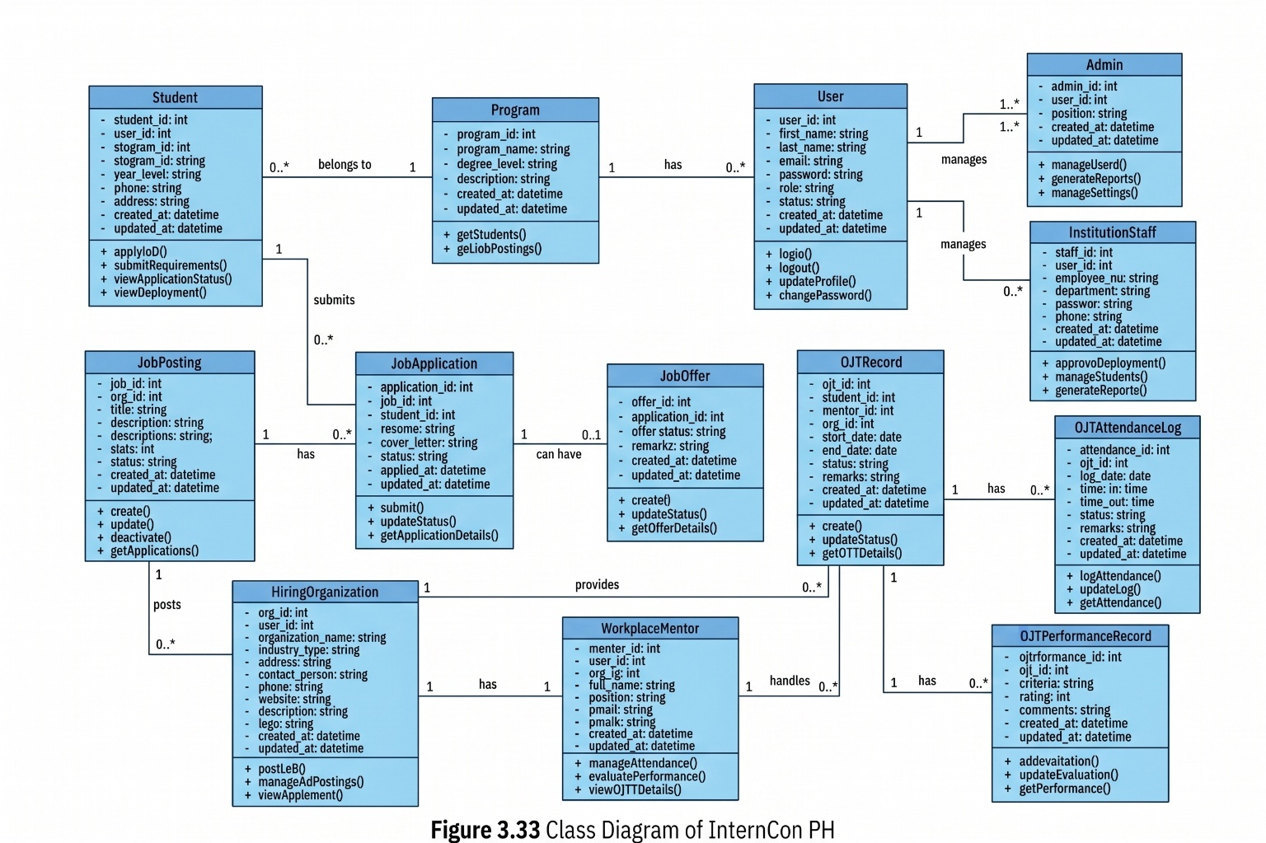
Class Diagram

Sequence Diagram

Student
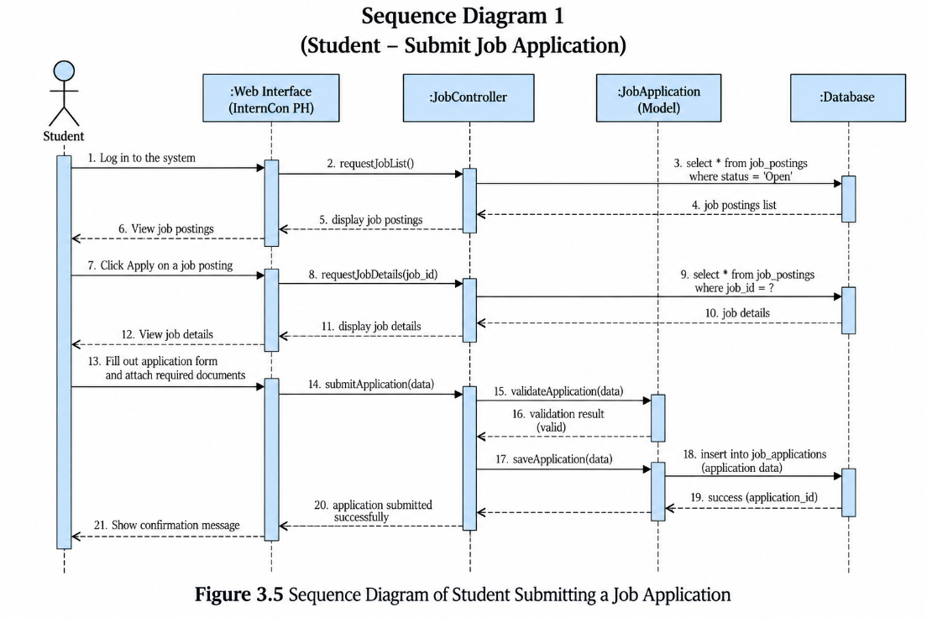

Hiring Organization
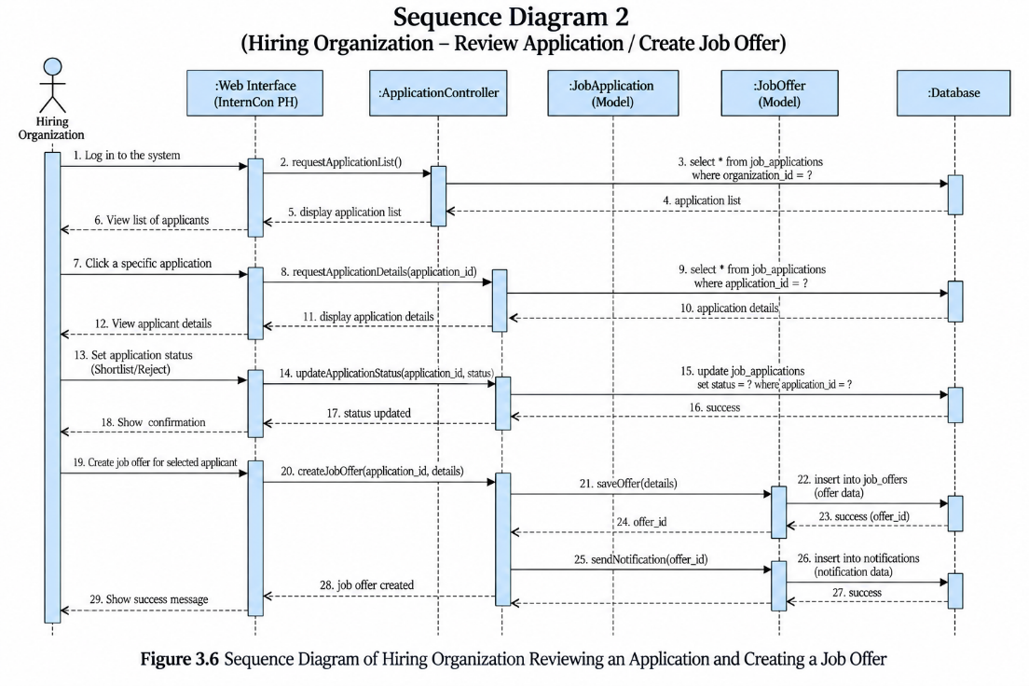

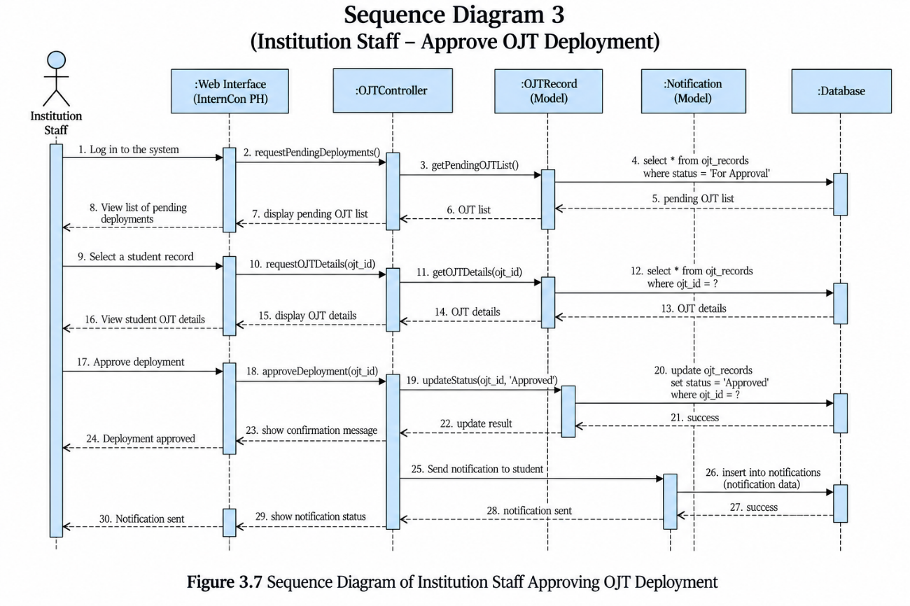
Institution Staff

Workplace Mentor
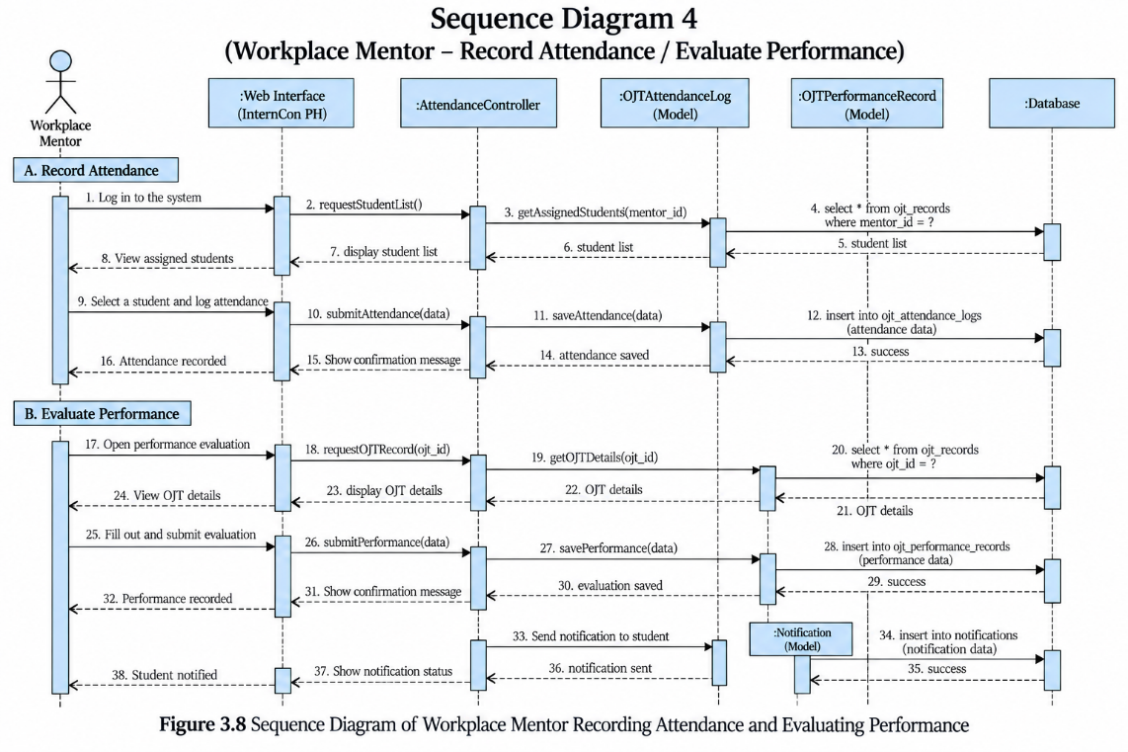

Admin
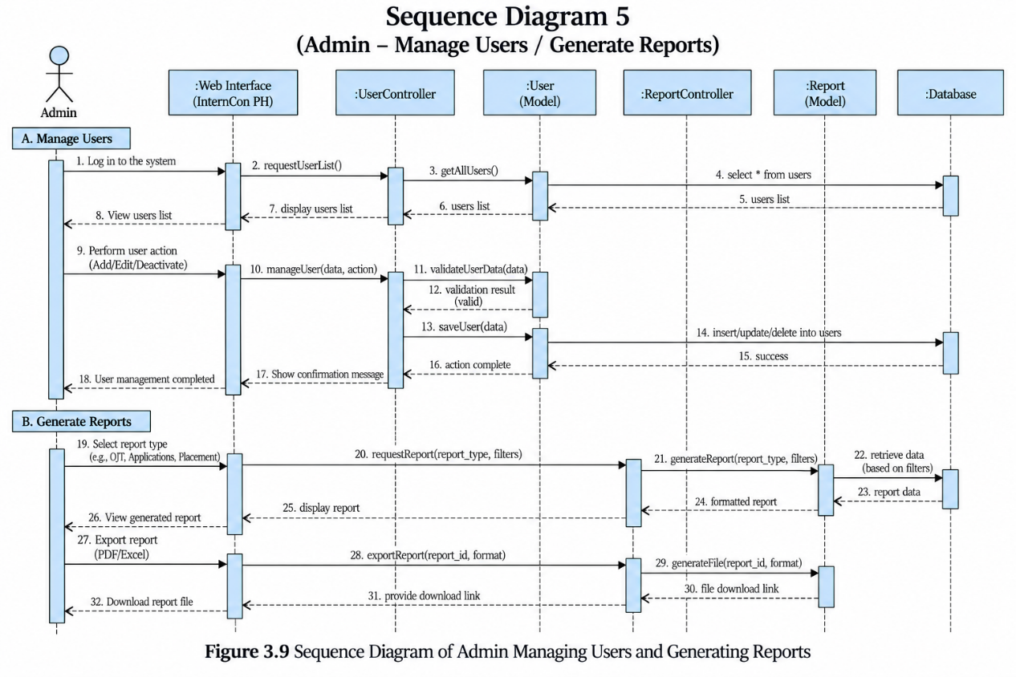

Story boarding

Login Page
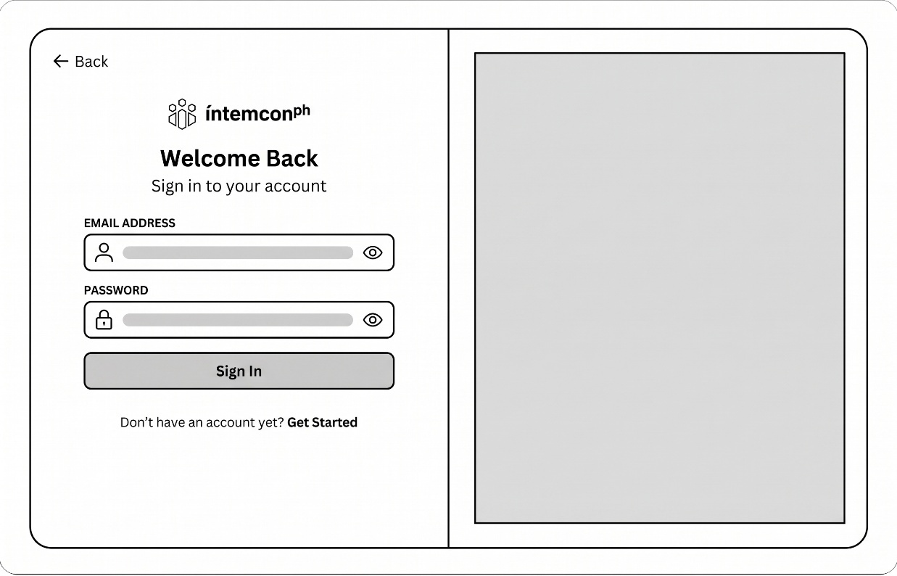

Figure 3.23 Storyboard of Login Page of Residential Estate Navigation Tracking and Leasing System

The user accesses the portal to register or log into their role-specific account, where they can authenticate credentials, select their institutional or organization affiliation, and securely upload proof-of-legitimacy documents or input delegation codes, all within a secure, responsive access-governance framework.

System Administrator Dashboard
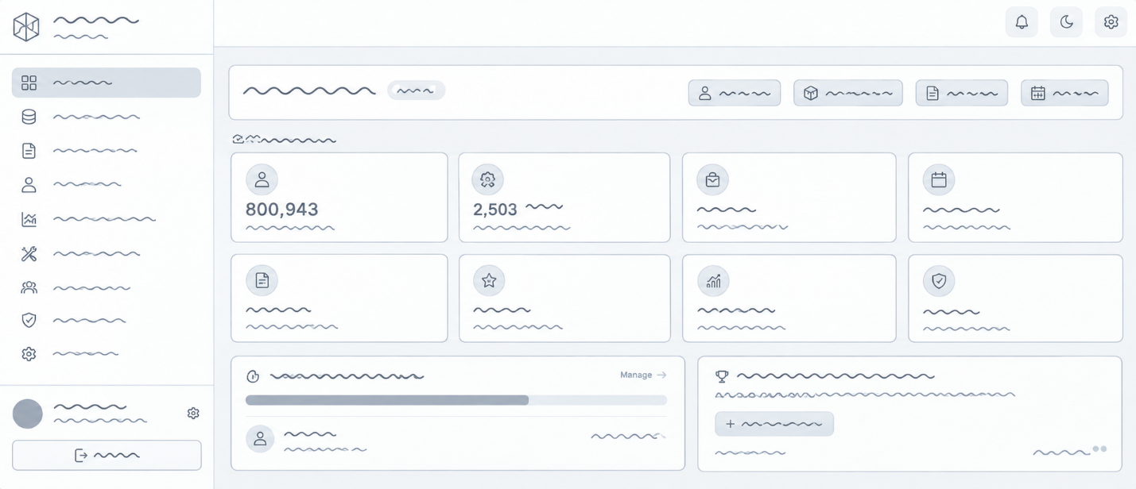

The system administrator logs into the admin overview, where they can verify new institutions and partner companies, audit platform-wide user activity, monitor grievance escalation queues, and configure global system policies, all within a real-time analytics and security-oversight framework.

Figure 3.23 Storyboard of Admin Page of Residential Estate Navigation Tracking and Leasing System

Institution Director Dashboard
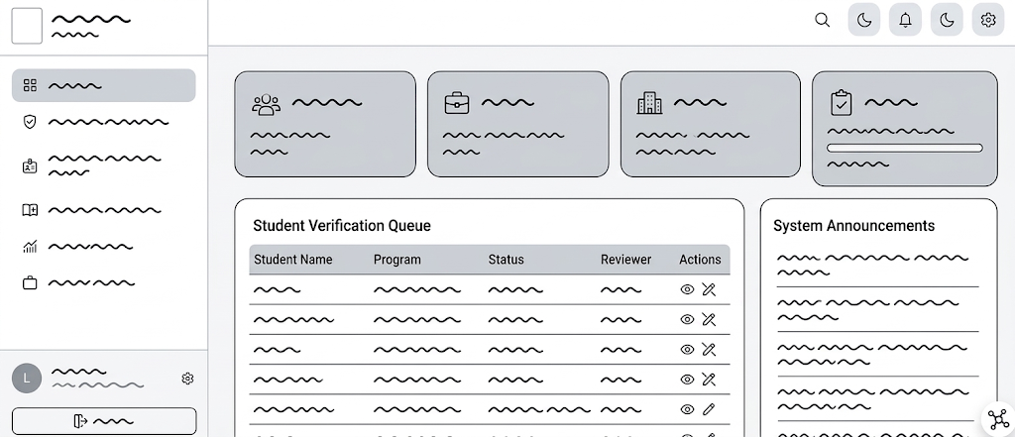

The institution director logs into the executive panel, where they can monitor department-wide OJT deployment rates, review MoA partnerships with host companies, track student safety indices, and endorse institutional clearance batches, all within a high-level academic compliance and reporting framework.

Figure 3.23 Storyboard of Institution Page of Residential Estate Navigation Tracking and Leasing System

Institution Staff Dashboard

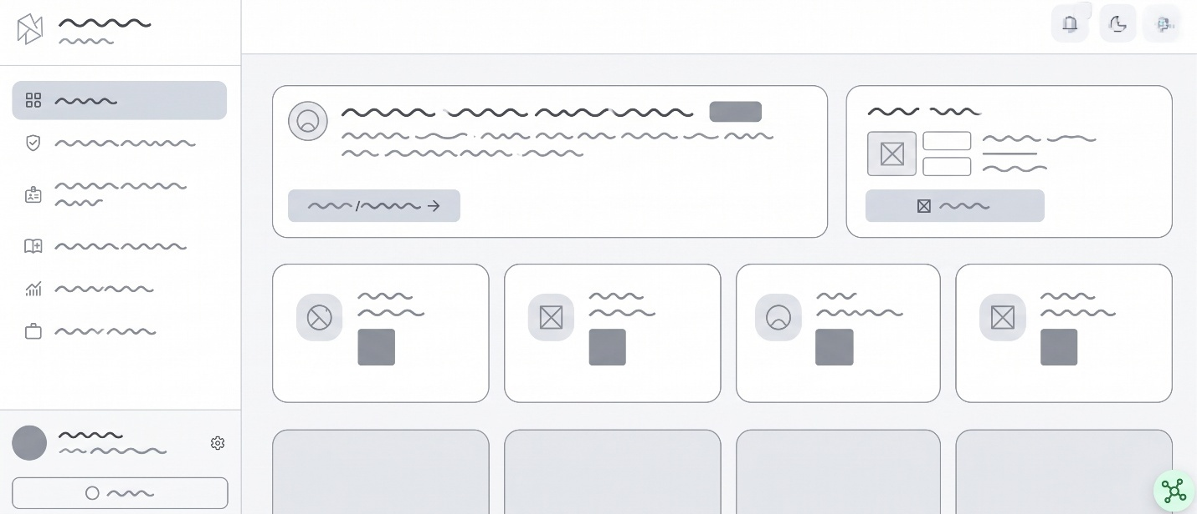

The institution staff member (coordinator/advisor) logs into the operational portal, where they can review pending student endorsements, validate company training outlines, track cohort DTR attendance progress, and issue verified passcodes, all within a hands-on student placement management framework.

Figure 3.23 Storyboard of Institution Staff Page of Residential Estate Navigation Tracking and Leasing System

Hiring Organization Dashboard
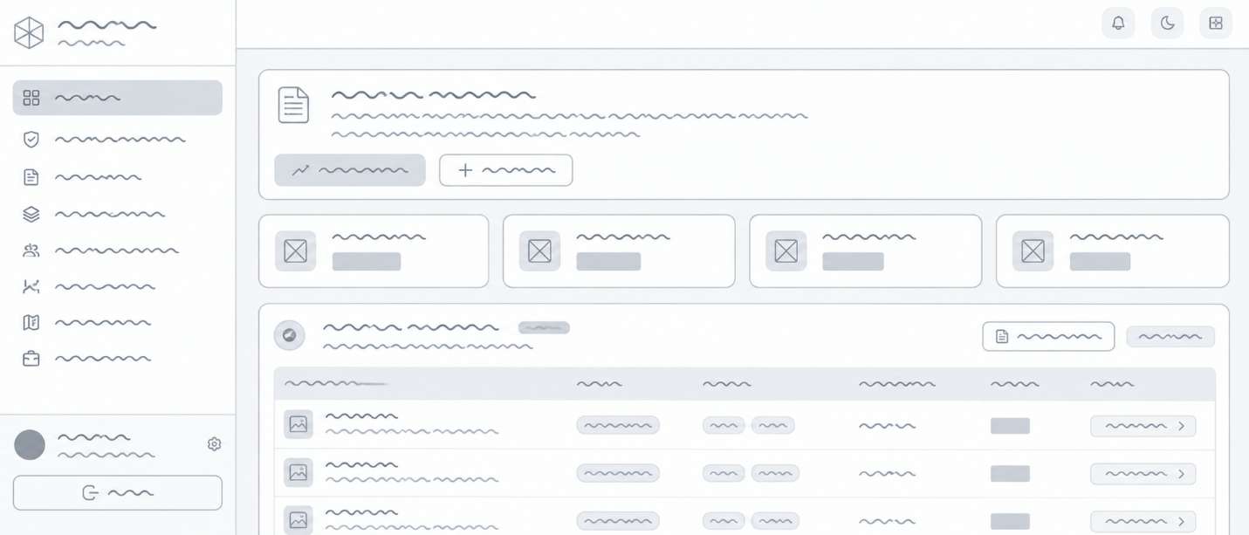

The employer representative logs into the company hub, where they can monitor active job and internship openings, review incoming student applications, schedule interviews, and oversee assigned trainees' milestone deliverables, all within an interactive talent acquisition and training pipeline framework.

Figure 3.23 Storyboard of Institution Staff Page of Residential Estate Navigation Tracking and Leasing System

Student Dashboard
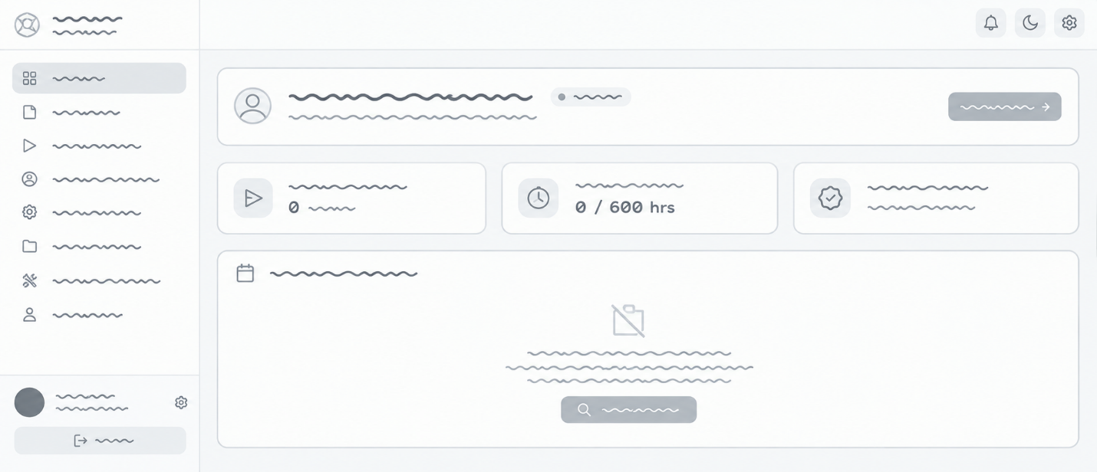
\

The student logs into their personal workspace, where they can track required versus completed internship hours, view matched job and OJT listings, access daily time record (DTR) clock-in shortcuts, and review real-time application updates, all within a student-centric progress-tracking framework.

Job Posting Page
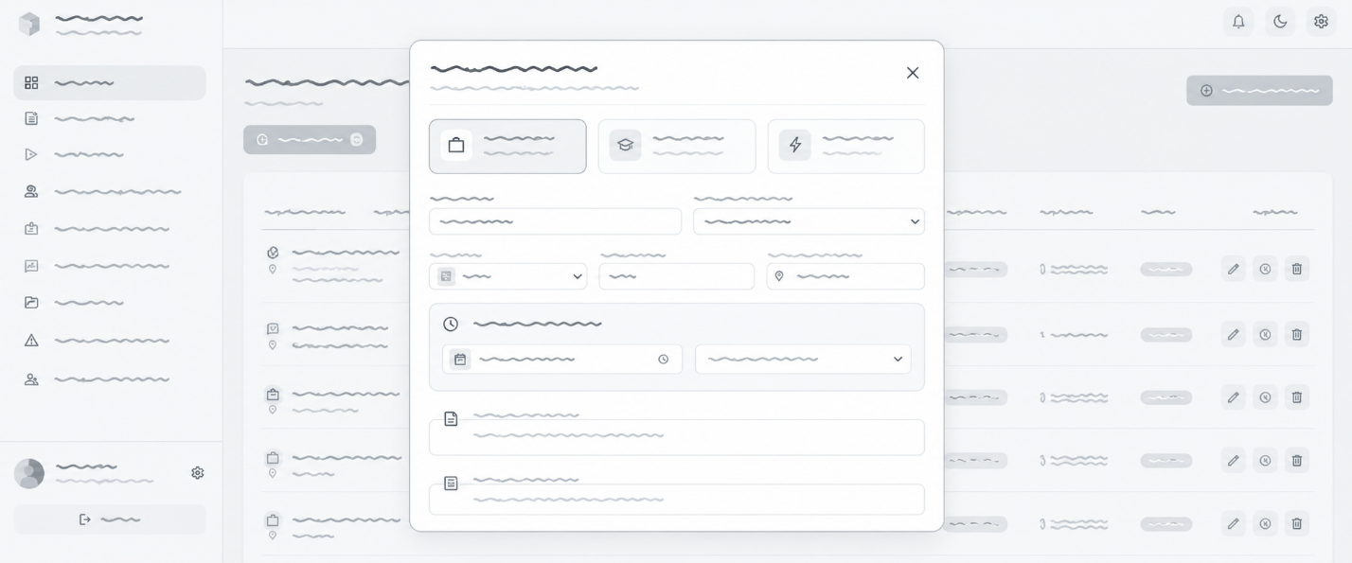

The employer creates and manages opportunities on the job posting screen, where they can define role specifications, specify required academic competencies, set

daily duty schedules, and designate OJT clearance criteria, all within a structured posting and institutional approval framework.

Job Application Page
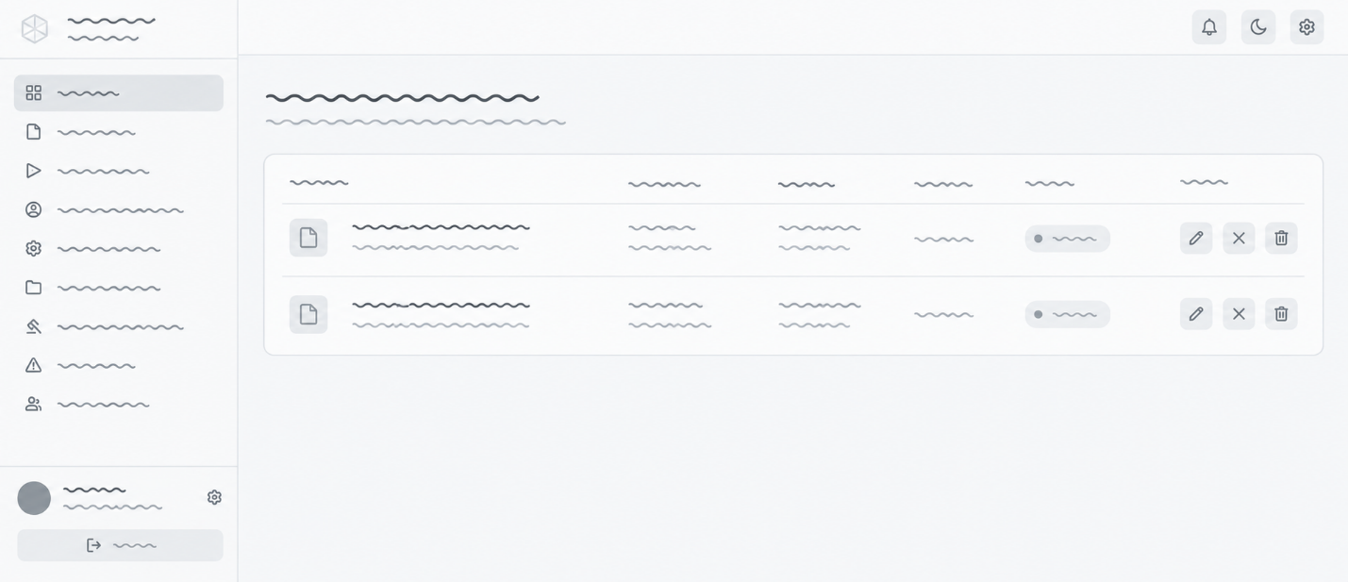

The student navigates the application interface, where they can review comprehensive position requirements, attach required institutional clearances, submit custom cover letters, and track multi-stage interview statuses, all within a guided candidate submission and status-monitoring framework.

OJT Deployment Page
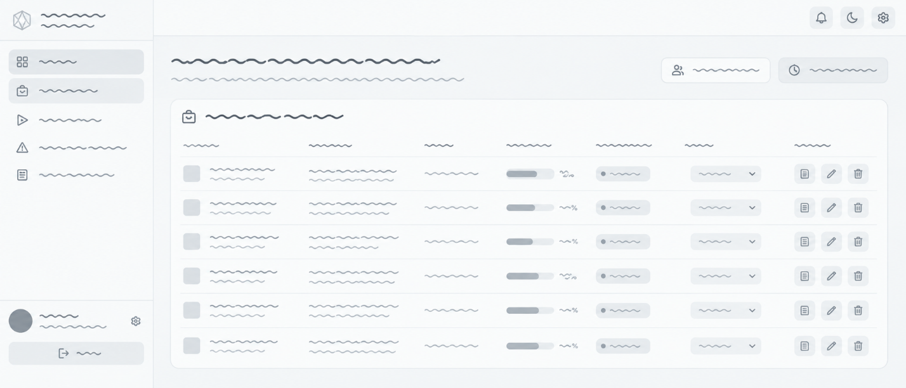

The coordinator and employer collaborate on the deployment portal, where they can formalize internship contracts, assign designated company mentors, confirm required training hours, and generate official deployment slips, all within a tripartite onboarding and compliance framework.

OJT Monitoring / Performance Page
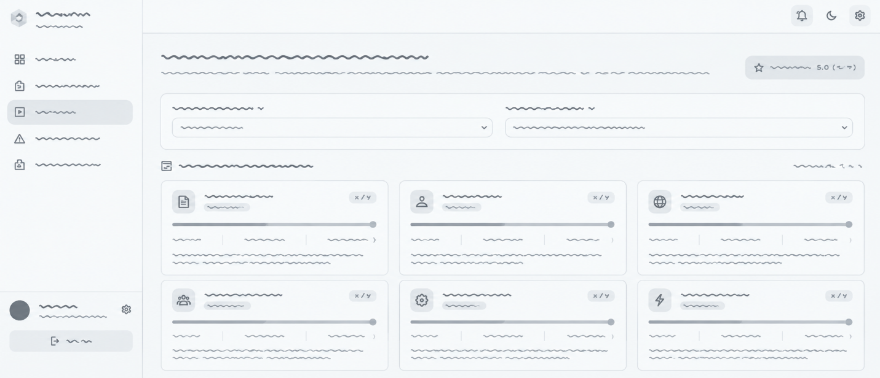

The supervisor and coordinator access the performance console, where they can review daily time records (DTR), approve clock-in/out geotags, submit periodic rubric-based competency ratings, and log weekly progress notes, all within an automated hour-verification and evaluation framework.

Student Portfolio / Resume Page
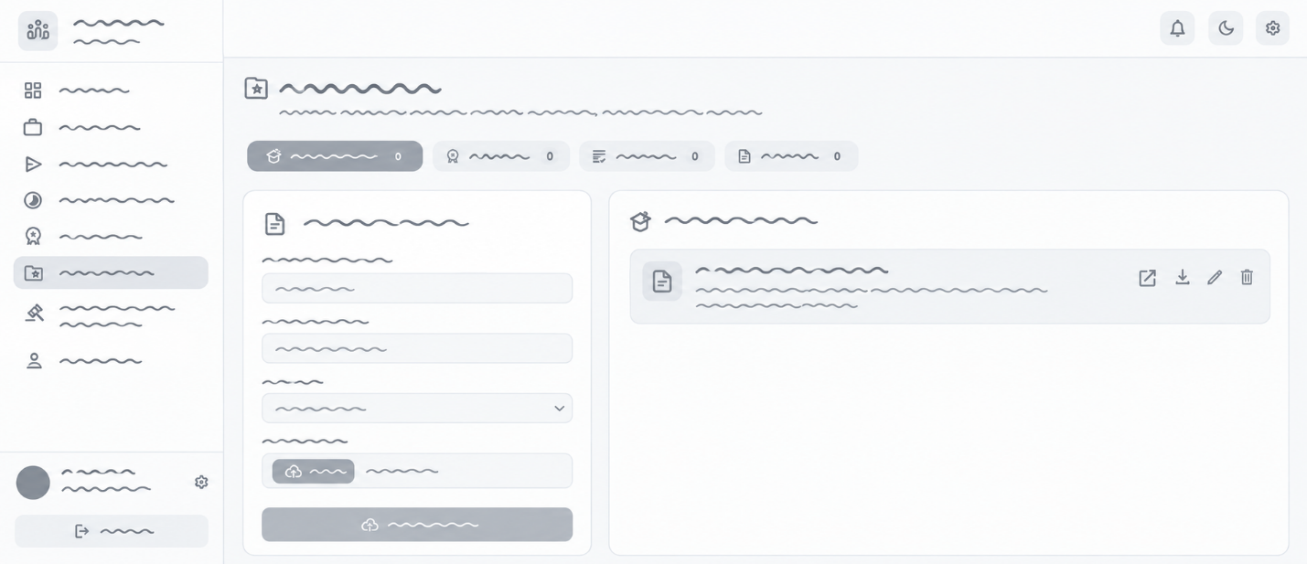

The student accesses their verified portfolio builder, where they can showcase institution-validated OJT hours, display supervisor evaluation badges, highlight acquired technical competencies, and generate exportable resume links, all within a tamper-proof credentialing framework.

Complaint Filing Page
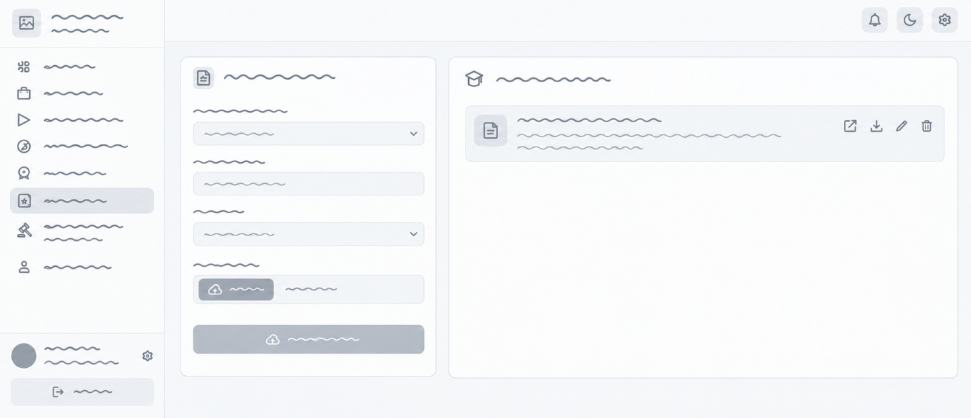

The student or employer accesses the confidential incident portal, where they can document grievances or workplace safety issues, upload timestamped supporting evidence, and opt for shielded or anonymous submission, all within an encrypted, rapid-response reporting framework.

Complaint Review Page
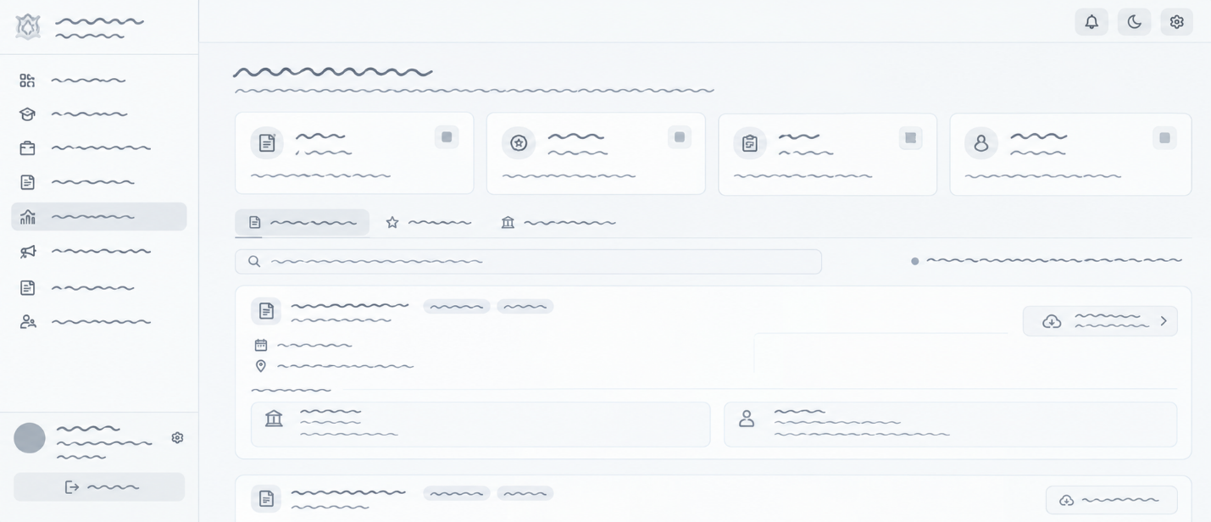

The institution coordinator and platform administrator access the grievance resolution console, where they can investigate reported violations, review attached incident documentation, initiate mediation proceedings, and log corrective action records, all within an impartial disciplinary and safeguarding framework.
Notifications Page
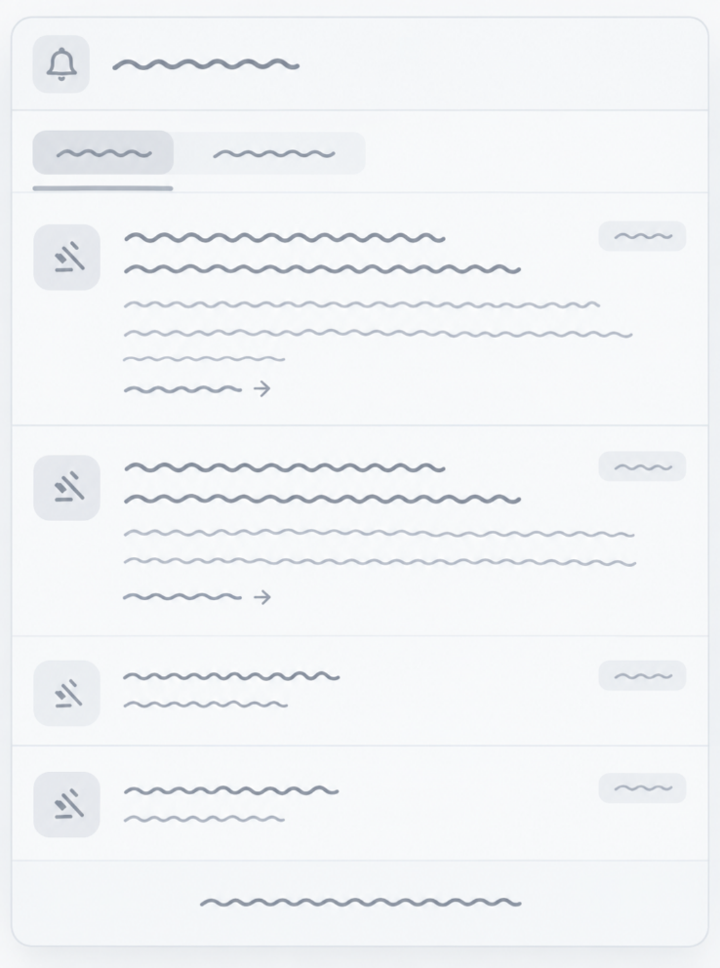

The user accesses the centralized communication center, where they can filter real-time alert streams, receive interview schedule updates, track DTR verification notices, and review priority institutional announcements, all within an organized, event-driven notification framework.

Forms Register Form
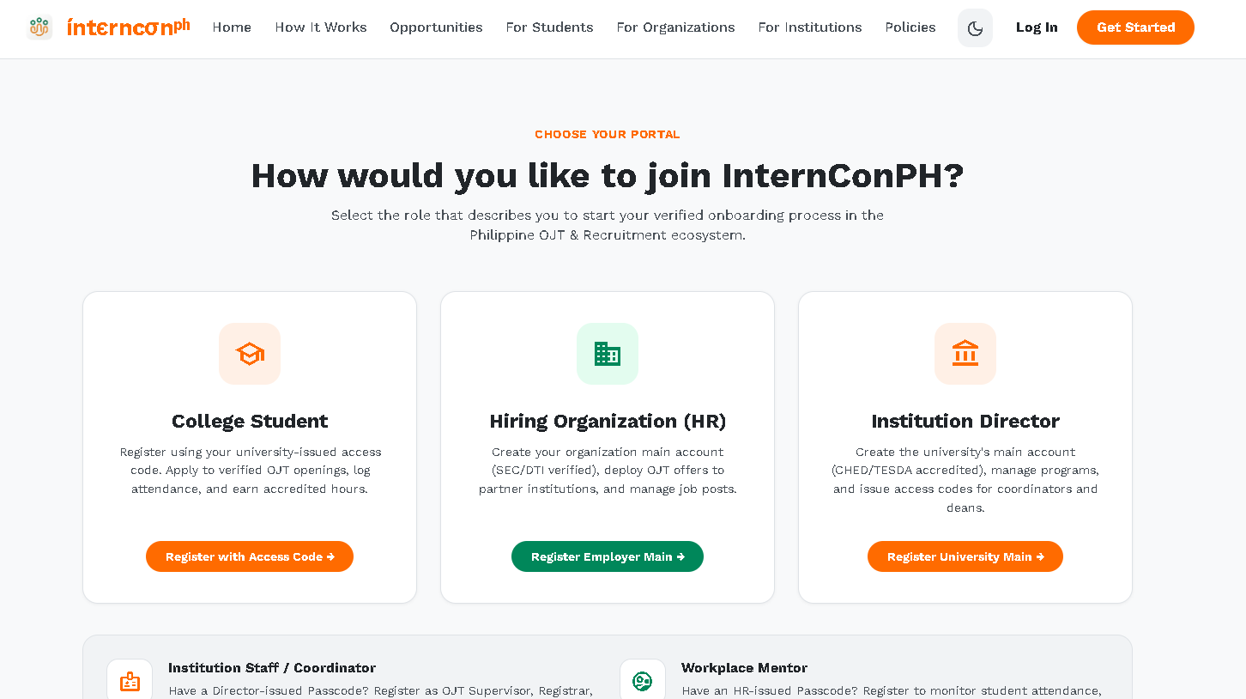

Applicant Form
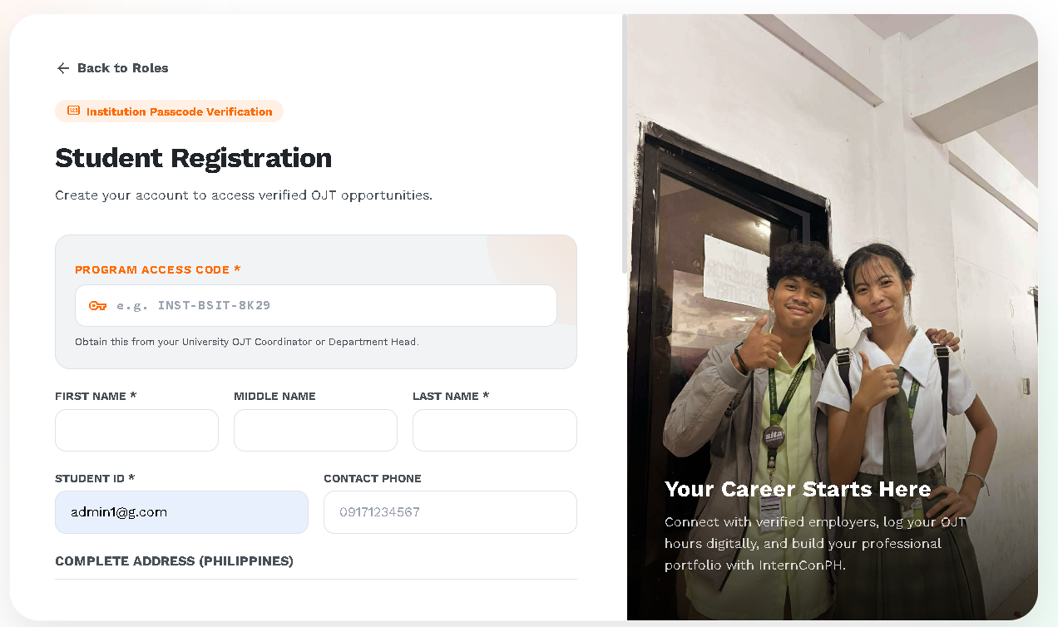

Add Property Form
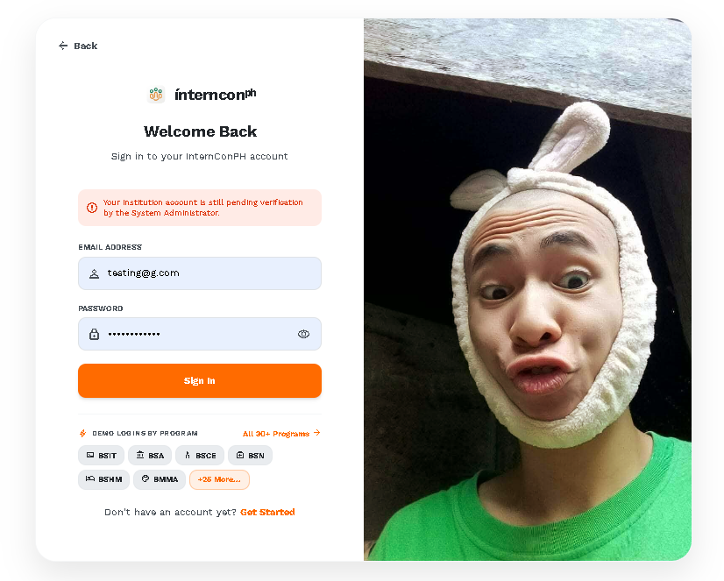

Reports
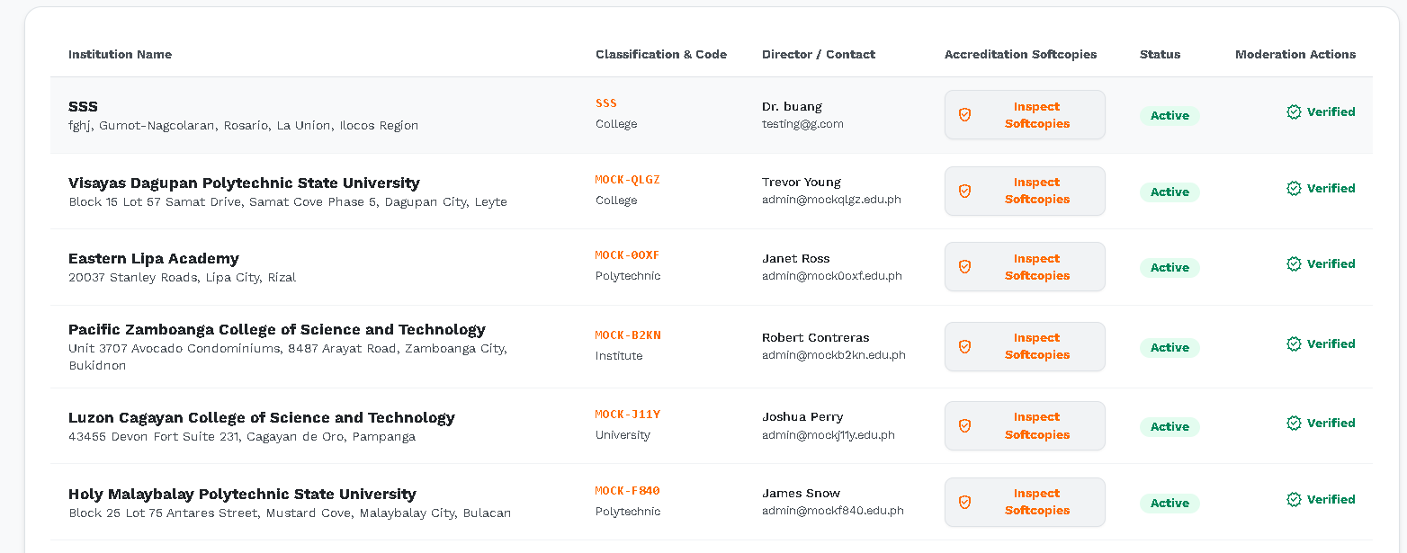

Data Dictionary

Table name | access_codes
Attributes | Type | Description | Constraints
code_id | bigint | Data for code id | NOT NULL
code_hash | varchar(64) | Data for code hash | NOT NULL
recipient_type | enum('institution_staff','student','workplace_mentor') | Data for recipient type | NOT NULL
institution_id | bigint | Data for institution id | DEFAULT NULL
organization_id | bigint | Data for organization id | DEFAULT NULL
program_id | bigint | Data for program id | DEFAULT NULL
target_identifier | varchar(100) | Data for target identifier | NOT NULL
intended_position | varchar(50) | Data for intended position | DEFAULT NULL
intended_department | varchar(100) | Data for intended department | DEFAULT NULL
intended_classification | varchar(50) | Data for intended classification | DEFAULT NULL
intended_status | varchar(50) | Current status | DEFAULT NULL
intended_email | varchar(150) | Email address for access_codes | DEFAULT NULL
assigned_permissions | json | Data for assigned permissions | DEFAULT NULL
created_by | bigint | Data for created by | NOT NULL
is_used | tinyint(1) | Data for is used | DEFAULT '0'
used_by_user_id | bigint | Data for used by user id | DEFAULT NULL
used_at | datetime | Data for used at | DEFAULT NULL
expires_at | datetime | Data for expires at | NOT NULL
created_at | datetime | Timestamp of creation | DEFAULT CURRENT_TIMESTAMP

Table name | accident_reports
Attributes | Type | Description | Constraints
accident_id | bigint | Data for accident id | NOT NULL
complaint_id | bigint | Data for complaint id | NOT NULL
organization_id | bigint | Data for organization id | NOT NULL
student_id | bigint | Data for student id | NOT NULL
incident_datetime | datetime | Data for incident datetime | NOT NULL
location | varchar(255) | Data for location | NOT NULL
severity | enum('minor','moderate','severe','critical','fatal') | Data for severity | NOT NULL, DEFAULT 'moderate'
injury_description | text | Data for injury description | NOT NULL
medical_attention_given | text | Data for medical attention given
witnesses | text | Data for witnesses
immediate_action_taken | text | Data for immediate action taken
preventive_measures | text | Data for preventive measures
reported_by | bigint | Data for reported by | NOT NULL
created_at | datetime | Timestamp of creation | DEFAULT CURRENT_TIMESTAMP
updated_at | datetime | Timestamp of last update | DEFAULT CURRENT_TIMESTAMP

Table name | audit_logs
Attributes | Type | Description | Constraints
log_id | bigint | Data for log id | NOT NULL
user_id | bigint | Data for user id | DEFAULT NULL
action | varchar(100) | Data for action | NOT NULL
table_name | varchar(100) | Data for table name | NOT NULL
record_id | bigint | Data for record id | DEFAULT NULL
old_values | json | Data for old values | DEFAULT NULL
new_values | json | Data for new values | DEFAULT NULL
ip_address | varchar(45) | Data for ip address | DEFAULT NULL
created_at | datetime | Timestamp of creation | NOT NULL, DEFAULT CURRENT_TIMESTAMP

Table name | complaints
Attributes | Type | Description | Constraints
complaint_id | bigint | Unique identifier for complaints | NOT NULL
student_id | bigint | Data for student id | NOT NULL
complainant_type | enum('student','organization') | Data for complainant type | DEFAULT 'student'
student_status | enum('ojt','graduated') | Current status | DEFAULT NULL
organization_id | bigint | Data for organization id | NOT NULL
category_id | int | Data for category id | NOT NULL
job_id | bigint | Data for job id | DEFAULT NULL
application_id | bigint | Data for application id | DEFAULT NULL
subject | varchar(200) | Data for subject | NOT NULL
description | text | Data for description | NOT NULL
is_accident | tinyint(1) | Data for is accident | DEFAULT '0'
forwarded_to_org | tinyint(1) | Data for forwarded to org | DEFAULT '0'
forwarded_to_org_at | datetime | Data for forwarded to org at | DEFAULT NULL
org_notice_summary | text | Data for org notice summary
include_student_details | tinyint(1) | Data for include student details | DEFAULT '0'
warning_note_to_student | text | Data for warning note to student
warning_sent_at | datetime | Data for warning sent at | DEFAULT NULL
status | enum('submitted','institution_review','admin_review','resolved','dismissed') | Current status | NOT NULL, DEFAULT 'submitted'
filed_at | datetime | Data for filed at | NOT NULL, DEFAULT CURRENT_TIMESTAMP
created_at | datetime | Timestamp of creation | NOT NULL, DEFAULT CURRENT_TIMESTAMP
updated_at | datetime | Timestamp of last update | NOT NULL, DEFAULT CURRENT_TIMESTAMP

Table name | complaint_categories
Attributes | Type | Description | Constraints
category_id | int | Data for category id | NOT NULL
category_name | varchar(100) | Data for category name | NOT NULL
description | varchar(255) | Data for description | DEFAULT NULL
created_at | datetime | Timestamp of creation | NOT NULL, DEFAULT CURRENT_TIMESTAMP
updated_at | datetime | Timestamp of last update | NOT NULL, DEFAULT CURRENT_TIMESTAMP

Table name | complaint_evidence
Attributes | Type | Description | Constraints
evidence_id | bigint | Data for evidence id | NOT NULL
complaint_id | bigint | Data for complaint id | NOT NULL
file_path | varchar(500) | Data for file path | NOT NULL
description | varchar(255) | Data for description | DEFAULT NULL
uploaded_at | datetime | Data for uploaded at | NOT NULL, DEFAULT CURRENT_TIMESTAMP
created_at | datetime | Timestamp of creation | NOT NULL, DEFAULT CURRENT_TIMESTAMP
updated_at | datetime | Timestamp of last update | NOT NULL, DEFAULT CURRENT_TIMESTAMP

Table name | complaint_reviews
Attributes | Type | Description | Constraints
review_id | bigint | Data for review id | NOT NULL
complaint_id | bigint | Data for complaint id | NOT NULL
reviewed_by | bigint | Data for reviewed by | NOT NULL
reviewer_role | enum('institution','admin') | Data for reviewer role | NOT NULL
findings | text | Data for findings
recommendation | text | Data for recommendation
action_taken | varchar(255) | Data for action taken | DEFAULT NULL
reviewed_at | datetime | Data for reviewed at | NOT NULL, DEFAULT CURRENT_TIMESTAMP
created_at | datetime | Timestamp of creation | NOT NULL, DEFAULT CURRENT_TIMESTAMP
updated_at | datetime | Timestamp of last update | NOT NULL, DEFAULT CURRENT_TIMESTAMP

Table name | entity_registrations
Attributes | Type | Description | Constraints
registration_id | bigint | Data for registration id | NOT NULL
entity_type | enum('institution','hiring_organization','institution_staff','student','workplace_mentor') | Data for entity type | NOT NULL
entity_id | bigint | Data for entity id | NOT NULL
user_id | bigint | Data for user id | NOT NULL
status | enum('pending','verified','rejected') | Current status | DEFAULT 'pending'
reviewer_user_id | bigint | Data for reviewer user id | DEFAULT NULL
reviewed_at | datetime | Data for reviewed at | DEFAULT NULL
rejection_reason | text | Data for rejection reason
submitted_at | datetime | Data for submitted at | DEFAULT CURRENT_TIMESTAMP

Table name | hiring_organizations
Attributes | Type | Description | Constraints
organization_id | bigint | Data for organization id | NOT NULL
organization_name | varchar(200) | Data for organization name | NOT NULL
business_structure | varchar(50) | Data for business structure | NOT NULL, DEFAULT 'corporation'
industry | varchar(150) | Data for industry | DEFAULT NULL
address | varchar(255) | Data for address | DEFAULT NULL
city | varchar(100) | Data for city | DEFAULT NULL
province | varchar(100) | Data for province | DEFAULT NULL
sec_dti_number | varchar(100) | Data for sec dti number | DEFAULT NULL
bir_tin | varchar(100) | Data for bir tin | DEFAULT NULL
mayors_permit_number | varchar(100) | Data for mayors permit number | DEFAULT NULL
contact_email | varchar(150) | Email address for hiring_organizations | DEFAULT NULL
contact_phone | varchar(20) | Data for contact phone | DEFAULT NULL
website | varchar(255) | Data for website | DEFAULT NULL
status | enum('pending','active','warned','suspended','deactivated') | Current status | NOT NULL, DEFAULT 'pending'
created_at | datetime | Timestamp of creation | NOT NULL, DEFAULT CURRENT_TIMESTAMP
updated_at | datetime | Timestamp of last update | NOT NULL, DEFAULT CURRENT_TIMESTAMP

Table name | institutions
Attributes | Type | Description | Constraints
institution_id | bigint | Unique identifier for institutions | NOT NULL
institution_name | varchar(200) | Data for institution name | NOT NULL
institution_code | varchar(30) | Data for institution code | NOT NULL
institution_type | varchar(50) | Data for institution type | NOT NULL, DEFAULT 'university'
address | varchar(255) | Data for address | DEFAULT NULL
city | varchar(100) | Data for city | DEFAULT NULL
province | varchar(100) | Data for province | DEFAULT NULL
postal_code | varchar(10) | Data for postal code | DEFAULT NULL
contact_email | varchar(150) | Email address for institutions | DEFAULT NULL
contact_phone | varchar(20) | Data for contact phone | DEFAULT NULL
accreditation_number | varchar(100) | Data for accreditation number | DEFAULT NULL
director_name | varchar(150) | Data for director name | DEFAULT NULL
director_title | varchar(150) | Data for director title | DEFAULT NULL
website | varchar(255) | Data for website | DEFAULT NULL
status | enum('pending','active','suspended','deactivated') | Current status | NOT NULL, DEFAULT 'pending'
created_at | datetime | Timestamp of creation | NOT NULL, DEFAULT CURRENT_TIMESTAMP
updated_at | datetime | Timestamp of last update | NOT NULL, DEFAULT CURRENT_TIMESTAMP

Table name | institution_documents
Attributes | Type | Description | Constraints
document_id | bigint | Data for document id | NOT NULL
institution_id | bigint | Data for institution id | NOT NULL
document_type | varchar(100) | Data for document type | NOT NULL, DEFAULT 'accreditation_certificate'
document_name | varchar(255) | Data for document name | DEFAULT NULL
file_path | varchar(500) | Data for file path | NOT NULL
file_name | varchar(255) | Data for file name | DEFAULT NULL
verified | tinyint(1) | Data for verified | NOT NULL, DEFAULT '0'
uploaded_at | datetime | Data for uploaded at | NOT NULL, DEFAULT CURRENT_TIMESTAMP
created_at | datetime | Timestamp of creation | NOT NULL, DEFAULT CURRENT_TIMESTAMP
updated_at | datetime | Timestamp of last update | NOT NULL, DEFAULT CURRENT_TIMESTAMP

Table name | institution_job_approvals
Attributes | Type | Description | Constraints
approval_id | bigint | Data for approval id | NOT NULL
job_id | bigint | Data for job id | NOT NULL
institution_id | bigint | Data for institution id | NOT NULL
approval_status | enum('pending','approved','rejected') | Current status | DEFAULT 'pending'
reviewed_by | bigint | Data for reviewed by | DEFAULT NULL
reviewed_at | datetime | Data for reviewed at | DEFAULT NULL
rejection_reason | text | Data for rejection reason
created_at | datetime | Timestamp of creation | DEFAULT CURRENT_TIMESTAMP

Table name | institution_registrations
Attributes | Type | Description | Constraints
registration_id | bigint | Data for registration id | NOT NULL
institution_id | bigint | Data for institution id | NOT NULL
submitted_by | bigint | Data for submitted by | NOT NULL
status | enum('pending','under_review','approved','rejected') | Current status | NOT NULL, DEFAULT 'pending'
reviewed_by | bigint | Data for reviewed by | DEFAULT NULL
review_notes | text | Data for review notes
submitted_at | datetime | Data for submitted at | NOT NULL, DEFAULT CURRENT_TIMESTAMP
reviewed_at | datetime | Data for reviewed at | DEFAULT NULL
created_at | datetime | Timestamp of creation | NOT NULL, DEFAULT CURRENT_TIMESTAMP
updated_at | datetime | Timestamp of last update | NOT NULL, DEFAULT CURRENT_TIMESTAMP

Table name | institution_reports
Attributes | Type | Description | Constraints
report_id | bigint | Data for report id | NOT NULL
institution_id | bigint | Data for institution id | NOT NULL
organization_id | bigint | Data for organization id | NOT NULL
complaint_id | bigint | Data for complaint id | NOT NULL
category_id | int | Data for category id | NOT NULL
title | varchar(200) | Data for title | NOT NULL
findings | text | Data for findings | NOT NULL
recommendation | text | Data for recommendation | NOT NULL
action_taken | text | Data for action taken
reported_by | bigint | Data for reported by | NOT NULL
status | enum('submitted','under_review','action_taken','closed') | Current status | DEFAULT 'submitted'
created_at | datetime | Timestamp of creation | DEFAULT CURRENT_TIMESTAMP
updated_at | datetime | Timestamp of last update | DEFAULT CURRENT_TIMESTAMP

Table name | institution_staff
Attributes | Type | Description | Constraints
staff_id | bigint | Data for staff id | NOT NULL
user_id | bigint | Data for user id | NOT NULL
institution_id | bigint | Data for institution id | NOT NULL
program_id | bigint | Data for program id | DEFAULT NULL
department | varchar(150) | Data for department | DEFAULT NULL
position | varchar(50) | Data for position | NOT NULL, DEFAULT 'ojt_supervisor'
employee_id | varchar(30) | Data for employee id | DEFAULT NULL
staff_number | varchar(50) | Data for staff number | DEFAULT NULL
first_name | varchar(100) | Data for first name | DEFAULT NULL
last_name | varchar(100) | Data for last name | DEFAULT NULL
contact_number | varchar(50) | Data for contact number | DEFAULT NULL
permissions | json | Data for permissions | DEFAULT NULL
is_active | tinyint(1) | Active status flag | NOT NULL, DEFAULT '1'
is_verified | tinyint(1) | Data for is verified | DEFAULT '0'
created_at | datetime | Timestamp of creation | NOT NULL, DEFAULT CURRENT_TIMESTAMP
updated_at | datetime | Timestamp of last update | NOT NULL, DEFAULT CURRENT_TIMESTAMP

Table name | interviews
Attributes | Type | Description | Constraints
interview_id | bigint | Unique identifier for interviews | NOT NULL
application_id | bigint | Data for application id | NOT NULL
schedule_at | datetime | Data for schedule at | NOT NULL
mode | enum('onsite','online','phone') | Data for mode | NOT NULL, DEFAULT 'onsite'
location_or_link | varchar(255) | Data for location or link | DEFAULT NULL
status | enum('scheduled','completed','cancelled','no_show') | Current status | NOT NULL, DEFAULT 'scheduled'
notes | text | Data for notes
created_at | datetime | Timestamp of creation | NOT NULL, DEFAULT CURRENT_TIMESTAMP
updated_at | datetime | Timestamp of last update | NOT NULL, DEFAULT CURRENT_TIMESTAMP

Table name | job_applications
Attributes | Type | Description | Constraints
application_id | bigint | Data for application id | NOT NULL
job_id | bigint | Data for job id | NOT NULL
student_id | bigint | Data for student id | NOT NULL
status | varchar(50) | Current status | NOT NULL, DEFAULT 'submitted'
accepted_at | datetime | Data for accepted at | DEFAULT NULL
completed_at | datetime | Data for completed at | DEFAULT NULL
applied_at | datetime | Data for applied at | NOT NULL, DEFAULT CURRENT_TIMESTAMP
created_at | datetime | Timestamp of creation | NOT NULL, DEFAULT CURRENT_TIMESTAMP
updated_at | datetime | Timestamp of last update | NOT NULL, DEFAULT CURRENT_TIMESTAMP

Table name | job_offers
Attributes | Type | Description | Constraints
offer_id | bigint | Data for offer id | NOT NULL
application_id | bigint | Data for application id | NOT NULL
status | enum('offered','accepted','declined','withdrawn') | Current status | NOT NULL, DEFAULT 'offered'
offered_at | datetime | Data for offered at | NOT NULL, DEFAULT CURRENT_TIMESTAMP
responded_at | datetime | Data for responded at | DEFAULT NULL
created_at | datetime | Timestamp of creation | NOT NULL, DEFAULT CURRENT_TIMESTAMP
updated_at | datetime | Timestamp of last update | NOT NULL, DEFAULT CURRENT_TIMESTAMP

Table name | job_postings
Attributes | Type | Description | Constraints
job_id | bigint | Data for job id | NOT NULL
organization_id | bigint | Data for organization id | NOT NULL
mentor_id | bigint | Data for mentor id | DEFAULT NULL
title | varchar(200) | Data for title | NOT NULL
description | text | Data for description | NOT NULL
requirements | text | Data for requirements
deliverables | text | Data for deliverables
posting_type | varchar(50) | Data for posting type | NOT NULL, DEFAULT 'ojt'
job_type | varchar(50) | Data for job type | NOT NULL, DEFAULT 'ojt'
location | varchar(255) | Data for location | DEFAULT NULL
finish_time | varchar(100) | Data for finish time | DEFAULT NULL
on_call_days | int | Data for on call days | DEFAULT NULL
salary_rate | decimal(10,2) | Data for salary rate | DEFAULT NULL
salary_rate_type | varchar(50) | Data for salary rate type | DEFAULT 'daily'
target_audience | varchar(50) | Data for target audience | DEFAULT 'ojt_students'
work_setup | varchar(50) | Data for work setup | NOT NULL, DEFAULT 'onsite'
slots_available | int | Data for slots available | NOT NULL, DEFAULT '1'
status | enum('draft','pending_review','active','closed','rejected') | Current status | NOT NULL, DEFAULT 'draft'
posted_at | datetime | Data for posted at | DEFAULT NULL
expires_at | datetime | Data for expires at | DEFAULT NULL
created_at | datetime | Timestamp of creation | NOT NULL, DEFAULT CURRENT_TIMESTAMP
updated_at | datetime | Timestamp of last update | NOT NULL, DEFAULT CURRENT_TIMESTAMP

Table name | job_posting_reviews
Attributes | Type | Description | Constraints
review_id | bigint | Data for review id | NOT NULL
job_id | bigint | Data for job id | NOT NULL
reviewed_by | bigint | Data for reviewed by | NOT NULL
status | enum('approved','rejected') | Current status | NOT NULL
notes | text | Data for notes
reviewed_at | datetime | Data for reviewed at | NOT NULL, DEFAULT CURRENT_TIMESTAMP
created_at | datetime | Timestamp of creation | NOT NULL, DEFAULT CURRENT_TIMESTAMP
updated_at | datetime | Timestamp of last update | NOT NULL, DEFAULT CURRENT_TIMESTAMP

Table name | job_required_programs
Attributes | Type | Description | Constraints
id | bigint | Data for id | NOT NULL
job_id | bigint | Data for job id | NOT NULL
program_id | bigint | Data for program id | NOT NULL
is_mandatory | tinyint(1) | Data for is mandatory | DEFAULT '1'
created_at | datetime | Timestamp of creation | NOT NULL, DEFAULT CURRENT_TIMESTAMP

Table name | job_required_skills
Attributes | Type | Description | Constraints
id | bigint | Data for id | NOT NULL
job_id | bigint | Data for job id | NOT NULL
skill_id | int | Data for skill id | NOT NULL
importance | enum('required','preferred') | Data for importance | NOT NULL, DEFAULT 'required'
created_at | datetime | Timestamp of creation | NOT NULL, DEFAULT CURRENT_TIMESTAMP

Table name | master_programs
Attributes | Type | Description | Constraints
master_program_id | int | Unique identifier for master_programs | NOT NULL
program_name | varchar(150) | Data for program name | NOT NULL
program_code | varchar(30) | Data for program code | NOT NULL
discipline | varchar(100) | Data for discipline | NOT NULL
default_ojt_hours | int | Data for default ojt hours | NOT NULL, DEFAULT '486'
description | text | Data for description
created_at | datetime | Timestamp of creation | DEFAULT CURRENT_TIMESTAMP

Table name | notifications
Attributes | Type | Description | Constraints
notification_id | bigint | Unique identifier for notifications | NOT NULL
user_id | bigint | Data for user id | NOT NULL
sender_id | bigint | Data for sender id | DEFAULT NULL
sender_name | varchar(150) | Data for sender name | DEFAULT NULL
title | varchar(150) | Data for title | NOT NULL
message | text | Data for message | NOT NULL
link | varchar(255) | Data for link | DEFAULT NULL
related_type | varchar(50) | Data for related type | DEFAULT NULL
related_id | bigint | Data for related id | DEFAULT NULL
type | enum('registration','verification','ojt','job','complaint','system','other') | Data for type | NOT NULL, DEFAULT 'other'
is_read | tinyint(1) | Data for is read | NOT NULL, DEFAULT '0'
created_at | datetime | Timestamp of creation | NOT NULL, DEFAULT CURRENT_TIMESTAMP
updated_at | datetime | Timestamp of last update | NOT NULL, DEFAULT CURRENT_TIMESTAMP

Table name | ojt_attendance_logs
Attributes | Type | Description | Constraints
attendance_id | bigint | Data for attendance id | NOT NULL
ojt_id | bigint | Data for ojt id | NOT NULL
student_id | bigint | Data for student id | NOT NULL
mentor_id | bigint | Data for mentor id | DEFAULT NULL
log_date | date | Data for log date | NOT NULL
time_in | time | Data for time in | NOT NULL
time_out | time | Data for time out | DEFAULT NULL
hours_rendered | decimal(5,2) | Data for hours rendered | DEFAULT '0.00'
tasks_accomplished | text | Data for tasks accomplished
status | enum('pending','verified','rejected') | Current status | DEFAULT 'pending'
verified_by | bigint | Data for verified by | DEFAULT NULL
verified_at | datetime | Data for verified at | DEFAULT NULL
rejection_notes | text | Data for rejection notes
created_at | datetime | Timestamp of creation | DEFAULT CURRENT_TIMESTAMP
updated_at | datetime | Timestamp of last update | DEFAULT CURRENT_TIMESTAMP

Table name | ojt_deployment_offers
Attributes | Type | Description | Constraints
offer_id | bigint | Data for offer id | NOT NULL
student_id | bigint | Data for student id | NOT NULL
organization_id | bigint | Data for organization id | NOT NULL
job_id | bigint | Data for job id | DEFAULT NULL
status | enum('offered','accepted','declined','withdrawn') | Current status | NOT NULL, DEFAULT 'offered'
offered_by | bigint | Data for offered by | NOT NULL
offered_at | datetime | Data for offered at | NOT NULL, DEFAULT CURRENT_TIMESTAMP
responded_at | datetime | Data for responded at | DEFAULT NULL
created_at | datetime | Timestamp of creation | NOT NULL, DEFAULT CURRENT_TIMESTAMP
updated_at | datetime | Timestamp of last update | NOT NULL, DEFAULT CURRENT_TIMESTAMP

Table name | ojt_performance_records
Attributes | Type | Description | Constraints
record_id | bigint | Data for record id | NOT NULL
ojt_id | bigint | Data for ojt id | NOT NULL
evaluator_id | bigint | Data for evaluator id | NOT NULL
evaluation_period | enum('midterm','final') | Data for evaluation period | NOT NULL
rating | decimal(3,2) | Data for rating | NOT NULL
comments | text | Data for comments
score_details | json | Data for score details | DEFAULT NULL
evaluated_at | datetime | Data for evaluated at | NOT NULL, DEFAULT CURRENT_TIMESTAMP
created_at | datetime | Timestamp of creation | NOT NULL, DEFAULT CURRENT_TIMESTAMP
updated_at | datetime | Timestamp of last update | NOT NULL, DEFAULT CURRENT_TIMESTAMP

Table name | ojt_records
Attributes | Type | Description | Constraints
ojt_id | bigint | Data for ojt id | NOT NULL
student_id | bigint | Data for student id | NOT NULL
organization_id | bigint | Data for organization id | NOT NULL
program_id | bigint | Data for program id | DEFAULT NULL
start_date | date | Data for start date | NOT NULL
end_date | date | Data for end date | DEFAULT NULL
required_hours | int | Data for required hours | NOT NULL, DEFAULT '0'
rendered_hours | int | Data for rendered hours | NOT NULL, DEFAULT '0'
status | enum('ongoing','completed','terminated','withdrawn') | Current status | NOT NULL, DEFAULT 'ongoing'
supervisor_name | varchar(150) | Data for supervisor name | DEFAULT NULL
supervisor_contact | varchar(100) | Data for supervisor contact | DEFAULT NULL
created_at | datetime | Timestamp of creation | NOT NULL, DEFAULT CURRENT_TIMESTAMP
updated_at | datetime | Timestamp of last update | NOT NULL, DEFAULT CURRENT_TIMESTAMP

Table name | ojt_requirements
Attributes | Type | Description | Constraints
requirement_id | bigint | Data for requirement id | NOT NULL
institution_id | bigint | Data for institution id | DEFAULT NULL
requirement_name | varchar(150) | Data for requirement name | NOT NULL
description | text | Data for description
is_mandatory | tinyint(1) | Data for is mandatory | NOT NULL, DEFAULT '1'
created_at | datetime | Timestamp of creation | NOT NULL, DEFAULT CURRENT_TIMESTAMP
updated_at | datetime | Timestamp of last update | NOT NULL, DEFAULT CURRENT_TIMESTAMP

Table name | ojt_student_requirements
Attributes | Type | Description | Constraints
id | bigint | Data for id | NOT NULL
ojt_id | bigint | Data for ojt id | NOT NULL
requirement_id | bigint | Data for requirement id | NOT NULL
status | enum('pending','submitted','approved','rejected') | Current status | NOT NULL, DEFAULT 'pending'
file_path | varchar(500) | Data for file path | DEFAULT NULL
submitted_at | datetime | Data for submitted at | DEFAULT NULL
created_at | datetime | Timestamp of creation | NOT NULL, DEFAULT CURRENT_TIMESTAMP
updated_at | datetime | Timestamp of last update | NOT NULL, DEFAULT CURRENT_TIMESTAMP

Table name | organization_documents
Attributes | Type | Description | Constraints
document_id | bigint | Data for document id | NOT NULL
organization_id | bigint | Data for organization id | NOT NULL
document_type | varchar(100) | Data for document type | NOT NULL
document_name | varchar(255) | Data for document name | DEFAULT NULL
file_path | varchar(500) | Data for file path | NOT NULL
file_name | varchar(255) | Data for file name | DEFAULT NULL
verified | tinyint(1) | Data for verified | NOT NULL, DEFAULT '0'
uploaded_at | datetime | Data for uploaded at | NOT NULL, DEFAULT CURRENT_TIMESTAMP
created_at | datetime | Timestamp of creation | NOT NULL, DEFAULT CURRENT_TIMESTAMP
updated_at | datetime | Timestamp of last update | NOT NULL, DEFAULT CURRENT_TIMESTAMP

Table name | organization_registrations
Attributes | Type | Description | Constraints
registration_id | bigint | Data for registration id | NOT NULL
organization_id | bigint | Data for organization id | NOT NULL
submitted_by | bigint | Data for submitted by | NOT NULL
status | enum('pending','under_review','approved','rejected') | Current status | NOT NULL, DEFAULT 'pending'
reviewed_by | bigint | Data for reviewed by | DEFAULT NULL
review_notes | text | Data for review notes
submitted_at | datetime | Data for submitted at | NOT NULL, DEFAULT CURRENT_TIMESTAMP
reviewed_at | datetime | Data for reviewed at | DEFAULT NULL
created_at | datetime | Timestamp of creation | NOT NULL, DEFAULT CURRENT_TIMESTAMP
updated_at | datetime | Timestamp of last update | NOT NULL, DEFAULT CURRENT_TIMESTAMP

Table name | organization_staff
Attributes | Type | Description | Constraints
org_staff_id | bigint | Data for org staff id | NOT NULL
user_id | bigint | Data for user id | NOT NULL
organization_id | bigint | Data for organization id | NOT NULL
program_id | bigint | Data for program id | DEFAULT NULL
staff_number | varchar(50) | Data for staff number | DEFAULT NULL
title | varchar(20) | Data for title | DEFAULT NULL
first_name | varchar(100) | Data for first name | NOT NULL
middle_name | varchar(100) | Data for middle name | DEFAULT NULL
last_name | varchar(100) | Data for last name | NOT NULL
suffix | varchar(20) | Data for suffix | DEFAULT NULL
position | varchar(50) | Data for position | NOT NULL, DEFAULT 'workplace_mentor'
job_title | varchar(100) | Data for job title | DEFAULT NULL
department | varchar(100) | Data for department | DEFAULT NULL
work_location | varchar(100) | Data for work location | DEFAULT NULL
years_of_experience | int | Data for years of experience | DEFAULT '1'
contact_number | varchar(50) | Data for contact number | DEFAULT NULL
passcode_used | varchar(64) | Data for passcode used | DEFAULT NULL
is_verified | tinyint(1) | Data for is verified | DEFAULT '0'
rejection_reason | text | Data for rejection reason
created_at | datetime | Timestamp of creation | DEFAULT CURRENT_TIMESTAMP
updated_at | datetime | Timestamp of last update | DEFAULT CURRENT_TIMESTAMP

Table name | organization_status_history
Attributes | Type | Description | Constraints
history_id | bigint | Data for history id | NOT NULL
organization_id | bigint | Data for organization id | NOT NULL
old_status | varchar(30) | Current status | DEFAULT NULL
new_status | varchar(30) | Current status | NOT NULL
changed_by | bigint | Data for changed by | NOT NULL
reason | text | Data for reason
changed_at | datetime | Data for changed at | NOT NULL, DEFAULT CURRENT_TIMESTAMP
created_at | datetime | Timestamp of creation | NOT NULL, DEFAULT CURRENT_TIMESTAMP

Table name | organization_suspensions
Attributes | Type | Description | Constraints
suspension_id | bigint | Data for suspension id | NOT NULL
organization_id | bigint | Data for organization id | NOT NULL
complaint_id | bigint | Data for complaint id | DEFAULT NULL
issued_by | bigint | Data for issued by | NOT NULL
reason | text | Data for reason | NOT NULL
start_date | date | Data for start date | NOT NULL
end_date | date | Data for end date | DEFAULT NULL
is_active | tinyint(1) | Active status flag | NOT NULL, DEFAULT '1'
created_at | datetime | Timestamp of creation | NOT NULL, DEFAULT CURRENT_TIMESTAMP
updated_at | datetime | Timestamp of last update | NOT NULL, DEFAULT CURRENT_TIMESTAMP

Table name | organization_warnings
Attributes | Type | Description | Constraints
warning_id | bigint | Data for warning id | NOT NULL
organization_id | bigint | Data for organization id | NOT NULL
complaint_id | bigint | Data for complaint id | DEFAULT NULL
issued_by | bigint | Data for issued by | NOT NULL
reason | text | Data for reason | NOT NULL
issued_at | datetime | Data for issued at | NOT NULL, DEFAULT CURRENT_TIMESTAMP
created_at | datetime | Timestamp of creation | NOT NULL, DEFAULT CURRENT_TIMESTAMP
updated_at | datetime | Timestamp of last update | NOT NULL, DEFAULT CURRENT_TIMESTAMP

Table name | portfolio_items
Attributes | Type | Description | Constraints
item_id | bigint | Data for item id | NOT NULL
portfolio_id | bigint | Data for portfolio id | NOT NULL
title | varchar(200) | Data for title | NOT NULL
description | text | Data for description
file_path | varchar(500) | Data for file path | DEFAULT NULL
file_name | varchar(255) | Data for file name | DEFAULT NULL
file_size | int | Data for file size | DEFAULT NULL
item_type | varchar(50) | Data for item type | NOT NULL, DEFAULT 'academic_portfolio'
sub_category | varchar(100) | Data for sub category | DEFAULT NULL
is_verified | tinyint(1) | Data for is verified | DEFAULT '0'
associated_org_id | bigint | Data for associated org id | DEFAULT NULL
associated_job_id | bigint | Data for associated job id | DEFAULT NULL
created_at | datetime | Timestamp of creation | NOT NULL, DEFAULT CURRENT_TIMESTAMP
updated_at | datetime | Timestamp of last update | NOT NULL, DEFAULT CURRENT_TIMESTAMP

Table name | programs
Attributes | Type | Description | Constraints
program_id | bigint | Unique identifier for programs | NOT NULL
institution_id | bigint | Data for institution id | NOT NULL
program_name | varchar(150) | Data for program name | NOT NULL
program_code | varchar(30) | Data for program code | NOT NULL
department | varchar(150) | Data for department | DEFAULT NULL
required_ojt_hours | int | Data for required ojt hours | NOT NULL, DEFAULT '0'
created_at | datetime | Timestamp of creation | NOT NULL, DEFAULT CURRENT_TIMESTAMP
updated_at | datetime | Timestamp of last update | NOT NULL, DEFAULT CURRENT_TIMESTAMP

Table name | roles
Attributes | Type | Description | Constraints
role_id | int | Unique identifier for roles | NOT NULL
role_name | enum('system_admin','institution','institution_staff','student','hiring_organization') | Data for role name | NOT NULL
description | varchar(255) | Data for description | DEFAULT NULL
created_at | datetime | Timestamp of creation | NOT NULL, DEFAULT CURRENT_TIMESTAMP
updated_at | datetime | Timestamp of last update | NOT NULL, DEFAULT CURRENT_TIMESTAMP

Table name | skills
Attributes | Type | Description | Constraints
skill_id | int | Unique identifier for skills | NOT NULL
skill_name | varchar(100) | Data for skill name | NOT NULL
category_id | int | Data for category id | DEFAULT NULL
created_at | datetime | Timestamp of creation | NOT NULL, DEFAULT CURRENT_TIMESTAMP
updated_at | datetime | Timestamp of last update | NOT NULL, DEFAULT CURRENT_TIMESTAMP

Table name | skill_categories
Attributes | Type | Description | Constraints
category_id | int | Data for category id | NOT NULL
category_name | varchar(100) | Data for category name | NOT NULL
created_at | datetime | Timestamp of creation | NOT NULL, DEFAULT CURRENT_TIMESTAMP
updated_at | datetime | Timestamp of last update | NOT NULL, DEFAULT CURRENT_TIMESTAMP

Table name | skill_demand_statistics
Attributes | Type | Description | Constraints
stat_id | bigint | Data for stat id | NOT NULL
skill_id | int | Data for skill id | NOT NULL
period_start | date | Data for period start | NOT NULL
period_end | date | Data for period end | NOT NULL
demand_count | int | Data for demand count | NOT NULL, DEFAULT '0'
created_at | datetime | Timestamp of creation | NOT NULL, DEFAULT CURRENT_TIMESTAMP
updated_at | datetime | Timestamp of last update | NOT NULL, DEFAULT CURRENT_TIMESTAMP

Table name | students
Attributes | Type | Description | Constraints
student_id | bigint | Unique identifier for students | NOT NULL
user_id | bigint | Data for user id | NOT NULL
institution_id | bigint | Data for institution id | NOT NULL
program_id | bigint | Data for program id | NOT NULL
student_number | varchar(50) | Data for student number | NOT NULL
category_id | int | Data for category id | NOT NULL
classification | varchar(50) | Data for classification | NOT NULL, DEFAULT 'regular'
ojt_status | varchar(50) | Current status | NOT NULL, DEFAULT 'starting_ojt'
passcode_used | varchar(64) | Data for passcode used | DEFAULT NULL
status_id | int | Current status | NOT NULL
first_name | varchar(100) | Data for first name | NOT NULL
middle_name | varchar(100) | Data for middle name | DEFAULT NULL
last_name | varchar(100) | Data for last name | NOT NULL
birthdate | date | Data for birthdate | DEFAULT NULL
gender | enum('male','female','other','prefer_not_to_say') | Data for gender | DEFAULT NULL
contact_number | varchar(20) | Data for contact number | DEFAULT NULL
address | varchar(255) | Data for address | DEFAULT NULL
year_level | tinyint | Data for year level | DEFAULT NULL
required_ojt_hours | int | Data for required ojt hours | NOT NULL, DEFAULT '0'
completed_ojt_hours | int | Data for completed ojt hours | NOT NULL, DEFAULT '0'
is_verified | tinyint(1) | Data for is verified | DEFAULT '0'
is_active | tinyint(1) | Active status flag | DEFAULT '1'
created_at | datetime | Timestamp of creation | NOT NULL, DEFAULT CURRENT_TIMESTAMP
updated_at | datetime | Timestamp of last update | NOT NULL, DEFAULT CURRENT_TIMESTAMP

Table name | student_achievements
Attributes | Type | Description | Constraints
achievement_id | bigint | Data for achievement id | NOT NULL
student_id | bigint | Data for student id | NOT NULL
title | varchar(200) | Data for title | NOT NULL
description | text | Data for description
date_achieved | date | Data for date achieved | DEFAULT NULL
created_at | datetime | Timestamp of creation | NOT NULL, DEFAULT CURRENT_TIMESTAMP
updated_at | datetime | Timestamp of last update | NOT NULL, DEFAULT CURRENT_TIMESTAMP

Table name | student_categories
Attributes | Type | Description | Constraints
category_id | int | Data for category id | NOT NULL
category_name | varchar(100) | Data for category name | NOT NULL
description | varchar(255) | Data for description | DEFAULT NULL
created_at | datetime | Timestamp of creation | NOT NULL, DEFAULT CURRENT_TIMESTAMP
updated_at | datetime | Timestamp of last update | NOT NULL, DEFAULT CURRENT_TIMESTAMP

Table name | student_documents
Attributes | Type | Description | Constraints
document_id | bigint | Data for document id | NOT NULL
student_id | bigint | Data for student id | NOT NULL
document_type | enum('resume','cor','good_moral','medical_certificate','waiver','other') | Data for document type | NOT NULL
file_path | varchar(500) | Data for file path | NOT NULL
verified | tinyint(1) | Data for verified | NOT NULL, DEFAULT '0'
uploaded_at | datetime | Data for uploaded at | NOT NULL, DEFAULT CURRENT_TIMESTAMP
created_at | datetime | Timestamp of creation | NOT NULL, DEFAULT CURRENT_TIMESTAMP
updated_at | datetime | Timestamp of last update | NOT NULL, DEFAULT CURRENT_TIMESTAMP

Table name | student_portfolios
Attributes | Type | Description | Constraints
portfolio_id | bigint | Data for portfolio id | NOT NULL
student_id | bigint | Data for student id | NOT NULL
title | varchar(200) | Data for title | DEFAULT NULL
summary | text | Data for summary
created_at | datetime | Timestamp of creation | NOT NULL, DEFAULT CURRENT_TIMESTAMP
updated_at | datetime | Timestamp of last update | NOT NULL, DEFAULT CURRENT_TIMESTAMP

Table name | student_registrations
Attributes | Type | Description | Constraints
registration_id | bigint | Data for registration id | NOT NULL
student_id | bigint | Data for student id | NOT NULL
status | enum('pending','verified','rejected') | Current status | NOT NULL, DEFAULT 'pending'
verified_by | bigint | Data for verified by | DEFAULT NULL
verification_notes | text | Data for verification notes
submitted_at | datetime | Data for submitted at | NOT NULL, DEFAULT CURRENT_TIMESTAMP
verified_at | datetime | Data for verified at | DEFAULT NULL
created_at | datetime | Timestamp of creation | NOT NULL, DEFAULT CURRENT_TIMESTAMP
updated_at | datetime | Timestamp of last update | NOT NULL, DEFAULT CURRENT_TIMESTAMP

Table name | student_resumes
Attributes | Type | Description | Constraints
resume_id | bigint | Data for resume id | NOT NULL
student_id | bigint | Data for student id | NOT NULL
file_path | varchar(500) | Data for file path | NOT NULL
file_name | varchar(255) | Data for file name | DEFAULT NULL
file_size | int | Data for file size | DEFAULT NULL
version | int | Data for version | NOT NULL, DEFAULT '1'
is_active | tinyint(1) | Active status flag | NOT NULL, DEFAULT '1'
created_at | datetime | Timestamp of creation | NOT NULL, DEFAULT CURRENT_TIMESTAMP
updated_at | datetime | Timestamp of last update | NOT NULL, DEFAULT CURRENT_TIMESTAMP

Table name | student_skills
Attributes | Type | Description | Constraints
id | bigint | Data for id | NOT NULL
student_id | bigint | Data for student id | NOT NULL
skill_id | int | Data for skill id | NOT NULL
proficiency_level | enum('beginner','intermediate','advanced') | Data for proficiency level | NOT NULL, DEFAULT 'beginner'
created_at | datetime | Timestamp of creation | NOT NULL, DEFAULT CURRENT_TIMESTAMP
updated_at | datetime | Timestamp of last update | NOT NULL, DEFAULT CURRENT_TIMESTAMP

Table name | student_skill_recommendations
Attributes | Type | Description | Constraints
recommendation_id | bigint | Data for recommendation id | NOT NULL
student_id | bigint | Data for student id | NOT NULL
skill_id | int | Data for skill id | NOT NULL
reason | varchar(255) | Data for reason | DEFAULT NULL
score | decimal(5,2) | Data for score | DEFAULT NULL
generated_at | datetime | Data for generated at | NOT NULL, DEFAULT CURRENT_TIMESTAMP
created_at | datetime | Timestamp of creation | NOT NULL, DEFAULT CURRENT_TIMESTAMP

Table name | student_staff_assignments
Attributes | Type | Description | Constraints
assignment_id | bigint | Data for assignment id | NOT NULL
student_id | bigint | Data for student id | NOT NULL
staff_id | bigint | Data for staff id | NOT NULL
assigned_at | datetime | Data for assigned at | NOT NULL, DEFAULT CURRENT_TIMESTAMP
is_active | tinyint(1) | Active status flag | NOT NULL, DEFAULT '1'
created_at | datetime | Timestamp of creation | NOT NULL, DEFAULT CURRENT_TIMESTAMP
updated_at | datetime | Timestamp of last update | NOT NULL, DEFAULT CURRENT_TIMESTAMP

Table name | student_statuses
Attributes | Type | Description | Constraints
status_id | int | Current status | NOT NULL
status_name | varchar(50) | Current status | NOT NULL
description | varchar(255) | Data for description | DEFAULT NULL
created_at | datetime | Timestamp of creation | NOT NULL, DEFAULT CURRENT_TIMESTAMP
updated_at | datetime | Timestamp of last update | NOT NULL, DEFAULT CURRENT_TIMESTAMP

Table name | system_settings
Attributes | Type | Description | Constraints
setting_id | bigint | Data for setting id | NOT NULL
setting_key | varchar(100) | Data for setting key | NOT NULL
setting_value | text | Data for setting value
description | varchar(255) | Data for description | DEFAULT NULL
updated_by | bigint | Data for updated by | DEFAULT NULL
created_at | datetime | Timestamp of creation | NOT NULL, DEFAULT CURRENT_TIMESTAMP
updated_at | datetime | Timestamp of last update | NOT NULL, DEFAULT CURRENT_TIMESTAMP

Table name | users
Attributes | Type | Description | Constraints
user_id | bigint | Unique identifier for users | NOT NULL
role_id | int | Data for role id | NOT NULL
email | varchar(150) | Email address for users | NOT NULL
avatar_url | text | Data for avatar url
display_name | varchar(150) | Data for display name | DEFAULT NULL
password_hash | varchar(255) | Data for password hash | NOT NULL
is_active | tinyint(1) | Active status flag | NOT NULL, DEFAULT '1'
is_verified | tinyint(1) | Data for is verified | NOT NULL, DEFAULT '0'
last_login_at | datetime | Data for last login at | DEFAULT NULL
created_at | datetime | Timestamp of creation | NOT NULL, DEFAULT CURRENT_TIMESTAMP
updated_at | datetime | Timestamp of last update | NOT NULL, DEFAULT CURRENT_TIMESTAMP

Table name | user_preferences
Attributes | Type | Description | Constraints
preference_id | bigint | Data for preference id | NOT NULL
user_id | bigint | Data for user id | NOT NULL
theme | varchar(20) | Data for theme | DEFAULT 'light'
sound_enabled | tinyint(1) | Data for sound enabled | DEFAULT '1'
email_notifications | tinyint(1) | Email address for user_preferences | DEFAULT '1'
sms_alerts | tinyint(1) | Data for sms alerts | DEFAULT '0'
ojt_updates | tinyint(1) | Data for ojt updates | DEFAULT '1'
grievance_alerts | tinyint(1) | Data for grievance alerts | DEFAULT '1'
marketing_emails | tinyint(1) | Email address for user_preferences | DEFAULT '0'
compact_view | tinyint(1) | Data for compact view | DEFAULT '0'
created_at | datetime | Timestamp of creation | DEFAULT CURRENT_TIMESTAMP
updated_at | datetime | Timestamp of last update | DEFAULT CURRENT_TIMESTAMP

Network Design

The network design connects the Customer, Tenant, and Admin devices to the InternConPH Web Application through the internet. The web application connects to the database server to store and retrieve system data.
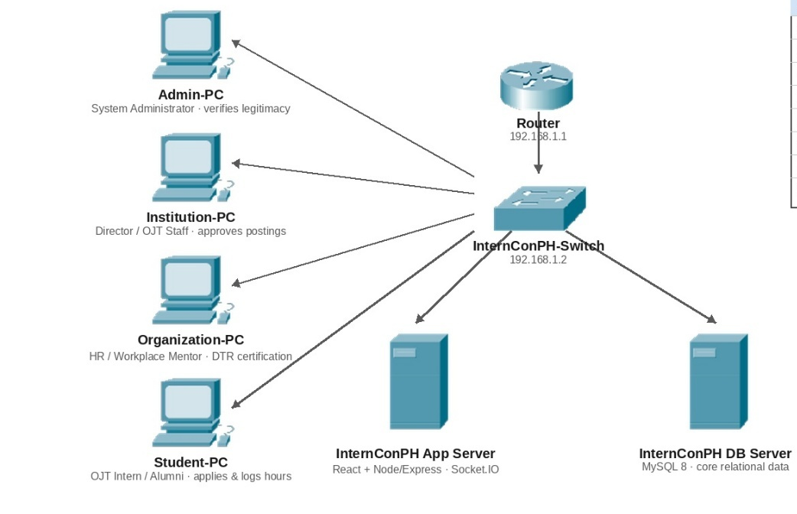

Figure 3.57 Network Design of INTERNCONPH: SYSTEM WORKFLOW, DATA ARCHITECTURE & OPERATIONAL GUIDE

Network Topology

The proposed system uses a Star Topology, where the user devices connect through a central network. This allows the Customer, Tenant, and Admin to access the InternConPH Web Application at the same time.

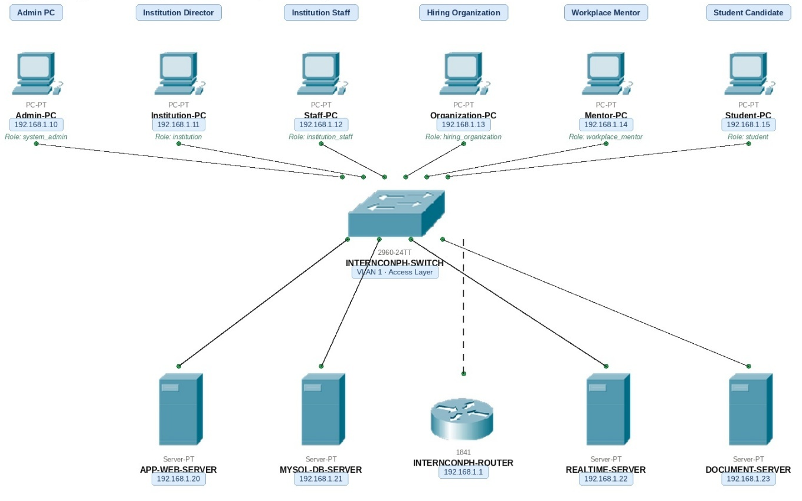

Figure 3.58 Network Topology of INTERNCONPH: SYSTEM WORKFLOW, DATA ARCHITECTURE & OPERATIONAL GUIDE

Deployment / Construction / Build Phase
Technology Stack Development

WINDOWS
Operating System
Antigravity
Other Tool

MySQL
Database
React .js
JavaScript

Software Specification

Language: JavaScript (ES Modules / ES6+)

Technology: JavaScript Node.js/ Powered by/ Express.js and Socket.io

Database: MySQL

IDE: Antigravity

Operating System: Windows

Hardware Specification

Processor: intel core i5 8th gen
Hard Disk: SSD 256gb
RAM: 12gb

Program Specification Language: PHP 8.1
Framework: React js
Database: MySQL
IDE: Antigravity
Frontend: JavaScript / JSX React 19 bundled using Vite. CSS / Tailwind CSS

List of Module

System Administrator Dashboard
This dashboard provides platform-wide administration and oversight. It allows the System Administrator to verify institution and hiring-organization registrations, inspect legitimacy documents, approve or reject registrations, review nationwide analytics and skill supply/demand information, govern escalated disputes, and monitor audit logs.

Institution Director Dashboard
This dashboard allows the Institution Director to manage the institution profile, campus information, degree programs and curricula, generate staff access codes, manage institution staff invitations, and review, approve, or reject OJT and Career opportunities offered by partner organizations.

Institution Staff Dashboard
This dashboard provides role-scoped academic operations for OJT Supervisors/Coordinators, Registrars, Guidance Counselors, and Academic Deans. Functions include student intake and verification, curriculum and required-hour validation, active OJT monitoring, clearances, incident and grievance handling, academic oversight, and department-level internship approvals.

Student Dashboard
This dashboard supports Regular, Returnee, and Transferee students throughout the OJT and career lifecycle. Students can complete registration, maintain academic information, browse approved OJT opportunities, apply for eligible openings, track applications and interviews, record daily OJT attendance and tasks, monitor credited hours, file grievances, manage skills and resumes, and access their verified career portfolio after completion and graduation.

Hiring Organization / HR Dashboard
This dashboard enables verified organizations to manage their organization profile and workforce opportunities. HR staff can create OJT, Career Job, and On-Call postings, specify work setup, slots, compensation or allowance, required skills, deadlines, target

institutions and programs, designate Workplace Mentors, review applicants, schedule interviews, issue offers, and manage active OJT deployments.

Workplace Mentor Dashboard
This dashboard supports mentors and workplace supervisors assigned to interns. Mentors can review assigned interns, verify Daily Time Records, confirm clock-in and clock-out information, credit rendered training hours, add authorized manual hours for special projects or overtime, submit Midterm and Final Performance Evaluations, and file incident, misconduct, or accident reports.

Opportunity & Institutional Clearance Module
This module separates OJT training, Career Jobs, and On-Call Projects. Hiring organizations create postings and invite specific Higher Education Institutions. Opportunities enter institutional clearance and cannot be displayed to students until
the appropriate Institution Director or Dean approves them. Approved postings are matched against programs and required skills.

Candidate Matching & Application Module
This module matches student qualifications against opportunity requirements using student skills and required job skills. Students submit applications with resumes, cover letters, and verified portfolio items. HR can review candidates, update application stages, shortlist applicants, request interviews, and issue formal OJT or career offers.

OJT Deployment & DTR Module
This module manages official OJT records and daily attendance. An OJT record stores the student, organization, program, start date, required hours, and rendered hours. Students submit daily shift details and tasks, while assigned mentors verify DTR entries and credited hours. Verified hours automatically update the student's OJT progress and remaining-hour balance.

Performance Evaluation & Career Portfolio Module
This module records Midterm and Final OJT Performance Evaluations using criteria such as Quality of Work, Dependability and Initiative, Technical Skill Mastery, and

Workplace Ethics. When OJT or an eligible On-Call project is completed, the system generates authenticated portfolio items linked to the verified organization, creating evidence for the student's lifelong career portfolio.

Incident, Complaint & Grievance Module
This module provides bidirectional accountability between students, organizations, and institutions. Organizations can report intern misconduct, safety violations, absences, and accidents. Students can report harassment, unpaid overtime, safety hazards, or other grievances. Student complaints are routed to the Guidance Counselor, with identity masking available when the institution communicates with the organization.

Access Code & Delegated Passcode Module
This module governs delegated registration for Institution Staff, Workplace Mentors, and Students. Authorized Directors, HR staff, and OJT Coordinators generate cryptographically protected access codes containing the required institution, organization, program, role, or identifier information. Codes are validated for expiration, prior use, identifier matching, and organizational or program scope.

Notification & Realtime Event Module
This module provides realtime dashboard notifications through the system event bus. Events include job updates, application status changes, OJT attendance and hour verification, notification delivery, and complaint updates so relevant users receive immediate operational information.

Audit & Compliance Module
This module records high-risk system operations such as approvals, rejections, password resets, access-code generation, and disciplinary complaints. Audit records capture the responsible user, action timestamp, target entity, and client IP address. It also supports compliance controls related to legitimacy verification, institutional clearance, attendance certification, and grievance handling.

