PROJECT TITLE PROPOSAL

- Name of Proponents:
Catolico, Denmark N.
Rojas, John Ber R.
Piquero, Stephen Dave M.
Verez, Stefanni

- Proposed Case Study Title
OJTConnect PH: A Verified Employment and On-Call Recruitment Platform for OJT Completers, Graduates, Educational Institutions, and Hiring Organizations in the Philippines

- Area of Investigation
The study will be conducted at the South East Asian Institute of Technology (SEAIT), Tupi, South Cotabato, for the pilot implementation and evaluation of the proposed system, while the system is intended for nationwide implementation.

4.0 Cited Problems
4.1 Incomplete Professional Profiles: Applicants struggle to present their OJT history and skills effectively, reducing their job market competitiveness.
4.2 Redundant Application Effort: Repeatedly uploading resumes and supporting documents for every application is time-consuming and increases the risk of submitting outdated files.
4.3 Skill Gap Unawareness: Applicants lack clear visibility into industry-required skills, making targeted career development difficult.
4.4 Exposure to Job Scams: Existing platforms often host unverified or fraudulent job postings, risking applicant safety.
4.5 Fragmented Student Data: Credentials, OJT records, and skills are stored across multiple platforms, leading to scattered, outdated profiles.
4.6 Limited Mechanisms for Reporting Fraudulent Job Postings: Applicants cannot easily report suspicious job posts, leaving fake listings active for others.
4.7 Limited Employer Transparency: Limited access to detailed employer profiles makes it hard to verify legitimacy or job fit before applying.
4.8 Inefficient Opportunity Matching: Applicants experience difficulty finding verified regular and on-call employment opportunities that match their OJT experience and skills.
4.9 Lack of Centralized Application Notifications: Without centralized notifications, applicants frequently miss interview invites, messages, and application status changes.

- Functions of the Proposed System
The proposed system, OJTConnect PH, enables OJT completers and graduates to create and maintain professional profiles containing OJT experience, employment history, certifications, resumes, and supporting documents. It provides recommendations for skills needed to qualify for target jobs, allows users to browse verified job opportunities, receive rule-based job recommendations, submit online applications, and report suspicious job postings. Additionally, the system provides access to verified hiring organization profiles, job requirements, and real-time notifications regarding application status, interview schedules, employer messages, and hiring decisions.

6.0 Features of the Proposed System
Personal Profile, OJT Experience, and Employment Management
Enables users to manage their personal profile, educational background, OJT experience, employment history, skills, and certifications in one platform.
Resume and Document Repository
Enables users to upload, securely store, and reuse resumes and supporting documents for multiple job applications.
Missing Skills Recommendation
Enables users to view recommended skills and certifications based on their target job requirements.

Verified Job Opportunity Portal
Enables users to browse verified on-call and regular job opportunities from approved hiring organizations.
Apply for On-Call and Regular Positions
Enables users to apply for verified job opportunities directly through the platform.
Suspicious Job Reporting
Enables users to report suspicious or fraudulent job postings for review.
Verified Hiring Organization Profiles
Enables users to view verified hiring organization profiles, company information, and organizational backgrounds.
Job Requirements and Qualification Viewer
Enables users to view job descriptions, qualifications, required skills, employment type, and application requirements.
Real-Time Notification System
Enables users to receive notifications for application updates, employer messages, interviews, and hiring decisions.

7.0 Programming Language and Database to be used:
Front End: HTML, CSS, JavaScript
Back End: PHP
Database: MySQL

8.0 Software Engineering Model to be Used
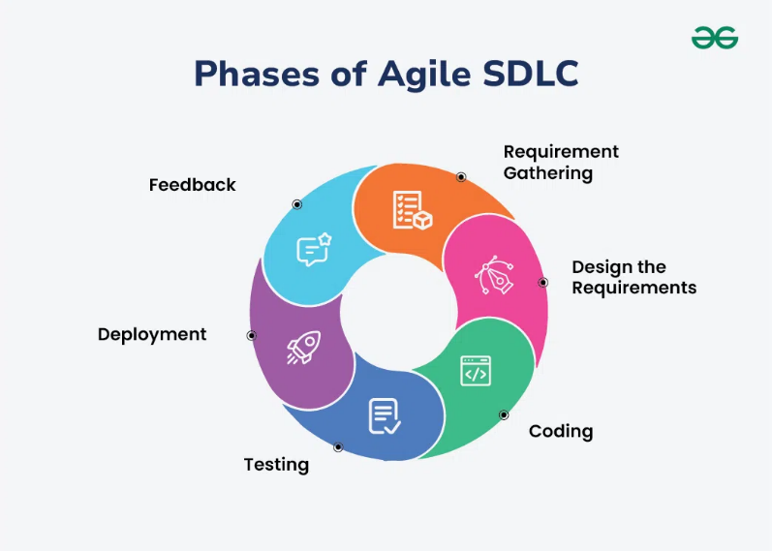

The Agile Software Development Life Cycle (SDLC) is selected because it supports iterative development, continuous testing, stakeholder feedback, and incremental system improvement throughout the project lifecycle. It helps the team quickly adapt to changes, resolve issues early, and develop a reliable system that meets the project's requirements.

- Reasons for the Choice
9.1 To provide a centralized system for managing personal profiles, OJT experience, and employment history.
9.2 To enable applicants to securely upload, store, and reuse resumes and supporting documents.
9.3 To help applicants identify and develop the skills required for their target jobs.
9.4 To provide verified on-call and regular job opportunities from legitimate employers.

9.5 To enable applicants to apply for jobs online using a single platform.
9.6 To allow applicants to report suspicious or fraudulent job postings.
9.7 To provide verified hiring organization profiles for informed job applications.
9.8 To display complete job requirements and qualifications before applying.
9.9 To provide timely notifications regarding application updates, interview schedules, employer messages, and hiring decisions.

10.0 Importance of the Study
The Profile & Skills Management
This subsystem benefits OJT completers and graduates by centralizing personal profiles, OJT experience, employment history, resumes, and supporting documents into a single platform. It also recommends missing skills based on users' target jobs, helping applicants better prepare for employment.
The Job Matching & Application
This subsystem benefits applicants by improving the recruitment process through verified job opportunities, online applications for on-call and regular positions, and suspicious job posting reporting, promoting a safer recruitment environment.
The Career Readiness
This subsystem helps applicants make informed career decisions by providing verified hiring organization profiles, detailed job requirements, and real-time notifications for application updates, interviews, and hiring decisions.

The Overall Importance
By integrating these three subsystems, OJTConnect PH provides a centralized, secure, and efficient recruitment platform that streamlines the employment process and connects qualified applicants with verified hiring organizations.

11.0 Target Users/ Beneficiaries
Primary Beneficiaries
  - OJT Completers
  - Graduates
  - Hiring Organizations (Private and Government Employers)
  - Educational Institutions (Colleges, Universities, and Training Institutions)
  - Career Development and Placement Offices
Secondary Beneficiaries
  - System Administrators
  - Researchers
  - Future System Developers

