Enterprise AI Agent Runtime Platform (working codename: Warden)
System Architecture Specification
Components, process topology, trust boundaries, control and execution planes, runtime API, data flow, repository structure
Document ID | WRD-02
Version | 0.5
Status | Working specification
Date | September 25, 2026
Owner | Architecture
Audience | Architects, engineers, security

Contents

1. Architectural constraints (invariants)
These constraints are checked by design review and, where possible, by automated tests.
- Clients contain no agent logic. Desktop, CLI and CI talk to the runtime through the Runtime API only.
- Agents contain no provider code. Agents see the Canonical Model API; adapters live behind the router.
- Providers cannot execute tools. Adapters return proposals; only the agent loop can turn a proposal into a PDP request.
- Nothing executes without a decision. Every tool execution is preceded by a policy.decision event with effect: allow and a matching approval when required.
- Sandboxes hold no secrets and have no direct network. Credentials are injected host-side; egress goes through the proxy.
- Every execution has an owner, session, task and policy context. Anonymous execution is impossible.
- Local and remote execution share the same contracts. Remote workers run the same wardend in server mode.

2. Component view
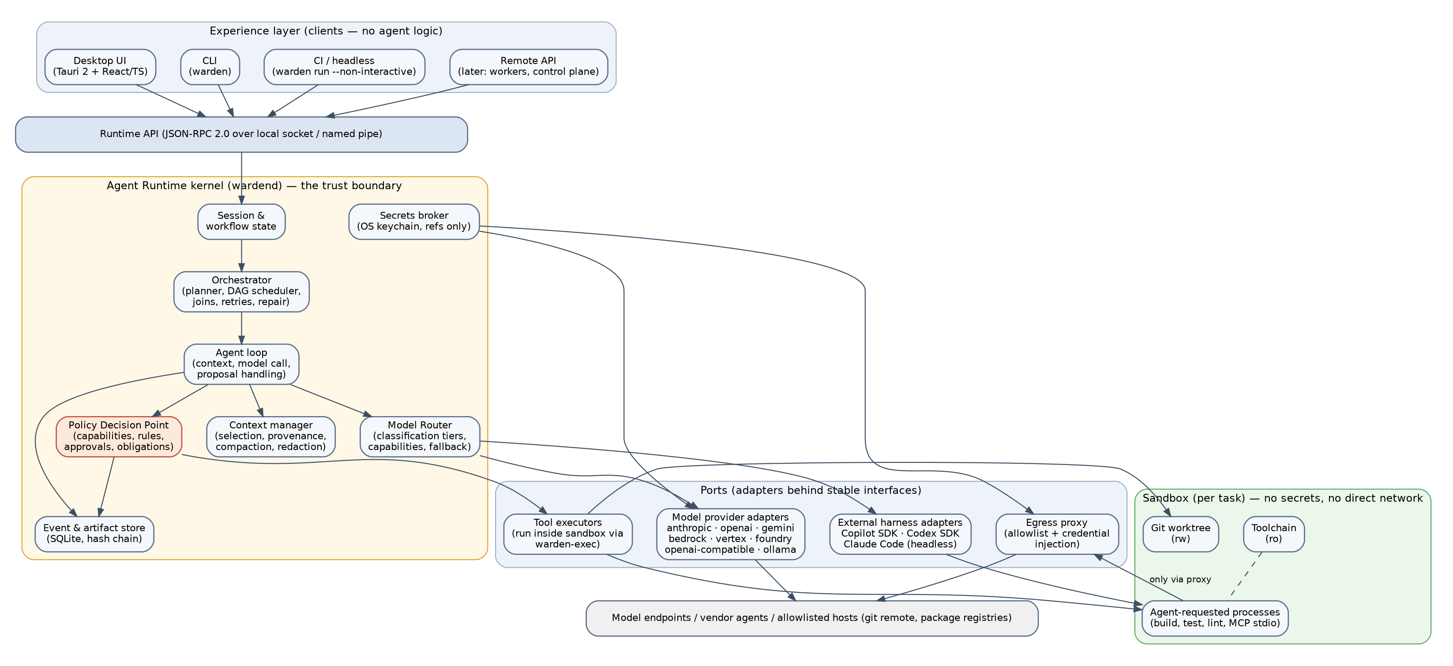
Figure 1. Layered architecture.

2.1 Experience layer (clients)
Client | Technology | Responsibilities
Desktop app | Tauri 2 shell, React + TypeScript UI, wardend as sidecar | Request entry, timeline, plan review, approvals, diff and artifact viewers, settings
CLI (warden) | Go, same module as the daemon | Scripting, headless runs (--non-interactive), audit export, eval runner, provider setup
CI | CLI in headless mode | Pre-approved policy, non-interactive approvals resolve to deny
Remote API (later) | WebSocket + mTLS | Control plane and worker communication

2.2 Runtime kernel (`wardend`)
Component | Responsibility | Key interfaces
Session manager | Sessions, transcripts, persistence, resume | Runtime API session.*
Orchestrator | Instantiates workflows, schedules ready tasks, joins, gates, retries, repair | WRD-07
Agent loop | Context assembly, model call, proposal handling, budgets, compaction | WRD-05, WRD-08
Policy Decision Point (PDP) | Capability check, invariants, rule evaluation, obligations, approvals | WRD-08
Model router | Candidate filtering by tier and capabilities, ranking, health, fallback | WRD-06
Context manager | Selection, classification, redaction, provenance | WRD-09
Secrets broker | Keychain access, secret:// resolution, injection into adapters and proxy | WRD-10
Egress proxy | HTTP CONNECT and SOCKS5 listener on a Unix socket per task; allowlist; credential injection | WRD-10
Sandbox manager | Creates and destroys sandboxes (L1/L2), launches warden-exec | WRD-10
Worktree manager | Creates, pins, merges and cleans worktrees | WRD-07
Event and artifact store | SQLite, hash chain, content-addressed blobs | WRD-09
Telemetry | Usage, cost, durations | WRD-09

2.3 Ports and adapters
Port | Adapters (MVP) | Adapters (later)
Model provider | anthropic-messages, openai-chat, openai-responses, openai-compatible | gemini, bedrock-converse, vertex, foundry (auth variants), ollama-native
External harness | copilot-sdk (optional) | codex-sdk, claude-code-headless (API-key billing)
Tool executor | warden-exec (fs, proc, git) | MCP stdio bridge, browser, cloud, database
Sandbox backend | bubblewrap (Linux), seatbelt (macOS), OCI container (Docker/Podman) | gVisor, Firecracker, Apple containers
Secret store | macOS Keychain, Windows Credential Manager, libsecret; encrypted file fallback | HashiCorp Vault, cloud secret managers (control plane)

3. Process topology and IPC
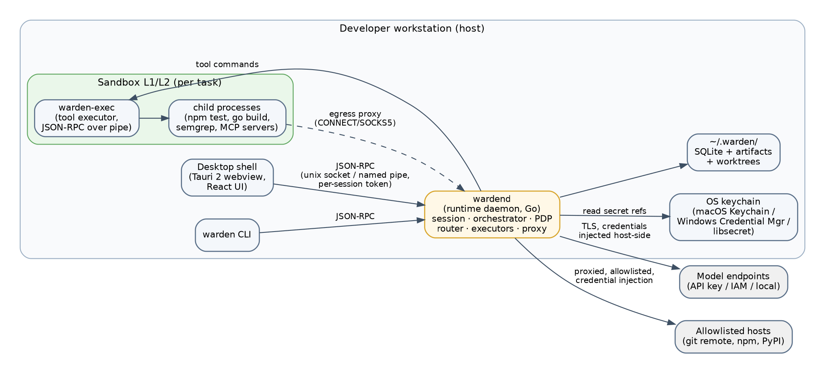
Figure 2. Process topology.
- Daemon lifecycle. The desktop shell starts the sidecar and passes a random session token via stdin; the CLI reads the token from a mode-0600 file under ~/.warden/run/. One daemon per user; multiple clients may attach.
- Transport. JSON-RPC 2.0 with Content-Length framing (LSP style) over a Unix domain socket (~/.warden/run/wardend.sock, mode 0600) or a Windows named pipe with an owner-only DACL. Server-initiated notifications carry streamed events.
- Executor channel. wardend launches warden-exec inside the sandbox with a socketpair; messages are JSON-RPC too (exec.fs.read, exec.proc.spawn, exec.proc.signal, …). The executor has no other communication channel.
- Proxy channel. The sandbox receives one Unix socket (bind-mounted) that terminates in the daemon's per-task proxy. Environment inside the sandbox sets HTTP_PROXY, HTTPS_PROXY, ALL_PROXY to that socket through a tiny in-sandbox forwarder (warden-exec proxy) exposing 127.0.0.1:<port> inside the network namespace only.

4. Runtime API (summary)
Namespace | Methods (selection)
session | open(workspace), list, resume(id), close(id), sendRequest(id, text), cancel(id, taskId?)
workflow | get(runId), approveGate(runId, gateId, decision), editPlan(runId, plan)
approval | list(sessionId), resolve(approvalId, decision, scope)
artifact | list(sessionId), get(id), read(id, range)
event | subscribe(sessionId, filter), query(filter, cursor)
provider | list, configure(spec), test(id), models(id)
policy | explain(actionSpec), list, reload
eval | run(suite, options), report(runId)
system | version, capabilities, sandboxStatus, shutdown

All methods require the session token. Methods with side effects outside the daemon (provider.configure, policy.reload) also require an interactive confirmation in the client. The full API is generated from a schema in schemas/runtime-api/.

5. Trust boundaries
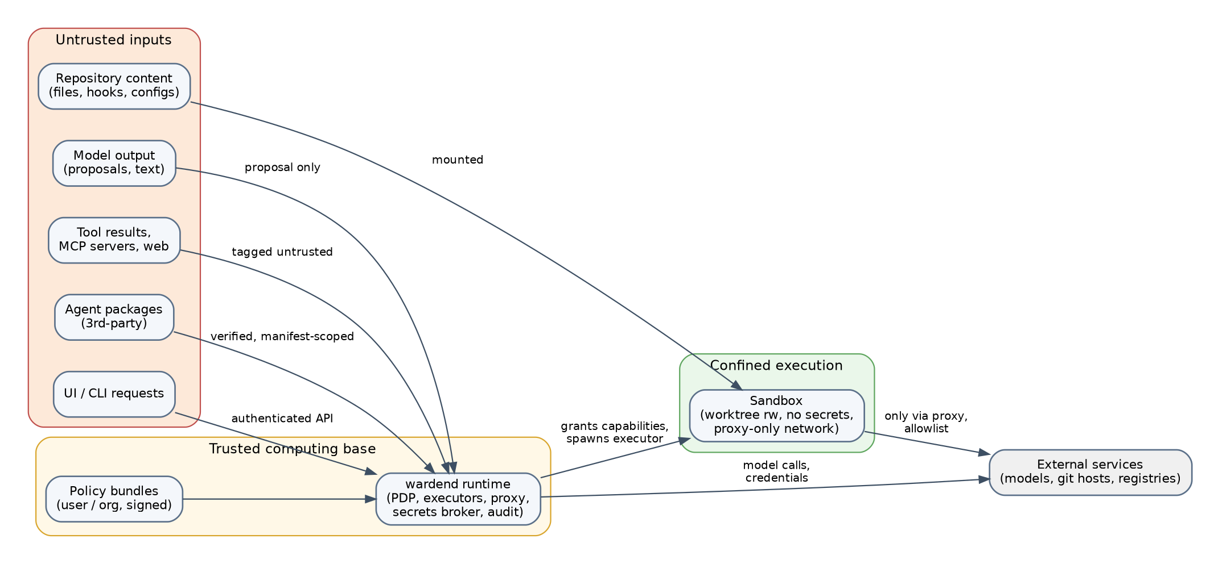
Figure 3. Trust boundaries.
Boundary | Control
User ↔ client | OS user session; client shows what will be done before it is done
Client ↔ runtime | Owner-only socket, per-session token, no privileged methods without confirmation
Runtime ↔ agent package | Digest-pinned packages; manifest defines maximum capabilities; signature verification (warn in MVP, enforce in enterprise)
Runtime ↔ model provider | Host-side TLS; credentials from the broker; data classification enforced by the router; requests logged without secrets
Runtime ↔ sandbox | Capability grants become concrete mounts, seccomp/Seatbelt profiles, namespaces, resource limits
Sandbox ↔ network | Proxy only; allowlist; injected credentials never visible to processes
Runtime ↔ secrets | References only; values live in the keychain; access events recorded
Local ↔ remote (later) | mTLS worker identity; signed bundles; event sync with chain verification
Control plane ↔ execution plane (later) | Signed policy and registry bundles with TTL; offline behavior defined

6. Data flow for one task
- Orchestrator marks task ready; sandbox manager creates the sandbox and mounts the worktree; proxy allocates a per-task listener with the task's egress allowlist.
- Agent loop assembles context (instructions, inputs, artifact summaries, workspace map) with provenance and redaction.
- Router selects (provider, model); adapter converts the request; the call is made from the daemon.
- Streamed events update the UI and are persisted.
- Tool proposals go to the PDP; decisions and approvals are events; approved actions are sent to warden-exec.
- Results are tagged untrusted, secret-scanned, and appended to context.
- On completion the output is validated; artifacts are stored; the sandbox is destroyed; the worktree remains until integration and cleanup.

7. Control plane and execution plane
The MVP contains only the execution plane. The interfaces that the control plane will use later are fixed now:
Contract | MVP source | Control-plane source (Phase 3)
Policy bundle | ~/.warden/policy/*.yaml | Signed bundle from the policy service, cached with TTL
Agent package | ~/.warden/agents/ | OCI registry, digest-pinned, signature required
Model catalog | ~/.warden/models.yaml | Model and provider registry with tiers and credential refs
Events | local SQLite | Local SQLite plus streaming to audit ingestion
Identity | OS user | OIDC identity token bound to the daemon

8. Technology decisions (see WRD-00 D-06, D-31)
Concern | Choice | Alternatives considered
Runtime language | Go | Rust (stronger memory safety, slower iteration; revisit for warden-exec if audits demand), TypeScript (team familiarity, weaker process control)
Desktop shell | Tauri 2 | Wails (Go-native, fewer security features), Electron (heavier)
UI | React + TypeScript | —
Local store | SQLite (WAL) | Embedded KV stores; rejected for weaker querying
Policy expressions | CEL (cel-go) | Rego/OPA (heavier, available later as a backend)
IPC | JSON-RPC 2.0 | gRPC (poor fit for webview clients without a bridge)
Packaging | OCI artifacts + sigstore/Ed25519 | Custom formats

9. Repository structure
warden/
cmd/
wardend/ # daemon entry point
warden/ # CLI entry point
warden-exec/ # in-sandbox executor
internal/
api/ # JSON-RPC server, schema, auth
session/ # sessions, transcripts, persistence
orchestrator/ # workflow instantiation, scheduler, gates, repair
agentloop/ # context, model call, proposals, budgets, compaction
policy/ # PDP, rule loading, CEL, approvals
router/ # candidate selection, health, fallback
model/ # canonical API types, streaming, normalization
providers/ # anthropic/, openai/, openaicompat/, (gemini/, bedrock/, vertex/)
harness/ # copilot/, (codex/, claudecode/)
tools/ # descriptors, registry, executor client
sandbox/ # linux_bwrap/, darwin_seatbelt/, oci/
proxy/ # egress proxy, allowlists, credential injection
secrets/ # keychain backends, redaction, scanning
worktree/ # git worktree lifecycle, hook neutralization
store/ # SQLite schema, events, artifacts, hash chain
evals/ # suite runner and graders
agents/ # built-in agent packages (planner, coder, verifier, security-reviewer, integrator)
schemas/ # JSON Schemas: manifest, workflow, events, artifacts, runtime API, policy
apps/desktop/ # Tauri 2 + React
docs/ # this documentation set

Import rules enforced by a lint step: providers/* and harness/* may import model/ only; tools/ may not import providers/; apps/desktop has no Go and calls only api/.

10. Context and memory architecture
Layer | Content | Lifetime
Request context | User request, selected repository summary | Task
Task context | Inputs, artifact summaries, tool results (tagged) | Task
Session context | Compacted transcript, plan, decisions | Session
Workspace knowledge (Phase 2) | Conventions, architecture notes produced by the explorer | Workspace
Enterprise knowledge (Phase 4) | Retrieval over approved sources with classification | Organization

Redaction applies before any content enters a model request: secret patterns (keys, tokens, private keys, connection strings) are replaced by placeholders and a redaction event records counts, never values.

11. Failure domains
Failure | Behavior
Daemon crash | Clients reconnect; sessions resume from SQLite; running tasks become failed(interrupted) and can be retried
Sandbox backend unavailable | Tasks cannot start; UI explains prerequisites; no fallback to unsandboxed execution
Provider outage | Router fallback within tier; otherwise waiting_for_input
Disk full | Event writes fail closed: the task pauses rather than continuing without audit
Keychain locked | Provider calls fail with auth_failed; user prompted to unlock

