Enterprise AI Agent Runtime Platform (working codename: Warden)
Canonical Model API Specification v0.1
Provider-neutral request and streaming contract, capability catalog, protocol adapters, authentication and billing modes, local models, external harness adapters
Document ID | WRD-05
Version | 0.5
Status | Working specification
Date | September 25, 2026
Owner | Architecture
Audience | Engineers, platform teams

Contents

1. Goals
- Agents and the orchestrator depend on one interface; adding a provider never touches agent code.
- Every real access mode is supported as a first-class configuration: API keys, cloud identity, enterprise gateways, local servers, and officially supported vendor subscriptions through their agent engines.
- Differences between models (tool calling, JSON output, reasoning, context size) are declared in a catalog and handled by the runtime, so that local and frontier models are both usable.
- All calls originate in the runtime process. Sandboxes never hold model credentials.
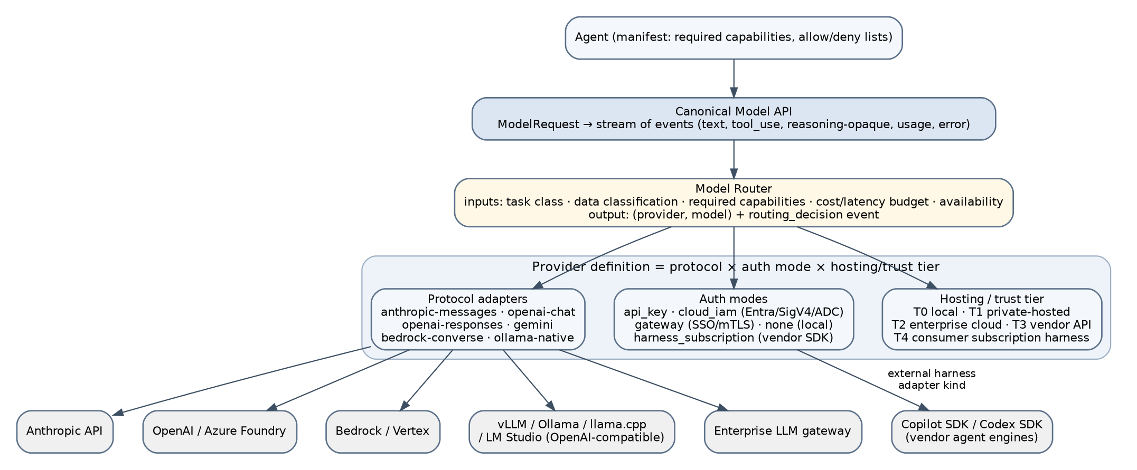
Figure 1. Model integration stack.

2. Provider definition: protocol × auth × hosting
A provider entry in ~/.warden/models.yaml (or the enterprise registry) combines three independent axes.
Axis | Values
protocol | anthropic-messages, openai-chat, openai-responses, gemini, bedrock-converse, ollama-native; openai-compatible is openai-chat with relaxed feature detection
auth | api_key, cloud_iam (entra, aws-sigv4, gcp-adc), gateway (bearer, mtls, sso-oidc), none
hosting / trust tier | T0 local (loopback), T1 private-hosted (LAN/VPC, organization-operated), T2 enterprise cloud (Azure/AWS/GCP under the organization's agreements), T3 vendor API (direct SaaS), T4 consumer subscription harness

Example catalog:
providers:
- id: anthropic
protocol: anthropic-messages
base_url: https://api.anthropic.com
auth: { mode: api_key, secret: "secret://providers/anthropic/api_key" }
tier: T3
data_agreement: { zero_retention: true, ref: "DPA-2026-03" } # optional; lets policy admit confidential data
- id: azure-foundry
protocol: openai-responses
base_url: https://myorg.openai.azure.com
auth: { mode: cloud_iam, kind: entra, scope: "https://cognitiveservices.azure.com/.default" }
tier: T2
- id: bedrock
protocol: bedrock-converse
region: eu-central-1
auth: { mode: cloud_iam, kind: aws-sigv4, profile: "myorg-ai" }
tier: T2
- id: gateway
protocol: openai-chat
base_url: https://llm-gateway.internal
auth: { mode: gateway, kind: sso-oidc, audience: "llm-gateway" }
tier: T1
- id: ollama
protocol: openai-compatible
base_url: http://127.0.0.1:11434/v1
auth: { mode: none }
tier: T0
- id: vllm-dc
protocol: openai-compatible
base_url: https://vllm.corp.internal/v1
auth: { mode: gateway, kind: mtls }
tier: T1
models:
- id: anthropic/claude-sonnet # catalog id used in manifests and policy
provider: anthropic
model: claude-sonnet-<version>
capabilities: { tool_calling: native, structured_output: true, streaming: true, vision: true,
reasoning: true, prompt_caching: true, max_context: 200000, max_output: 64000 }
pricing: { input_per_mtok: 3.00, output_per_mtok: 15.00, cached_input_per_mtok: 0.30, currency: USD }
- id: local/qwen-coder-32b
provider: ollama
model: qwen2.5-coder:32b
capabilities: { tool_calling: native, structured_output: true, streaming: true, vision: false,
reasoning: false, prompt_caching: false, max_context: 32768, max_output: 8192 }
pricing: null

Catalog entries are validated at load and probed on first use (provider.test), which also detects tool_calling support empirically for openai-compatible servers.

3. Canonical request
ModelRequest {
model_id: string # catalog id, chosen by the router
messages: Message[] # roles: system | user | assistant | tool
tools?: ToolDefinition[] # name, description, input_schema (JSON Schema)
tool_choice?: "auto" | "none" | "required" | { name }
response_format?: { type: "json_schema", schema, strict?: bool } | { type: "text" }
generation?: { max_output_tokens, temperature, top_p, stop[], seed, reasoning_effort: low|medium|high }
cache?: { hint: "system_prefix" | "none" } # adapters map to provider caching where available
budget?: { max_input_tokens } # enforced by the agent loop before sending
trace: { session_id, task_id, execution_id, step }
provider_options?: { <protocol>: object } # escape hatch, ignored by other adapters
}
Message { role, content: ContentBlock[] }
ContentBlock =
| { type: "text", text }
| { type: "image", media_type, data | uri }
| { type: "tool_use", id, name, input }
| { type: "tool_result", tool_use_id, content: ContentBlock[], is_error?: bool }
| { type: "reasoning", opaque: string } # provider-specific reasoning blocks, passed back verbatim
| { type: "document", media_type, data, title? }

Rules:
- The first system message is the only place for instructions; adapters map it to the provider's system field.
- reasoning blocks are opaque: the runtime never reads or edits them, but returns them to the same provider in subsequent turns when the provider requires it (Responses API, Anthropic thinking). They are dropped when switching providers mid-task (a task pinned to one provider avoids this).
- tools names are the tool ids from WRD-04; adapters rename where a provider restricts characters (fs.write → fs__write) and map back.

4. Streamed response events
StreamEvent =
| { type: "message_start", model, provider, request_id }
| { type: "text_delta", index, text }
| { type: "reasoning_delta", index, opaque }
| { type: "tool_use_start", index, id, name }
| { type: "tool_use_delta", index, partial_json }
| { type: "tool_use_end", index }
| { type: "usage", input_tokens, output_tokens, cached_input_tokens?, reasoning_tokens? }
| { type: "message_end", stop_reason: end_turn | tool_use | max_tokens | stop_sequence | content_filter }
| { type: "error", code, message, retryable: bool, retry_after_ms? }

Normalized error codes: rate_limited, auth_failed, context_too_long, provider_unavailable, content_filtered, invalid_request, tool_format_unsupported, model_not_found, timeout, cancelled. Adapters attach the raw provider error in details for diagnostics; it is stored in the event but never shown to the model.

5. Adapter contract (Go interface, illustrative)
type Provider interface {
ID() string
Capabilities(modelID string) (ModelCapabilities, error)
Generate(ctx context.Context, req ModelRequest) (Stream, error) // streaming always; buffered for non-streaming providers
CountTokens(ctx context.Context, req ModelRequest) (int, error) // exact if supported, estimate otherwise
Health() ProviderHealth // circuit breaker state, rate-limit window
}

Adapter responsibilities: message and tool translation, streaming parsing, usage extraction, error normalization, cancellation on context cancel, retry metadata. Adapters never log request bodies at info level; debug logging redacts content.

6. Protocol adapters
Adapter | Covers | Notes
anthropic-messages | Anthropic API, Bedrock (via converse or native), Vertex, Microsoft Foundry | Tool use blocks, thinking as reasoning, cache control on system prefix
openai-chat | OpenAI Chat Completions, Azure OpenAI, most gateways, vLLM, Ollama, llama.cpp server, LM Studio, LiteLLM, and the Gemini API through its OpenAI-compatible endpoint (API key) | Detects tools/response_format support by probe; strict JSON schema where available
openai-responses | OpenAI Responses API, Azure Foundry | Preserves reasoning items across turns; built-in tools disabled (runtime tools only)
gemini | Gemini API and Vertex AI | Function declarations, responseSchema
bedrock-converse | Any Bedrock model | Unified tool config
ollama-native | Ollama-specific features (keep-alive, model pull) | Optional; openai-compatible suffices for inference

Phase 2 delivers the native gemini adapter (Vertex AI, context caching, full reasoning controls), bedrock-converse and the cloud identity auth modes; the MVP ships the first three, which already reach Gemini with an API key through the OpenAI-compatible endpoint (D-27).

7. Capability handling and emulation
Capability | If missing | Runtime behavior
tool_calling: native | emulated | The adapter injects a compact tool protocol into the system prompt (JSON blocks fenced with a sentinel), parses proposals, and validates them against the schema; the agent loop treats them identically
tool_calling: none | — | Model excluded from tasks whose manifest requires tool_calling (all built-in agents except summarization helpers)
structured_output | false | Output schema enforced by post-validation plus one repair turn
max_context small | — | Context manager compacts more aggressively; repo map trimmed; large files read in ranges
vision | false | Image blocks replaced by a textual note; tasks requiring vision are routed elsewhere
reasoning | false | reasoning_effort ignored
prompt_caching | false | cache hint ignored

Evaluation (WRD-12) records success per model class so that routing strategies can be tuned with data instead of assumptions.

8. Authentication and billing modes
Mode | How credentials flow | Billing | Tier
api_key | Keychain → secrets broker → adapter header; never logged | Per token (catalog prices) | T3
cloud_iam | Provider SDK credential chain on the host (Entra ID device/managed identity; AWS profile/SSO; GCP ADC) | Cloud account | T2
gateway | OIDC token or mTLS cert from the organization; gateway may add its own routing | Organization-internal | T1/T2
none | No credentials; loopback or private network | Infrastructure cost only | T0/T1
harness_subscription | The vendor's engine authenticates itself (its own login stored in its own profile directory, mounted read-only into the sandbox of harness tasks) | Vendor subscription quota (premium requests, plan limits) | T4

The runtime records billing_mode and, for harnesses, quota units consumed in usage events (WRD-09). Cost estimates are shown only where a price is known.

9. External harness adapters (subscription-backed vendor agents)
Some vendors expose their agent engine, not only their inference API, and allow it to be billed to a user's subscription. Rather than spoofing their clients, the platform integrates those engines as task backends running inside the sandbox.
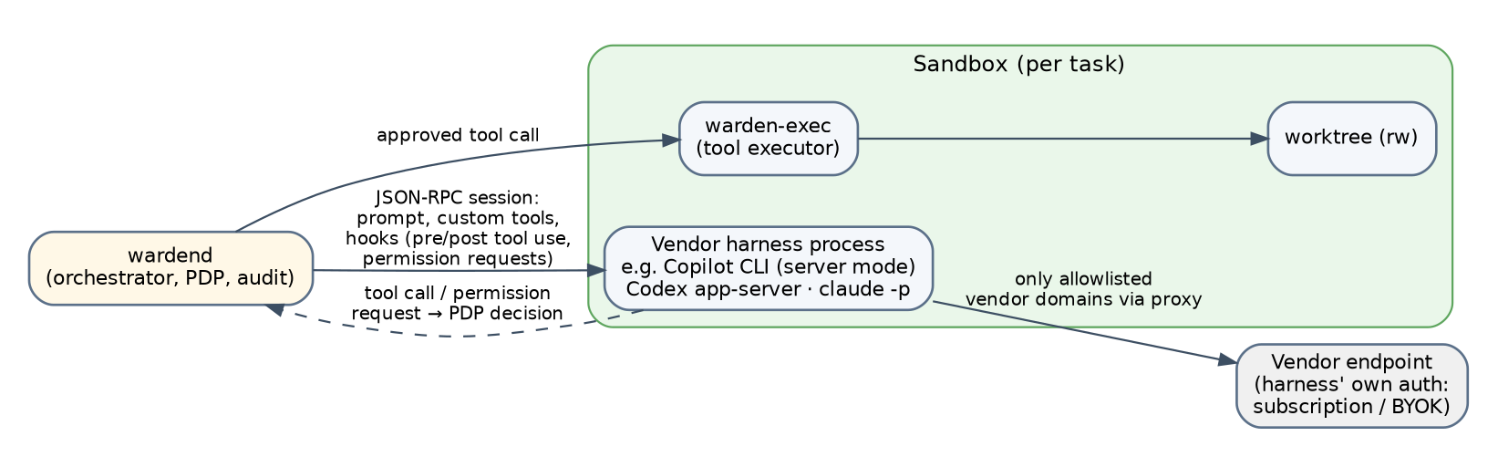
Figure 2. External harness integration: the vendor engine runs inside the sandbox; the runtime governs it through hooks and the sandbox boundary.
Harness | Integration | Vendor terms (September 2026) | Default
GitHub Copilot SDK | Copilot CLI in server mode launched in the sandbox; JSON-RPC session; built-in tools overridden by runtime tools; pre/post tool use and permission hooks routed to the PDP; BYOK possible | Permitted; generally available; billed as premium requests | Enabled (optional install)
OpenAI Codex SDK / app-server | Codex app-server in the sandbox; approval callbacks routed to the PDP; ChatGPT-plan login or API key | Tolerated for ChatGPT-plan OAuth (no explicit guarantee); API key fully supported | Shipped in Phase 2; ChatGPT-plan mode opt-in with a notice and approval at session start (D-26)
Claude Code (headless, claude -p) | Claude Code CLI in the sandbox with API-key billing (Agent SDK terms) | Consumer-subscription OAuth in third-party tools prohibited; API key, extra usage, Bedrock/Vertex/Foundry permitted | Shipped in Phase 2; enabled only with billing: api_key (D-26)
Gemini CLI | Same pattern | Consumer subscription restricted since February 2026; API key permitted | API key only

Harness contract inside the runtime:
- A harness task is a normal task: it has a manifest (role: harness, harness: copilot), capabilities, limits and produces the same artifacts (code-diff, test-report).
- The harness process is spawned by warden-exec inside the sandbox; its network is restricted to the vendor's endpoints through the proxy; its configuration directory is mounted read-only; the worktree is the only writable path.
- Where the harness offers tool override or permission hooks, the runtime registers them; a harness tool call becomes a PDP request like any other, executed by warden-exec. Where a harness lacks hooks, the sandbox is the only enforcement, and policy may forbid such harnesses for confidential and restricted workspaces.
- The harness's own credential is exposed to processes in its sandbox; a malicious repository could attempt to read it. Mitigations: mount only the token file the harness needs, run harness tasks at L2 by default, and mark harness output tainted.
- The platform never implements token replay, client spoofing, or localhost proxies that impersonate vendor CLIs. Vendor terms are recorded in the catalog (vendor_terms: permitted | tolerated | prohibited) and prohibited entries cannot be enabled.

10. Local models
- Discovery: warden provider add ollama probes /v1/models and creates catalog entries with capability probes; the same for vLLM, llama.cpp server and LM Studio.
- Recommended classes for the MVP evaluation: 7B–14B coder models for planning summaries and quick edits; 30B-class coder models for implementation tasks; anything larger routed by the organization's own serving infrastructure.
- Context budgets: the router requires max_context ≥ min_context_tokens from the manifest; the context manager reserves 25% of the window for output and tool results.
- Local endpoints are T0 only when bound to loopback; a LAN or VPC endpoint is T1 and must be declared as such.

11. Observability of model calls
Every call produces model.call.start, zero or more model.call.delta (not persisted; UI only), model.call.end with usage, latency, stop reason, provider request id, and routing_decision (WRD-06). Request bodies are persisted only when observability.log_full_args is on and never with secret values; a content hash is always stored for reproducibility.

12. Compatibility and versioning
The canonical types are versioned (model.v1). Adapters declare which canonical version they implement. Provider API changes are absorbed in adapters; a change in canonical types requires a major runtime version.

