Enterprise AI Agent Runtime Platform (working codename: Warden)
Model Routing Policy Specification
Data classifications, provider trust tiers, routing inputs and strategies, fallback rules, health and quotas, routing policy syntax, auditability
Document ID | WRD-06
Version | 0.5
Status | Working specification
Date | September 25, 2026
Owner | Architecture / Security
Audience | Platform teams, security, engineers

Contents

1. Purpose
The router answers one question for every model call: which provider and model may and should handle this request. "May" is a security decision derived from data classification and provider trust; "should" is an optimization derived from capabilities, quality, cost, latency and availability. The router never trades the first for the second.

2. Data classifications (D-17)
Classification | Typical content | Default assignment
public | Open-source code, public documentation | Explicit only
internal | Non-sensitive internal code and documents | Explicit only
confidential | Proprietary source code, customer-facing systems, internal designs | Default for every repository
restricted | Secrets-adjacent code, regulated data handling, security-sensitive components | Explicit; path overrides supported (paths: ["services/payments/**"])

Classification is a property of the workspace with optional path overrides; a task's classification is the maximum over the paths it reads. Reading a restricted path mid-task raises the task's classification and may force a re-route or a stop (waiting_for_input) if the current provider is no longer allowed.

3. Provider trust tiers
Tier | Definition | Examples
T0 | Runs on the local machine, loopback only | Ollama, llama.cpp, LM Studio
T1 | Operated by the organization on its own network | vLLM in the data center, internal gateway to internal models
T2 | Enterprise cloud under the organization's agreements | Azure OpenAI / Foundry, Bedrock, Vertex AI
T3 | Vendor SaaS API with API key | Anthropic, OpenAI, Google, Mistral direct
T4 | Consumer subscription harness | Copilot SDK, Codex with ChatGPT plan

A provider's tier is declared in the catalog and may be raised by policy (never lowered by a workspace).

4. Default admission matrix (D-18)
Classification | Allowed tiers by default | Notes
restricted | T0, T1 | T2 only when policy explicitly lists the provider
confidential | T0, T1, T2 | T3 when the provider entry carries a data_agreement (for example zero-retention terms) and org policy allows; T4 never
internal | T0–T3 | T4 only for harnesses marked permitted
public | T0–T4

The matrix is a policy artifact (routing.admission) and can be tightened by organization or user policy. Workspace policy may only remove tiers.

5. Routing inputs
Input | Source
Task class | Manifest role and workflow task type (plan, implement, verify, review, summarize)
Data classification | Workspace plus paths read so far
Required capabilities and minimum context | Manifest spec.model
Allow/deny lists | Manifest, org policy, user preferences, session pin
Strategy | quality-first, cost-first, latency-first, prefer-internal (workspace default prefer-internal when a T0/T1 provider exists, else quality-first)
Budgets | Task max_cost_usd; session and daily budgets from policy
Health | Circuit-breaker state, rate-limit window, recent error rate, p50 latency
Quality priors | Evaluation results per task class and model (WRD-12), used as a ranking signal

6. Algorithm
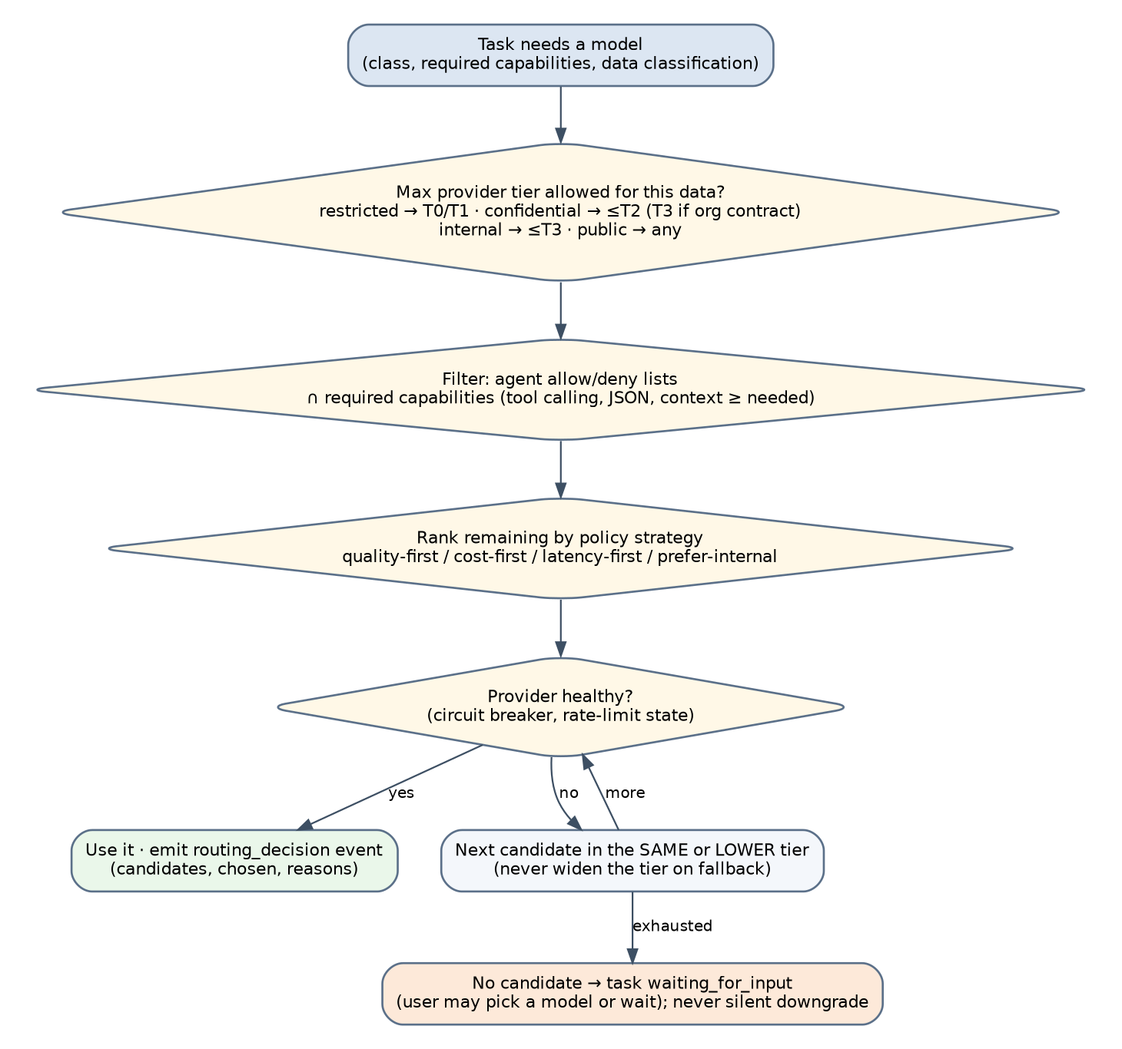
Figure 1. Routing decision.
- Admission: candidates = models whose provider tier is admitted for the task's classification.
- Filter: apply allow/deny lists; require capabilities and context size; exclude models over budget for the estimated request size.
- Rank per strategy: quality-first sorts by quality prior then cost; cost-first sorts by cost then quality prior with a minimum quality threshold; latency-first by p50; prefer-internal prefers T0/T1 that meet a quality threshold, then the rest by quality.
- Health: skip candidates whose circuit is open; a half-open circuit admits one probe request.
- Select the first healthy candidate; emit routing_decision with all candidates and the reason each was rejected or ranked.
- No candidate: the task enters waiting_for_input with a message explaining which constraint eliminated everything (for example "confidential data; no T0–T2 provider configured"), offering to configure a provider or to lower the strategy's quality threshold if policy permits. The router never selects an inadmissible provider.

7. Fallback rules (D-19)
- Fallback triggers: provider_unavailable, rate_limited beyond the retry budget, timeout, model_not_found.
- Fallback candidates are the remaining ranked list, restricted to the same or lower tier than the failed candidate's admitted maximum; the admission matrix is re-applied, never relaxed.
- Mid-task fallback keeps the transcript; opaque reasoning blocks from the previous provider are dropped, and a context.note tells the model that the conversation continues on a different model.
- Each fallback emits routing_fallback with the cause; three fallbacks in one task stop the task (waiting_for_input).
- Retries before fallback: up to 3 for rate_limited and provider_unavailable with exponential backoff and jitter, honoring retry_after_ms.

8. Health, quotas, budgets
- Circuit breaker per provider: opens after 5 consecutive failures or an error rate above 50% over 60 s; half-open after 30 s.
- Rate-limit windows are learned from provider headers where available.
- Budgets: task (max_cost_usd), session (policy budgets.session_usd), daily per user (policy budgets.daily_usd), and quota units for harnesses (budgets.daily_premium_requests). Exceeding a budget yields failed(budget) for the task and waiting_for_input for the session.

9. Routing policy syntax
Routing policy is part of the policy bundle (WRD-08) under the routing key.
routing:
admission:
restricted: [T0, T1]
confidential: [T0, T1, T2]
internal: [T0, T1, T2, T3]
public: [T0, T1, T2, T3, T4]
exceptions:
- when: 'provider.id == "anthropic" && provider.data_agreement.zero_retention'
admit: { confidential: [T3] }
strategy:
default: prefer-internal
by_task_class:
plan: quality-first
implement: quality-first
verify: cost-first
summarize: cost-first
quality_threshold: 0.6 # minimum eval success prior to be considered under prefer-internal/cost-first
pins:
allow_user_pin: true # user may pin a model within admission
budgets:
session_usd: 25
daily_usd: 100
daily_premium_requests: 300
deny_models: ["*/preview-*"]

Conditions use CEL over the routing input object (task, workspace, provider, model, user).

10. Worked examples
Situation | Outcome
Security review on a confidential repository; providers: Ollama (T0), Anthropic with zero-retention agreement (T3), OpenAI without agreement (T3) | Candidates: Ollama, Anthropic (exception). Strategy prefer-internal: Ollama chosen if its 32B coder model meets the quality threshold for review; otherwise Anthropic. OpenAI rejected: "confidential data; no data agreement".
Implementation task on a public repository, user pinned openai/gpt-x | Pin honored (admitted). Fallback list excludes T4 unless a permitted harness is configured.
Anthropic returns 529 repeatedly during a restricted task | No fallback beyond T1; if only T0/T1 candidates exist and none qualifies, the task waits for input with the explanation.
Task reads services/payments/** (restricted override) while running on a T2 provider | The task's classification rises; the router re-evaluates: T2 is not admitted for restricted; the task pauses (waiting_for_input) with options to continue on a T0/T1 model or to exclude the path.

11. Audit
routing_decision event payload: task class, classification, strategy, candidates with per-candidate status (admitted, rejected:<reason>, unhealthy), chosen model, estimated cost, quality prior, budget remaining. The UI shows a one-line explanation ("Chosen: local/qwen-coder-32b (prefer-internal; confidential data; 2 candidates)") with a details view.

