Enterprise AI Agent Runtime Platform (working codename: Warden)
Workflow and Task DAG Specification
Workflow schema, scheduler, task state machine, joins, approval gates, retries and repair, cancellation, worktree lifecycle and integration, artifact-based agent communication, planner contract
Document ID | WRD-07
Version | 0.5
Status | Working specification
Date | September 25, 2026
Owner | Architecture
Audience | Engineers

Contents

1. Orchestration model
The orchestrator turns a request into a workflow run: a directed acyclic graph of tasks, each executed by an agent in its own sandbox, connected by artifacts. Three rules from the drafts are kept and made precise:
- DAG, not swarm. Tasks exist only because the template or the planner created them with a stated purpose and inputs.
- Decompose only when useful. A request that fits one task runs as one task; the planner must justify each additional task in the plan artifact (field rationale).
- Artifacts are the only channel. Agents do not share transcripts; a task receives the artifacts named in its inputs and nothing else.
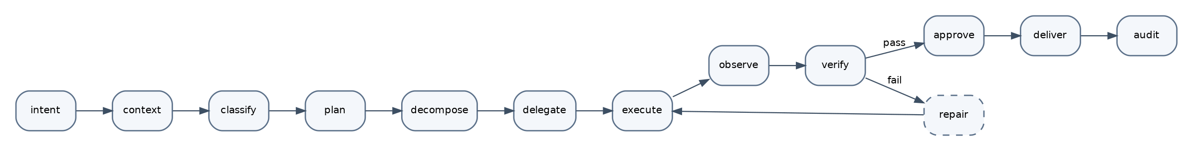
Figure 1. Universal workflow lifecycle.

2. Workflow schema
apiVersion: warden.dev/v1alpha1, kind: Workflow. The same schema describes templates (shipped with the runtime, instantiated per request) and plans (generated by the planner within a template's slots, or fully dynamic in Phase 2).
apiVersion: warden.dev/v1alpha1
kind: Workflow
metadata: { name: coding-change, version: 1.0.0 }
spec:
inputs: { request: string, workspace: ref }
concurrency: { max_parallel: 3, groups: { implement: 3, analysis: 2 } }
tasks:
- id: explore
agent: explorer@^1
input: { request: "${inputs.request}" }
produces: [repo-map]
- id: security-analysis
agent: security-reviewer@^1
depends_on: [explore]
input: { scope: "${artifact(explore.repo-map)}" }
produces: [security-notes]
group: analysis
on_failure: skip # analysis is advisory
- id: plan
agent: planner@^1
depends_on: [explore, security-analysis]
input: { request: "${inputs.request}", repo_map: "${artifact(explore.repo-map)}",
notes: "${artifacts(security-analysis.security-notes)?}" }
produces: [plan]
expands: { slot: implement, min: 1, max: 3 } # planner may create 1..3 tasks in the 'implement' slot
- id: gate-plan
type: approval_gate
depends_on: [plan]
present: ["${artifact(plan.plan)}"]
approvers: [session-owner]
timeout_seconds: 86400
- id: implement # slot; concrete tasks implement-1..n are generated
slot: true
agent: coder@^1
depends_on: [gate-plan]
worktree: per-task
produces: [code-diff]
group: implement
retry: { max_attempts: 2, backoff: { initial_ms: 2000, multiplier: 2, jitter: true } }
on_failure: repair
- id: integrate
agent: integrator@^1
depends_on: [implement.*]
join: all_succeeded
produces: [integrated-diff]
- id: build
agent: verifier@^1
depends_on: [integrate]
input: { profile: build }
produces: [build-report]
on_failure: repair
- id: test
agent: verifier@^1
depends_on: [integrate]
input: { profile: test }
produces: [test-report]
on_failure: repair
- id: review
agent: security-reviewer@^1
depends_on: [integrate]
input: { diff: "${artifact(integrate.integrated-diff)}" }
produces: [security-report]
- id: gate-final
type: approval_gate
depends_on: [build, test, review]
join: all_succeeded
present: ["${artifact(integrate.integrated-diff)}", "${artifact(test.test-report)}", "${artifact(review.security-report)}"]
approvers: [session-owner]
repair:
agent: repairer@^1
max_rounds: 2
rerun: affected # re-run only the verification tasks that failed and their dependents
outputs: [integrate.integrated-diff, test.test-report, review.security-report]

Schema rules: task ids unique; depends_on acyclic; join ∈ all_succeeded (default) | any_succeeded | all_finished; on_failure ∈ fail (default) | skip | repair; slots expand only through the planner contract (§9).
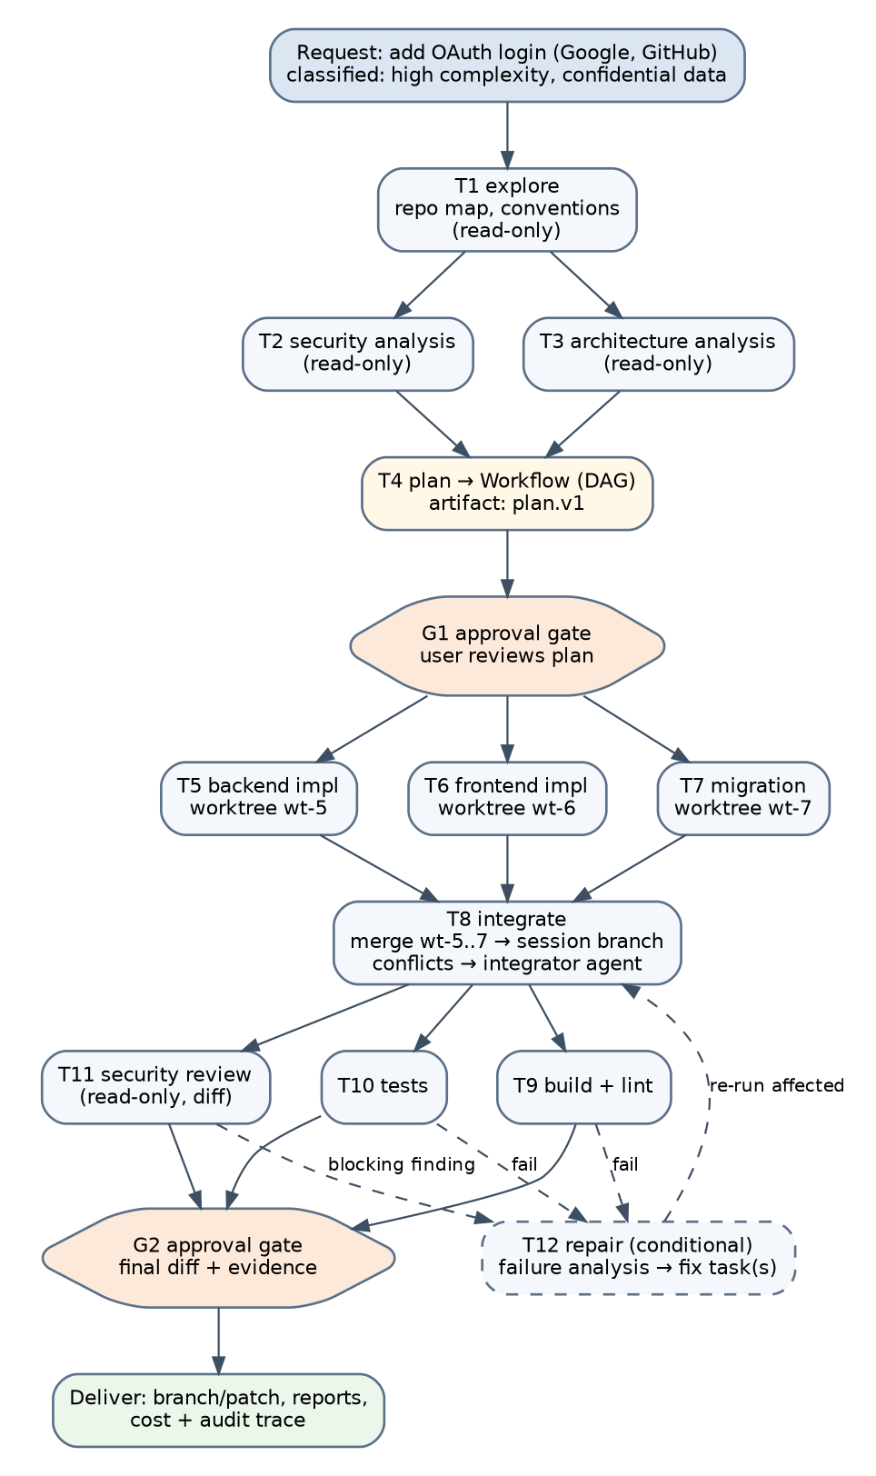
Figure 2. The MVP coding template as a DAG.

3. Scheduler
- A task becomes queued when every dependency reached a state accepted by its join.
- The scheduler runs queued tasks up to concurrency.max_parallel and per-group limits; tasks with a worktree: per-task requirement also need an available worktree slot.
- Priority: approval gates and repair tasks first, then tasks on the critical path (longest remaining chain), then FIFO.
- Every scheduling action is an event (task.state), which makes runs resumable: on daemon restart, the scheduler rebuilds from events, marks running executions as failed(interrupted), and re-queues them if attempts remain.

4. Task state machine
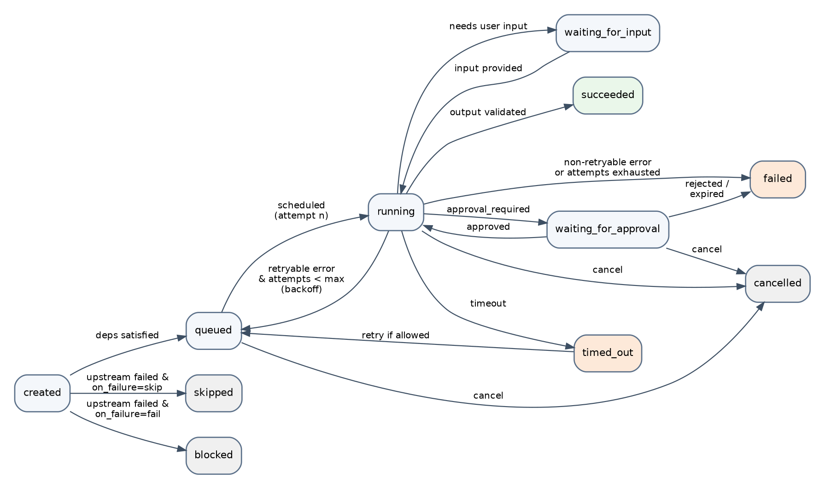
Figure 3. Task state machine.
From | To | Trigger
created | queued | dependencies satisfied per join
created | skipped / blocked | an upstream failed and on_failure is skip / fail
queued | running | scheduled; attempt += 1; sandbox and worktree ready
running | waiting_for_approval | PDP returned approval_required
waiting_for_approval | running / failed / cancelled | approved / rejected or expired / cancelled
running | waiting_for_input | agent used approval.request for a question, or router has no candidate
running | succeeded | output validated, artifacts stored
running | queued | retryable error and attempt < max_attempts (after backoff)
running | failed | non-retryable error, attempts exhausted, budget exhausted, schema failure after repair turn
running | timed_out | timeout_seconds elapsed; may re-queue if attempts remain and the task is idempotent
any non-terminal | cancelled | user cancel; propagates to children

Terminal states: succeeded, failed, cancelled, skipped, blocked. Every transition carries a reason code (budget, policy_denied, schema, verification, interrupted, provider, tool).

5. Retry semantics (D-12)
Error class | Retryable | Notes
Provider transient (provider_unavailable, rate_limited, timeout) | Yes, handled first by the router within the same execution | Counts toward task attempts only if the execution fails
Tool transient (sandbox creation failure, executor crash) | Yes | New sandbox; worktree preserved
Policy denied | No | The agent may adapt within the same execution; the task fails only if the agent cannot complete
Output schema invalid | One repair turn inside the execution, then fail
Verification failed (build, tests, review blocking finding) | Not a retry; creates a repair round | See §6
Budget exhausted | No | Checkpoint artifact; user may raise limits and resume

Idempotency: a re-queued task resumes from its worktree state (a checkpoint commit warden: checkpoint attempt n is created on the task branch) with a context.note summarizing the previous attempt's failure.

6. Repair rounds
- When a verification task fails and on_failure: repair, the orchestrator creates a repair task with inputs: the failed reports, the integrated diff, and the plan.
- The repairer produces a failure-analysis artifact (root cause, affected files, proposed fix) and one or more fix tasks (bounded by repair.max_rounds and the implement slot size).
- Fix tasks run in fresh worktrees based on the session branch; integration re-runs; only the failed verification tasks and their dependents re-run (rerun: affected).
- After max_rounds, the workflow reaches the final gate with the failing reports attached; the user decides.

7. Approval gates
Gates are tasks of type approval_gate. They present artifacts, list approvers, and expire. A gate's decision is an approval record (WRD-08) with scope once. Gate decisions may include an edited artifact (the user edits the plan at G1); the edited artifact becomes a new version with provenance edited_by: user.

8. Cancellation (D-13)
- session.cancel(taskId?) cancels one task or the run; children first, then parents.
- Running executions receive a cooperative cancel (context cancellation to the adapter and executor); warden-exec sends SIGTERM to all children, waits 3 s, then SIGKILL; the sandbox is torn down.
- Partial artifacts are stored with partial: true; worktrees are preserved for inspection until session cleanup.
- Cancelled tasks are terminal; the user can re-run the workflow from the last successful gate.

9. Planner contract
The planner is an agent whose output artifact plan conforms to schemas/plan.json:
{ "summary": "...",
"classification": { "complexity": "high", "risk": "medium", "data": "confidential" },
"tasks": [
{ "slot": "implement", "id": "implement-backend", "title": "Add OAuth provider abstraction and Google/GitHub handlers",
"paths": ["src/auth/**", "src/config.ts"], "depends_on": [], "estimate": { "steps": 40, "cost_usd": 1.2 },
"rationale": "Backend and frontend touch disjoint paths; parallel execution is safe." },
{ "slot": "implement", "id": "implement-frontend", "title": "Login UI and session handling", "paths": ["web/src/auth/**"], "depends_on": [] }
],
"verification": ["build", "test", "review"],
"risks": ["session cookie flags", "state parameter validation"],
"expected_files": 14 }

Validation: task count within slot bounds; paths disjoint across parallel tasks (overlaps force a dependency or a merge into one task); every task has a rationale. The orchestrator materializes slot tasks from the plan; the planner never spawns tasks directly.

10. Worktree lifecycle and integration
- On session start the runtime creates the session branch warden/<session-id> from the workspace's current HEAD (dirty working trees are stashed by the user's request or the session is refused; the runtime never modifies the user's working tree).
- For each worktree: per-task task: git worktree add ~/.warden/worktrees/<workspace>/<task> -b warden/<session>/<task> <session-branch-head>; hooks path is set to an empty directory; the worktree is bind-mounted into the sandbox as the only writable path.
- On task success the task branch holds commits made by the agent (git.commit R1 on task branches) or an automatic checkpoint commit.
- The integrator merges task branches into the session branch in plan order; conflicts are resolved by the integrator agent restricted to conflicted files, followed by re-verification; unresolvable conflicts produce a merge-conflict artifact and a waiting_for_input.
- At the final gate, the user chooses: apply the session branch as a branch in the repository, create a commit on a new branch, or export a patch. git push is a host tool with mandatory approval.
- Cleanup removes worktrees after the session ends (configurable retention for inspection).

11. Artifact-based communication
Task inputs reference artifacts by id or by task.type expressions; the runtime injects summaries (from the artifact's summary field or a generated one) into context and lets the agent artifact.read sections on demand. Parents never see children's transcripts; children never see the parent's. This bounds context growth and keeps provenance exact.

12. Phase 2: dynamic planning
The template stays the default. Dynamic planning lets the planner emit a complete Workflow (not only slot tasks) subject to policy limits: max_tasks, max_depth, allowed agents, mandatory verification tasks and gates that cannot be removed. The scheduler and state machine are unchanged.

