Enterprise AI Agent Runtime Platform (working codename: Warden)
Policy Engine Specification
Policy inputs, layers and precedence, rule syntax with CEL, effects and obligations, approvals and scopes, platform invariants, explainability, non-interactive mode, testing
Document ID | WRD-08
Version | 0.5
Status | Working specification
Date | September 25, 2026
Owner | Security / Architecture
Audience | Security, platform teams, engineers

Contents

1. Role of the policy engine
The Policy Decision Point (PDP) is called before every tool execution, every delegation, every secret access, every harness session start and every model call (through the router's admission step). It answers with an effect and obligations and it explains itself. It is the only component that may say "yes"; every other component may only ask.
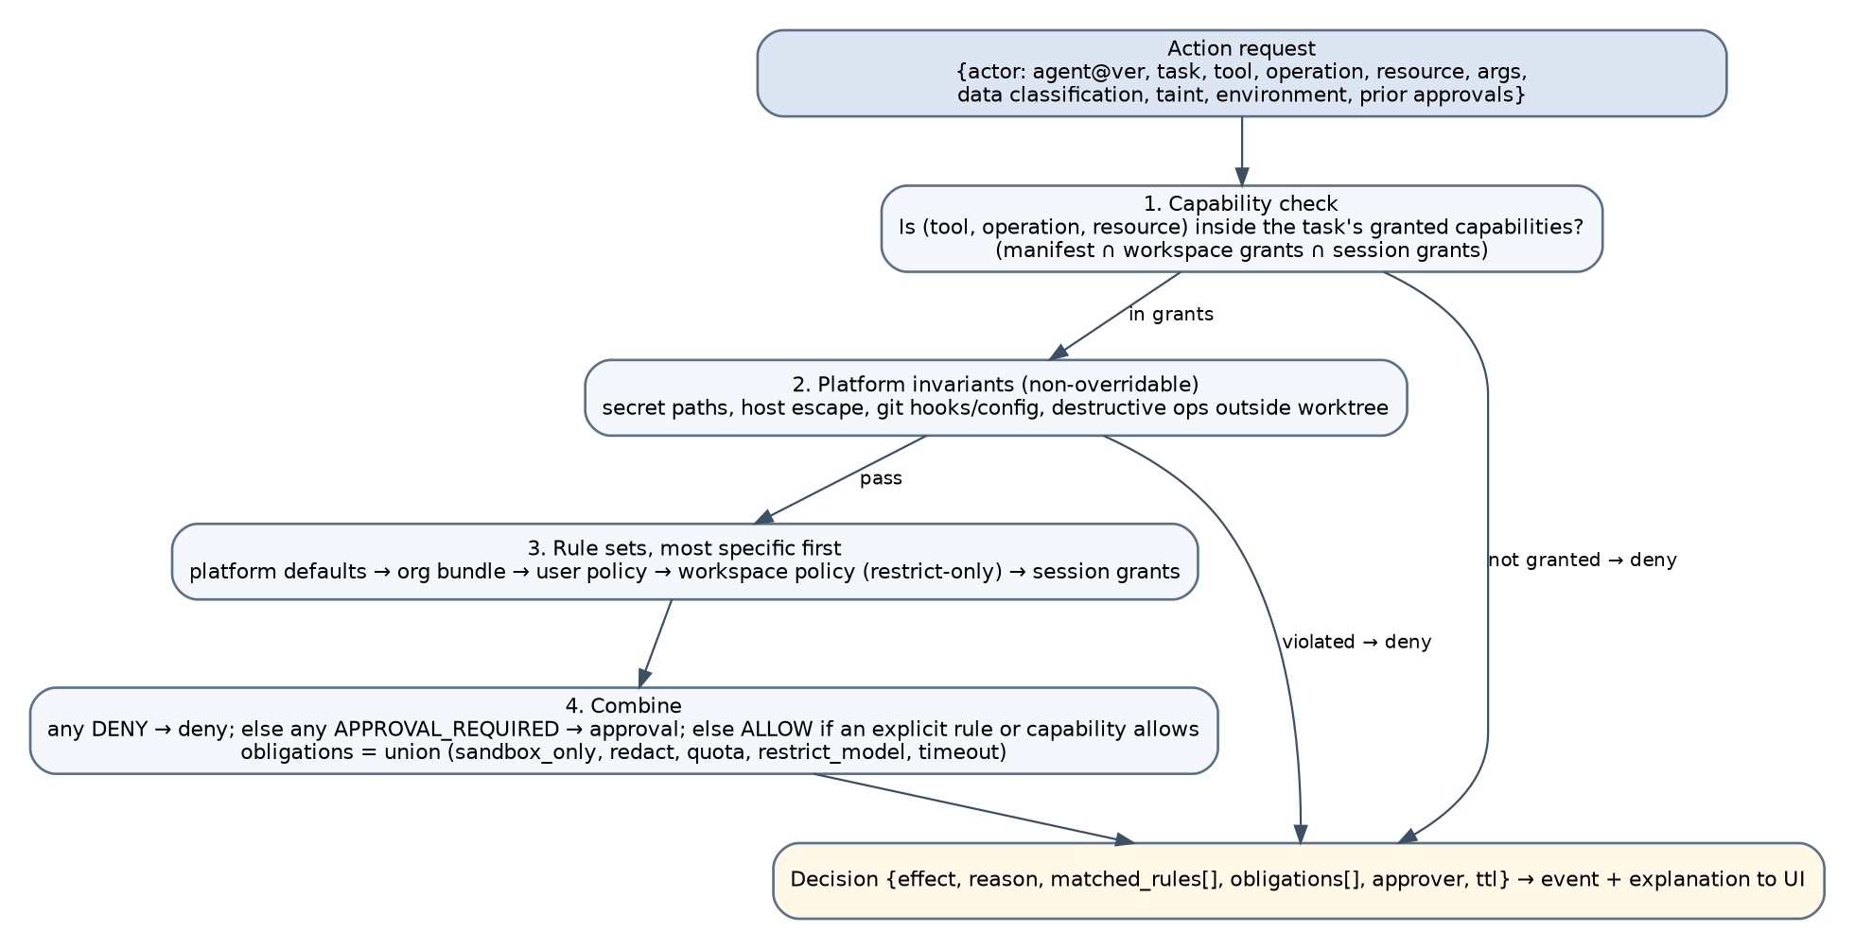
Figure 1. Policy evaluation.

2. Action request (input)
ActionRequest {
actor: { user, agent: {name, version, digest, trust}, task_id, execution_id, harness? }
action: { tool, operation, args (redacted copy), resource: {kind, path|command|host|server|model}, risk_class }
context: { workspace: {id, classification, root}, task_classification, taint: {untrusted_external: bool, sources[]},
environment: interactive|non_interactive, sandbox_level, session_grants[], prior_approvals[] }
time: RFC3339
}

args are canonicalized (paths resolved inside the sandbox, command basenames resolved) before evaluation so that rules match reality, not the model's spelling.

3. Decision (output)
Decision {
effect: allow | deny | approval_required
reason: string # human-readable, generated from matched rules
matched_rules: [rule_id...]
obligations: { sandbox_level?, timeout_seconds?, max_output_bytes?, redact_output?: bool,
restrict_models?: [glob], quota?: {kind, remaining}, log_full_args?: bool }
approval?: { approvers: [session-owner|role:<r>], scope_max: once|task|session|workspace, ttl_seconds }
ttl_seconds: int # how long the decision may be cached for identical requests
}

Effects are the only three listed. Routing fallback, scheduling deferral and quotas are not effects; they are obligations or belong to other components (fix of P-06).

4. Layers and precedence
Layer | Source | May grant | May deny | May require approval
L0 Platform invariants | Built into the runtime | no | yes (non-overridable) | yes
L1 Platform defaults | Shipped policy | yes | yes | yes
L2 Organization bundle (Phase 3) | Control plane, signed | yes | yes | yes
L3 User policy | ~/.warden/policy/*.yaml | yes (within L2) | yes | yes
L4 Workspace policy | <repo>/.warden/policy.yaml | no | yes | yes
L5 Session grants | Approvals with scope session/workspace, recorded | yes (only for actions that were approval_required) | no | no

Combination:
- Capability check: the action must be within the effective capability (manifest ∩ L1–L3 grants). Otherwise deny ("not granted").
- L0 invariants: any violation is deny.
- Collect matching rules from L1–L4. If any rule says deny → deny. Else if any says approval_required and no valid L5 grant covers the action → approval_required. Else allow.
- Obligations are the union of obligations from all matching rules; conflicting numeric obligations take the most restrictive value.
- Taint escalation: if taint.untrusted_external and risk_class ≥ R5, allow becomes approval_required and L5 grants of scope session/workspace are ignored for this action.
Workspace policy cannot grant (fix of P-20): a repository can make the runtime stricter for everyone who opens it, never more permissive.

5. Platform invariants (L0)
Id | Invariant
INV-1 | No read or write of paths on the secret deny-list (WRD-10 §6), inside or outside the worktree
INV-2 | No write outside the task worktree from a sandboxed executor
INV-3 | No execution of git hooks; no modification of .git/config, .git/hooks, .gitmodules without R5 approval
INV-4 | No process may be spawned outside a sandbox by agent request
INV-5 | No network egress except through the proxy; no proxy rule may allow * in confidential or restricted workspaces
INV-6 | No secret value may be passed as a tool argument or environment variable to a sandbox
INV-7 | Harnesses with vendor_terms: prohibited cannot be enabled
INV-8 | Non-interactive mode cannot resolve approval_required to allow without a pre-recorded policy grant
INV-9 | A task cannot exceed manifest limits; policy may only lower them

6. Rule syntax
Policy files are YAML; conditions are CEL expressions over the ActionRequest (actor, action, context, time).
apiVersion: warden.dev/v1alpha1
kind: Policy
metadata: { name: developer-local, layer: user, version: 3 }
spec:
defaults:
sandbox_level: L1
approval_scope_max: session
rules:
- id: writes-in-worktree
when: 'action.tool == "fs" && action.operation in ["write","patch"] && action.resource.path.startsWith(context.worktree)'
effect: allow
- id: test-commands
when: 'action.tool == "proc" && action.resource.command_profile in ["node-test","go-test","python-test","lint","build"]'
effect: allow
obligations: { timeout_seconds: 900, max_output_bytes: 262144 }
- id: other-commands
when: 'action.tool == "proc" && action.resource.command_profile == ""'
effect: approval_required
approval: { scope_max: task }
reason: "Command is outside the approved profiles."
- id: package-install
when: 'action.resource.command_profile == "install"'
effect: approval_required
approval: { scope_max: workspace }
obligations: { egress_allow: ["registry.npmjs.org:443", "pypi.org:443", "files.pythonhosted.org:443", "proxy.golang.org:443"] }
- id: egress-other
when: 'action.tool == "proxy" && !(action.resource.host in context.task_egress_allow)'
effect: approval_required
approval: { scope_max: session }
- id: push
when: 'action.tool == "git" && action.operation == "push"'
effect: approval_required
approval: { scope_max: once }
- id: protected-branches
when: 'action.tool == "git" && action.operation == "commit" && action.resource.branch.matches("^(main|master|release/.*)$")'
effect: deny
reason: "Direct commits to protected branches are not allowed; use a session branch."
- id: restricted-paths-model
when: 'context.task_classification == "restricted"'
effect: allow
obligations: { restrict_models: ["local/*", "gateway/*"] }
routing: { ... } # see WRD-06 §9
secrets:
allow_refs: ["secret://providers/*"]
harnesses:
copilot: { enabled: true, max_classification: internal }
codex: { enabled: false }
budgets: { session_usd: 25, daily_usd: 100 }

CEL environment: strings, lists, maps, matches, startsWith, in, timestamps; no network or filesystem functions; evaluation is bounded (cost limit) and side-effect free. Rule ids are stable and appear in events.

7. Approvals and scopes
Scope | Meaning | Allowed for risk classes
once | This call only | all
task | Identical action pattern for the rest of the task | R3, R4
session | Pattern for the rest of the session | R3, R4
workspace | Pattern persisted for this workspace and user (stored under ~/.warden, not in the repository) | R3, R4 (install and egress patterns); never R5

An approval record contains the canonical action pattern (tool, operation, resource pattern), scope, approver, timestamp, expiry, and the decision id it resolved. Approvals are events (WRD-09). Revocation: the user can revoke any grant from the session view; revocation is an event and takes effect on the next decision.
Approval prompt content (WRD-11): what will happen, why it needs approval (rule reason), which agent and task, the exact command or path, the risk class, and the scope selector limited by scope_max.

8. Explainability
policy.explain(actionSpec) returns the decision that would be made, with matched rules and the layer of each, without executing anything. The CLI exposes warden policy explain --tool proc --argv "npm test"; the desktop uses the same method in the settings screen ("What can agents do here?").

9. Non-interactive mode
In CI (--non-interactive) there is no approver. approval_required resolves to deny, unless the policy bundle contains a pre-approval with the same shape as an approval record (scope workspace, signed by an organization key in Phase 3). The run report lists every denied action so that the pipeline owner can add pre-approvals deliberately.

10. Caching and performance
Decisions are cached per (execution, canonical action) for ttl_seconds (default 60 s); any policy reload, approval, revocation or taint change flushes the cache. Target latency: under 2 ms per decision (CEL programs are compiled once per policy load).

11. Testing the policy engine
- Unit tests for combination logic with a table of (layers × effects).
- Golden tests: a corpus of ActionRequest JSON files with expected decisions, run in CI for the built-in policies.
- Property test: for any request, removing a workspace policy never turns allow into deny for a stricter result (monotonicity of restrict-only layers).
- Negative tests: every L0 invariant has a test that attempts a bypass through each entry point (tool, harness hook, MCP, delegation).
- warden policy test <dir> lets organizations run their own corpus against their bundle.

