Enterprise AI Agent Runtime Platform (working codename: Warden)
MVP User Experience Specification
Screens, states, approval experience, plan review, verification and diff review, settings, CLI parity, errors and cancellation
Document ID | WRD-11
Version | 0.5
Status | Working specification
Date | September 25, 2026
Owner | Product / Design
Audience | Design, engineers

Contents

1. Experience principles
- Show the decision before the effect. Nothing with an effect happens without the user having seen what will happen and why it is allowed.
- One request, one timeline. Orchestration complexity is hidden behind a single timeline; details are one click away.
- Explain the machine. Model choice, policy decisions and costs are explained in one sentence with a details view.
- Never trap the user. Cancel is always available; nothing is applied to the repository without the final gate.
- Same power in the CLI. Every desktop action has a CLI equivalent (scripting, CI, accessibility).
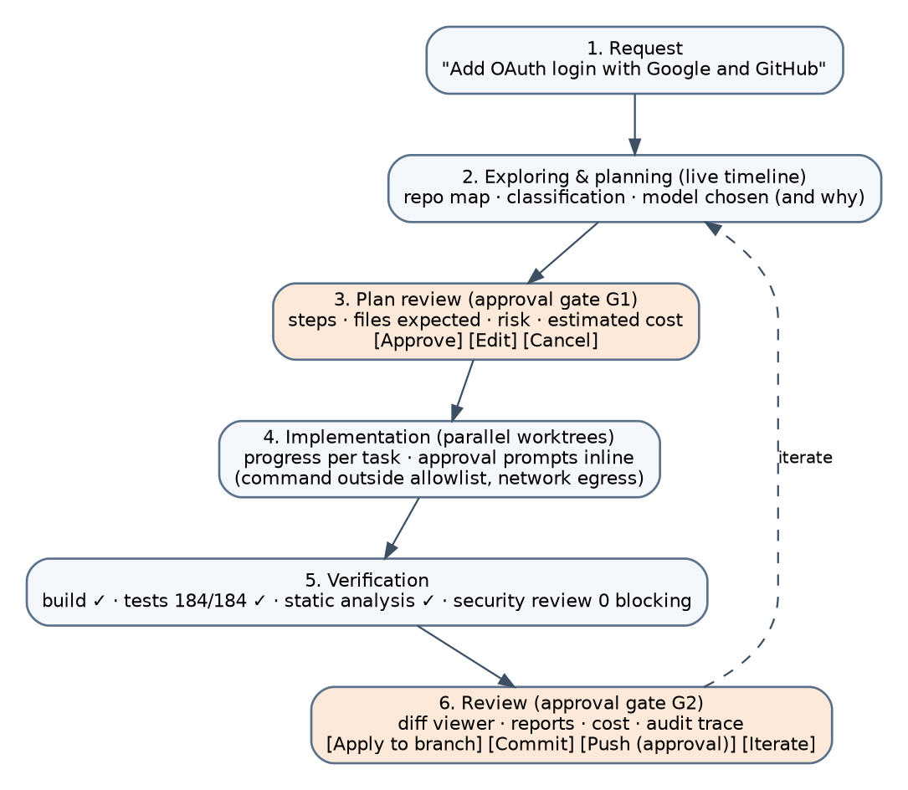
Figure 1. The MVP journey.

2. Screens

2.1 Workspace home
- Open repository (directory picker or recent list); shows classification badge, sandbox level, configured providers, and policy summary ("Agents can: read/write this repo, run test and build profiles; need approval for: installs, other commands, push").
- Sessions list with status, cost and last activity.

2.2 Session view (the main screen)
Layout: left, the timeline; right, a context panel that changes with the selected item (plan, task, approval, artifact, diff).
Timeline entries (each with status icon, elapsed time, cost badge):
Entry | Content
Request | User text; classification and complexity chips
Explore | Progress ("Reading 142 files, 3 build commands detected"); repo-map artifact link
Model chosen | "local/qwen-coder-32b (prefer-internal; confidential data)" with details
Plan gate (G1) | Inline plan card: tasks, paths, risks, estimated cost; buttons Approve, Edit, Cancel
Task cards (parallel) | Live step counter, tool calls collapsed, approval prompts inline
Integration | Merge result; conflicts if any
Verification | Build, tests, lint, security review with pass/fail and counts
Repair (if any) | Failure analysis summary; new fix tasks
Final gate (G2) | Diff summary, reports, cost total, chain status; Apply, Commit, Push (approval), Iterate

2.3 Approval prompt (inline card and OS notification)
Content order: what (exact command, path, host or model), who (agent and task), why it needs approval (rule reason, risk class, taint sources if any), scope selector (limited by policy), Approve / Reject, and "Explain" (opens the policy explanation). Keyboard: A approve, R reject, 1–4 scope. Prompts never auto-dismiss; a task waiting for approval shows a pulsing state; a session-level badge counts pending approvals.

2.4 Diff review
Side-by-side or unified; per-file accept/revert (reverting creates a note for the iterate loop); file list grouped by task; link from each hunk to the task and step that produced it (provenance); test results per file where mappable.

2.5 Artifacts and audit
Artifact browser by type; event stream with filters (policy, tool, model, approval); Verify chain button; export.

2.6 Settings
Providers (add API key stored in keychain, cloud identity sign-in, local server discovery, gateway, harness enablement with vendor-terms notice), models and pinning, policy viewer with explain tester, sandbox status (doctor), budgets, retention, telemetry (off by default).

3. States and empty states
State | UX
No provider configured | Guided setup with three paths: API key, local model (detects Ollama), cloud/gateway
Sandbox prerequisites missing | Blocking banner with OS-specific instructions; no unsandboxed fallback
Provider unavailable / no admissible model | Task card in waiting for input with the reason and actions (configure provider, change strategy if allowed)
Budget exhausted | Card with spend, limit, and "raise limit for this session" (policy permitting)
Cancelled | Greyed entries; "Resume from last gate" action
Chain verification failed | Red banner in the session; export still possible with a warning

4. CLI parity
Desktop action | CLI
Open workspace | warden open .
New request | warden run "Add OAuth login with Google and GitHub"
Approve plan | warden approve <gate-id> or interactive prompt in the terminal
Resolve approval | warden approvals then warden approve <id> --scope task
Cancel | warden cancel [<task-id>]
Diff | warden diff <session>
Reports | warden report <session> --json
Audit | warden audit export/verify
Policy explanation | warden policy explain --tool proc --argv "npm test"
Providers | warden provider add/list/test
Non-interactive | warden run --non-interactive --policy ci.yaml "..." (exit codes: 0 verified, 2 needs approval, 3 failed)

5. Errors and messages
Every error shows: what happened, what the runtime did (paused, retried, fell back), and what the user can do. Provider errors are mapped to plain language ("Rate limited by OpenAI; retrying in 20 s (2/3)"). Policy denials shown to the user include the rule id for support.

6. Accessibility and localization
Keyboard navigation for the timeline and prompts; ARIA roles; reduced-motion mode; English first, strings externalized; Romanian and German next.

7. Instrumentation for UX research
Prompts per task, time to first approval, plan edit rate, diff revert rate, cancel rate, time to verified change. Collected locally; shared only when the user opts in.

