Enterprise AI Agent Runtime Platform (working codename: Warden)
Deployment and Operations Guide
Installation per operating system, configuration, directories, provider setup, sandbox prerequisites, operations, updates, backup, troubleshooting, and later deployment models
Document ID | WRD-13
Version | 0.5
Status | Working specification
Date | September 25, 2026
Owner | Engineering / Operations
Audience | Developers, platform teams, operations

Contents

1. Deployment models
Model | Phase | Components
Desktop, local-first | MVP | Desktop app with bundled wardend, or CLI alone
Desktop plus control plane | 3 | Adds signed policy and registry bundles, identity, central audit
CI worker | 2 | wardend headless in a runner with L2/L3 sandboxes
Remote worker fleet | 4 | wardend server mode, job queue, mTLS enrollment
Private cloud / on-premises control plane | 3 | Control plane services (WRD-15)

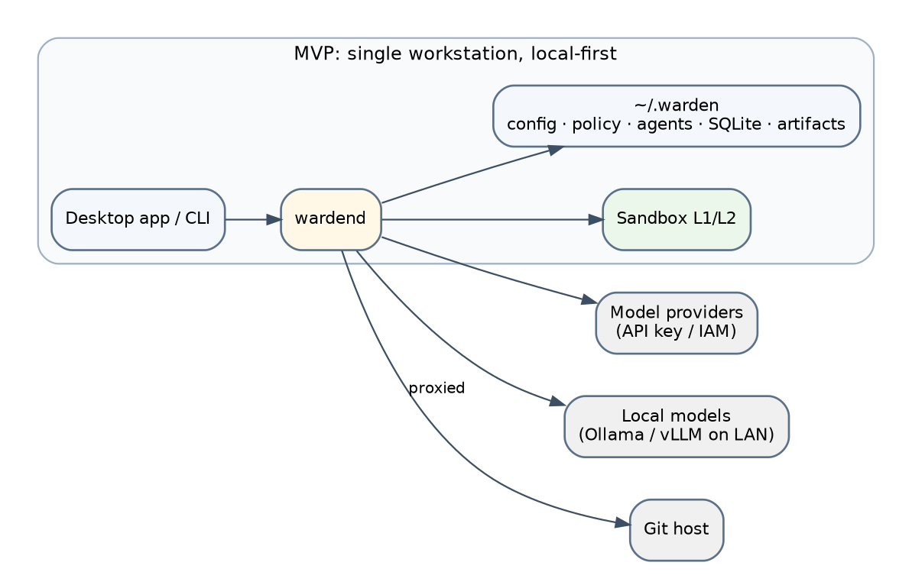
Figure 1. Local deployment.

2. Installation

2.1 macOS (14+)
- Desktop: signed and notarized .dmg; the app bundles wardend and warden-exec as sidecars; first launch runs warden doctor.
- CLI: brew install warden (tap) or a signed tarball.
- Sandbox L1 uses Seatbelt; no additional install. L2 requires Docker Desktop, Podman Desktop or Apple container tooling.

2.2 Linux (Ubuntu 22.04+, Fedora 39+, Debian 12+)
- Packages: .deb, .rpm, and an AppImage for the desktop; CLI tarball with checksums and signatures.
- L1 prerequisites: bubblewrap; unprivileged user namespaces enabled (kernel.unprivileged_userns_clone=1 on older Debian/Ubuntu); doctor reports and links to fixes.
- L2: rootless Docker or Podman.

2.3 Windows 11
- MSIX installer for the desktop; winget install warden.
- L2 required: Docker Desktop or Podman Desktop with the WSL2 backend; the runtime stores worktrees inside the WSL2 filesystem (\\wsl$\...) for performance and mounts them into containers; doctor verifies.
- Native L1 is not available in the MVP; the UI states this.

3. Directories and files
See WRD-09 §8 for ~/.warden. Permissions are owner-only. On Windows %LOCALAPPDATA%\Warden is used with an equivalent layout.
config.yaml:
runtime:
socket: ~/.warden/run/wardend.sock
log_level: info
telemetry: off
sandbox:
default_level: L1 # L2 on Windows
backend: auto # bwrap | seatbelt | docker | podman
images: { node: ghcr.io/warden/sandbox-node@sha256:..., go: ..., python: ..., java: ... }
package_cache: ~/.warden/cache
proxy:
dns_over_proxy: true
worktrees:
root: ~/.warden/worktrees
retention_hours: 24
store:
retention_days: 90
budgets: { session_usd: 25, daily_usd: 100 }

4. Provider setup
Path | Command | Notes
API key | warden provider add anthropic --api-key | Prompts for the key; stores in the keychain; tests the endpoint
Local model | warden provider add ollama | Discovers models; probes tool-calling support
OpenAI-compatible server | warden provider add openai-compatible --url https://vllm.corp.internal/v1 --auth mtls
Gateway | warden provider add gateway --url ... --auth sso-oidc | Browser login flow; token stored in keychain
Cloud identity (Phase 2) | warden provider add azure-foundry --auth entra | Uses the platform credential chain
Harness | warden harness enable copilot | Requires Copilot CLI installed and logged in; shows vendor terms notice

warden provider test <id> validates connectivity, capabilities and prices; warden models lists the catalog with tiers.

5. Operating the daemon
- Lifecycle: started by the desktop app or on demand by the CLI; warden daemon status|stop|restart.
- Logs: ~/.warden/logs/wardend.log (rotated, redacted); warden logs -f.
- Health: warden doctor checks sandbox backend, namespaces, proxy socket, keychain access, disk space, catalog validity, policy compilation.
- Resource footprint: idle daemon under 60 MB; each L1 sandbox adds the toolchain's usage only; L2 images pinned by digest and pulled on first use (documented size per image).

6. Updates
- Desktop auto-update with signature verification (Tauri updater) and a release notes prompt; CLI via package manager.
- Schema migrations for SQLite run on daemon start with a backup of the database file; downgrade is not supported across migrations.
- Sandbox images are updated independently, pinned in config.yaml by digest.

7. Backup and restore
~/.warden is self-contained: backing up the directory (excluding run/ and cache/) preserves sessions, artifacts, worktrees and policies; secrets live in the keychain and must be re-entered on a new machine. warden audit export produces portable session archives.

8. Troubleshooting
Symptom | Likely cause | Action
"Sandbox backend unavailable" | bubblewrap missing or user namespaces disabled; Docker not running | warden doctor; install or enable; or switch to L2
Tasks never start on Windows | Docker Desktop without WSL2 backend | Enable WSL2 integration
"No admissible model" | Classification excludes configured providers | Add a T0–T2 provider or adjust admission via policy
Approval prompts for every command | Toolchain commands not in profiles | Add commands to a workspace profile via a once/workspace approval
Slow file operations on macOS L2 | Bind mounts through Docker Desktop | Prefer L1 on macOS or use VirtioFS
Keychain prompts repeatedly | Application signature changed | Reinstall signed build

9. CI usage (Phase 2)
warden run --non-interactive --policy ci-policy.yaml --workspace . "Fix flaky test in auth module" runs with a pre-approval bundle; exit codes drive the pipeline; artifacts and reports are uploaded as job outputs; events can be shipped to central audit when the control plane exists.

10. Hybrid deployment (Phase 3+)
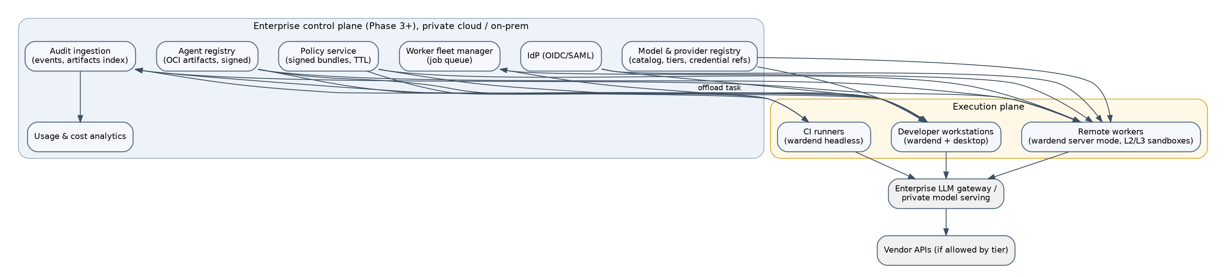
Figure 2. Hybrid deployment with control plane.
Workstations and workers enroll with the control plane, pull signed bundles with TTLs, and stream events. Offline behavior is defined in WRD-15 §9.

