Maekawa Algorithm

一、问题的提出

经典的分布式互斥Ricart and Agrawala算法中，消息通信的数量是2(n-1)个消息，这里n为一组要求互斥的进程个数，消息包括(n-1)个请求消息(request)和n-1个的许可消息(permission)。也就是说，n个进程中，任一个进程申请临界区执行时，需求其他n-1个进程的全部一致许可(或仲裁)后，才能执行临界区代码。人们研究后发现，这样的n-1个许可信息没有必要，比如，日常生活、工作中的表决(Voting)方法，表决结果由多数人的一致认可决定，而不需要全部一致的许可，这里所谓多数，一般只要求大于n/2。

东京大学的Maekawa[1985]在这方面的研究得到一个重大成果，这就是著名的“分布式互斥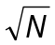算法”，简称算法或Maekawa算法。算法的消息复杂度为c,c为常量，c∈[3,5]，N为进程数，并且给出c=3的算法。

二、算法简介

假设一组分布式互斥进程个数为N ,它们编号为1、2、…、N。
定义：一组分布式互斥进程的一个子集S_{i},称为请求集，请求集S_{i}中的一个进程要求进入临界区执行时，其请求只须发送给S_{i}中的进程并得到S_{i}中进程的一致许可 (i=1、2、…、N) 。
1.四个属性
属性a：任意i,j,1≤i,j≤N, 都有S_{i}∩S_{j}≠Φ。
属性b：任意j, 1≤j≤N,进程j∈S_{j}。
属性c：任意i, 1≤i≤N, S_{i}的进程个数为K。也就是
|S₁|=|S₂|=…=|S_{N}|=K
属性d：D为已知常量，任意j,1≤j≤N, 在S₁、S₂、…、S_{N}中存在D个请求集，它们都包含进程j。
这里属性a是实现互斥的关键，属性b可以减少消息个数，属性c和d称为分布式属性。
2.请求集S_{i}
请求集S_{i}的生成不是唯一的，后来很多学者就如何快速得到N请求集S_{i}进行了大量的专门研究。
从属性b和d看出，请求集S_{i}的一个进程(也称成员)，包含在其他(D-1)个请求集中，所以，满足属性a的请求集最多为:
(D-1)K + 1
因此N =(D-1)K + 1.
当算法同时满足属性c和d时，必有K = D，因为KN/D就是请求集的个数N。得到
N = K(K-1)+1
满足属性a-d的请求集称为对称请求集。能够生成对称请求集的算法称为对称请求集生成算法。
当且仅当满足以上四个属性，且任意i,j,1≤i,j≤N, 都有
|S_{i}∩S_{j}|=1
则称为最优请求集。
最优请求集的求解等价于数学上著名的有限投影平面
A finite projective palne of order n, with n>0, is a collection of n²+n+1 lines and n²+n+1 points such that：
- every lines contains n+1 points,
- every point is on n+1 lines,
- ant two distinct lines intersect at exactly one point,and
- any two distinct points lie on exactly one line.
It is known that a plane of order n exists if n is a primer power. The first value of n which is not a primer power is 6[1938].The next open value is n=10[1989].
N=3，K=2 | S₁={1,2}  S₃={1,3}  S₂={2,3}
N=5，K=3 | S₁={1,2,3}  S₄={1,4,5}  S₆={1,6,7}  S₂={2,4,6}  S₅={2,5,7}  S₇={3,4,7}  S₃={3,5,5}
N=13，K=4 | S₁ ={1, 2, 3, 4}  S₅ ={1, 5, 6, 7}  S₈ ={1, 8, 9,10}  S₁₁={1,11,12,13}  S₂ ={2, 5, 8,11}  S₆ ={2, 6, 9,12}  S₇ ={2, 7,10,13}  S₁₀={3, 5,10,12}  S₃ ={3, 6, 8,13}  S₉ ={3, 7, 9,11}  S₁₃={4, 5, 9,13}  S₄ ={4, 6,10,11}  S₁₂={4, 7, 8,12}
2.请求集S_{i}
3.算法
Each node executes an identical algorithm. The algorithm is based on the fact
that, if node i locks all members of Si, no other node can capture all its members
because of property (a). Therefore, when it invokes mutual exclusion, node i tries
to lock all members of Si. If it succeeds, it can enter its critical section. If it fails,
it waits for all its member nodes to be freed, at which point it captures and locks
them. It then enters its critical section. Since there is a danger of deadlock when
more than one node simultaneously requests mutual exclusion, a node will yield
to others if the priority of its request is lower than that of any other conflicting
request. The request’s priority is determined by the sequence number (timestamp)
of the request’s corresponding REQUEST message. A REQUEST with a smaller
sequence number is given higher priority and is said to precede other REQUESTS
with larger sequence numbers. If a newly arrived REQUEST at a member node
precedes the current locking REQUEST, the node sends an INQUIRE message
to the node originating the current locking REQUEST to inquire whether the
originating node will really succeed in capturing all its members. The originating
node will return a RELINQUISH message when it becomes ,apparent that the
node will not be able to capture all its members. On the other hand, if the
originating node has succeeded in capturing all its members, it will return a
RELEASE message only after it has completed its critical section operation.

The algorithm is now described below:
(1) When node i invokes mutual exclusion, it sends a REQUEST message to every
member of Si. Node i pretends to have received a REQUEST. The REQUEST message is given a sequence number greater than any REQUEST message sent, received, or observed at this node.
(2) Upon receiving a REQUEST, a member node of Si marks itself locked for the
REQUEST if it is not currently locked for another REQUEST, and then returns a
LOCKED message to the requesting node i. If the node is locked for a REQUEST
from another node, the REQUEST from node i is placed in the WAITING QUEUE
of the node. (These REQUEST messages placed in the WAITING QUEUE are called
outstanding REQUESTS.)
It is then tested to determine whether the current locking REQUEST or any other outstanding REQUEST at the node precedes the received REQUEST. (See below for the definition of the locking REQUEST.) If so, a FAILED message is returned to node i. Otherwise, an INQUIRE message is sent to the node originating the current locking REQUEST to inquire whether this originating node has succeeded in locking all its members. If an INQUIRE has already been sent for a previous REQUEST and its reply message (either RELINQUISH or RELEASE) has not yet been received, it is not necessary to send in INQUIRE. REQUEST A is said to precede REQUEST B if (the sequence of number A < the sequence number of B) or ((the sequence of number A = the sequence number of B ) and (the node number of A < the node number of B)). Each node can be locked by only one REQUEST at a time, and this REQUEST is called the locking REQUEST. Any subsequent REQUESTS arrived at the node are placed in the WAITING QUEUE of the node in decreasing order of the precedence defined above.
(3) When a node receives an INQUIRE message, it returns a RELINQUISH message if it knows that it will not succeed in locking all its members; that is, it has received a FAILED message from some of its members. By so doing, the node relinquishes its member node to a more preceding REQUEST. This breaks a circular locking, which is necessary to avoid deadlocks. The node cancels the LOCKED message previously received from the member node. When the node has succeeded in locking all its members and is in its critical section, it returns a RELEASE message, but only after it has completed its critical section. If an INQUIRE message has arrived before it is known whether the node will succeed or fail to lock all its members, a reply is deferred until this becomes known. If an INQUIRE message has arrived after the node has sent a RELEASE message, it is simply ignored.
(4) When a node receives a RELINQUISH message, it relieves itself of the current locking REQUEST and then locks itself for the most preceding REQUEST in the WAITING QUEUE. Thus, regardless of which REQUEST had caused the sending of an INQUIRE,the node is locked for the REQUEST that happens to be most preceding
when a RELINQUISH message is received. The current locking REQUEST is placed
in the WAITING QUEUE, whereas the most preceding REQUEST is removed from
it. A LOCKED message is then returned to the node originating the new locking REQUEST.
(5) If all members of Si have returned a LOCKED message, node i enters its critical
section.
(6) Upon completing the critical section, node i sends a RELEASE message to each
member of S_{i}.
(7) When a node receives a RELEASE message, it relieves itself from the current REQUEST. It deletes this locking REQUEST and then relocks itself for the most locking preceding REQUEST in the WAITING QUEUE if the queue is not empty. A LOCKED message is returned to the node originating the new locking REQUEST. If the WAITING QUEUE is empty, the node marks itself unlocked.
(8) The above steps (l)-(7) are repeated for each mutual exclusion request.

4.一个例子

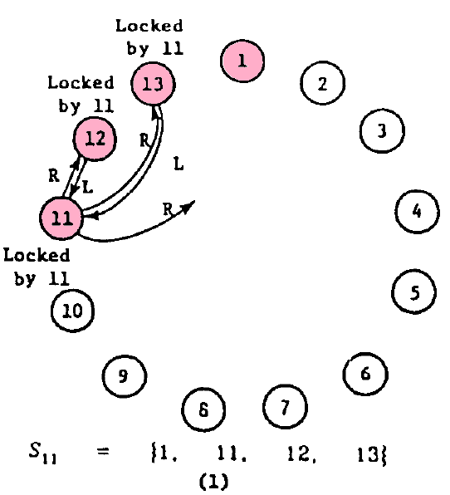
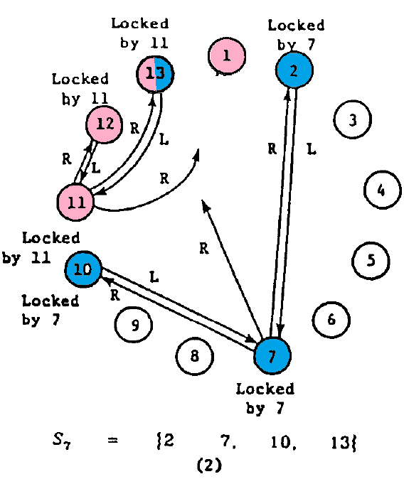
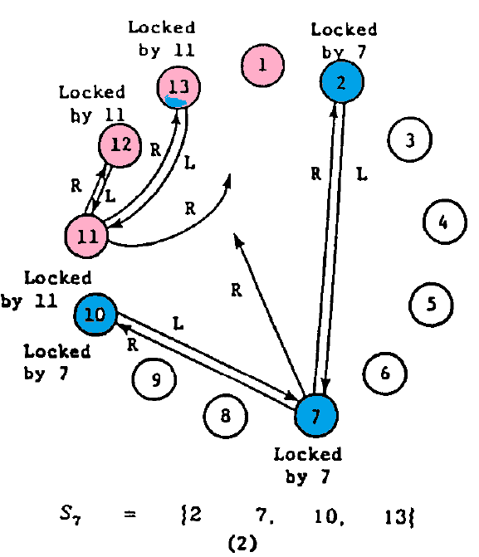
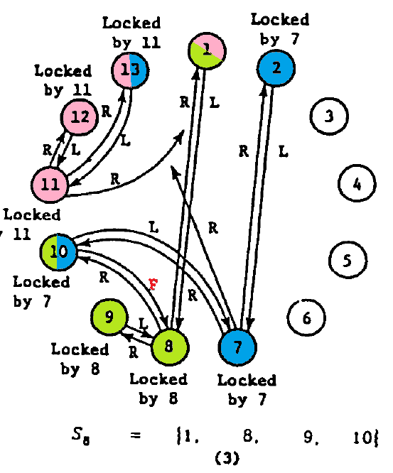

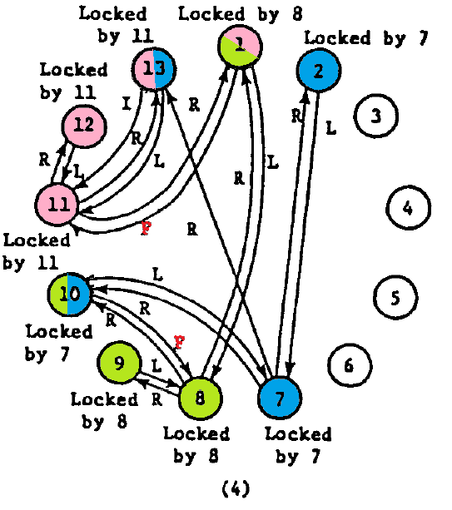
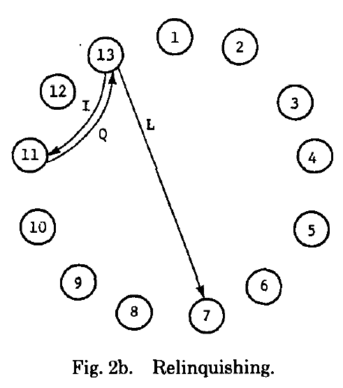

5.关于S_{i}

If a corresponding finite projective plane does not exist or if N is not expressed as K(K - 1) + 1, one or both of the above two conditions must be sacrificed. create a near-optimal set of S_{i}’s.
