obtain security token

#### ****William Higgs****

*Default description*

## **Login to salesforce**

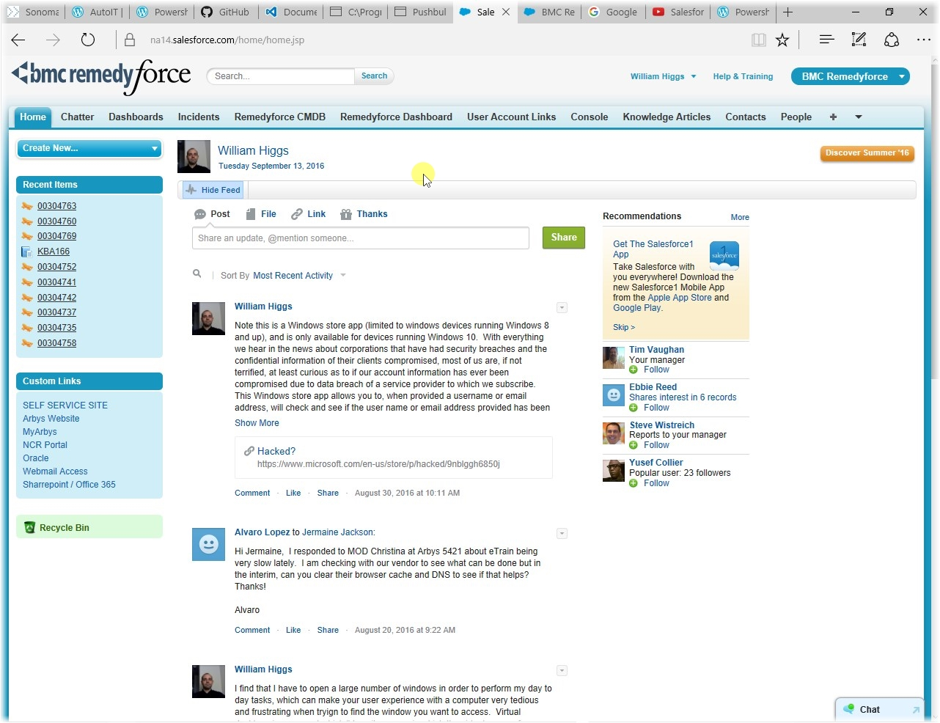

Basically, you cannot simply "obtain" your salesforce security token. The way that salesforce is setup forces you to reset your security token, and will then send the new token to your arbys email

