The Global Reference Architecture (GRA)

Entity Resolution Service (ERS) 1.0.0

Service Description Document

Version 1.0.0

October 2013
The ERS service specification was developed by SEARCH in collaboration with the Hawaii Criminal Justice Data Center and Vermont Department of Public Safety.

This project was supported by Grant No. 2009-SQ-B9-K114 awarded by the National Institute of Justice, Office of Justice Programs. The opinions, findings, and conclusions or recommendations expressed in this publication are those of the author(s) and do not necessarily reflect the views of the U.S. Department of Justice.
Table of Contents
1. Introduction to GRA 1
2. Service Overview 2
2.1 Purpose 2
2.2 Scope 2
2.3 Capabilities 2
2.4 Real-World Effects 3
2.5 Summary 3
2.6 Description 3
2.7 Security Classification 4
2.8 Service Specification Package Version 4
3. Business Scenarios 4
3.1 ERS Business Scenario #1 4
3.1.1 Primary Flow 4
3.2 ERS Business Scenario #2 5
3.2.1 Primary Flow 5
4. Service Interoperability Requirements 5
4.1 Service Interaction Requirements 5
4.2 ERS 5
4.2.1 Service Consumer Authentication 6
4.2.2 Service Consumer Authorization 6
4.2.3 Identity and Attribute Assertion Transmission 6
4.2.4 Service Authentication 6
4.2.5 Message Non-Repudiation 6
4.2.6 Message Integrity 6
4.2.7 Message Confidentiality 7
4.2.8 Message Addressing 7
4.2.9 Reliability 7
4.2.10 Transaction Support 7
4.2.11 Service Metadata Availability 7
4.3 Service Assumptions 7
4.4 Service Dependencies 7
4.5 Execution Context 8
4.5.1 Reachability 8
4.5.2 Awareness 8
4.5.3 Intermediaries, Connectors, and Adaptors 8
4.6 Policies and Contracts 8
4.6.1 Security 8
4.6.2 Privacy 8
4.7 Additional Information 9
4.7.1 Timeout and Exception Handling 9
5. Service Model 9
5.1 Information Model 9
5.1.1 IEPD Reference 11
5.1.2 Data Inputs 11
5.1.3 Data Outputs 11
5.1.4 Provenance 11
5.2 Behavior Model 12
5.2.1 Action Model 12
5.2.2 Process Model 12
Appendix A—References 15
Appendix B—Glossary 16
Appendix C—Document History 17

Introduction to GRA

In the context of the Global Reference Architecture (GRA) and Service-Oriented Architecture (SOA) in general, a service is the means by which one partner gains access to one or more capabilities offered by another partner. Capabilities generate real-world effects that can be as simple as sharing information or can involve performing a functional part of a complex process or changing the state of other related processes. Justice and public safety organizations have numerous capabilities and a multitude of partner organizations, both inside and outside the traditional justice and public safety community. There are significant benefits for these organizations to have access to each other's capabilities. The justice and public safety world has nearly 100,000 agencies, each with its own governance, business needs, applications, hardware, and networks. Achieving interoperability among justice and public safety organizations and with external partner organizations requires alignment of business and technical requirements and capabilities. In addition, it is critical to have a consistent way of specifying these requirements and capabilities and sharing them across organizational boundaries. The GRA was developed to facilitate interoperability and to assist in meeting other key requirements in a justice and public safety information sharing environment. In order to achieve this goal, there is a strong need to define a consistent approach to identifying and describing services and their interactions that can be implemented in many different technical environments, across multiple government lines of business, at all levels of government, and with other partner organizations.

The GRA defines a service interface as “the means for interacting with a service.” It includes the specific protocols, commands, and information exchange by which actions are initiated on the service. A service interface is what a system designer or implementer (programmer) uses to design or build executable software that interacts with the service. That is, the service interface represents the “how” of the interaction. Since the service interface is the physical manifestation of the service, best practices call for service interfaces which can be described in an open-standard, referenceable format (that is, a format which could be automatically processed by a computer).

A Service Specification is a formal document describing the capabilities made available through the service; the service model that defines the semantics of the service by representing its behavioral model, information model, and interactions; the policies that constrain the use of the service; and the service interfaces which provide a means to interact with the service. A Service Specification is analogous to the software documentation of an Application Programming Interface (API). It provides stakeholders with an understanding of the structure of the service and the rules applicable for its implementation. It gives the service consumers the information necessary for consuming a particular service, and service providers the information necessary for implementing the service in a consistent and interoperable way.

The main components of a Service Specification are the Service Description, one or more Service Interface Descriptions, and the schemas and the samples required to implement and test the service.
A Service Description contains information about all aspects of the service not directly tied to the physical implementation (in other words, the service interface). A Service Interface Description is a description of the physical implementation—specifically, the service interface used in a specific implementation of the service. Since a service can leverage multiple Service Interfaces, the Service Specification might contain more than one Service Interface Description.

This document is a Service Description Document for the Entity Resolution Service (ERS).

Service Overview

The Entity Resolution Service (ERS) provides a means to analyze a set of entity records, through matching and merging logic, to determine whether the records represent the same real-world entity.

An entity is a real world person, place, item, location, etc. A system record represents an entity. A system record is comprised of a number of record attributes. For example, a system record containing ‘person’ record attributes such as a name, address, city, etc. represents the ‘person’ entity.

A ‘match’ function is a pair-wise comparison between record attributes of entities that yields a ‘match score’. Specific implementations (adapters) can introduce their own matching algorithms.

Purpose

The purpose of the Entity Resolution Service (ERS) is to provide a means to analyze a set of entity records, through matching and merging logic, to determine whether the records represent the same real-world entity.

Scope

The scope of the ERS includes performing a ‘match’ or ‘match/merge’ function on a set of records, representing any entity.

Capabilities

The ERS receives an entity match request or entity match/merge request from a requesting system and performs the following functions on the request records

- A ‘match’ function on a set of entity records and determine the ‘match score’.

- A ‘merge’ function, based on a pre-defined “match threshold”, on a set of entity records and consolidating the results as a set of merged records for each real-world entity.

- Determine a ‘true match’ result for matching on biometric identifier attributes.

Real-World Effects

Consumers of the ERS are able to submit match/merge requests for a set of records in order to:

- Assists investigators in building a complete entity profile based on entity records from multiple justice systems.

- Provides investigators with additional entity information that could lead to criminal apprehension.

Summary

The ERS determines a “match score” for each pair-wise record attribute provided to the service. The ERS creates a merged “entity” record based on a pair-wise “match threshold” analysis of record attributes provided to the service.

Description

ERS

The Entity Resolution Service (ERS) resolves and correlates entities across multiple data sources. Law enforcement support systems (e.g., federated query or link analysis applications) will use this service whenever they need to determine (at some probability) whether two entities are the same based on similar attributes within a record.

One method of resloving entities is done by determining the similarity between the values of strings in the records being compared. There are several algorithms available to perform string distance computation. Particular implementations of this service could use any or all of these, or invent new ones. The service’s information model provides a structure to configure the behavior of the service; the algorithm provided in this service specification structure allows each message to define what string distance algorithm to use for each attribute in the input data, and the match threshold for each attribute. The definition of the attribute is expected to provide an XPath expression that resolves the input message to a single string value for each entity. It is this value, for each entity, that is compared (in whatever way appropriate for the implementation) with the same attribute in all other entities.

A detailed description of the more commonly used service algorithms is provided in the ERS_Match-Merge Functions document provided with the SSP.

Security Classification

ERS

The intermediary capability of the ERS is based on the premise that the ERS would be implementated in the following scenarios: (1) in an Intermediary container between a Search Results Aggregation Service and a Merge Notification Service, (2) in an Intermediary container between a Query Request Service and a Merge Notification service [see section 5.2.2, Figures 3,4]. Note that in both scenarios all services would reside in the same intermediary environment/container. In both scenarios, the ERS would receive a message from a service and pass a message to the Merge Notification Service all within the same intermediary container. The Entity Resolution Service would not receive or send any message outside the intermediary. Based on this premise, the ERS does not provide direct access to any information from outside the Intermediary, nor does the underlying capability store any information. Therefore, in the above scenarios the ERS has no security classification or security requirements.

In addition, implementation of the ERS could occur in a scenario where the service receives a message and/or sends a message outside it’s container environment. In this scenario, security requirements may apply.

Therefore, the ERS could be classified as ‘unsecured’ or ‘secured’ depending on the implementation scenario.

Service Specification Package Version

This service specification is built based on version 1.0.0 of the Service Specification Package.

Business Scenarios

ERS Business Scenario #1

Investigators will use this service to match and or match/merge entity records received from a system search (e.g., federated search, link analysis).

Primary Flow

- Assembly of Search Criteria and Entity Resolution Parameters (match threshold)
- Submit Search
- Query message is split
  - Query Criteria are routed to data source
  - Entity Resolution Parameters are sent to aggregator
- A query is executed at the data source
- Query results are sent (reported) to an aggregator
- An aggregator creates Entity Information comprised of Entity Resolution Parameters and Query Results (from each data source).
- The Entity Information is passed to the Match or Match/Merge function for computation.

ERS Business Scenario #2

Justice systems will use this service to match and or match/merge entity records when performing system-to-system transfers of information or to make determinations about redundancy of information in the system.

Primary Flow

- Assembly of a Set of Records and Entity Resolution Parameters (e.g., match threshold)
- Message is submitted
- The Entity Information is passed to the Match or Match/Merge function for computation.

Service Interoperability Requirements

Service Interaction Requirements

The following table lists the Service Interaction Requirements established by the GRA Framework, and indicates whether each is mandatory for this service.

ERS

“Unsecured” implementation (as shown in Section 5.2.2)

Requirements | Mandatory (Yes/No) | Justification/Notes
Service Consumer Authentication | No
Service Consumer Authorization | No
Identity and Attribute Assertion Transmission | No
Service Authentication | No
Message Nonrepudiation | No
Message Integrity | No
Message Confidentiality | No
Message Addressing | No
Reliability | No
Transaction Support | No
Service Metadata Availability | No

“Secured” implementation

Requirements | Mandatory (Yes/No) | Justification/Notes
Service Consumer Authentication | Yes
Service Consumer Authorization | Yes
Identity and Attribute Assertion Transmission | Yes
Service Authentication | Yes
Message Nonrepudiation | Yes
Message Integrity | Yes
Message Confidentiality | Yes
Message Addressing | Yes
Reliability | No
Transaction Support | No
Service Metadata Availability | Yes

Service Consumer Authentication

The service consumer must provide information in the message sent to this service that the service can use to authenticate the consumer and confirm that the consumer is a member of the federation.

Service Consumer Authorization

The service must confirm that the service consumer is in fact authorized to send messages to the service.

Identity and Attribute Assertion Transmission

The service consumer must make information about itself available to the service. Likewise, the service must make information about itself available to service consumers.

Service Authentication

A service consumer must be able to verify the identity of the service in trusted manner.

Message Non-Repudiation

All messages sent to this service must contain information to prove that a particular authorized sender in fact sent the message.

Message Integrity

All messages sent to this service must contain information for the service to confirm that the message has not changed since it left control of the sender.

Message Confidentiality

All messages sent to this service must be protected in a manner that prevents anyone except the authorized recipient from reading the message.

Message Addressing

All messages sent to this service must contain a unique message identifier (this supports correlation of asynchronous request/response) along with information indicating where the message originated, the ultimate destination of the message, a specific recipient to whom the message should be delivered and a specific address or entity to which reply messages should be sent, if they exist.

Reliability

This service does not require Reliability.

Transaction Support

This service does not require Transaction Support.

Service Metadata Availability

Since this service is part of a federation, this metadata about this service must be made available to all federation members

Service Assumptions

ERS
- All messages sent to the ERS will result in a synchronous acknowledgement of receipt or failed delivery. This acknowledgement will contain just enough information to confirm that the message was delivered and is not considered part of the service model.

- Messages other than the synchronous acknowledgement—specifically, the results of performing matching and merging—are returned asynchronously.

Service Dependencies

ERS

The ERS provides the ability to receive a Entity Match or Entity Merge request but this service does not return results of that request.

The Match Notification Service (MNS) should be used in conjunction with this service to provide entity resolution results.

In an ‘unsecured’ implementation scenario of the ERS (see Section 2.7) there is a more tightly coupled implementation with other services.

Execution Context

This section is divided into sub-sections based on the implementation guidelines established in the GRA Execution Context guidelines 1.2

Reachability

The infrastructure must provide a communication path that allows service consumers to send messages to the service.

Awareness

Providers of this service should make details about the service and service interface available to potential service consumers.

Intermediaries, Connectors, and Adaptors

The infrastructure that implements this service should do so in a manner according to section 3.4 of the GRA Execution Context Guidelines 1.2.

Policies and Contracts

None

Security

ERS

None

Privacy

Care should be taken when using service implementations to resolve information about person entities. The possibility exists that, based on a particular configuration, the service could suggest that two entities are the same when in fact they are not. When the entities represented are people, then it would be possible in criminal justice scenarios (particularly investigative scenarios) to associate erroneously the records of one person with another person. (Note that this kind of improper association of records across people can and does occur without use of an entity resolution approach.)

One solution to this problem would be to develop and promulgate privacy policies that impose obligations on users of the service, such as independent verification of such associations, via examination of original source documents or records. Such approaches will significantly help avoid violations of citizens’ privacy and civil liberties. Policies could also require the publication of advice to users (e.g., via training, or disclaimers alongside the display of merged records) that explain the nature of entity resolution (i.e., that it is a heuristic approach that can contain errors, and that the mere fact of two entities’ being merged is generally not adequate to assume they are the same under most circumstances).

Additional Information

Timeout and Exception Handling

Implementers are responsible for determining appropriate timeout periods, cases of response messages received after a timeout has expired, and appropriate handling of response messages that indicate some sort of problem.

It is important to note that most match/merge algorithms exhibit performance time that grows geometrically with the number of input entities. This may emphasize the need to deal carefully with timeouts, and implementations may wish to consider setting a configurable limit on the number of entities that can be resolved with each request.

Service Model

Information Model

The Attribute Threshold Parameters are optional.
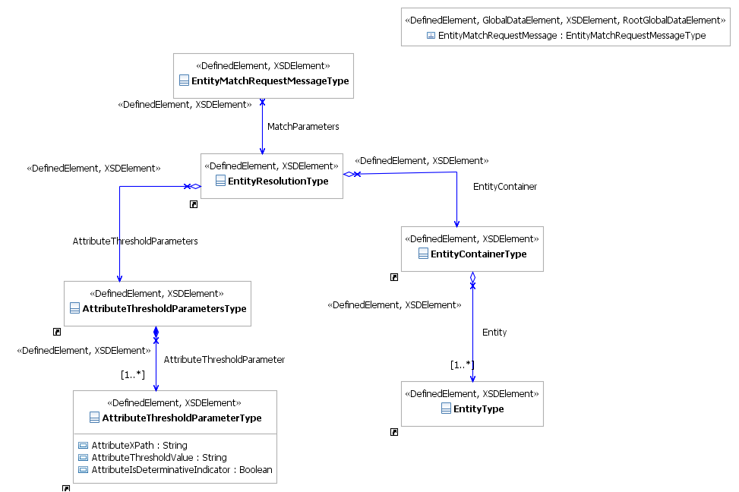

Figure 1 - EntityMatchRequestMessage – Information Model

Note: Click here for a larger view of the diagram.

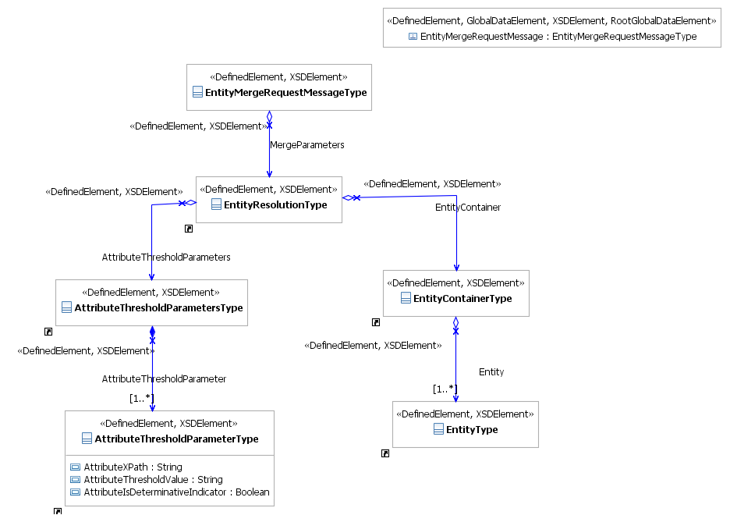

Figure 2 - EntityMergeRequestMessage – Information Model

Note: Click here for a larger view of the diagram.

IEPD Reference

This service uses the EntityResolutionRequest-IEPD. This IEPD exists in the artifacts/service model/information model directory of the Service Specification Package.

Data Inputs

- EntityMatchRequestMessage

Data Outputs

This is an asynchronous service so there are no data outputs on this service.

Provenance

The data exchanged by this service would originate at the partnering data source. The provenance of the data will be restricted to the data available from the specific partnering data source.

Behavior Model

Action Model

Action Name | Submit-Entity-Match
Action Purpose

A request that the match function be performed on a set of record attributes.

Action Inputs | Action Outputs
EntityMatchRequestMessage | N/A
Action Provenance

The provenance of this action is the same as the provenance of the service.

Action Name | Submit-Entity-Merge
Action Purpose

A request that both a match and merge function be performed on a set of record attributes.
Action Inputs | Action Outputs
EntityMergeRequestMessage | N/A
Action Provenance

The provenance of this action is the same as the provenance of the service.

Process Model

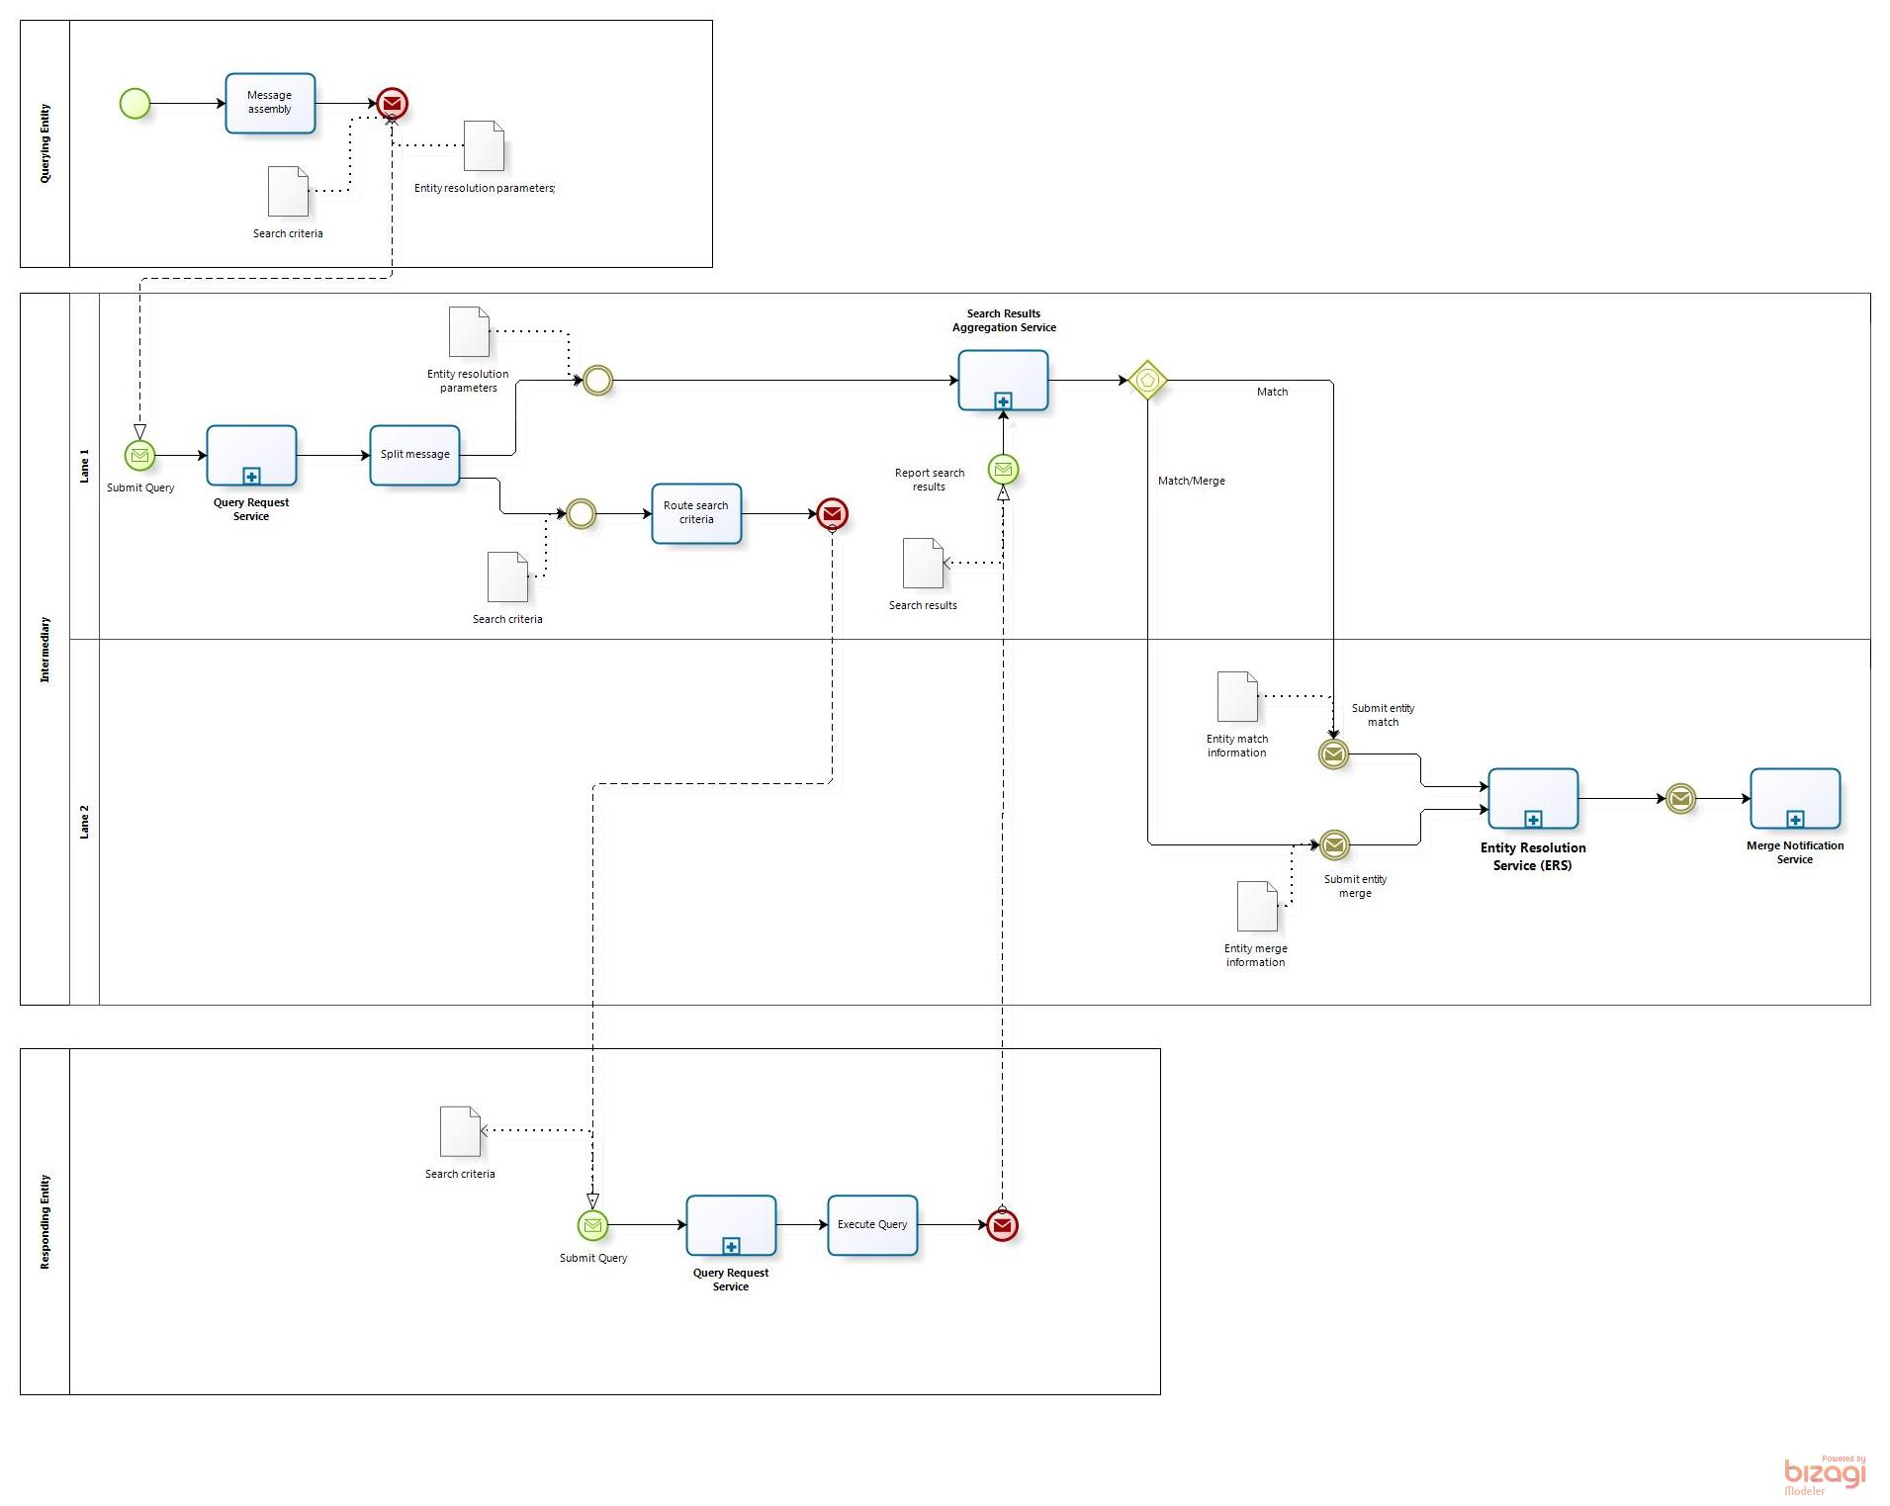

Figure 3: Service Process Model – Business Scenario #1

Note: Click here for a larger view of the diagram.

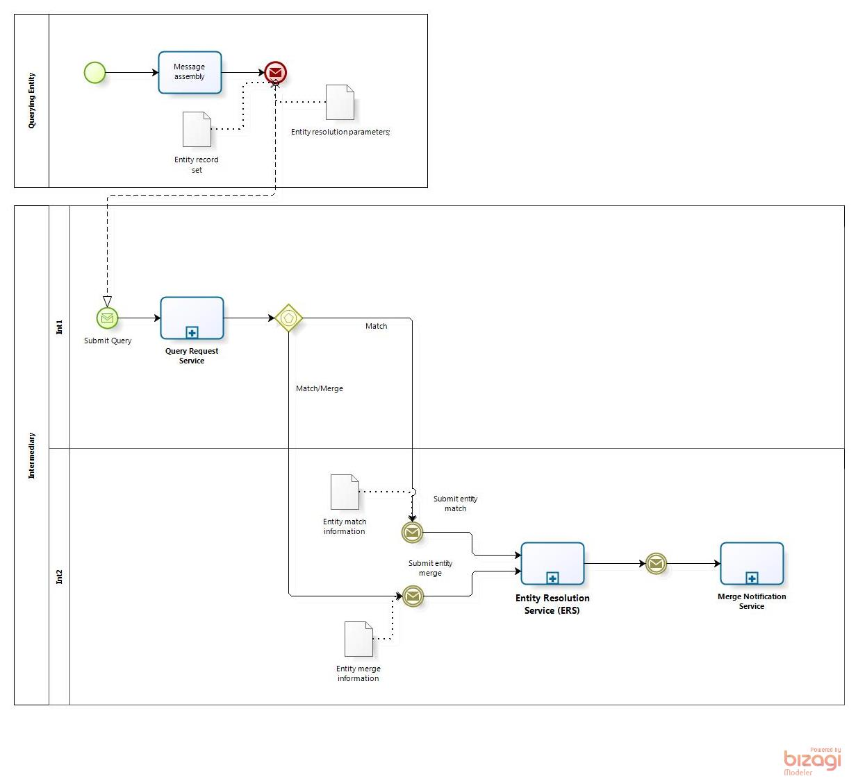

Figure 4: Service Process Model – Business Scenario #2

Note: Click here for a larger view of the diagram.

Appendix A—References

Global Reference Architecture Web Site | http://www.it.ojp.gov/globalgra

Appendix B—Glossary

Appendix C—Document History

Date | Version | Editor | Change
9/21/2013 | 1.0.0 | Andrew Owen, Jim Douglas | Initial Version



