The Global Reference Architecture (GRA)

Merge Notification Service (MNS) 1.0.0

Service Description Document

Version 1.0.0

By SEARCH

October 2013
The ERS service specification was developed by SEARCH in collaboration with the Hawaii Criminal Justice Data Center and Vermont Department of Public Safety.

This project was supported by Grant No. 2009-SQ-B9-K114 awarded by the National Institute of Justice, Office of Justice Programs. The opinions, findings, and conclusions or recommendations expressed in this publication are those of the author(s) and do not necessarily reflect the views of the U.S. Department of Justice.
Table of Contents
1. Introduction to GRA 3
2. Service Overview 4
2.1 Purpose 4
2.2 Scope 4
2.3 Capabilities 4
2.4 Real-World Effects 4
2.5 Summary 5
2.6 Description 5
2.7 Security Classification 5
2.8 Service Specification Package Version 5
3. Business Scenarios 5
3.1 Primary Flow 5
4. Service Interoperability Requirements 5
4.1 Service Interaction Requirements 5
4.1.1 Service Consumer Authentication 6
4.1.2 Service Consumer Authorization 6
4.1.3 Identity and Attribute Assertion Transmission 6
4.1.4 Service Authentication 6
4.1.5 Message Non-Repudiation 6
4.1.6 Message Integrity 6
4.1.7 Message Confidentiality 7
4.1.8 Message Addressing 7
4.1.9 Reliability 7
4.1.10 Transaction Support 7
4.1.11 Service Metadata Availability 7
4.2 Service Assumptions 7
4.3 Service Dependencies 7
4.4 Execution Context 7
4.4.1 Reachability 8
4.4.2 Willingness 8
4.4.3 Awareness 8
4.4.4 Intermediaries, Connectors, and Adaptors 8
4.5 Policies and Contracts 8
4.5.1 Security 8
4.5.2 Privacy 8
5. Additional Information 9
6. Service Model 9
6.1 Information Model 9
6.1.1 IEPD Reference 9
6.1.2 Data Inputs 10
6.1.3 Data Outputs 11
6.1.4 Provenance 11
6.2 Behavior Model 11
6.2.1 Action Model 11
6.2.2 Process Model 12
Appendix A—References 13
Appendix B—Glossary 14
Appendix C—Document History 15

Introduction to GRA

In the context of the Global Reference Architecture (GRA) and Service-Oriented Architecture (SOA) in general, a service is the means by which one partner gains access to one or more capabilities offered by another partner. Capabilities generate real-world effects that can be as simple as sharing information or can involve performing a functional part of a complex process or changing the state of other related processes. Justice and public safety organizations have numerous capabilities and a multitude of partner organizations, both inside and outside the traditional justice and public safety community. There are significant benefits for these organizations to have access to each other's capabilities. The justice and public safety world has nearly 100,000 agencies, each with its own governance, business needs, applications, hardware, and networks. Achieving interoperability among justice and public safety organizations and with external partner organizations requires alignment of business and technical requirements and capabilities. In addition, it is critical to have a consistent way of specifying these requirements and capabilities and sharing them across organizational boundaries. The GRA was developed to facilitate interoperability and to assist in meeting other key requirements in a justice and public safety information sharing environment. In order to achieve this goal, there is a strong need to define a consistent approach to identifying and describing services and their interactions that can be implemented in many different technical environments, across multiple government lines of business, at all levels of government, and with other partner organizations.

The GRA defines a service interface as “the means for interacting with a service.” It includes the specific protocols, commands, and information exchange by which actions are initiated on the service. A service interface is what a system designer or implementer (programmer) uses to design or build executable software that interacts with the service. That is, the service interface represents the “how” of the interaction. Since the service interface is the physical manifestation of the service, best practices call for service interfaces which can be described in an open-standard, referenceable format (that is, a format which could be automatically processed by a computer).

A Service Specification is a formal document describing the capabilities made available through the service; the service model that defines the semantics of the service by representing its behavioral model, information model, and interactions; the policies that constrain the use of the service; and the service interfaces which provide a means to interact with the service. A Service Specification is analogous to the software documentation of an Application Programming Interface (API). It provides stakeholders with an understanding of the structure of the service and the rules applicable for its implementation. It gives the service consumers the information necessary for consuming a particular service, and service providers the information necessary for implementing the service in a consistent and interoperable way.

The main components of a Service Specification are the Service Description, one or more Service Interface Descriptions, and the schemas and the samples required to implement and test the service.
A Service Description contains information about all aspects of the service not directly tied to the physical implementation (in other words, the service interface). A Service Interface Description is a description of the physical implementation—specifically, the service interface used in a specific implementation of the service. Since a service can leverage multiple Service Interfaces, the Service Specification might contain more than one Service Interface Description.

This document is a Service Description Document for the Merge Notification Service (MNS).

Service Overview

The Merge Notification Service (MNS) provides multiple individual system records that, based on certain criteria, represent the same real-world entity.

A ‘merge’ function is the merging of entities into a single record based on a match score meeting a pre-determined match threshold. A matching threshold is determined to be the point of justification in which record attributes for two entities are close enough to suggest that two entities represent the same entity.

Purpose

The purpose of the Merge Notification Service is to provide information about multiple individual system records that, based on certain criteria, represent the same real-world entity.

Scope

The scope of the Merge Notification Service includes informing interested parties of multiple individual system records that, based on certain criteria, represent the same real-world entity.

Capabilities

This service has the ability to receive multiple systems records and to determine that likely represent the same real-world entity, based on pre-determined criteria.

Real-World Effects

This service assists service consumers (e.g., investigators) in building a complete entity profile based on entity records from multiple justice systems.

Summary

This service provides information about individual system records that, based on certain criteria, represent the same real-world entity.

Description

This service is able to provide information to interested parties about individual system records that probably represent the same real world. This type of information can facilitate investigations by providing a sense of probability that otherwise independent pieces of information are actually about the same entity.

Law enforcement support systems (e.g., federated query or link analysis applications) will use this service whenever they need to determine (at some probability) whether two entities are the same based on common attributes within a record.

In most implementations, this service is the asynchronous callback for a nearby Entity Resolution Service (ERS). In the Entity resolution ecenario, the ERS is first provided with a set of entities to match/merge, and a configuration (based on any given entity resolution algorithm) controlling how to perform the entity resolution. The Merge Notification Service is the destination to which such an ERS implementation sends, asynchronously, the results.

Security Classification

The highest level of security classification for the information exchanged by this service is Sensitive but Unclassified (SBU). As a result the service can be assigned a security classification of SBU.

Service Specification Package Version

This service specification is built based on version 1.0.0 of the Service Specification Package.

Business Scenarios

Primary Flow

A system or service (e.g., ERS) will analyze system records and perform entity resolution to determine match scores based on pairwise comparisons and compile information about those matches and whether the matches justify merging of entities – in other words: suggesting that one or more entities probably represent the same real world entity. That system will then submit these merge results to the Merge Notification Service

Service Interoperability Requirements

Service Interaction Requirements

The following table lists the Service Interaction Requirements established by the GRA Framework, and indicates whether each is mandatory for this service.

Requirements | Mandatory (Yes/No) | Justification/Notes
Service Consumer Authentication | Yes
Service Consumer Authorization | Yes
Identity and Attribute Assertion Transmission | Yes
Service Authentication | Yes
Message Nonrepudiation | Yes
Message Integrity | Yes
Message Confidentiality | Yes
Message Addressing | Yes
Reliability | No
Transaction Support | No
Service Metadata Availability | Yes

Service Consumer Authentication

The service consumer must provide information in the message sent to this service that the service can use to authenticate the consumer and confirm that the consumer is a member of the federation.

Service Consumer Authorization

The service must confirm that the service consumer is in fact authorized to send messages to the service.

Identity and Attribute Assertion Transmission

The service consumer must make information about itself available to the service. Likewise, the service must make information about itself available to service consumers.

Service Authentication

A service consumer must be able to verify the identity of the service in trusted manner.

Message Non-Repudiation

All messages sent to this service must contain information to prove that a particular authorized sender in fact sent the message.

Message Integrity

All messages sent to this service must contain information for the service to confirm that the message has not changed since it left control of the sender.

Message Confidentiality

All messages sent to this service must be protected in a manner that prevents anyone except the authorized recipient from reading the message.

Message Addressing

All messages sent to this service must contain a unique message identifier (this supports correlation of asynchronous request/response) along with information indicating where the message originated, the ultimate destination of the message, a specific recipient to whom the message should be delivered and a specific address or entity to which reply messages should be sent, if they exist.

Reliability

This service does not require Reliability.

Transaction Support

This service does not require Transaction Support.

Service Metadata Availability

Since this service is part of a federation, this metadata about this service must be made available to all federation members

Service Assumptions

- All messages sent to the MNS will result in a synchronous acknowledgement of receipt or failed delivery. This acknowledgement will contain just enough information to confirm that the message was delivered and is not considered part of the service model.

- Messages other than the synchronous acknowledgement are returned asynchronously.

Service Dependencies

The MNS is able to provide information (results) to interested parties about individual system records that probably represent the same real world. The Entity Resolution Service (ERS) should be used in conjunction with the MNS.

Execution Context

This section is divided into sub-sections based on the implementation guidelines established in the GRA Execution Context guidelines 1.2

Reachability

The infrastructure must provide a communication path that allows service consumers to send messages to the service.

Willingness

The infrastructure must enable encryption of the communication path between service consumer and service provider.

The infrastructure must also provide a mechanism for the service to confirm that the message sent from the consumer has not changed since it left the control of the consumer.

Awareness

Providers of this service should make details about the service and service interface available to potential service consumers.

Intermediaries, Connectors, and Adaptors

The infrastructure that implements this service should do so in a manner according to section 3.4 of the GRA Execution Context Guidelines 1.2.

Policies and Contracts

None

Security

Communication with this service must happen in a manner that information sent to the service is guaranteed confidential. Also, the service must be able to verify the identity of the consumer and the consumer must be able to verify the identity of the service provider.

Privacy

Care should be taken when using service implementations to resolve information about person entities. The possibility exists that, based on a particular configuration, the service could suggest that two entities are the same when in fact they are not. When the entities represented are people, then it would be possible in criminal justice scenarios (particularly investigative scenarios) to associate erroneously the records of one person with another person. (Note that this kind of improper association of records across people can and does occur without use of an entity resolution approach.)

One solution to this problem would be to develop and promulgate privacy policies that impose obligations on users of the service, such as independent verification of such associations, via examination of original source documents or records. Such approaches will significantly help avoid violations of citizens’ privacy and civil liberties. Policies could also require the publication of advice to users (e.g., via training, or disclaimers alongside the display of merged records) that explain the nature of entity resolution (i.e., that it is a heuristic approach that can contain errors, and that the mere fact of two entities’ being merged is generally not adequate to assume they are the same under most circumstances).

Additional Information

None

Service Model

Information Model

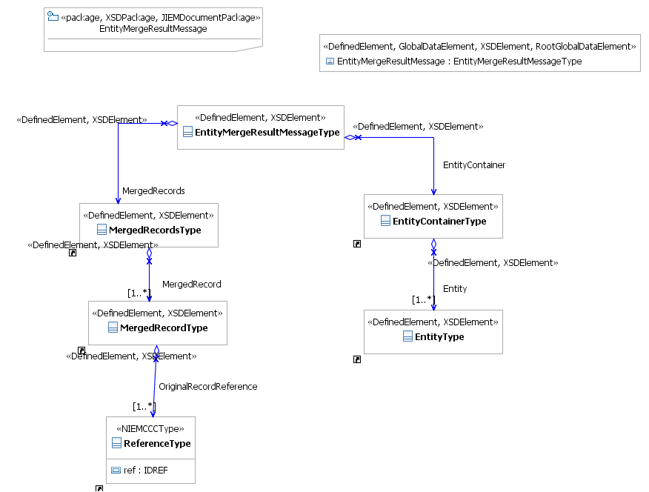

Figure 1 - EntityMergeResultMessage – Information Model

Note: Click here for a larger view of the diagram.

IEPD Reference

This service uses the EntityMergeResultMessage-IEPD. This IEPD exists in the artifacts/service model/inform ation model directory of the Service Specification Package.

Data Inputs

- EntityMergeResultMessage

This message contains the original set of entities returned from a previously submitted search, along with entity merge information that was produced by an entity resolution process (e.g., ERS). In other words, this message does not contain altered search results; instead it contains original results with additional detail of match and merge results.

This message consists of two main sections: Entity Container and Merged Records.

The Entity Container - simply contains a collection of Entity information provided by a data source. This section should be fairly flexible as to allow for the ability to assert information about any kind of entity.

The Merged Records - section contains one or more Merged Record. A Merged Record is a grouping of one or more entities, originally declared in the Entity Container, that were determined to likely represent the same real-world object as the result of some entity resolution process. Each entity in the Entity Container must exist in exactly one Merged Record, even if the entity is only merged with itself. A Merged Record should not duplicate information in the Entity Container; instead the Merged Record should simply reference the original record.

Each Merged Record can also contain a Merge Quality. Merge Quality will contain one or more set of Merge Statistics; one for each attribute used to make the merge possible.

In the example provided in the service specification a String Distance example is provided as an example of Merge Quality. String Distance Statistics is a composite concept that consists of the following:

- An attribute identifier – specifies the specific attribute used to perform a match/merge (in XML implementations, this could be an XPath to the attribute)
- String Distance Mean – the mean value of all string distances calculated for the specific attribute for a given set of entities.
- String Distance Average – the average value of all string distances calculated for the specific attribute for a given set of entities.
- String Distance Standard Deviation – the extent of string distance deviation for the occurrence of this attribute among a given set of entities. This could be calculated as:
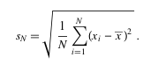
Where s_{N} = Standard Deviation
N = Number of Attributes
x = String Distance
x (bar) = Mean String Distance

Example

The following illustrates the distance scores that may be attributed to any two Person entity records and the corresponding, mean, average and standard deviation.

Attribute String Distance (Match Function Result)

First Name 0.91 0.45 0.92 0.85 0.65 0.41
Last Name 0.94 0.42 0.90 0.85 0.70 0.80
Street Address 0.82 0.20 0.95 0.82 0.70 0.22
City 0.95 0.95 1.00 1.00 0.80 0.15
Height 0.85 0.85 1.00 1.00 0.75 0.30
Ethnicity 1.00 1.00 1.00 1.00 1.00 1.00
DOB 0.62 0.20 0.95 1.00 0.80 0.31

x(bar) 0.91 0.45 0.95 1.00 0.75 0.31
x (average) 0.87 0.68 0.96 0.93 0.77 0.45
s_{N} 0.12 0.32 0.04 0.086 0.11 0.32

Data Outputs

This is an asynchronous service so there are no data outputs on this service.

Provenance

The data used to consume this service originates with the requesting agency.

Behavior Model

Action Model

Action Name | NotifyofMergedRecords
Action Purpose

A service consumer will invoke this action in order to notify of merged records resulting from an entity resolution process
Action Inputs | Action Outputs
EntityMergeResultMessage | N/A
Action Provenance

The data provenance for this action is identical to that of the information model for this service.

Process Model

This service offers a single action which allows for submission of Entity Merge Results.

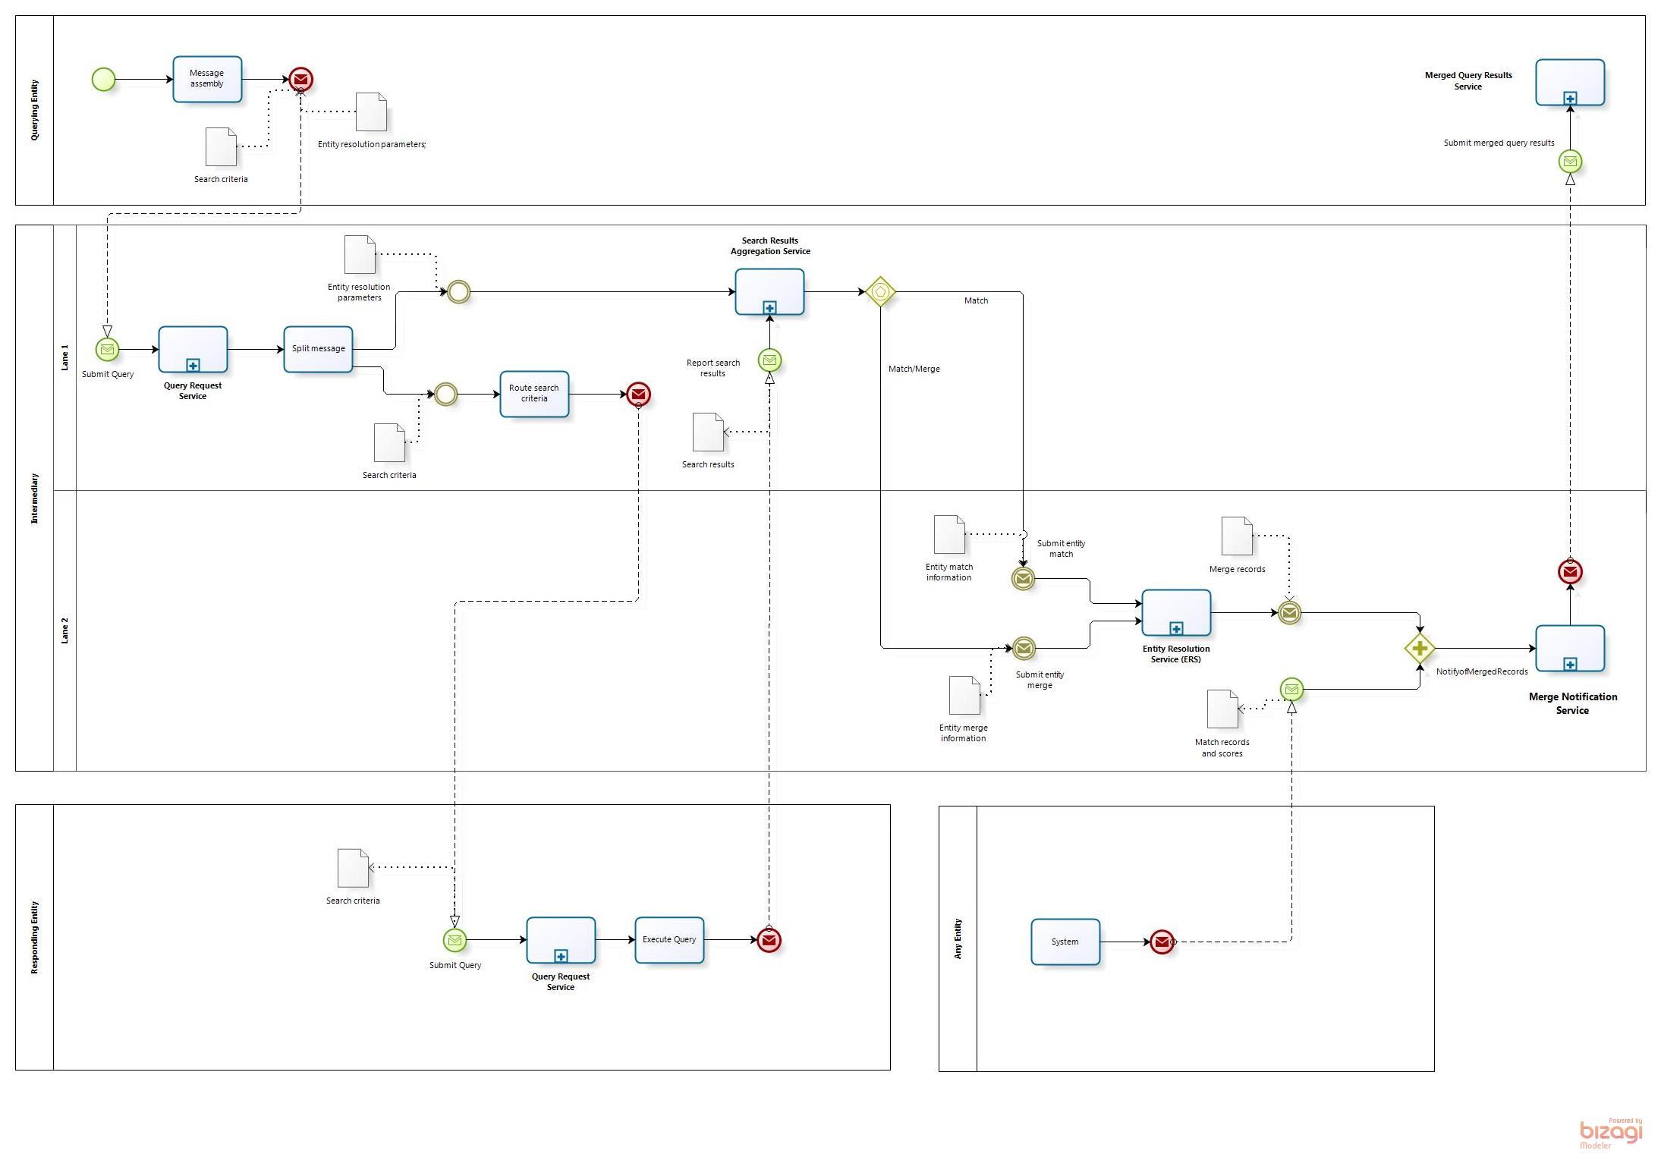

Figure 3: Service Process Model

Note: Click here for a larger view of the diagram.

Appendix A—References

Global Reference Architecture Web Site | http://www.it.ojp.gov/globalgra

Appendix B—Glossary

Appendix C—Document History

Date | Version | Editor | Change
9/21/2013 | 1.0.0 | Andrew Owen, Jim Douglas | Initial Version



