# Setup SDK

## Setup JDK

### Download JDK

### Install JDK

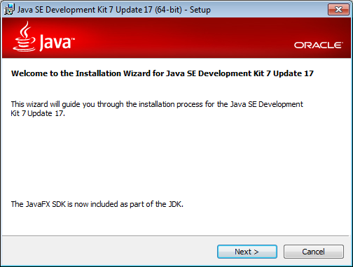

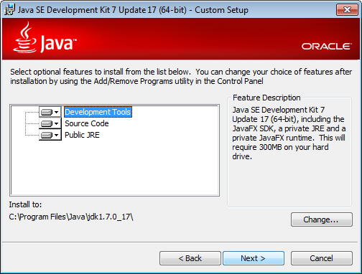

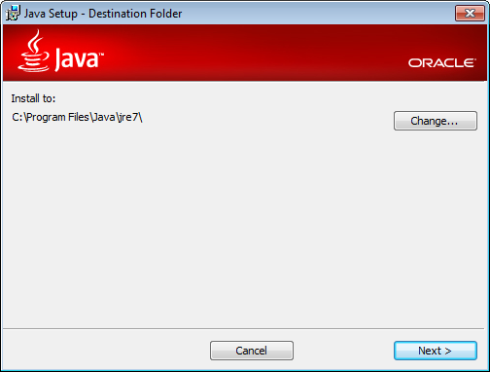

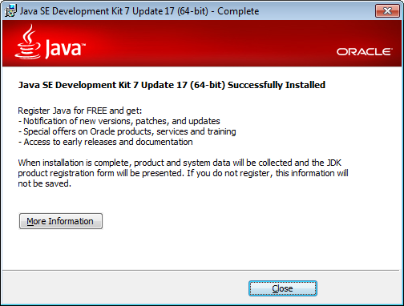

# Setup Web Container

## Setup Tomcat

### Download Tomcat

### Install Tomcat

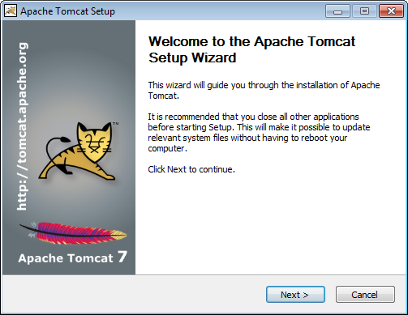

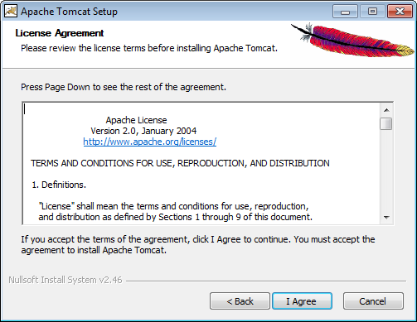

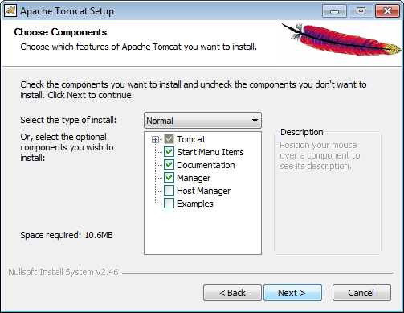

#### Setup Admin Authentication

#### Setup Admin Authorization

Roles: manager-gui & **manager-script**!

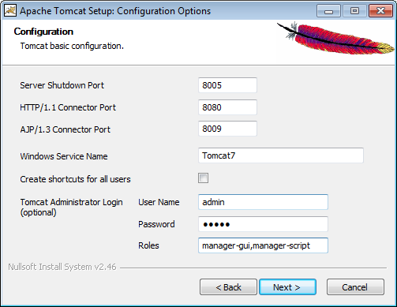

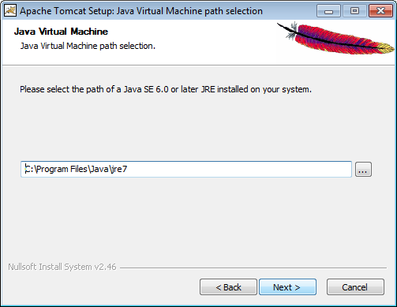

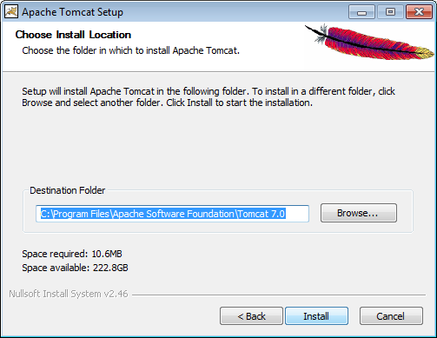

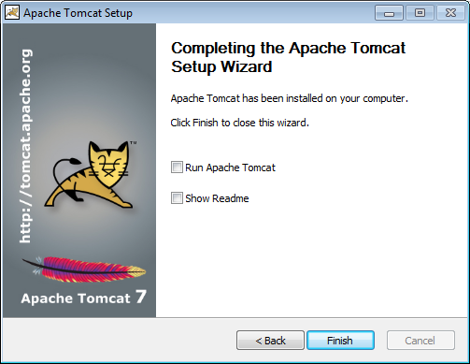

# Setup IDE

## Setup Eclipse Spring Tool Suite (STS)

### Download STS

### Install STS

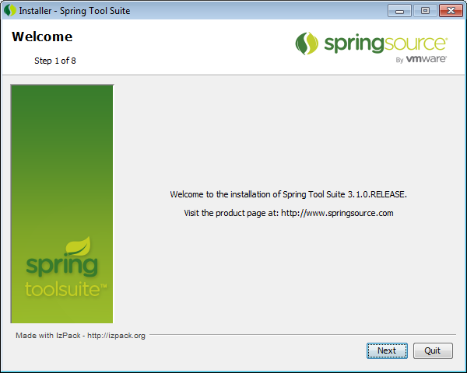

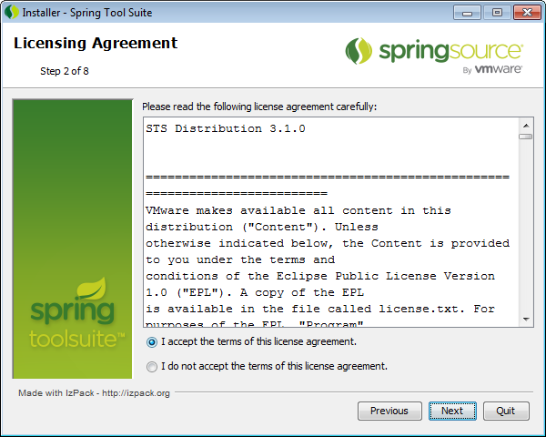

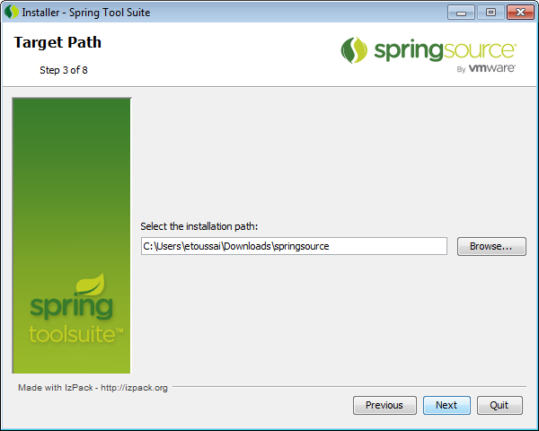

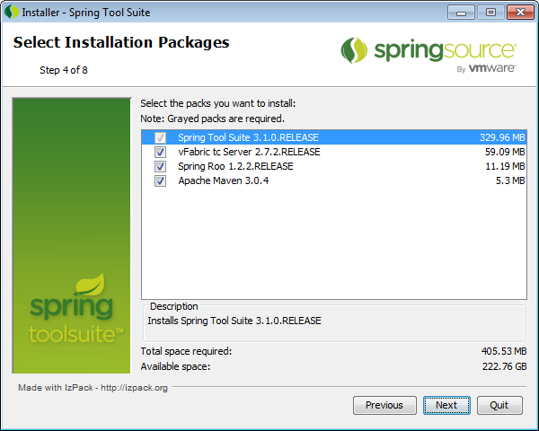

### Point to JDK

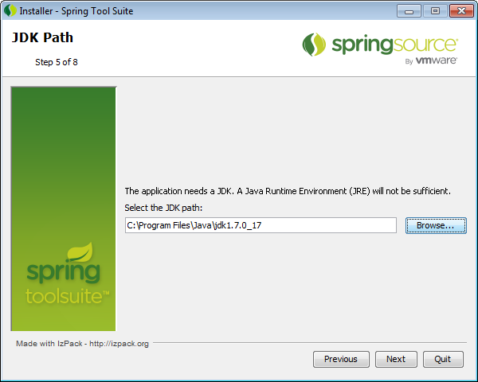

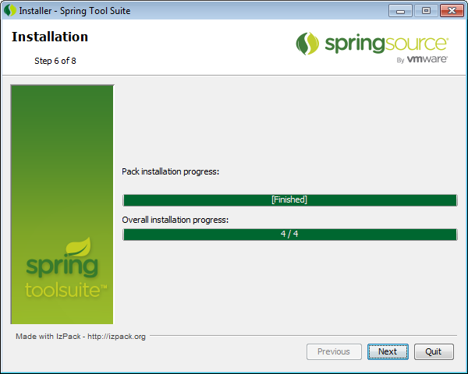

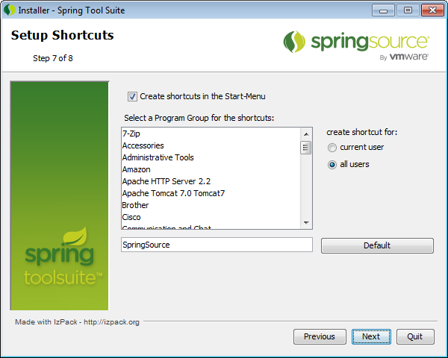

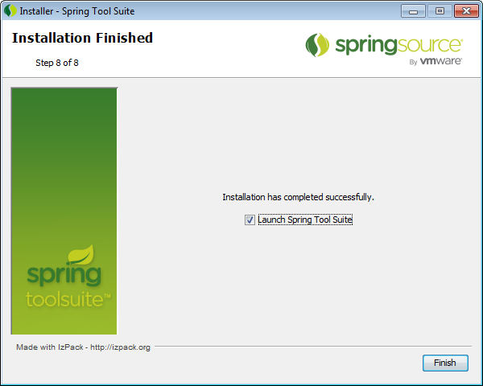

### Add Tomcat Server

On Package Explorer panel (left), Right click Servers > New > Other… >

Server > Server > Next >

Apache > Apache Tomcat v7.0 Server > Next

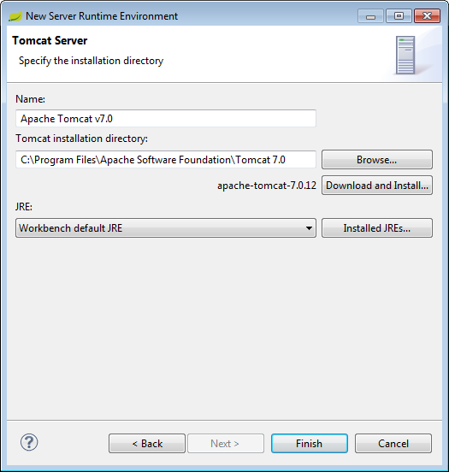

### Other Configurations

#### Show Hidden Files

Package Explorer -> View Menu -> Filters -> uncheck .* resources

# Setup Source Code Management

## Setup Git

### Default Repository Folder

Window > Preferences > Team > Git

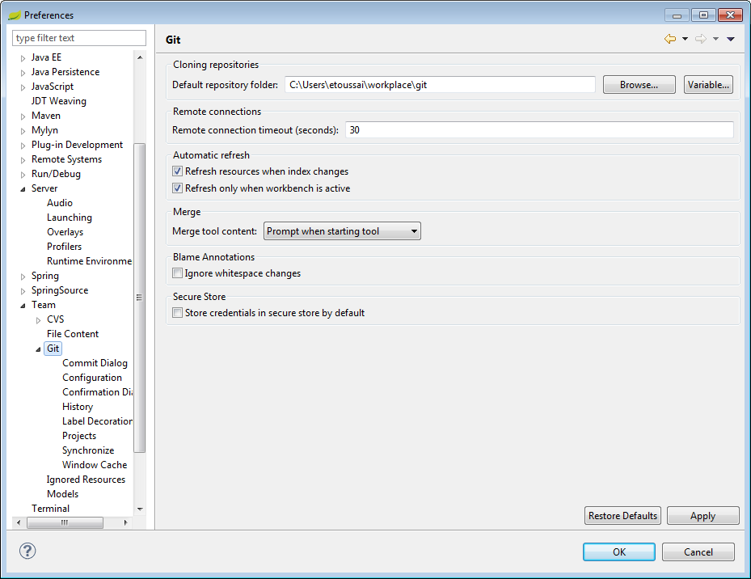

### Configuration

Window > Preferences > Team > Git > Configuration

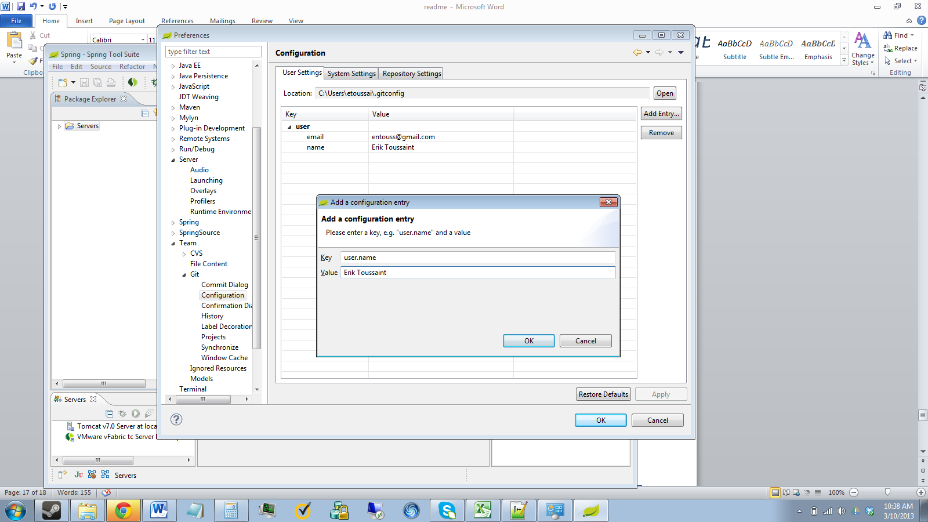

# Setup Build Automation

## Setup Maven

### User Settings & Local Repository

Window > Preferences > Maven > User Settings

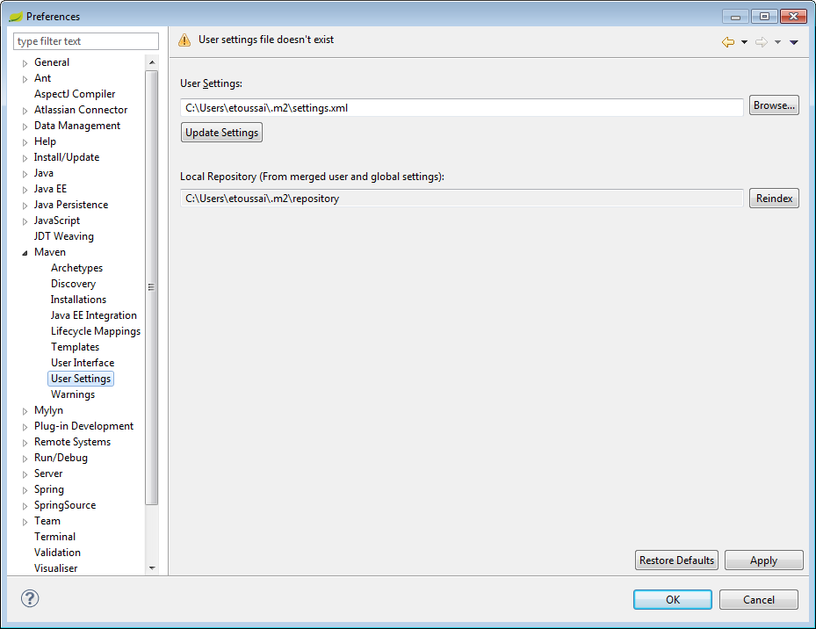

### Create Settings.xml



# Setup Project

## Setup GitHub Repository

### Sign up for GitHub

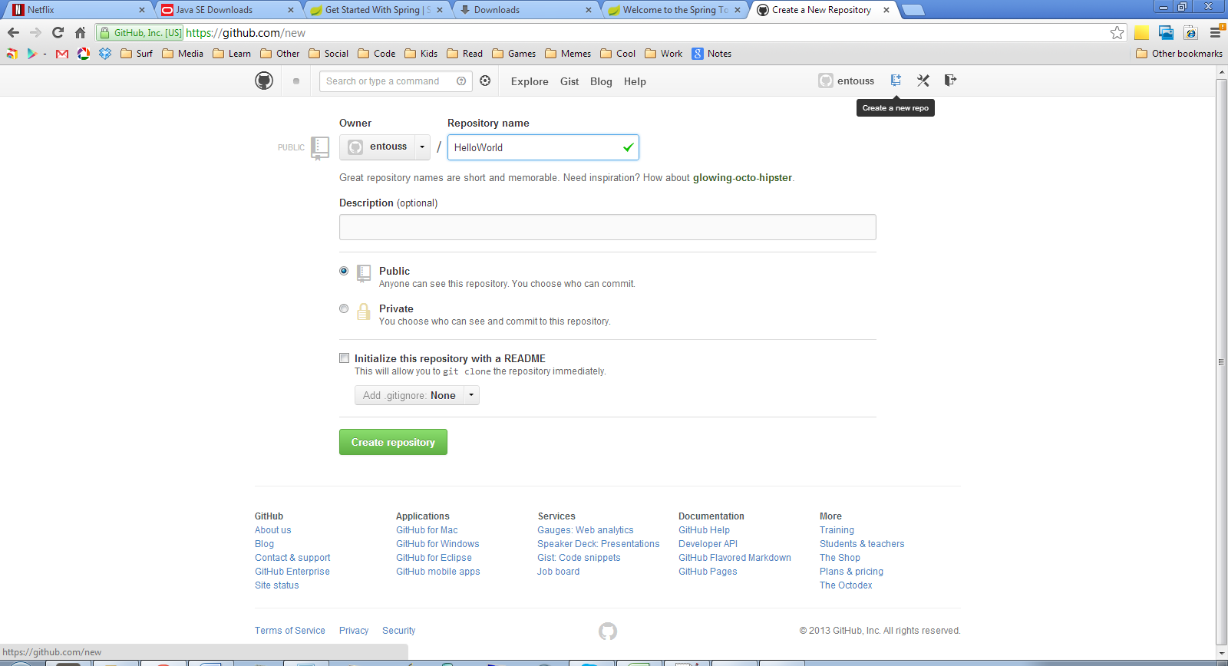

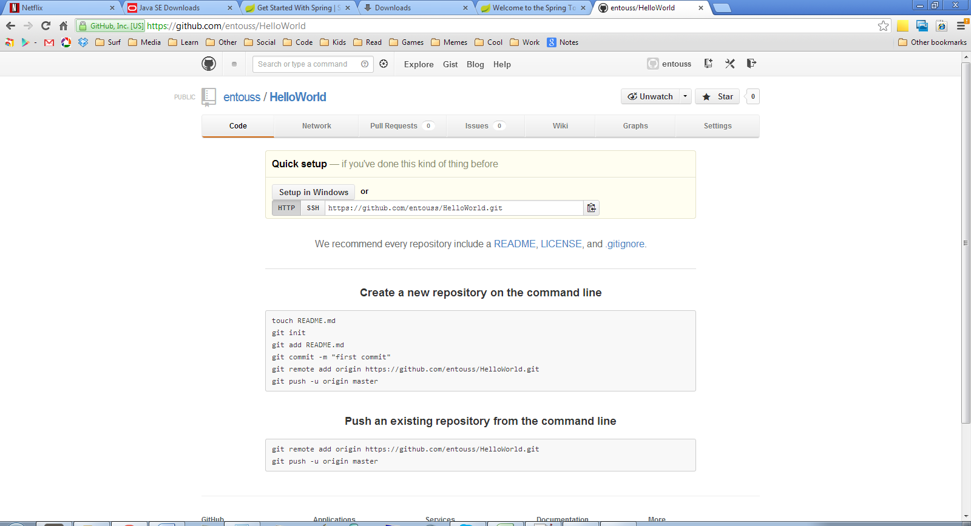

## Import Project

Right click ‘Package Explorer’ panel > Import… >

Git > Projects from Git > URI > Next >

Copy Paste Git URL from GitHub screenshot above into URI field

Add GitHub Authentication information

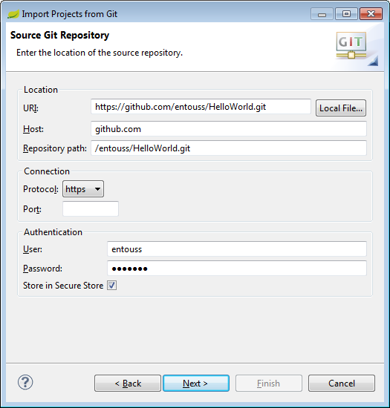

Right Click ‘Package Explorer’ panel > New > Project… > General > Project

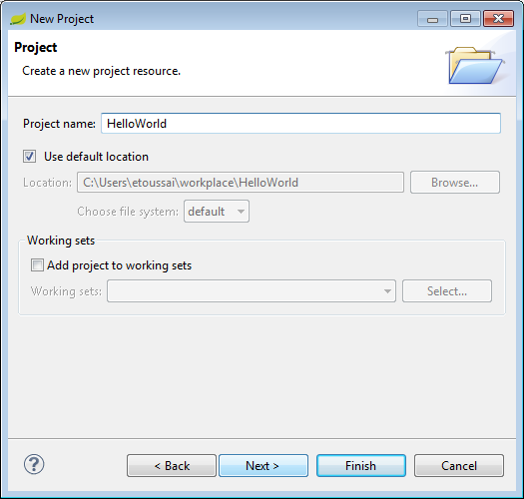

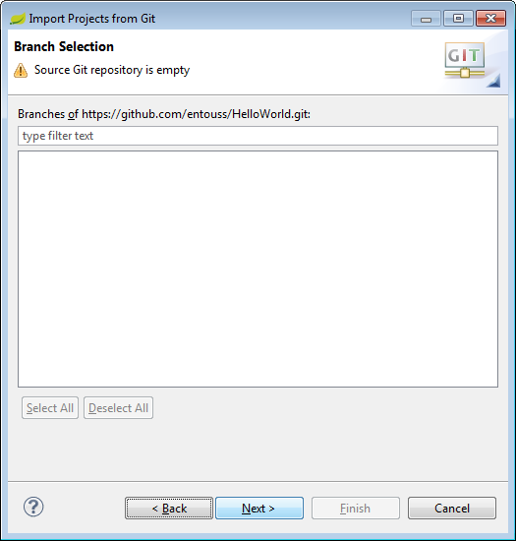

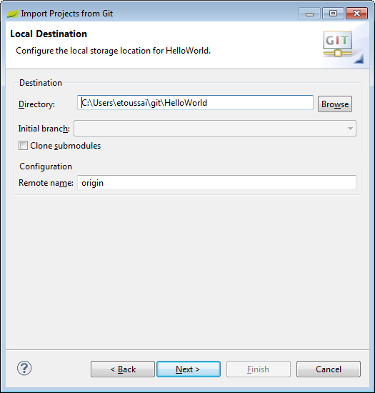

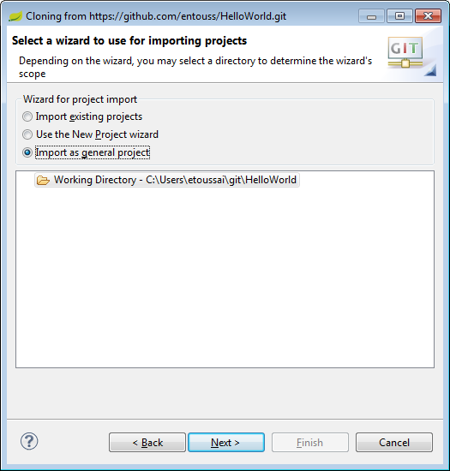

## Configure Bare Maven POM

Right Click ‘HelloWorld’ project in ‘Package Explorer’ panel > Configure > Convert to Maven Project

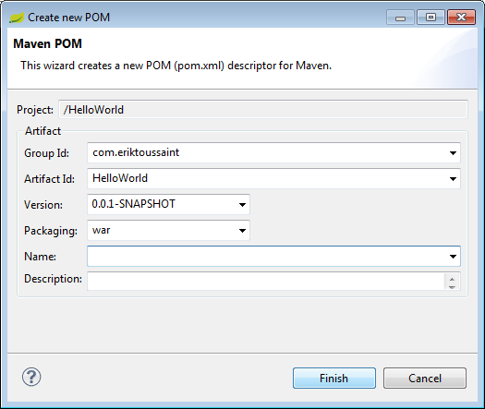

## Initial Commit

### Ignore Files

In ‘Package Explorer’ panel, Right Click HelloWorld > [following files & folders] >

Team > Ignore

* .settings
* target
* .classpath
* .gitignore
* .project

### Commit

In ‘Package Explorer’ panel, Right Click HelloWorld >

Team > Commit

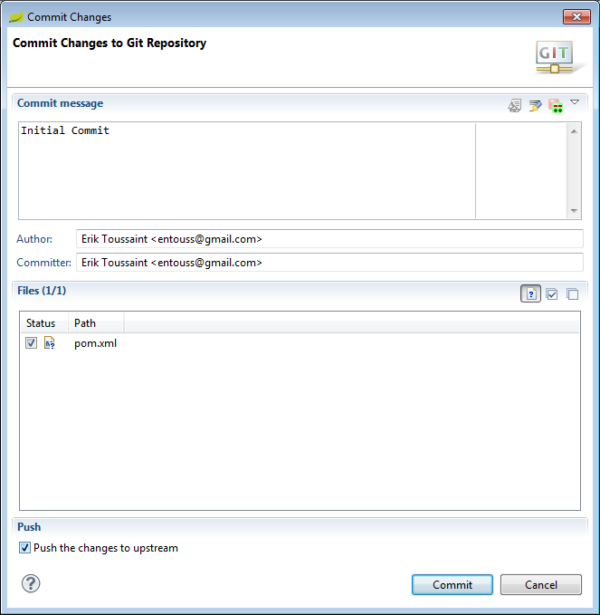

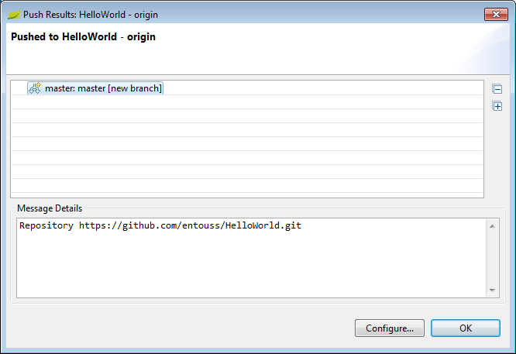

# Configure Project

## Create src/main/webapps/index.html



## Configure src/main/webapp/WEB-INF/web.xml

## Add Project to Server

In the ‘Server’ view, Right click ‘Tomcat v7.0 Server at localhost’ > Add and Remove… >

HelloWorld > Add> > Finish

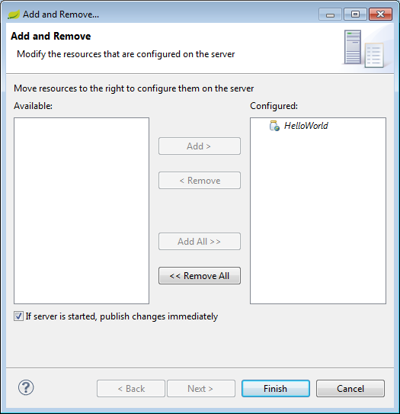

## Run Server

In ‘Server’ view, Right click Tomcat v7.0 Server at locahost > Start

## Hello World!

Go to http://localhost:8080/HelloWorld

## Commit

# Run Hello World MVC

## Configure POM.xml



## Configure src/main/webapp/WEB-INF/web.xml

## Configure src/main/webapp/WEB-INF/spring/appServlet/Spring Context



## Wire Model

## Wire View – src/main/webapp/WEB-INF/views/home.jsp



## Wire Controller – controller.HomeController.java



## Commit