Prepare for the annual expense for taxation purpose

**Income**

Mostly the income on the consulting basis. From 1st Jan to 31st Dec

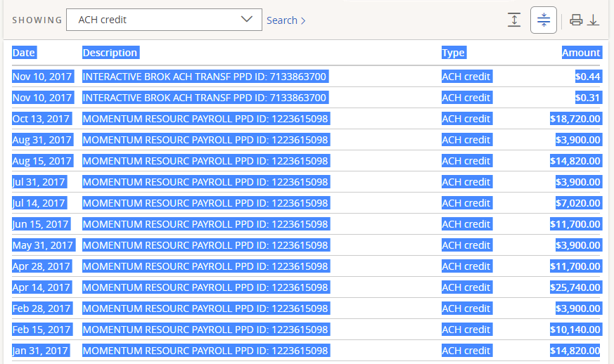

Copy and paste the selected into a text file and process it with a python script

**Get chase expenses**

Download the expense report from Chase.com (business account), save as chase_expense_yyyy.csv

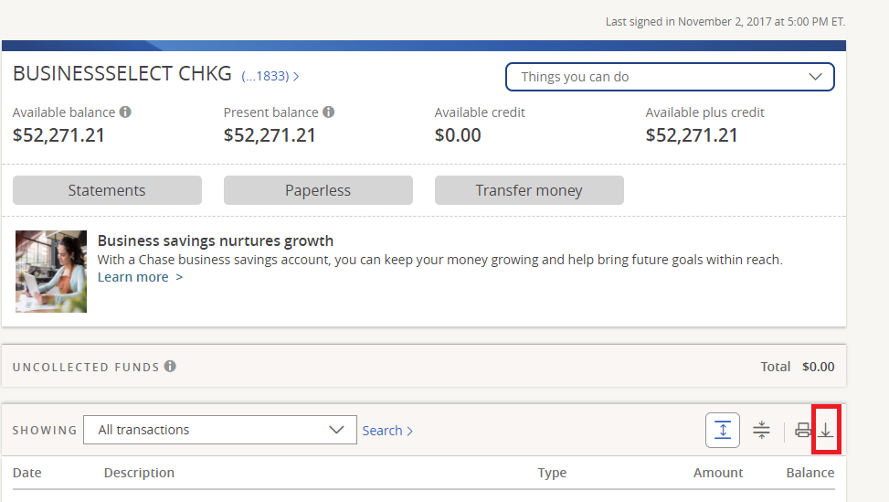

**Commission**: includes ATM cash out, and misc.

**Debit** (those cashed out from a teller)

**Excluded expenses:**

* Goddard tuitions;
* Rego Park maintenance;
* Wendy’s service fee.

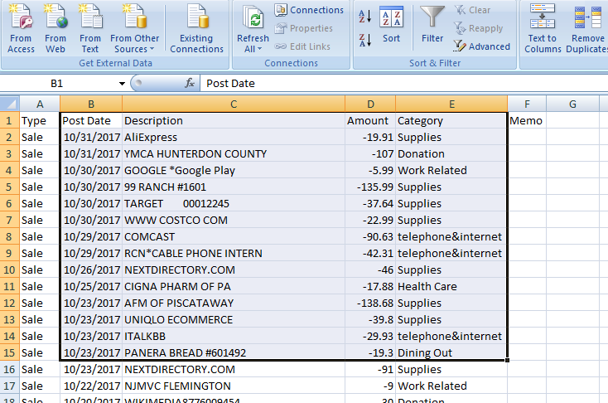

**Get Citi expense:**

From wife, a csv file, filter out the autopay, pickup the 3 columns as shown below, saving it into a csv file citi_expense_yyyy.csv

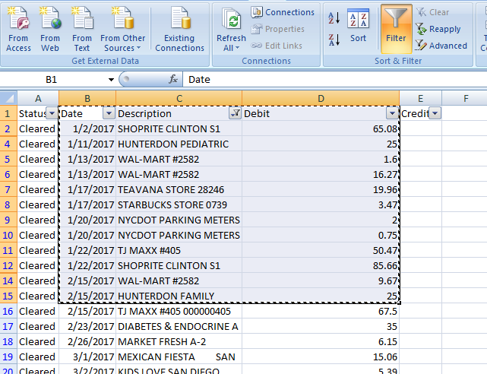

Only interest in the four columns as above.

American Express: from wife, very few, manually handle it

Manually update the file and send it to Wendy.